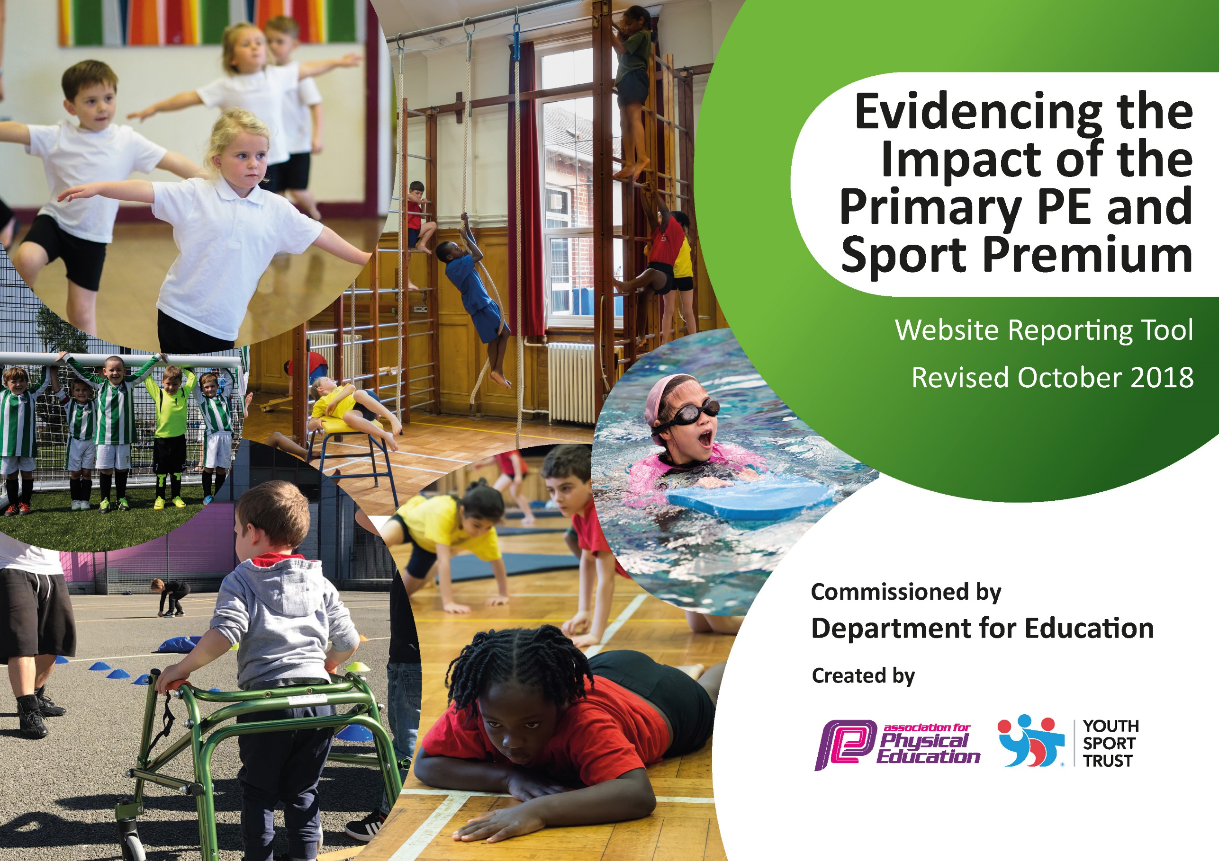
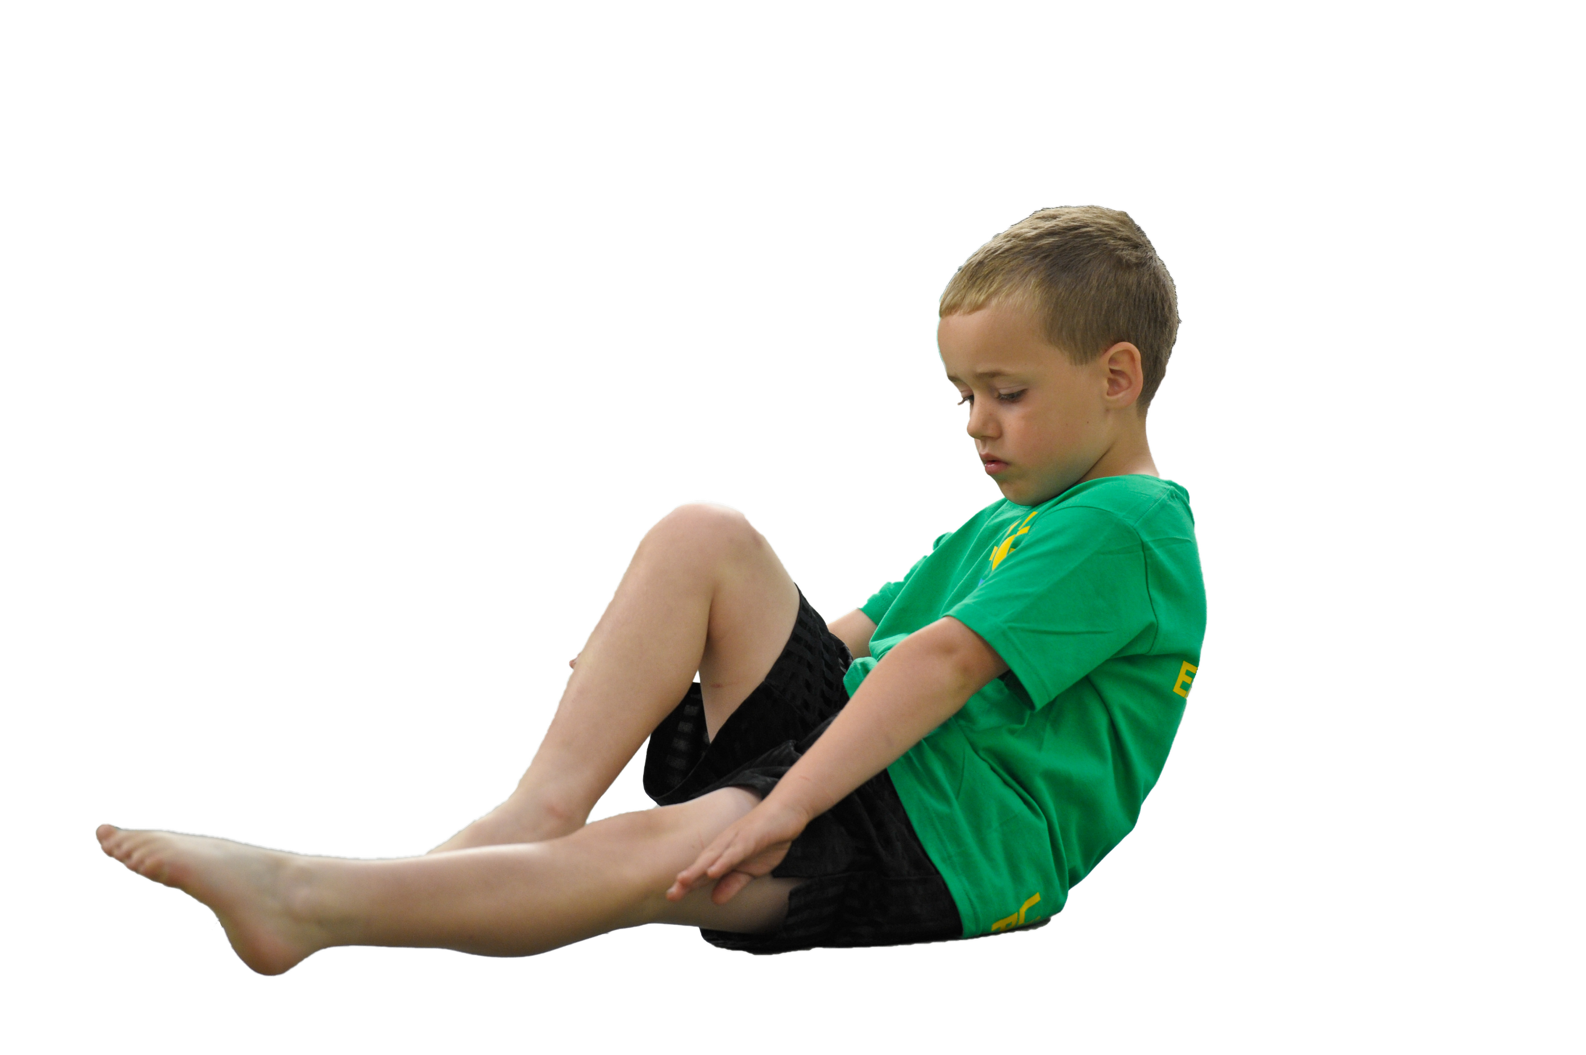
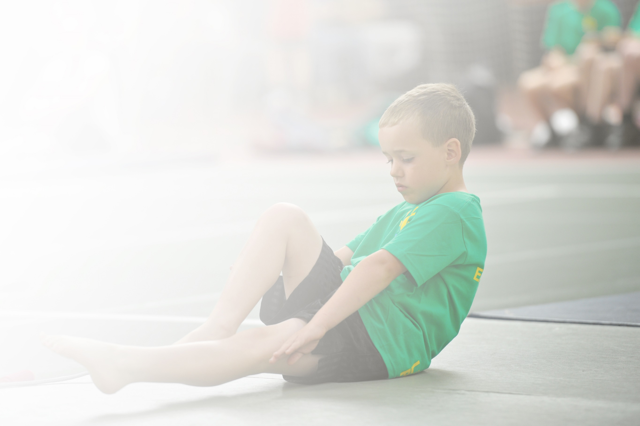
Schools must use the funding to make additional and sustainable improvements to the quality of Physical Education, Sport and Physical Activity (PESPA) they offer. This means that you should use the Primary PE and Sport Premium to:

- Develop or add to the PESPA activities that your school already offer
- Build capacity and capability within the school to ensure that improvements made now will benefit pupils joining the school in future years

Please visit gov.uk for the revised DfE guidance including the 5 key indicators across which schools should demonstrate an improvement. This document will help you to review your provision and to report
your spend. DfE encourages schools to use this template as an effective way of meeting the reporting requirements of the Primary PE and Sport Premium.

We recommend you start by reflecting on the impact of current provision and reviewing the previous
spend. Under the Ofsted Schools Inspection Framework, inspectors will assess how effectively leaders use the Primary PE and Sport Premium and measure its impact on outcomes for pupils, and how effectively governors hold them to account for this.

Schools are required to publish details of how they spend this funding as well as on the impact it has on pupils’ PE and sport participation and attainment by the end of the summer term or by 31 July 2020 at the
latest.
We recommend regularly updating the table and publishing it
on your website throughout the year, as evidence of your
ongoing review into how you are using the money to
secure maximum, sustainable impact. To see an
example of how to complete the table please
click HERE.

Support for review and reflection - considering the 5 key indicators from DfE, what development needs are a priority for your setting and your students now and why? Use the space below to reflect on previous spend, identify current need and priorities for the future.

Key achievements to date: | Areas for further improvement and baseline evidence of need:
- High profile of PE and sport (on school development plan since 2013; AfPE Quality Mark with Distinction 2017; Merseyside Sport Primary School of the year 2016)  - School Games Platinum Award (July 2019)  - Increased staff knowledge and confidence in PE due to coaching and mentoring (evidenced by HMI best practice case study 2014)  - Increased participation and engagement (evidenced by School Games Award for past 5 years) | - Developing further the physical health and wellbeing provision across the school as identified by the School’s Health Education Survey (SHEU).

Meeting national curriculum requirements for swimming and water safety | Please complete all of the below:
What percentage of your current Year 6 cohort swim competently, confidently and proficiently over a distance of at least 25 metres?
N.B. Even though your children may swim in another year please report on their attainment on leaving
primary school.
What percentage of your current Year 6 cohort use a range of strokes effectively [for example, front crawl, backstroke and breaststroke]?
What percentage of your current Year 6 cohort perform safe self-rescue in different water-based situations?
Schools can choose to use the Primary PE and Sport Premium to provide additional provision for swimming but this must be for activity over and above the national curriculum requirements. Have you used it in this way?

Action Plan and Budget Tracking
Capture your intended annual spend against the 5 key indicators. Clarify the success criteria and evidence of impact that you intend to measure to evaluate for students today and for the future.

Academic Year: 2020/21 | Total fund allocated: £16330 | Date Updated: December 2020
Key indicator 1: The engagement of all pupils in regular physical activity – Chief Medical Officer guidelines recommend that primary school children undertake at least 30 minutes of physical activity a day in school |  |  |  | Percentage of total allocation:
 |  |  |  | Approx. 20%
School focus with clarity on intended impact on pupils: | Actions to achieve: | Funding allocated: | Evidence and impact: | Sustainability and suggested next steps:
Increase physical activity levels of children across the whole-school | - Pitch Hire  - HSBC Ready Set Ride Programme  - Use SHEU survey to offer new clubs to less active children  - Fit Fun Fests in partnership with Clare Mount Specialist Sports College designed for less active pupils  - Active 30:30 Wristband Challenge | £1800  £200  Clare Mount Specialist Sports College SLA (£3500) | *Evidence and impact delayed by COVID-19  - 57% OF OM children engaged with extra-curricular sports (March 2020)  - Pitch hire has allowed as wide a range of activities as possible to be provided. It has allowed all classes to receive min. 2 hrs PE per week and will allow some extra-curricular activities to continue.  - Fit Fun Fests (Spring 2020) have helped to encourage less active children to become more active.  - Partnership with John Moores University to measure OM fitness levels, educate children on health and fitness and improve fitness levels (Movement Matters Spring 2020)  - Partnership with Leeds Beckett University – Active 30:30 Wristband challenge. CPD delivered to teaching staff. Programme to resume again March 2021. | - Bike purchase and maintenance will help continuation of HSBC Ready Set Ride programme to teach pupils to ride a bike. Bike club will run during additional needs groups Spring and Summer 2021 (clubs Covid-19 permitting)  - Continue to provide a wide range of PE and sport activities (informed by SHEU and pupil voice) These will happen even if within class ‘bubbles’.
Key indicator 2: The profile of PESSPA being raised across the school as a tool for whole school improvement |  |  |  | Percentage of total allocation:
 |  |  |  | Approx. 20 %
School focus with clarity on intended impact on pupils: | Actions to achieve: | Funding allocated: | Evidence and impact: | Sustainability and suggested next steps:
Maintain high profile of PESSPA: further develop provision of PE and mental health (on SDP 2018-19)  Improve and support physical health, fitness and well-being of all pupils  Further develop leadership opportunities (main focus on girls) | - SDP includes PE and mental health as a priority  - PE report at governor’s meetings  - Termly PE staff meetings (focusing on different areas of CPD e.g. leadership, autism in PE, My Personal Best etc.)  - SHEU survey to highlight issues and trends and target support  - Mental Health and Keep Safe Week  - Girls Active (YST) with aim of leading whole-school fun fitness sessions and raise activity levels | £2500 TLR  payment  £2500 TLR  release time  £3500 (SLA)  £300  £400  Using TLR release as above | - PE and mental health on agenda at all full governors meetings  - ‘Active in Mind’ began in February 2020. Neil Danns athlete mentor ran training for 10 Y6 pupils. They led physical and mental health activities for peers.  - Staff CPD: My Personal Best . YST Training for 2 members of staff completed (Autumn 2019) and has been cascaded in INSET (Autumn 2020). Mentoring for 2 different staff members from JW and for others from DS (ongoing).  - SHEU survey update and interventions planned for rest of academic year. | - YST My Personal Best to be introduced Autumn 2020.  - Girls Active programme Summer 2021.

Key indicator 3: Increased confidence, knowledge and skills of all staff in teaching PE and sport |  |  |  | Percentage of total allocation:
 |  |  |  | Approx. 20%
School focus with clarity on intended  impact on pupils: | Actions to achieve: | Funding  allocated: | Evidence and impact: | Sustainability and suggested  next steps:
To further develop the confidence, knowledge and skills of all staff.  To provide bespoke targeted support of PE and sport to meet the needs of staff. | - Teaching Assistant survey of knowledge and confidence of autism in PE and inclusive practice  - Inclusive Portal online training for Teaching Assistants (co-ordinated by DS and JW)  - CPD: staff meetings and from external agencies through partnership with Clare Mount Specialist Sports College  - Coaching and mentoring from TLR and specialist PE staff  - Opportunities for peer lesson observations (Summer 2021 – Covid-19 permitting)  - Staff to run extra-curricular sports clubs and activities (Summer 2021 – Covid-19 permitting) | £3500 (SLA)  £2500 TLR  £2500 TLR release | - CPD (INSET) carried out by DS/JW: My Personal Best for teachers and teachers  - Targeted staff CPD: inclusive PE, boccia, assessment etc.  - ‘World in a Box’ resource used in dance/topic lessons during academic year 2019-20. | - Monitoring of impact of staff confidence and knowledge in delivering My Personal Best  - TA’s to receive CPD for autism in PE. Use Inclusive PE Training Portal (Summer 2021).
Key indicator 4: Broader experience of a range of sports and activities offered to all pupils |  |  |  | Percentage of total allocation:
 |  |  |  | Approx. 20%
School focus with clarity on intended  impact on pupils: | Actions to achieve: | Funding  allocated: | Evidence and impact: | Sustainability and suggested  next steps:
Provide a range of sports and activities for all pupils.  Offer a range of opportunities which some children may never experience out of school.  Offer activities and links which promote lifelong physical activity and positive mental health. | - Curriculum enrichment (e.g. judo, bikeability, fencing, OAA etc.) *Covid-19 permitting  - Military Education (teambuilding and outdoor education) *Covid-19 permitting  - Extra-curricular festivals and event held by Clare Mount Sports College (e.g. BMX, in-line skating etc.) *Covid-19 permitting  - PE Assistant (TA Level 1) to run a range of extra-curricular clubs and support in lessons *Covid-19 permitting | £1000  £2050  £3500 (SLA)  £4000 | - SHaDoW Dance virtual dance programme and virtual competition (Autumn 2020) – Giraffe Class.  - Extra-curricular festivals e.g. Fit-Fun Fest, boccia. *Covid-19 permitting. These events will involve of our less-active pupils and gave them a range of opportunities they may never experience and which would help promote lifelong physical activity.  - Curriculum enrichment: Judo 5 week taster course for Year 6 children (2021) | - Curriculum enrichment (e.g. judo, bikeability, fencing, OAA etc.) *Covid-19 permitting  - Extra-curricular festivals and events held by Clare Mount Sports College (e.g. BMX, in-line skating etc.*Covid-19 permitting
Key indicator 5: Increased participation in competitive sport |  |  |  | Percentage of total allocation:
 |  |  |  | Approx. 20%
School focus with clarity on intended  impact on pupils: | Actions to achieve: | Funding  allocated: | Evidence and impact: | Sustainability and suggested  next steps:
Increase the overall number of children participating in competitive sport.  Increase physical activity levels and make a positive impact on children’s health and wellbeing. | - *COVID-19 permitting  - SHEU survey results to signpost children to their favourite activities and help design programme of events  - Clare Mount Sports College events  - Fit Fun Fests  - School Games Day and Level 1/2 events  - Local cluster events  - Girls Active programme | £150  £3500 (SLA) | - 57% OF OM children engaged with extra-curricular sports (March 2020) | - Continue to offer wide range of activities and use SHEU survey data to inform planning of event  - SSOC (School Sport Organising Committee) training to help child-centred provision and planning  - Girls Active programme Summer 2021.

