Governors Report – Summer 2021
Science
Gina MacGregor
Achievements
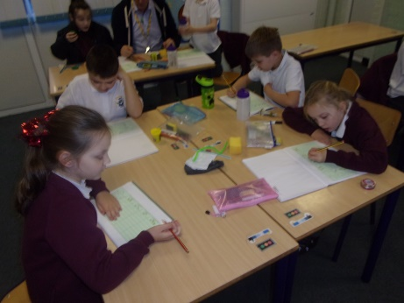
During this academic year, science has become a subject where the children have flourished and the teachers have really enjoyed delivering. We have taught all five blocks of the National Curriculum science through discrete science weeks, alongside lessons within our Dimensions curriculum. The science weeks have been interesting, engaging and practical which has made science into something that the children really enjoy. From feedback from children and staff, everyone has enjoyed the discrete teaching of science through these science weeks and children have made exceptional progress as a result of this.
CPD
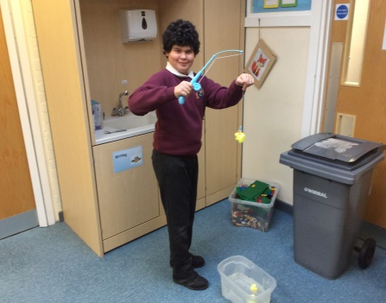
Despite the Covid restrictions, I was able to attend some CPD opportunities this year via Zoom calls. I took part in the Liverpool Primary Science subject leader meetings each term which were very informative about any changes in the curriculum and allowing children to catch up.
In order to offer CPD to staff at Orrets, I led a staff meeting that focused on methods for encouraging more independence in science; particularly offering teaching styles which would encourage children accessing the KS2 curriculum to think of their own investigations in science. During this staff meeting, I also gave teachers the opportunity to think of any new resources to support their teaching; I then ordered some new equipment to further develop independence within science lessons such as tuff trays for practical activities.
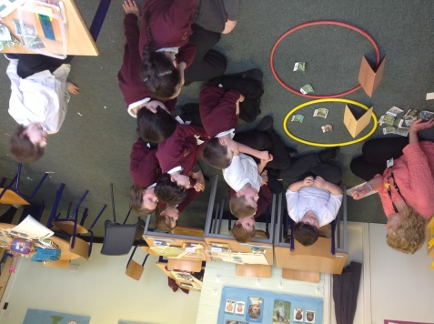
Quality of teaching learning
As the science subject leader, I have completed a range of activities to oversee science this year. During the autumn term, I created my subject leader file, ensuring all important documents were available such as the Science policy, which I updated in June 2020, the Primary Science National Curriculum and the progression of skills for science, which I also updated in June 2020. I also conducted a book scrutiny to monitor the impact of teaching science discretely through science week.

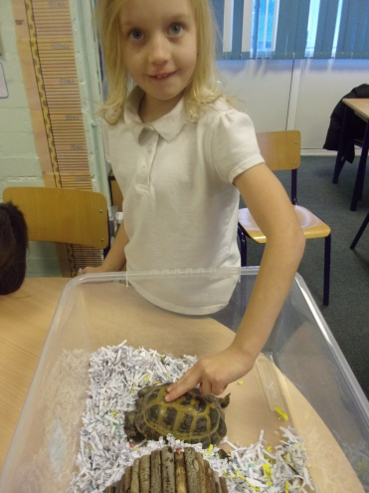
In the spring term, I conducted a pupil and staff survey to monitor the enjoyment of science across the school. Results showed that 100% of staff and pupils enjoyed the science weeks rather than weekly lessons. I also conducted a second book scrutiny, this time exploring independent scientific thinking which informed a staff meeting that I led in spring term.
In the summer term, I conducted a learning walk during our final science week where I was able to see all classes doing a range of practical science activities. It was fantastic to see a range of lessons and excellent quality teaching which was adapted to suit the needs of our children. I also did a lesson observation of a year 6 class and was able to see fantastic progress across the school. Finally, I did a data analysis of progress across the school; I was able to see patterns in the data which showed how girls make less progress in science than boys, therefore, I will monitor this target group next year.
Strengths
From the moderations and learning walks that I have conducted, I have been able to see some real strength across the school in science. A great strength is having discrete teaching of science through science weeks; they are exciting, interesting and allow children to retain a lot more information in one week rather than weekly lessons. The teaching of science is extremely strong at Orrets Meadow as the teachers follow thorough plans which offer a range of ways to support thinking scientifically objectives. The teachers deliver creative and imaginative lessons which are adapted to suit all their students’ needs. Another strength is how all staff deliver at least one practical investigation lesson across the week to develop skills in ‘thinking scientifically’ in order for them to make progress on the skills ladder. Throughout the year, children are able to work more independently on investigations, which is well evidenced in the books.
Ways forward
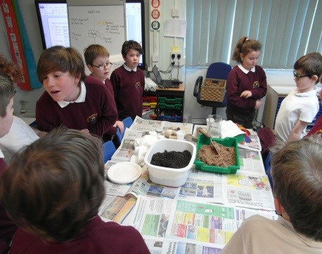
Next year, I will be working towards gaining the Science Quality Mark for school which is year-long CPD programme that helps schools to achieve a quality mark, whether science within the school has been a low profile for a while or the school wants to improve the provision further, which is my focus for the subject. It focuses on developing effective, confident science leadership for whole school impact on science teaching and learning. The quality mark will enable me to develop and articulate a clear intent and aspirational vision for science; to effectively implement a curriculum for science that is informed by research evidence and best practice data and to ensure science has a strong and positive impact on our children.
2021-2022 targets
- To achieve the Science Quality Mark (all year)
- To monitor girls progress in science (February and July)
- To lead an assembly in each science week about a famous female scientist (Each science week)
- To lead a staff meeting about promoting independence and progressing in science across the school (Spring term)
- To promote enrichment activities / trips for all year groups (Spring term)

