Governors Report - Summer 2023
Science
Katy Fleming / Gina MacGregor
Achievements
In September 2022, Orrets Meadow School was awarded the Primary Science Quality Mark. This award celebrates the commitment to excellence in science teaching and learning. We have demonstrated improvements in our programme for Primary Science, and acquired professional development for subject leaders. The Primary Science Quality Mark has enabled our science leader to become more confident, knowledgeable and a reflective leader, which results in an improvement in the way in which science is planned and taught across the whole school and ultimately raised standards.
During this academic year, science has become a subject where the children have flourished and the teachers have really enjoyed delivering it. We have taught all five blocks of the National Curriculum Science framework through discrete science weeks and within our Dimensions Curriculum. Due to many of the children having poor working memory and difficulties recalling information, the revisiting of Science skills and knowledge allows the children to overlearn and promotes sticky knowledge. End of term Kahoot quizzes and what they know now at the beginning and end of each unit, shows how much scientific knowledge the children are gaining through our chosen methods of implementation. The Science weeks have been interesting, engaging and practical, which has made science into something that the children really enjoy. From children and staff surveys, everyone enjoys the discrete teaching of science and the majority of children have made exceptional progress as a result of this.
CPD
Both Miss MacGregor and I have been able to attend CPD opportunities this year. We have taken part in the Liverpool Primary Science subject leader meetings each term which have been very informative about the latest changes in the field of Science education. Miss MacGregor also attended a Science leaders’ conference at Eureka.
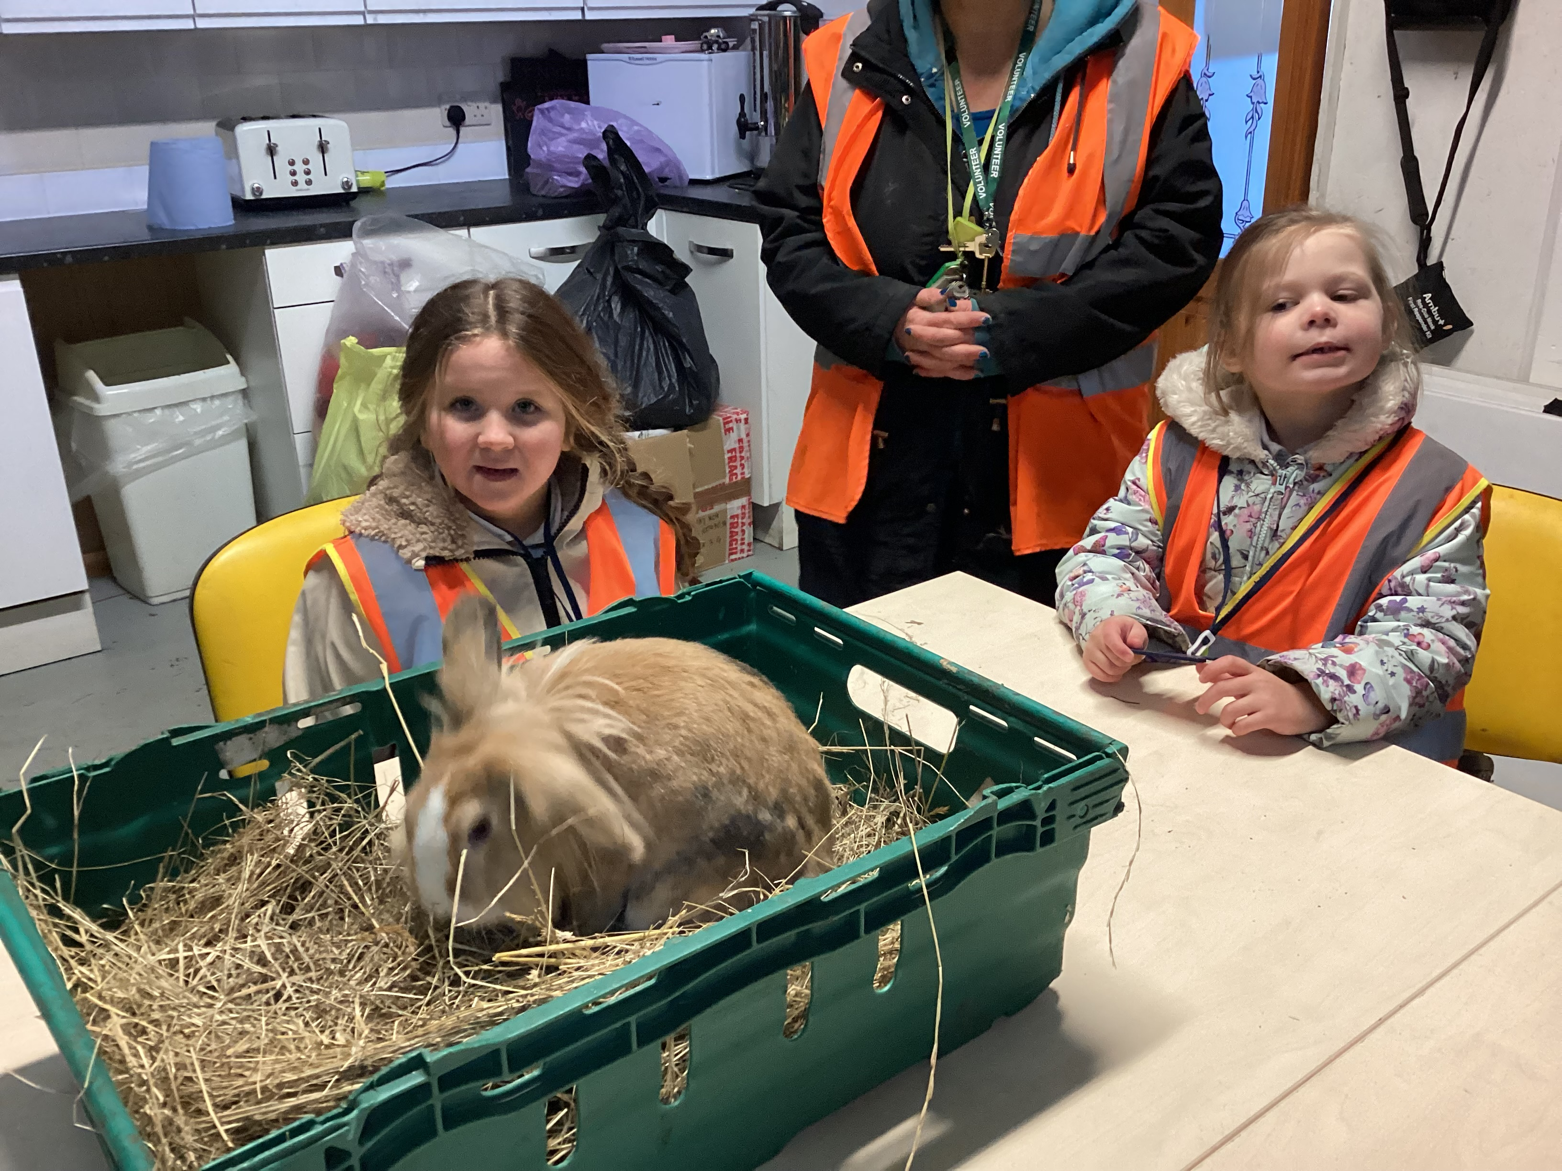
Relevant information from these courses has been fed back during staff meetings and staff surveys reflect they feel well supported and skilled to teach Science at Orrets Meadow.
Quality of Teaching and Learning
As the Science subject leaders, we have completed a range of monitoring activities this year. The subject leader file has been maintained, ensuring all important documents are available and up to date.
Miss MacGregor conducted a number of learning walks during the Science weeks. A range of lessons were observed and teachers demonstrated an excellent quality of teaching which were adapted to meet the needs of our children.
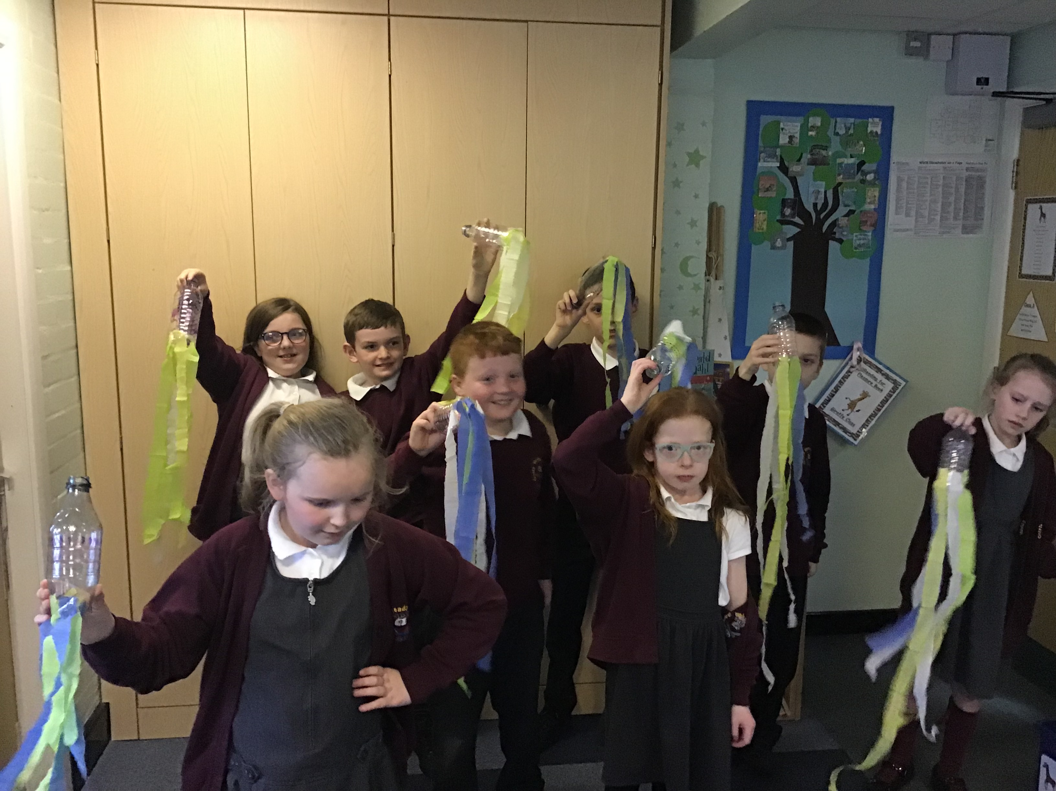
In the spring term, a book scrutiny was carried out to monitor the standards of Science teaching and the progress children are making. Evidence was seen of progress across all books.
A pupil and staff survey was conducted in the spring term. The aim was to monitor the enjoyment of science. Findings showed that all staff and pupils prefer science being taught discretely, rather than weekly lessons. It helps them know and remember more.
Finally, a data analysis of progress made by different groups was carried out. This resulted in showing girls make slightly less progress than boys in Science. This will be monitored next year.
Strengths
Gaining the Primary Science Quality Mark has confirmed the high standards of teaching and learning in science across the school. The award raised the profile of science in school and it highlighted the clear intent and vision shared by all staff.
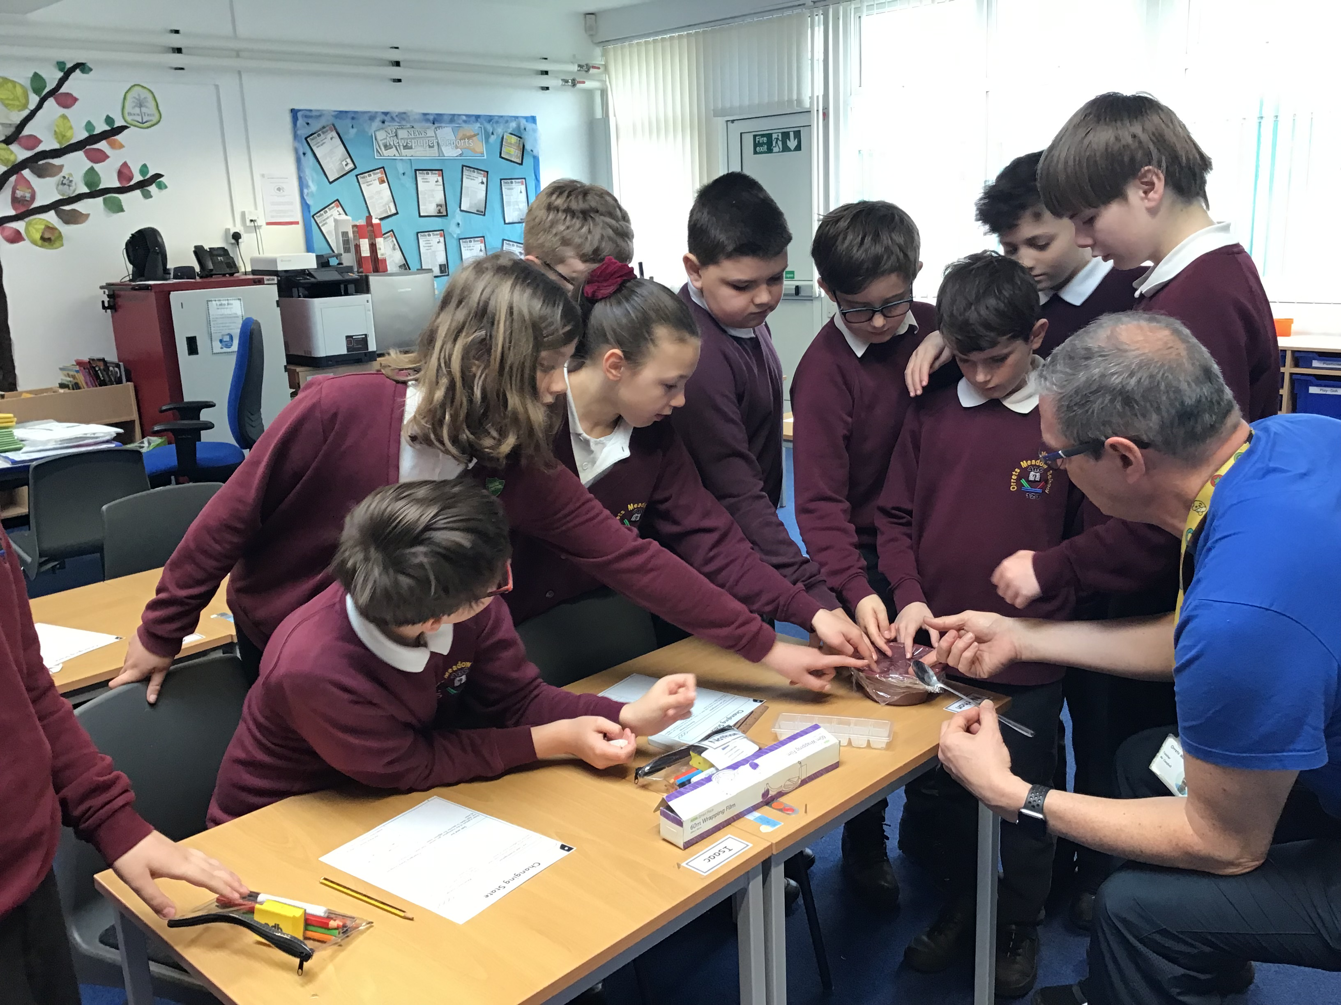
Monitoring activities have shown real strengths across the school. Discrete teaching of science through themed weeks is a great strength and this method suits the needs of our pupils, by allowing them to focus on one topic in depth. Lessons are exciting, engaging and pupils enjoy them. The learning from science week is revisited through the Dimensions topic, so children can build and recap on their learning through the year. The teaching of science is extremely strong at Orrets Meadow School. Teachers follow thorough plans which offer a range of ways to support thinking scientifically. Teachers deliver exciting and creative lessons which are adapted to suit the children’s needs and staff deliver at least one practical investigation lesson across the week which enables the children to develop skills in ‘thinking scientifically’ in order for them to progress on the skills ladder.
Ways forward
Next year, we will continue the high standards of teaching and learning which gained us the Science Quality Mark.
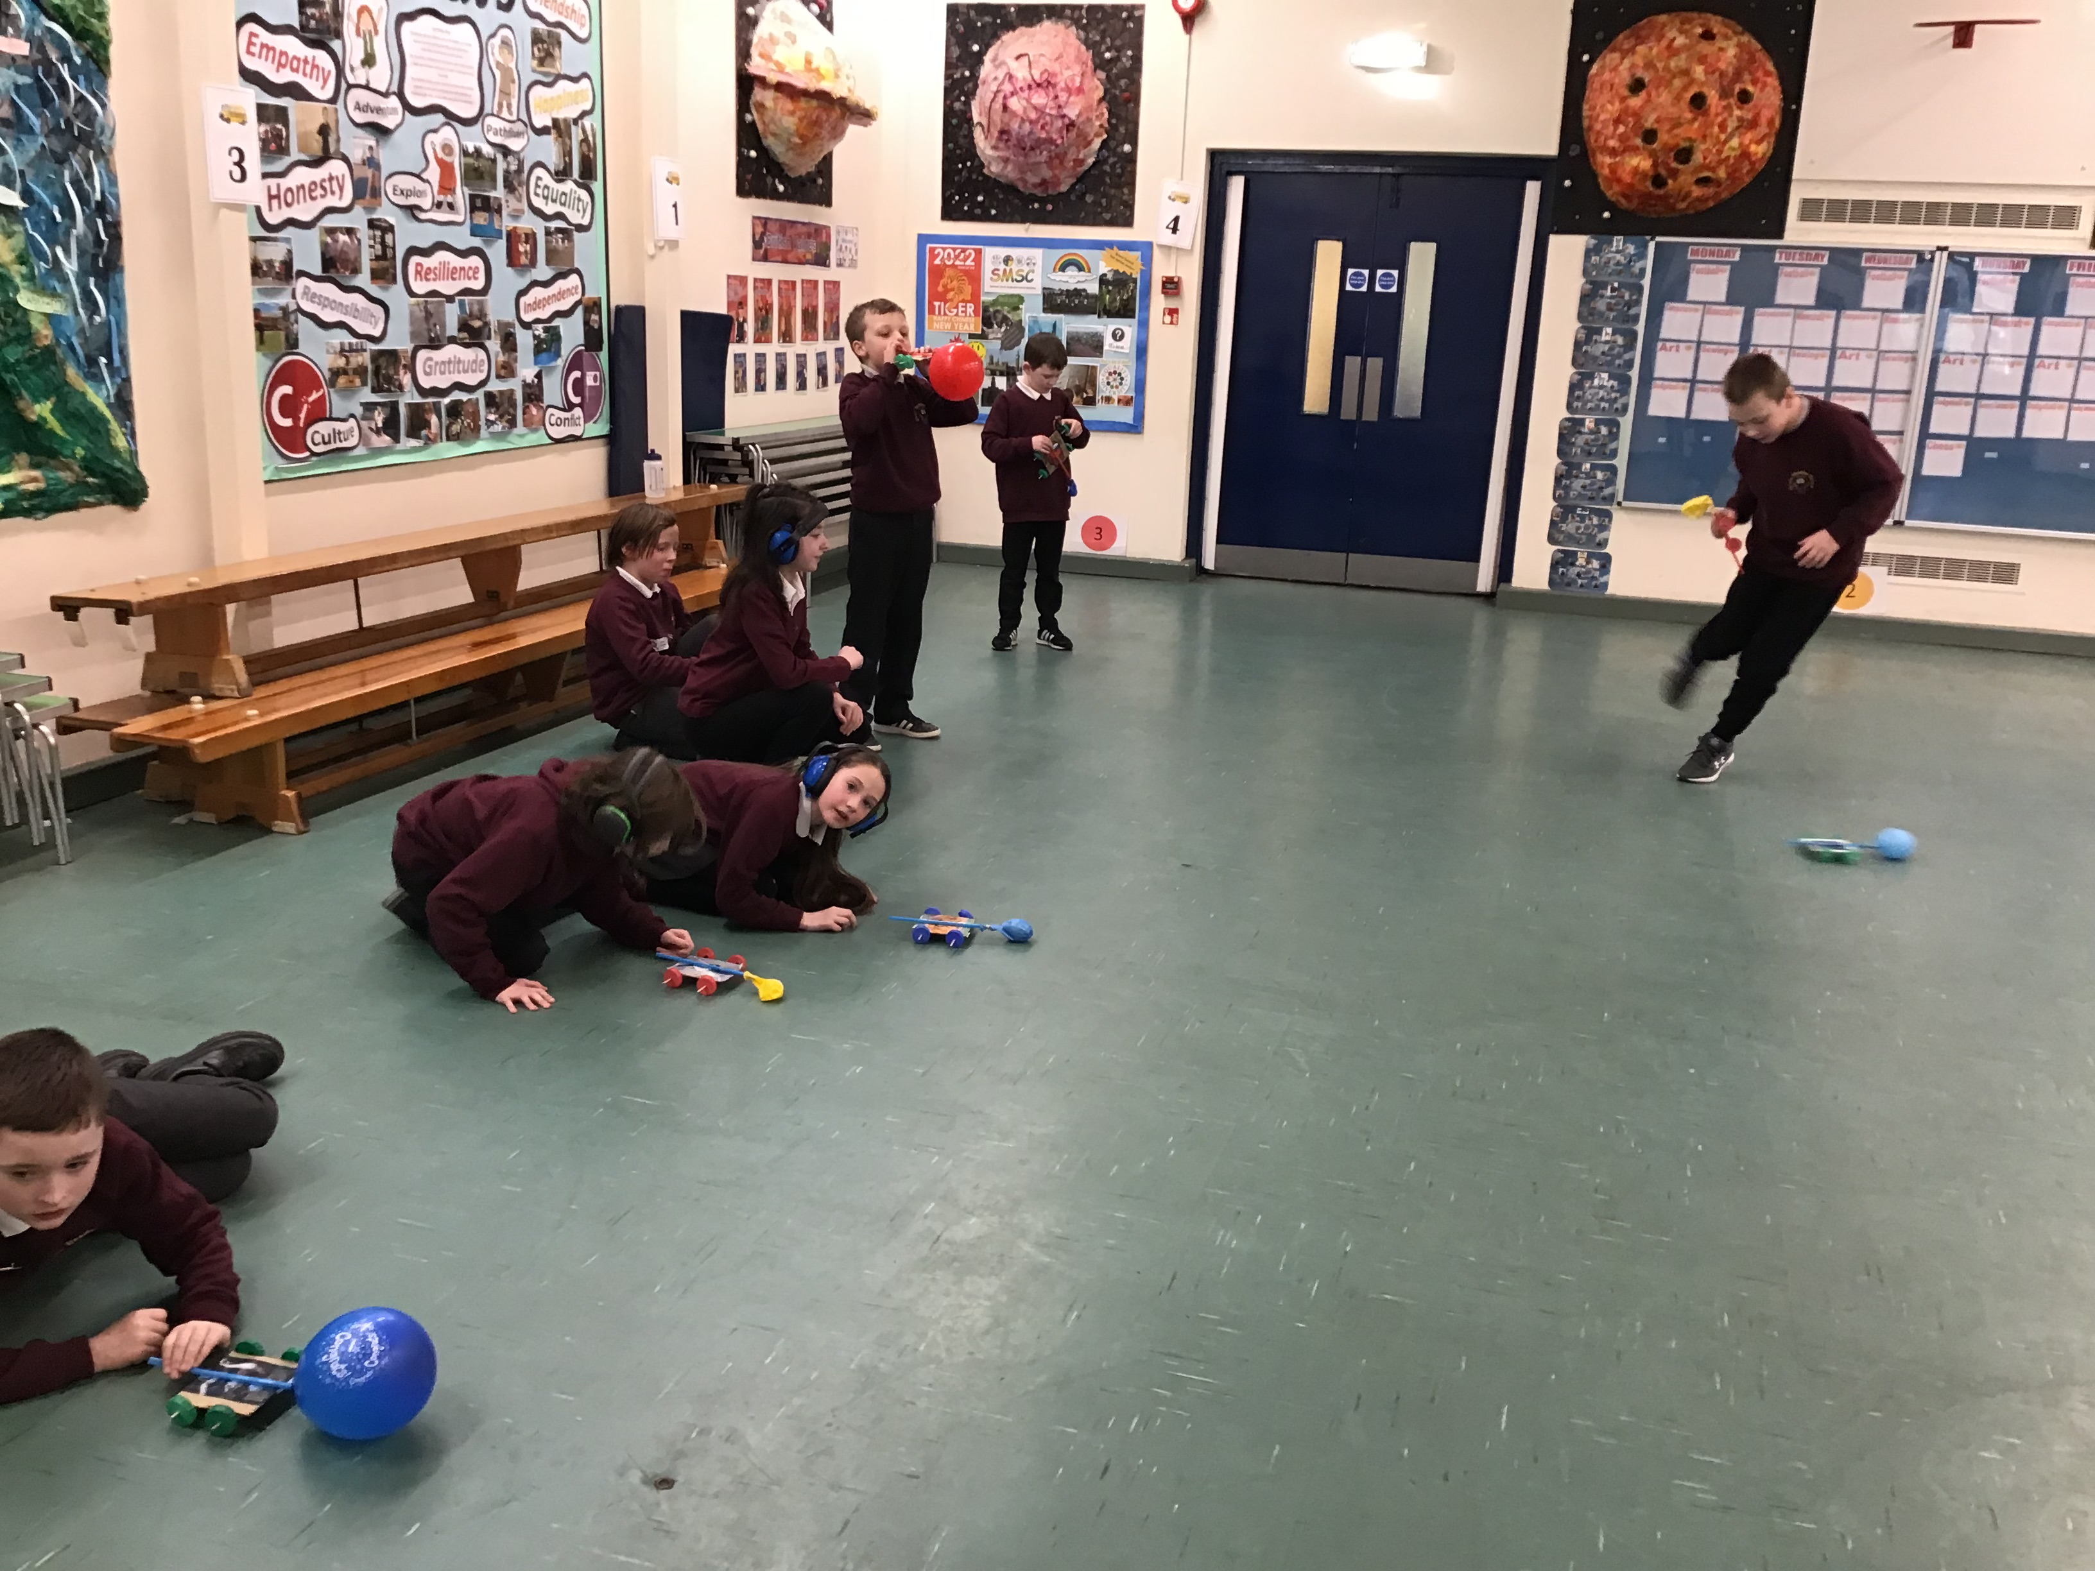
Targets 2023-2024
- Monitor girls progress in science (February and July)
- Each class to go on a Science focused trip over the year.
- Gain the Learning Outside of the Classroom Mark (April 24)
- Promote the teaching of Science outside of the classroom
- Bring real Scientists into schools to promote Scientific investigations (Autumn and Spring Term)
- Research White Rose Science Hub and see if it would be more suitable for our pupil’s needs. (Summer 24)

