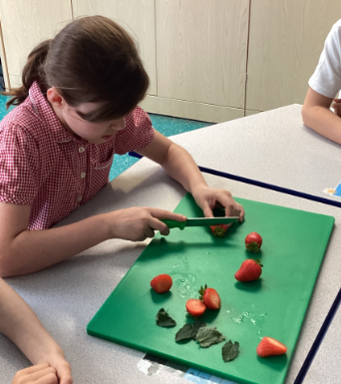
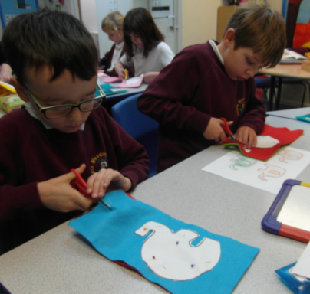

Governors Report
Summer 2022
DT
Jane Gordon

Achievements
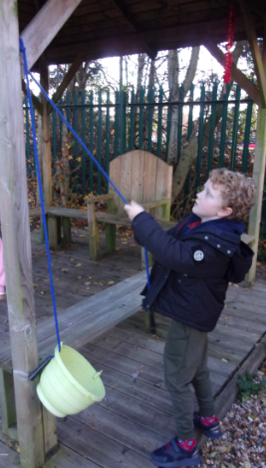
Reflecting on targets set last year I have implemented the promotion of diversity and inclusion in DT by focusing on the roles of designers ranging from architects to puppet makers during our whole school DT days. This has enabled the children to understand how diverse the career pathways are in Design and Technology. The Dimensions projects also provided opportunities for the children to design products for clients from other countries and those with physical difficulties and mobility needs.
The DT focus days across the year were a great success and I received fantastic feed back from both staff and children. I led staff meetings to ensure the correct coverage of subject knowledge and progression of skills across the school. This resulted in a wonderful array of Design and Technology outcomes clearly matching the children's ability and levels. Projects covered through these days featured Cooking and Nutrition, Levers and Linkages and Textiles. These focus days are an invaluable opportunity to ensure National Curriculum coverage across the school.
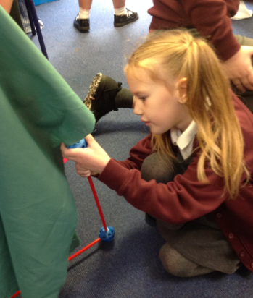
CPD
I attended the Subject Leader Briefings each term provided by the School Improvement Liverpool Hub. These were an excellent opportunity to reflect on what Design and Technology looks like in school and how to move forward with areas such as DfE updates, Formative assessments and Ofsted updates.
Staff meetings this year have, in addition to promoting progression of skills and technology processes, also focused on maintaining and highlighting good practise in the drive to continue to raise standards in the coverage and recording of DT. Quality of Teaching and Learning
As subject leader I have completed a range of monitoring activities this year to oversee the continuing high quality of teaching and learning in DT. I have carried out a Key Stage 1 lesson observation where I was delighted to watch an outstanding lesson on designing , making and evaluating a Fairy Bag demonstrating a range of activities designed to meet the children’s learning styles. During Iearning walks during DT Focus Days I observed examples of Cultural Capital and enrichment activities such as tasting and testing foods, learning where our food comes from, what makes a healthy meal and learning about architects and building their own dens/shelters. Further successful experiences were observed during these weeks where the children made kites, tested and evaluated their flying success, designed and sewed their very own puppets for a puppet show and made stuffed animals to be sold in a the Zoo gift shop!
Book scrutiny’s, data analysis, pupil and staff surveys were all carried out over the year and analysed to support high quality teaching and learning which is taking place in the classroom.

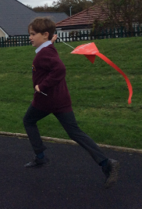
Strengths
The strengths in DT that I have found through carrying out my moderation activities are the amazing, rich and varied Cultural Capital and enrichment opportunities provided through the DT Focus days. Each class created a wonderful collection of evidence to track how the design process was carried out to design and make an exciting and varied range of products.
Staff survey analysis shows that teachers enjoyed the opportunity to focus on teaching DT during focused days throughout the year. This finding was also echoed in the pupil survey analysis, where all the children enjoyed DT. Their feedback about what they were proud of learning was overwhelmingly positive and demonstrates the high quality multi-sensory teaching opportunities being created for all.

Ways Forward 2022-2023
• To review coverage of each Dimensions DT topics across the school to ensure coverage is evidenced. (Staff meeting - Autumn 1)
• To establish a clearer evidencing structure for the design process to ensure a consistent whole school approach. (Staff meeting Autumn 1)
• To purchase resources linked to each Dimensions project . (Staff survey Autumn Term)
• To create Cultural Capital opportunities for each class to experience DT in the real world. (Spring/Summer Term).

