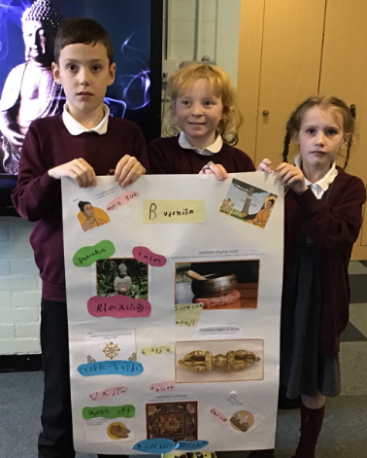
Governors Report – Summer 2023
RE
Subject leader: Jane Gordon
Achievements
The ‘ways forward’ identified last year from this year’s school development plan and the actions taken:
To review how classes with a largely pre curriculum cohort record evidence.
Through my staff survey In Autumn Term 1 I identified that the staff of the classes that had a majority of pre curriculum level children would prefer the floor book approach to recording learning in RE. Through monitoring these floor books this year I have been able to see that this approach has enabled staff and children to express their creative approach to evidencing RE.

To introduce the use of objectives from the progression of skills into class books to ensure clear progression of coverage in Christmas and Easter topics.
In my Autumn Term staff meeting I launched my RE coverage plan that clearly outlines Christmas and Easter week coverage. The document enables a clearer vision of the progression of Orrets Meadow skills alongside the Wirral SACRE Learning outcomes for classroom teachers to follow and therefore embedding the Christmas and Easter themes securely across the school.
To introduce new units of study into KS2 on Humanism and religious and non-religious world views as prescribed by the Wirral SACRE
Using my contacts through the Wirral LTRE HUB I was able to source appropriate resources and materials for the introduction of these new units. Teaching staff were given the opportunity to access contacts of teachers delivering this area of RE. Monitory activities I have carried out show a successful introduction of these new units.
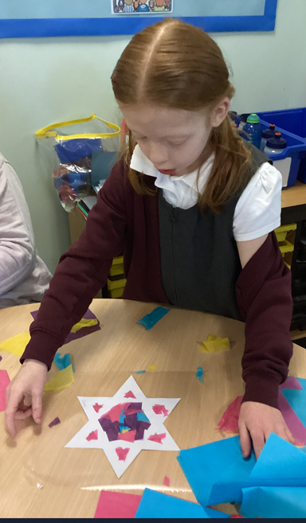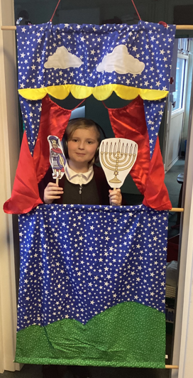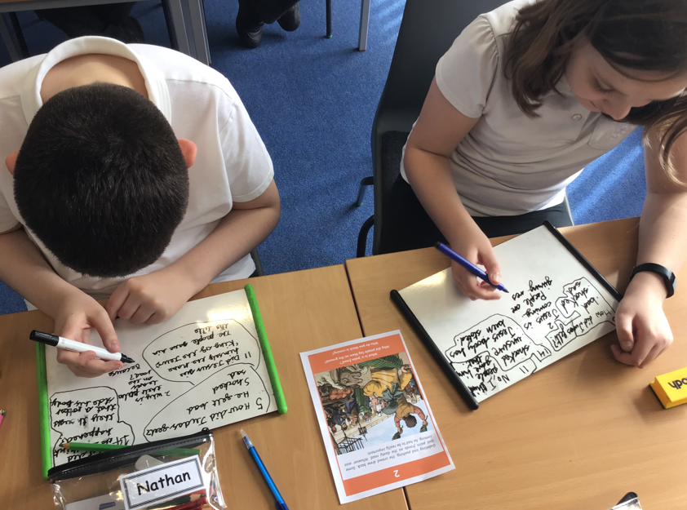
CPD
I am a member of the Wirral LTLRE HUB which is an excellent opportunity to keep in touch with the local RE subject leaders and share ideas and good practice. Through this channel I have accessed regular Zoom training meetings led by Wirral LTLRE HUB. I have sign posted teaching staff to relevant courses covering aspects of the six faiths promoted by the Wirral SACRE. Staff meetings this year have, in addition to promoting sensory teaching strategies, also focused on maintaining and highlighting good practise in the drive to continue to raise standards in the coverage and recording of RE.
The wealth of knowledge imparted by visitors and trips to places of other faiths and religions has also enabled teaching staff to gain new and valuable insights to life lived by Jewish, Buddhists and Muslin’s.
Quality of Teaching and Learning
As subject leader I have completed a range of monitoring activities this year to oversee the continuing high quality of teaching and learning in RE. During Religion Week Learning walk I observed wonderful examples of Cultural Capital and enrichment activities such as food tasting, role play, Arts and craft activities and sharing books. Further successful experiences were observed during Religion week with trips to the local Mosque where the children experienced learning about Islam through a real-life experience and Rania from the Wirral Deen Centre visited the Bears to share Islamic stories. A wonderful Jewish ex head teacher visited our school to teach us all about Judaism in a very entertaining way. A class even visited the Buddhist Centre in Liverpool to look at the architecture of the building and were warmly welcomed in by the Monks and invited back again next year! Book scrutiny’s, data analysis, pupil and staff surveys were all carried out over the year and analysed to support high quality teaching and learning which is taking place in the classroom.
Some of the highlights from this year staff voice are below:
What have you enjoyed about Religion week?
Trips, creative opportunities, links with English Curriculum, visitors, comparisons – how we all fit together in society, time for multisensory and enrichment activities in depth knowledge, art and drama opportunities, seeing different class groups presenting a range of Religions.
‘I love RE week. It gives the opportunity to teach RE through a creative and fun filled week.’

Strengths
What were the strengths in your subject you found this year from all your moderation activities?
- Confidence and enjoyment of teaching RE
- Gaining the Bronze Quality Mark for RE
- Religion Week
- Christmas and Easter coverage using the new coverage documents.
- Multisensory and creative teaching strategies
- The introduction of Non-Religious and Humanism topics
- Governor lesson observations across the school to acknowledge fantastic teaching and coverage of RE.

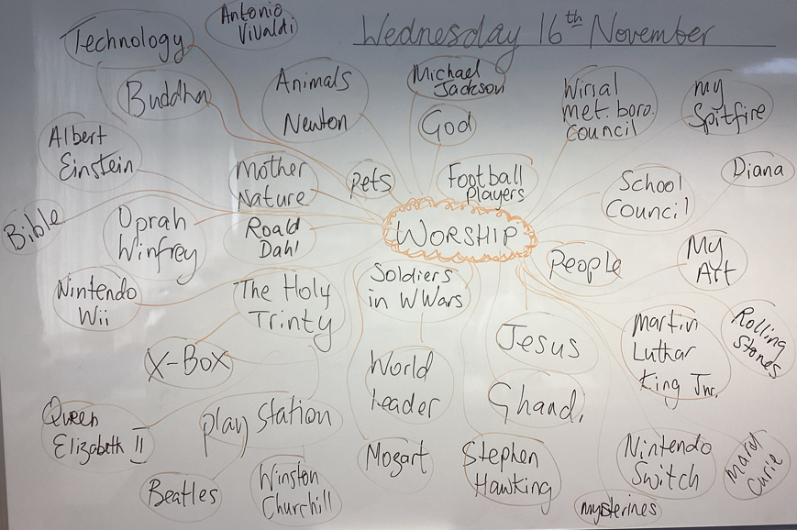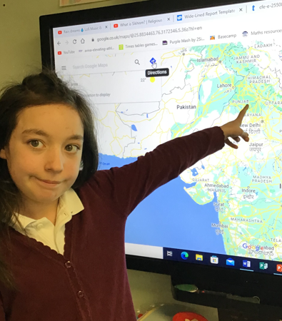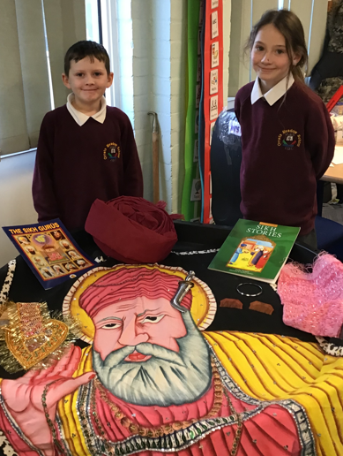
Ways forward
- To review the Long-Term plan in line with the new schemes of work introduced by the Wirral LTRE HUB. Staff Meeting Autumn Term 1
- To review the Orrets Progression of skills in line with the new Wirral schemes of work. Autum Term 2
- To update the RE Policy to reflect the changes in the Wirral RE scheme of work. Spring Term 2.
- To make contacts with potential Hindu and Sikh visitors. Spring Term 1
