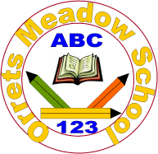
Governors Report – June 2023
English
Matthew Ferris-Rice
Achievements:
English, in all its threads, has continued to thrive at Orrets Meadow this year. The main focus for this year, as detailed in the 22/23 SDP, was to further develop opportunities for pupils to enhance their comprehension. By working closely with all staff and SALT pupils have been given additional opportunities to extend their comprehension. This has taken the form of both reading comprehension as well as language comprehension.
There have been some real strengths and highlights throughout English this year. These include;
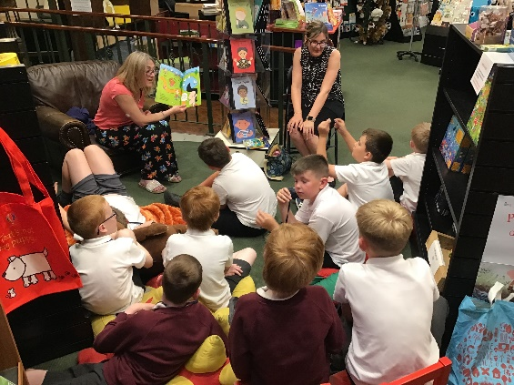
- A record number of pupils entering, and being selected, in various Young Writers competition.
- A visit from a famous poet.
- Trips to a local bookshop.
- The establishment of The Reading Ambassadors.
- Pupils’ continuing to make exceptional overall progress within English.
- Positive responses from external bodies with regards to our teaching of English. (See SAP report)
Throughout pupil surveys and pupil conferencing I have been able to hear how excited and willing to share their experiences pupils’ have become. This shows the strength of our English curriculum, especially surrounding reading for pleasure.

Subject Leader CPD
Sarah Squared:
As a subject lead I have continued to pursue CPD in order to ensure that I stay up to date with national and local updates within English. I have continued to attend English subject leader updates and English moderation cluster meetings through Sarah Squared. As well as developing myself as a leader and discovering a range of ways to further support our pupils, I have also continued to develop relationships with other subject leads. This has given me the opportunity to discuss what has worked well in other schools and how schools are responding to national changes.
During the moderation sessions with the Moreton cluster this year we have continued to focus on the development of the various strands of writing and what these may look like for our pupils. Once this document is finalised it can be shared with staff in order to show progression through these strands.
Wirral Teacher Reading Group:
A new group has been set up with the English Leads around Wirral. These events focus on books for pupils. Each session has a theme, non-fiction November, poetry, graphic novels, etc. All members bring book recommendations and discuss age ranges and topics that the book would suit. These have proven a fantastic source of exploring new books. Some of the recommendations have been trialled and added to the school literacy spine.
Wirral Local Authority CPD:
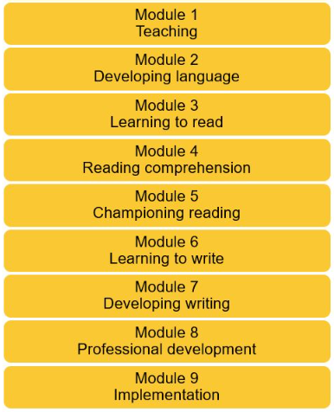
This year the LA have organised training sessions for English Leads across the Wirral. This took the form of 6 sessions for each reading and writing. By attending these I have received access to further instruction of ways to improve both reading, writing and leading English within school. It has also provided access to a vast collection of research material regarding English.
NPQLL (National Professional Qualification for Leading Literacy)
This year there has been a new NPQ created that focuses on Leading Literacy I have been lucky enough to gain a place on this course, which will continue until December 2023. This has been a further opportunity to explore different ways of developing reading, writing and language across the school. Through online learning and assessments, face to face conferencing events and one to one mentoring, I have been able to develop a greater knowledge of developing English from an early stage. This has again provided opportunities to explore strategies that will better enable our pupils to develop their skills across all strands of English.

Staff CPD:
All staff have had several CPD opportunities focusing on areas of English led by both myself and external bodies. These have included phonics, reading and language development.
Phonics Training:
All new staff to the school attended a CPD session led by myself, this course was also offered to all existing members of staff who wanted to further develop their phonetic knowledge. This was delivered as a series of sessions focusing on pronunciation, leading a phonics session, text selection and segmenting and blending.
Leading on from these sessions I also worked closely with new teaching staff through peer observations, peer teaching and regular check-ins, in order to ensure they felt confident delivering phonics using the Orrets phonics scheme.
Blank Level Questioning:
All of the teaching assistants engaged in a CPD session delivered by speech and language therapists (SALT) focusing on ‘Understanding of Language and Questions’. This session showed how question could be tiered and progressive in order to support pupils in developing their comprehension (blank level questioning) and inferencing skills, as well as highlighting strategies that could support pupils.

In addition to these course I also led several staff meetings throughout the year focusing on different areas of the English curriculum including:
- The Reading and Writing Journey
- Developing disciplinary literacy throughout the curriculum.
- Writing Moderation
Leading on from the staff meeting on developing disciplinary literacy, all subject leaders have created a literacy spine for their subject including texts they feel will engage pupils and develop their knowledge within the subject.

Reading for Pleasure at Orrets Meadow
Reading Ambassadors:
This year has seen the founding of the Reading Ambassadors club, which has given pupils more ownership over how reading is promoted at Orrets. All of the reading ambassadors have helped to organise the library and keep it tidy as, as well as creating displays of books that they would recommend. They have helped to create and distribute a reading newsletter with details of reading events within the school, as well as giving a recommendation of a book that they have enjoyed throughout the term.
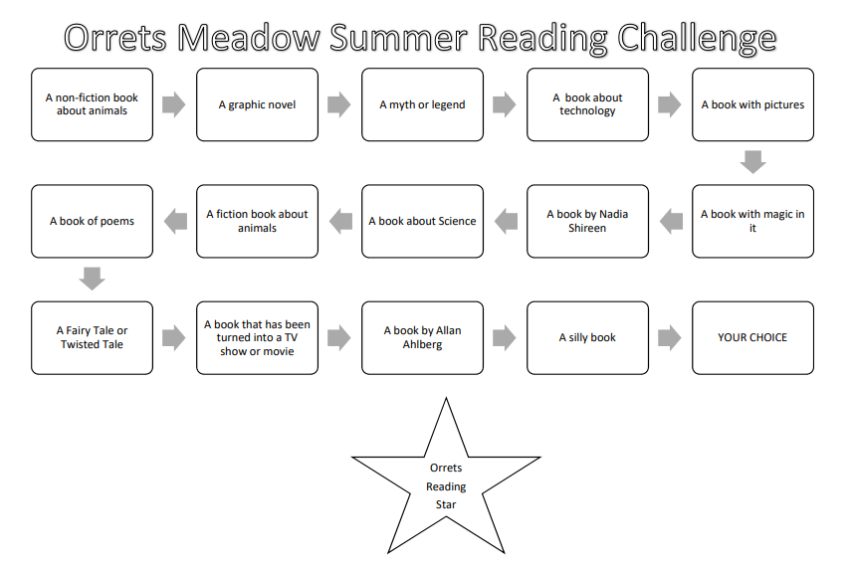
Many of the members have been extremely involved taking it upon themselves to engage their peers in book talk. In addition to this they worked together to create a reading challenge for the summer term and have been eagerly advertising this around the school. As a leader it has been extremely satisfying to see pupils excited and conversing about their love of books.

Library:
The library has continued to grow this year and has had many lovely books kindly donated through our amazon wish list. All pupils have had the opportunity to visit the library regularly and to borrow books. The library has also been utilised throughout our themed weeks as source of developing pupils understanding. Alongside the reading ambassadors club on a Friday, the library has also hosted a reading for pleasure club throughout the year.
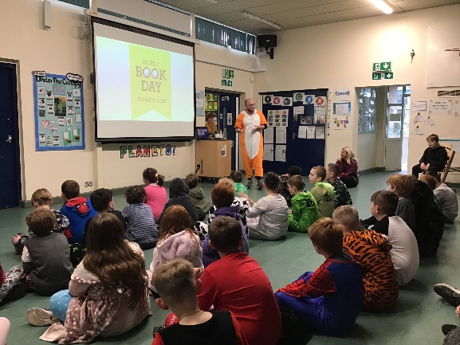
World Book Day:
This world book day we focused on bedtime stories. We asked pupils to come dressed in their pyjamas or a onesie, and they did not disappoint! Throughout the day classes shared lots of stories with the pupils and there were reading buddies throughout the day. The older pupils paired up with a younger pupil and they chose a story that they would like to read to that child. They then practiced reading it and thinking about how to engage their buddy. They all did a fantastic job.
Finally there was a book treasure hunt, where children solved riddles found on the back of book covers to, which led them to various locations around the school. The final clue led to treasure tokens that pupils could then exchange for a book that they could take home and keep.

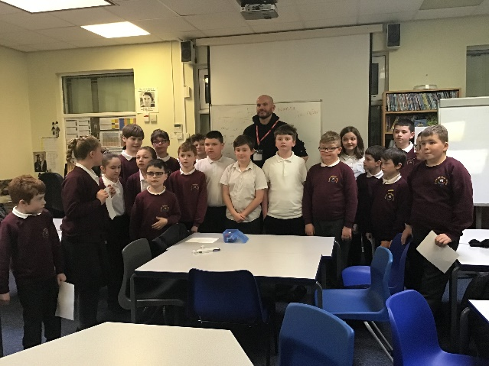
Visiting Authors:
On World Poetry Day we arranged for Matt Goodfellow to come in and lead an assembly, as well as lead poetry writing sessions with all pupils. The pupils, and staff, where extremely engaged and thoroughly enjoyed the day. It generated a real buzz around the school, with pupils swarming to the poetry section in the library for weeks afterwards.
This year I have developed links with Linghams bookshop. Each class has visited the shop and had a story read to them. The shop regularly has authors visiting and putting on events, I am hopeful this will enable to get more author visits for our pupils.
Speech and Language:
As the cohort of the school has changed we are seeing more pupils with growing speech and communication difficulties. In order to support pupils with these needs all classes have worked closely with speech and language therapists in order to assess and monitor pupils’ comprehension of various areas of speech, alongside providing high quality interventions.
At the beginning of the year I identified those pupils that were not registering on our reading tests. From this the SALT assessed their receptive and expressive language comprehension in order to ascertain if this was an area that could benefit from further development. Interventions were put in place and pupils were assessed at the end of the year again. The vast majority of pupils had made accelerated progress, with many of them now able to register a reading score.

Quality of teaching and learning
I have continued to closely monitor and review the teaching and learning throughout the school throughout this year. Following on from our focus on phonics in the previous academic year I monitored the implementation of our updated phonics scheme and ensured a level of consistency around the school. I have been tracking rates of progress throughout each testing phase, so far all pupils have made outstanding progress in phonics. I am awaiting the final testing to view the full progress picture of the year and look for any trends that may be present.
Also this year I have continued to collate reading data, monitoring reading test results, book bands and bug club book bands. This gives a strong overall picture of where the pupils are currently reading and is informing reading ages for book bands, at Orrets.
Further monitoring has been in the form of the reading and writing trackers that track the progress towards the national curriculum. Again I have been looking for actionable trends within these.
Pupil conferences highlighted how more readily pupils are able to partake in book talk. All pupils spoken to could name a book that they enjoyed, what books they had borrowed from the library and what books they had read within class.
Finally I have had the opportunity to complete book scrutinies in order to triangulate between work in books, planning and national curriculum targets. The English Governor joined me for another book scrutiny and we both agreed that the progress within the books was apparent and impressive. In addition to looking in books I have had a chance to observe the teaching of phonics in formal observations with the head teacher, as well as informal observations in order to coach and reassure staff.

Phonics:
Leading on from the implementation of our updated phonics scheme last year I have;
- Ensured all new staff are adequately trained to deliver phonics.
- Provided further training to existing staff.
- Met with the phonics governor to discuss the scheme and how phonics has been progressing.
- Take part in observations of phonics.
- Monitor book selection and offer advice when needed.
- Analyse the results of phonics testing.
All staff have welcomed the updated phonics scheme and have ensured the smooth transition to the new expanded scheme.

Strengths
Orrets continues to have an exceptionally strong English curriculum offer, which is clearly evidenced in the progress that pupils make, as well as their enjoyment of the subject. We have a particular strength at helping children who are disaffected with reading get back on a journey to finding a love of books and enjoying exploring a new world. As one pupils told me recently, ‘Books are like a portal to lots of different worlds.’ I feel strongly that within English as a subject we have strengths in all strands of the curriculum. Pupils are highly engaged in phonics, reading, writing and speaking and listening, this shows through conversations and the accelerated progress that pupils make within the subject.
Ways forward
Adapt the English curriculum to ensure there are writing opportunities for all, particularly the most complex pupils. (See school development plan 23/24 for further details)

