TALKING MATHS
MATHS
Dear parents and carers,
Each year we decide on a focus for maths throughout the school. This year our focus is ‘Talking Maths’.
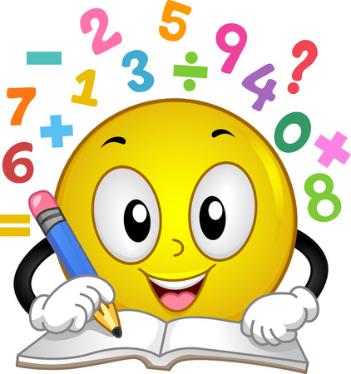
“The national curriculum for mathematics reflects the importance of spoken language in pupils’ development across the whole curriculum – cognitively, socially and linguistically. The quality and variety of language that pupils hear and speak are key factors in developing their mathematical vocabulary and presenting a mathematical justification, argument or proof. They must be assisted in making their thinking clear to themselves as well as others, and teachers should ensure that pupils build secure foundations by using discussion to probe and remedy their misconceptions.”
National Curriculum in England, Department for Education, 2013
Using correct mathematical language is crucial for thinking, learning and communicating mathematically. Children may build knowledge through remembering information that they hear, but it is only when they put these ideas into their own words that it becomes clear whether concepts have been learned effectively.
We would like to encourage all our parents and carers to spend extra time talking about maths at home.
Examples

Use vocabulary related to SHAPE, NUMBER, MEASURE, FRACTIONS, TIME , DATA
Look at shapes around the house. Windows doors boxes TV wheels etc
Look at measure on food products.
Play games with number.
Make patterns shape and number
Talk about time and how it can be shown and recorded. Discuss and learn the days of the week months etc
Parents to model questions and answers. Use full sentences to answer.
Encourage the child to talk as much as they can about each topic and correct misinterpretations.
Have fun and enjoy talking maths.
Mrs Billington

