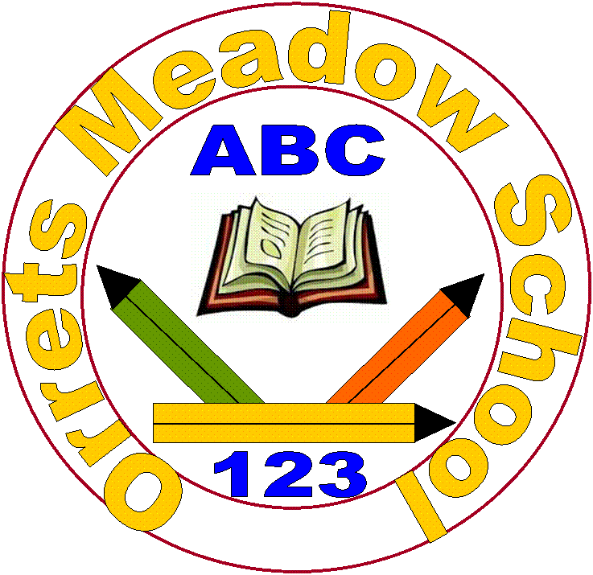

**OM’s Personalised Curriculum**

Every child is unique. Many children will present with a ‘spikey’ learning profile, with areas of strength and areas that are under developed, which would benefit from intervention. Additionally, children will experience a range of different barriers to learning, in areas such as sensory processing, communication, attention deficits, anxiety or low self-esteem.

The effects of social communication difficulties are unique to every child and the impact on the ability to learn is extremely varied so we therefore deliver a curriculum to meet the pupils’ dynamic needs.

Children will require support to develop a wide range of skills, including: Communication, life, mental health and social.

Orrets Meadow promotes a personalised learning curriculum to meet the diverse needs and abilities of our pupils.

**Values we promote in our curriculum**

* Respect * Empathy * Independence

* Equality * Responsibility * Happiness

* Resilience * Gratitude *Friendship * Honesty

**Aims of OM Provision**

* To ensure all our children are at the centre of a broad, varied and interesting learning experience that is enjoyable and relevant for the future.
* Our creative, multisensory curriculum creates a sense of awe and wonder and helps to inspire a lifelong love of learning.
* The holistic nature of our practice promotes positive mental health and well-being and enhances our children’s life skills, social skills and cultural awareness.
* Relationships are developed between children and adults that are positive, consistent and secure.
* Provide a ’Total communication’ environment which meets the needs of all children.
* Meet sensory needs.
* Develop self-awareness and self-control.
* Develop resilience and motivation for learning.
* Support children in responding to change.
* Recognise and support anxiety in children.
* Celebrate success in all its forms.

**Orrets Meadow’s Provision Rationale**

At Orrets Meadow we believe that children are entitled to a curriculum that raises the aspirations of every child and gives them the confidence to fulfil their potential through positive learning experiences. Orrets Meadow is a school for pupils with social communication difficulties, including autism. This impacts on individual development and, to differing extents, shapes the nature of the child’s learning experience. Education for children with social communication difficulties should reflect the unique presentation of each individual, for example meeting sensory needs, providing for social and communication difference or challenging areas of strength. We believe these differences merit a specific approach, whereby skills can be fostered to maximum effect, rather than trying to fit the child into a ‘normative’ model of development. Core aims of the curriculum at Orrets Meadow are to support the child in developing independence, to encourage a positive sense of self and to promote a positive attitude to learning, so that each child can access learning fully.

Children with social communication difficulties require a support network that is cohesive. We believe it is imperative to work in close partnership with parents, carers and families, to facilitate the sharing of good practice and success across both environments. Drawing on the relevant expertise of outside agencies and professionals such as speech and language therapists, sensory occupational therapists, mental health specialists, psychologists and social care workers, ensures we have a dynamic and holistic approach to every child.