Governors Report – Summer 2023
History
Mr Eóin M Campbell
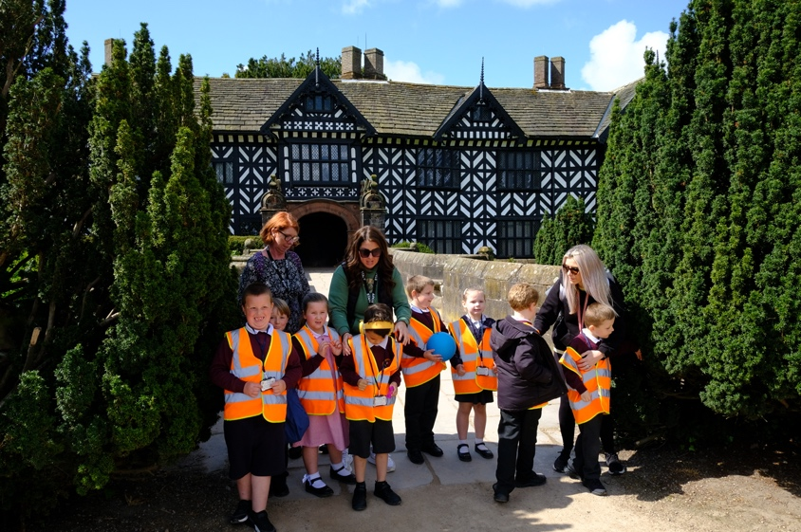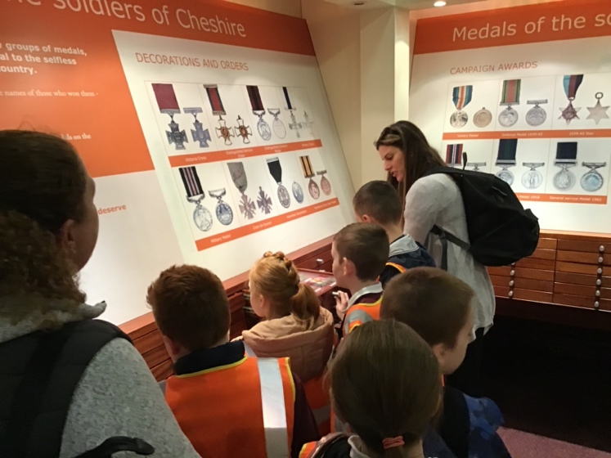
Achievements
With memories of Lockdown long behind us and two full years of straight teaching under our metaphorical belts, our student population in History seems to have settled into a successful routine of learning the subject and its associated skills. It’s easy to parrot clichés of our Dimensions curriculum being ‘holistic and balanced’, yet it is precisely and unquestionably that! The enthusiasm demonstrated by our pupils is wholly warming to experience, both in and out of the classroom. History remains a hugely popular subject with our children. Quantitive successes are visible in the subject data analyses presented in each summer term. These scores demonstrate a measured success in History equivalent to and even in some cases exceeding those of other foundation subjects. Qualitative successes are far more enthusing for the teaching and educational staff at Orrets. Whether staff are working with physical timelines made of spools of toilet roll, writing in the first person about being Rosa Parks or discussing and debating the consequences and aftermath of the battle of Marathon, our pupils are wholly engaged and ultimately enthusiastic. What better way to learn and retain knowledge and skills!
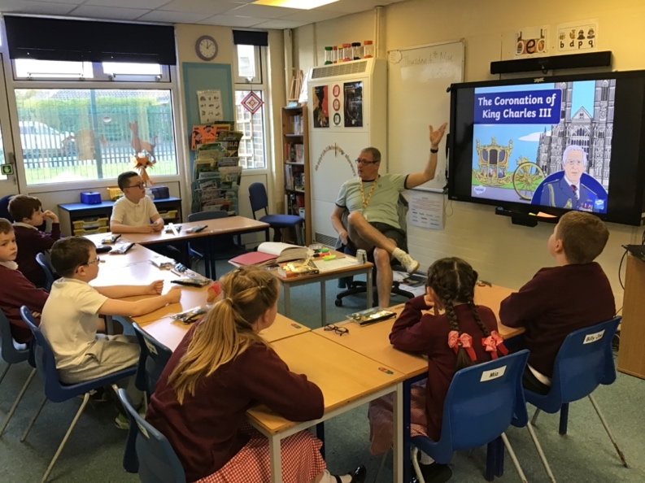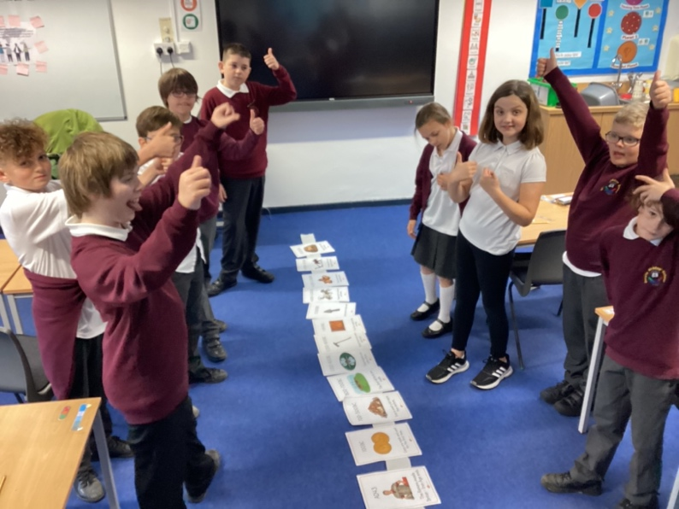
CPD
I have continued to be provided a healthy quota of History CPD, most notably my Merseyside hub Zoom sessions which continue to provide me with up-to-date subject information as regards the History Primary curriculum. I also garner many new and alternative teaching strategies, skills and interventions. Although we have our global, holistic curriculum here at Orrets Meadow, the value of such interactive CPD and the subsequent information I draw from this is very helpful in preparing and presenting my numerous staff meetings throughout the academic year. These provide me the opportunity to impart this information to my colleagues; information pertaining to policy, practice and methodology. I have always understood the the notion of an ‘open door’ attitude to any requests for alternative CPD and given the small size and tight budget a provision such as Orrets Meadow has, it is commendable that such requests may be entertained.
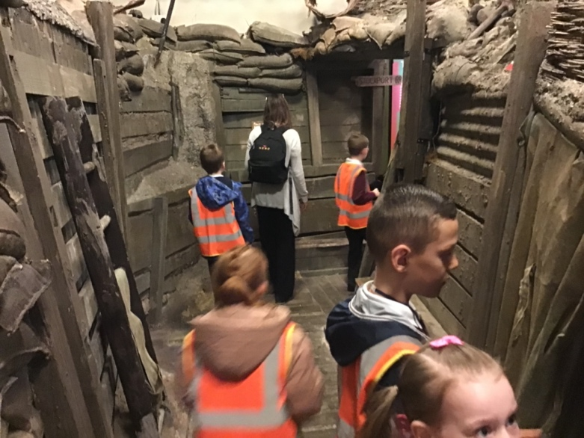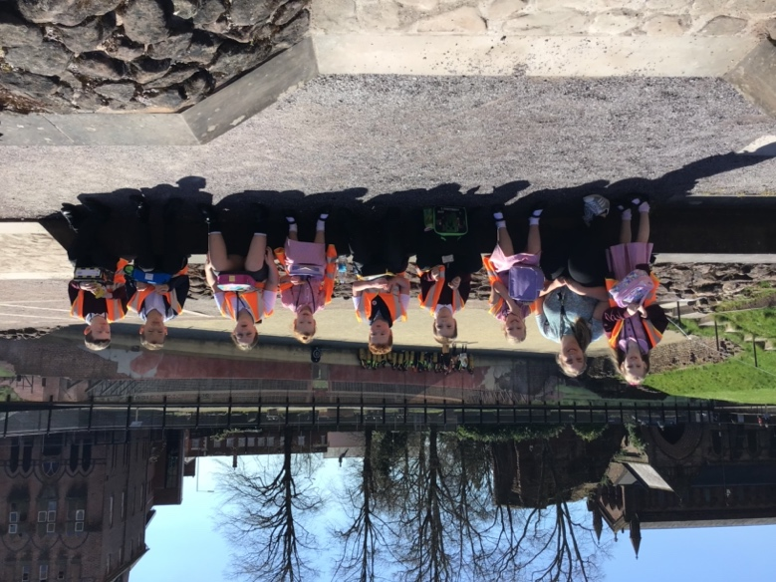
Quality of teaching & learning
I’m fortunate to be given time off timetable to visit and observe classes’ lessons and carry out sporadic learning walks. There can always be a sense of ‘scrutiny’ for teachers in such circumstances and yet Orrets’ staff understand that the nature of my visits is purely to enjoy and absorb any given session’s Historical content. We have a remarkable team of educators in our school and I never fail to learn new ‘stuff’ with every drop-in. Given the teacher assessment scores, the quality of teaching and resources provided that suit our very unique pupil population, the progress made is remarkable. Colleagues here learn about their student groups very quickly and are able to tailor and adapt sessions and tasks to each pupil’s particular needs and skills. Although much of our lesson planning is provided through the Dimensions Curriculum hub, this only scratches the surface of the preparation and planning undertaken by colleagues. Tasks are made as multisensory as possible, as it is fundamentally understood that the best way to learn is through experience rather than merely writing, typing or regurgitating. Consequently, Orrets Meadow is now into its second year of National Trust membership. This provides the school with the opportunity to visit any number of historical venues such as Speke Hall, Styal Mill and even the homes of the Beatles in Liverpool. On asking colleagues to recall trips they experienced when they attended school, the vivid memories of such outings were still etched in their minds, even up to and beyond fifty years after the actual event. Is there any better form of sticky knowledge? The extended and enriching knowledge staff then passes on to our pupils and the cross curricular opportunities are limitless.

Reviews and survey samples
Two of my most valuable sources of information are the pupil and staff voices in History. These two summaries inform me on ways forward and a synopsis of opinion on my subject specialism. If the popularity of History and our children’s motivation and preparedness to learn are understood and digested, then the stage is set to move forward in seeking newer or other tried and trusted ways to feed this enthusiasm. History continues to be a very popular subject area of learning here at Orrets. To an outsider, Dimensions may seem to dissipate foundation subjects from autonomous subject domains into a blended seamless entity that can potentially leave students unclear about the specific subject they’re engaging in, in any given lesson. Yet when reviewing the pupil voices rendered this year, it’s abundantly clear that children can see clearly and report back numerous aspects of Historical content they’ve been exposed to. Students are very clear on how to go about seeking advice and support and from the same survey samples, the overriding sense of not being phased or anxious about being stuck is ever-present. Asking for help and support is simply the way it is in our school and children have no aprehention about doing so. Children know they are expected and encouraged to seek guidance. Children happily discuss their learning on returning home, which is a marvellous affirmation of the subject’s popularity and the indelible mark it leaves on them.
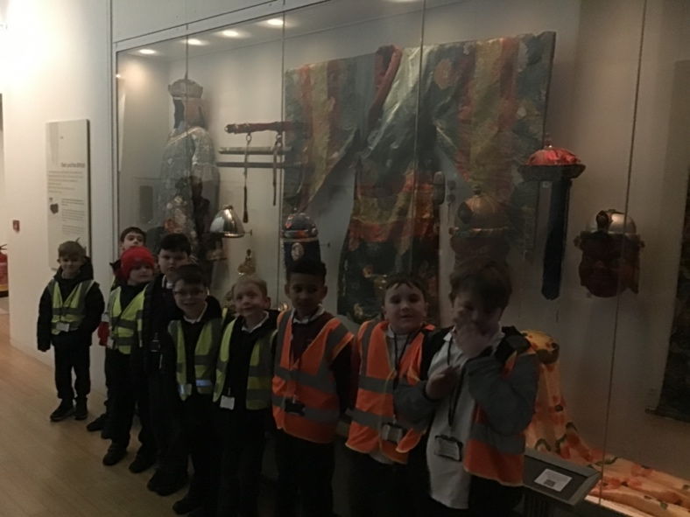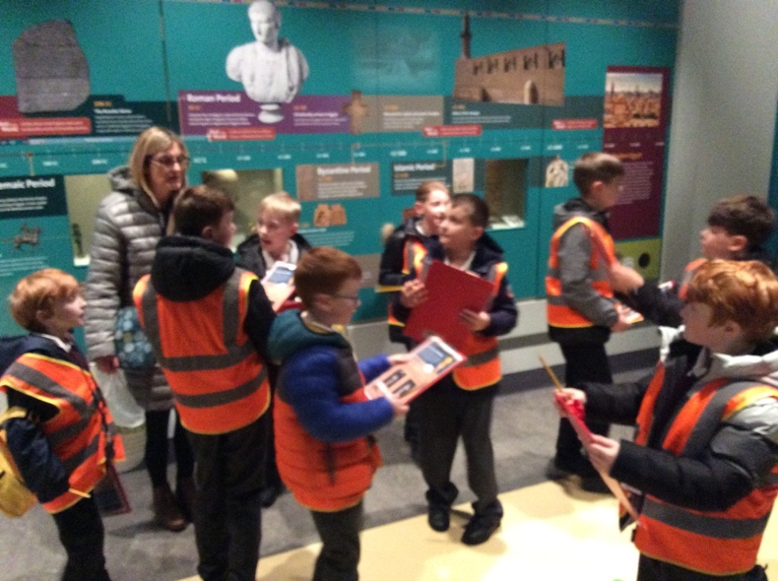
Strengths in History
Given the feedback from colleagues, be this orally in day-to-day conversation, textually through surveys or during staff meetings, it’s apparent that History is a very popular subject area for teachers within our Dimensions Curriculum. The early days of adjusting to a holistic from an autonomous methodology are now a routinely entrenched. Staff can pick out specific aspects of historical study and recount experiences of their given group’s learning, their strengths and needs or ways forward. The ‘what, where, when, why & how’ approach to informing, discussing and eliciting responses is not simply a tried and tested formula but one which suits our pupil population perfectly. It’s a great guideline that meets the needs of our children. They seem to know where they are.

Ways forward
Now that we are into our second year of National Trust membership, I intend that we begin to utilise this as fully as possible. The revision and enrichment of the current education packs provides staff with a number of ideas for them to prepare and conduct their visit. Now that educational visits and trips are becoming more and more common and a staple part of Orrets learning ‘diet’, it’s important to remember that although a fantastic and exciting experience to compliment learning, it is in essence and educational experience. It may be possible to focus trips purely on historical content and yet the opportunity to enrich a global learning experience of foundation and core subjects should not be missed.
Orrets staff are some of the most imaginative and resourceful people one could ever meet in an educational environment and therefore, seeking their counsel on improving the history experience here is an absolute must.

Targets for 2023-2024
The staff survey samples provided a healthy, productive insight into how the teaching team understood they could move forward in History. The following is a short, concise list of some of these proposals:
- Highlight the historical aspects of our Wonders of Wirral module in the Summer 2 term to cover NC History skills and knowledge and provide teaching teams with an opportunity to plug any learning gaps that may have emerged through the course of the year.
- Continue encourage greater use of National Trust membership with a Historical focus
- Revise the ‘education packs’ for cultural capital venues & seek feedback from staff regarding their use for and at given NT locations.
- Explore cross curricular opportunities that will enrich the learning of History.
- Attend more CPD courses in History 2023-24

