

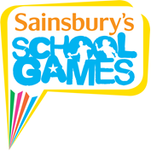

Quadkids Athletic Event

A group of our gifted and talented athletes went the Oval Athletics Track in Bebington to compete in Quadkids. Quadkids gives pupils the chance to participate in outdoor track and field athletics. It is inclusive, competitive, quick and fun and allows all pupils to compete in each of the four activities: a standing long jump, vortex howler throw, sprint and long distance run. The children had a super time and came back full of enthusiasm for athletics and trying to beat their personal bests.
