ORRETS MEADOW



Introduction

At Orrets Meadow Primary School, children receive a daily maths lesson. As a basis for planning the staff use the New Curriculum for maths which outlines what is expected for children during the primary age phase.

The purpose of this booklet is to outline the various calculation methods that children are taught as they progress through the school, many of which look different to the methods that you may have been taught in your primary school days. As children progress through the school, they are building up a bank of strategies that can be applied when appropriate. Each strategy can be refined or extended to suit the calculation needed. We hope the explanations and examples of strategies will help you to assist your child at home.

Included in the booklet are also various ideas and suggestions for maths activities that you can enjoy doing with your child in the world away from school. It is not an exhaustive list and you will doubtless have many more ideas of your own. In addition, follow this link to the BBC website to get further ideas - http://www.bbc.co.uk/schools/parents/work/primary/numeracy_and_science/maths_at_home_primary.shtml .

Calculations

A lot of emphasis in numeracy teaching is placed on using mental calculations where possible, using jottings to help support thinking. As children progress through the school and are taught more formal written methods, they are still encouraged to think about mental strategies they could use first and only use written methods for those calculations they cannot solve in their heads. It is important that children are secure with number bonds (adding numbers together and subtracting them) and have a good understanding of place value (ten and units etc) before embarking on formal written methods.

Each numeracy lesson generally starts with a mental maths sessions. The children are introduced to different methods of calculating numbers in their head. Number cards, hundred squares, number lines and other apparatus may also be used in this session. Mental maths plays an important role in the year six SATs (end of key stage standard assessment tests) with a whole paper devoted to it. Practise is important and skills are built on throughout the school.

Discussing the efficiency and suitability of different strategies is an important part of maths lessons. Explaining strategies and processes orally helps to develop the use of appropriate mathematical vocabulary.
When faced with a calculation problem, encourage your child to ask:

- Can I do this in my head?
- Could I do this in my head using drawings or jottings to help me?
- Do I need to use a written method?
- Should I use a calculator? 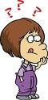

Also help your child to estimate and then check the answer. Encourage them to ask:

- Is the answer sensible?

The Use of Number Lines
Number lines are a very important tool used in all calculations. Children are introduced to them right from their first year of schooling.

Number lines can take many forms and are used in a huge variety of ways to help develop children’s understanding of number. Children become proficient in making ‘jumps’ up and down a number line to help them solve a mathematical problem.

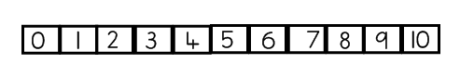

All classrooms have number lines of various types appropriate to the age group, including 0 – 10, 0 – 50 and number lines incorporating negative numbers.

As children progress though the school, they are also taught the value of drawing a blank number line that can accommodate relevant numbers to solve calculations.

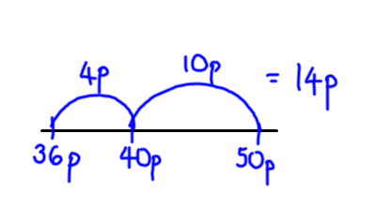
e.g. finding change from 50p after spending 36p
Addition

Children are taught to understand addition as combining sets and counting on. Calculations are put into practical contexts so that the child sees the relevance of the method they are learning.

2 + 3 =  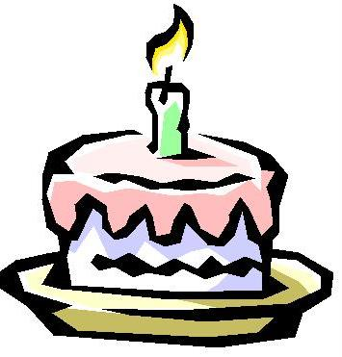  At a party, I eat two cakes and my friend eats three. How many cakes did we eat altogether? | Children could draw a picture to help them work out the answer or use practical equipment to model the problem.
6 + 5 =    Six people are on the bus. Five more people get on at the next stop. How many people are on the bus now?  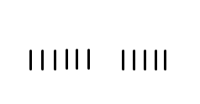  or | Children could use dots or tally marks to represent objects.
5 + 3 =  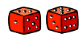  What is the total of the numbers on these two dice?  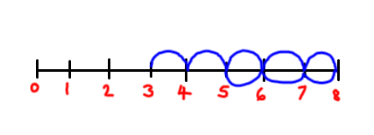  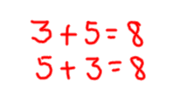 | Children can count along a number line, making ‘jumps’ to reach the answer. They can also see that the addition can be done in any order, developing awareness that it is often more efficient to put the larger number first.
12 + 9 =  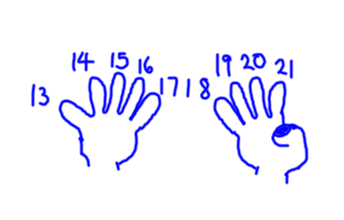  12 birds are sitting on the grass. Nine more fly to join them. How many are there altogether? | Children can use their hands to calculate. Numbers greater than 10 can be worked with by holding the larger number in their head and counting on, using fingers.
47 + 25 =  My sunflower is 47cm tall. My friend’s is 25cm taller. How tall is my friend’s sunflower?  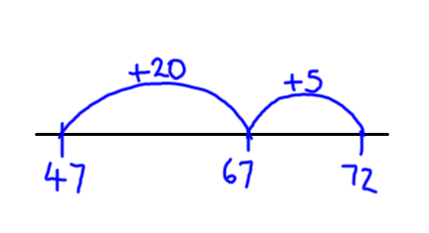 | Drawing an empty number line helps children to record the steps they have taken in a calculation. Start on 47, +20, +5. This is more efficient than counting on in ones.  Empty number lines can be used with numbers of any size.
87 + 64 =  One shelf measures 87 cm and another shelf measures 64cm. What is their total length in cm and m?  (80 + 60) + (7 + 4 )  140 + 11  = 151cm or 1.51m | By partitioning (splitting) both numbers into tens and units, each part can be added separately and then the answers combined to give the total.
487 + 546 =  There 487 boys and 546 girls in a school. How many children are there altogether?  5 4 6 5 4 6  4 8 7 or 4 8 7  9 0 0 1 3  1 2 0 1 2 0  1 3 9 0 0  1 0 3 3 1 0 3 3 | Children are taught written methods for those calculations they cannot do in their heads. Expanded methods build on mental methods and make the value of the digits clear to children. The language used is very important – 500 + 400, 40 + 80, 6 + 7 and then 900 + 120 + 13 OR starting with the units, tens and then hundreds.  Children are taught the importance of placing digits with the same value underneath each other in clear columns.
2685 + 1746 =  2685 people visited the museum last year. The number of visitors increased by 1546 this year. How many people visited this year?  2 6 8 5  + 1 7 4 6  4 4 3 1  ¹ ¹ ¹ | Children move onto using more compact standard written methods when they are secure with their understanding of place value. The units column is added first with the ten carried over and placed underneath the tens column. The tens column is added up with the hundred carried over and placed underneath the hundreds column. The same process is repeated with the hundreds column and then the thousands column is added up.

Subtraction

Children are taught to understand subtraction as taking away (counting back) and finding the difference (counting on/up). Calculations are put into practical contexts so that the child sees the relevance of the method they are learning.

5 – 2 =  I had five balloons. Two burst. How many do I have left?  Take away  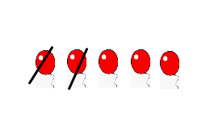  A teddy bear costs £5 and a ball costs £2. How much more does the bear cost?  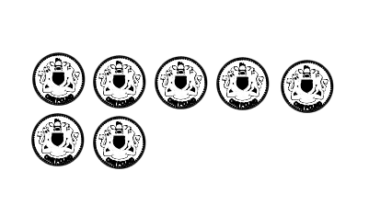  Find the difference | Drawing a picture helps children to visualise the problem. The use of practical equipment, such as bricks, helps to model the problem.
8 – 3 =  We baked eight biscuits. I ate three. How many were left?  Take away  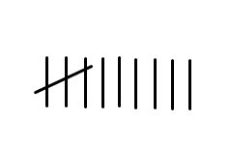  Lisa has eight felt tip pens and Tim has three. How many more does Lisa have?    Find the difference | Using dots or tally marks is quicker than using a picture.
9 – 5 =  I had nine pence. I spent five pence. How much did I have left?  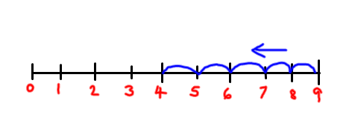 | The number line is used for counting back or jumping back.  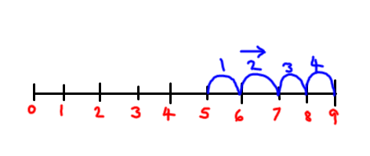  The number line can also be used for counting on.

50 – 36 =  I spent 36p in a shop. How much change did I get from 50p?  36p + ____p = 50p | Counting on using a number line is particularly useful in calculating change.
84 – 27 =  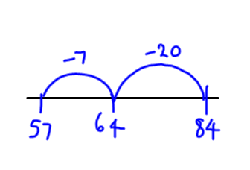  I cut 27cm off a ribbon measuring 84 cm. How much is left?  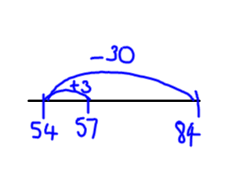 | Children can count back using an empty number line. This is a good way to record the steps they have taken and shows their understanding of how numbers can be partitioned (split) to make a calculation easier - (start on 84, - 20, -7)  Children can also use the compensation method – taking away too much and adding back. In this example, -30 and + 3 back on.
834 – 378 =  The library owns 834 books. 378 are out on loan. How many are left on the shelves?  378 + _______ = 834  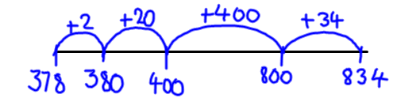  2  2 0  4 0 0  3 4  4 5 6 | Children can count up from the smallest number to the biggest using an empty number line. It is easiest to count up to a multiple of 10 or 100 (‘friendly numbers’). The steps can also be recorded vertically, making sure that digits of the same value are always underneath each other.

2006 – 1998 =  Sarah was born in 2006 and Mark in 1998. How much older is Mark than Sarah?  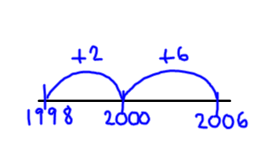 | Using a number line and the counting on method is particularly helpful when numbers are actually quite close to each other but cross a tens, hundreds or thousands barrier and so look harder than they actually are.
754 – 86 =  754 cars were waiting to load onto the car ferry. 86 drove on. How many were still waiting?  7 5 4 = 700 + 50 + 4  8 6 80 + 6  = 700 + 40 + 14 → 7 4¹4  80 + 6 8 6  = 600 + 140 + 14 → 6¹4¹4  80 + 6 8 6  600 + 60 + 8 6 6 8 | Children progress onto subtraction using decomposition – where there are fewer units, tens, hundreds etc in the larger number. The use of the expanded written method helps them understand the process and they then move onto the move compact standard written method for decomposition. Starting with the units, 4 – 6 we can’t do, so we carry over a ten to make 14 units leaving 4 tens. 14 – 6 equals 8 units. Moving onto the tens column, 4 tens subtract 8 tens we can’t do, so we carry over a hundred to make 14 tens leaving 6 hundreds. Now 14 tens subtract 8 tens equals 6 tens. Finally the hundreds column, 6 hundreds subtract nothing equals 6 hundreds.
6463 – 2686 =  The second hand car cost £6463. The teacher only had £2686. How much did she need to borrow to pay for the car?  ⁵6 ¹³4 ¹⁵6 ¹3  - 2 6 8 6  3 7 7 7 | Decomposition can be used with any numbers provided the child has checked that a mental strategy and a number line jotting would not be more efficient.  Children are encouraged to see that by adding the answer to what was taken away they will end up with what they started with – a bit of maths magic!

Multiplication

Times tables
A good knowledge and quick recall of times tables is essential to children’s mathematical progress. The children are taught up to 10 x 10. The target is for all children to know their tables by the end of year four.

When learning their tables, children are taught to look for patterns such as odd and even number answers, or patterns made by adding together the separate digits in the answers.

Children are also taught to recognise the reversible effect so that they know 6 x 2 is the same as 2 x 6. They are also taught the relationship with division so that knowing 6 x 2 = 12 means they also know that 12 ÷ 2 = 6 and 12 ÷ 6 = 2. For each known times table fact, they also know three others:
6 x 7 = 42 so they know that 7 x 6 = 42
42 ÷ 6 = 7
42 ÷ 7 = 6

To help children with their multiplication, one of the ways we use is to find all the factors that are used to make up a number. For example the factors of 18 are 1,18, 2, 9, 6, 3 because 18 x 1, 1 x 18, 3 x 6, 6 x 3, 9 x 2, 2 x 9 all equal 18.

Multiplication Methods
Children are taught to understand multiplication as repeated addition and scaling. It can also describe an array. Calculations are put into practical contexts so that the child sees the relevance of the method they are learning.

2 x 4 =  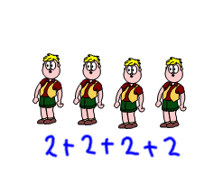  Each child has two eyes. How many eyes do four children have? | Drawing a picture is a helpful way to visualise a problem.

5 x 3 =  There are five cakes in a pack. How many cakes are in three packs?  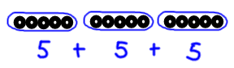 | Dots or tally marks are often drawn in groups.  This shows three lots of five. The children can clearly see the repeated addition.
4 x 3 =  A chew costs four pence. How much do three chews cost?  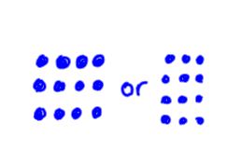 | Drawing an array (3 rows of 4 or 3 columns of 4) gives children an image of the answer. It also helps the understanding that 4 x 3 is the same as 3 x 4.
6 x 4 =  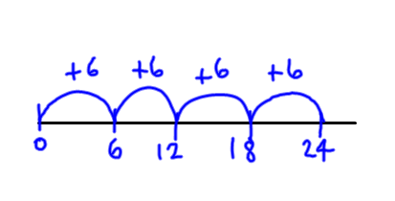  There are four cats. Each cat has six kittens. How many kittens are there altogether? | Children can count on in equal steps recording each jump on an empty number line. This shows four jumps of six.
13 x 7 =  There are 13 biscuits in a packet. How many biscuits in seven packets?  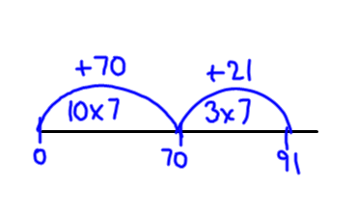  13 x 7 = (10 x 7) + (3 X 7)  = 70 + 21  = 91 | When numbers get bigger, it is inefficient to do lots of smaller jumps. 13 can be partitioned (split) into 10 and 3. The calculation can be worked out on a number line or horizontally.
6 x 124 =  124 books were sold. Each book cost six pounds. How much money was taken?  600 + 120 + 24 = 744 | This is called the grid method. 124 is partitioned (split) into hundreds, tens and units. Each part is then multiplied by six. The answers are then added together mentally or set out vertically.
  x | 100 | 20 | 4
  6 | 600 | 120 | 24

72 x 34 =  A cat is 72 cm long. A tiger is 34 times longer. How long is the tiger?  2100 + 60 = 2160  280 + 8 = 288  2448 | The grid method also works for ‘long multiplication’. The numbers are partitioned (split up) and each part is multiplied separately and then each answer is added together.  The grid method can be used for numbers of any size.
  x | 70 | 2
  30 | 2100 | 60
  4 | 280 | 8
28 x 7 =  In a school there were seven classes each with 28 children. How many children were in the school?  2 8 2 8  x 7 x 7  5 6 ( 8 x 7)→ 1 9 6  +1 4 0 (20 x 7) ⁵  1 9 6 | From the grid method, the children begin to use more standard written methods, working vertically. Children are reminded that digits of the same value must be underneath each other.  Starting with the units, 8 x 7 = 56. The 6 goes in the units column and the 5 tens are carried underneath the tens column. 2 tens x 7 = 140, add 5 more tens equals 190.
36 x 24=  There are 24 packets of exercise books. In each packet there are 36 books. How many books altogether?  3 6  x 2 4  1 4 4  ²  7 2 0  ¹  _____  8 6 4 | All the previous work builds up to using the more compact standard written method for long multiplication. Children multiply the 36 by 4, carrying where necessary. Then they place a zero in the units column as they are now multiplying the 36 by 20. Finally they add the two separate lines together,

Division

Children are taught to understand division as sharing and grouping. Multiplication and division are interlinked. Calculations are put into practical contexts so that the child sees the relevance of the method they are learning.

6 ÷ 2 =  Six sweets are shared between two children. How many sweets does each child get?  sharing  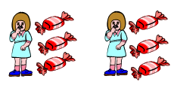  between two  There are six sweets. How many children can have two each?  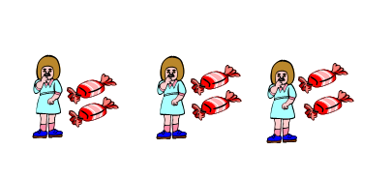  grouping  in 2’s | Drawing pictures make it easy for the child to visualise the problem and often makes it easier to solve. Practical equipment is also used to model and solve the problem.
12 ÷ 4 =  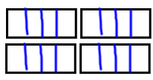  12 apples are shared equally between four baskets. How many apples are in each basket?  sharing  between four  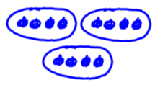  grouping  in 4’s | Dots or tally marks can either be shared out one at a time or split up into groups. This then clearly shows how many groups or how many in each group.
15 ÷ 3 =  How many threes in 15?  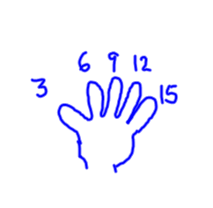 | To work out how many threes there are, children can use their fingers to count up in groups of three.  They can also draw these as jumps along a number line. This shows you need five jumps
84 ÷ 6 =  Each ladybird has six legs. How many ladybirds are there if there are 84 legs?  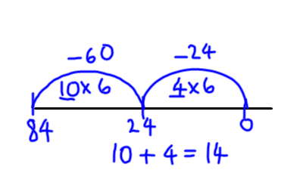 | It would take a long time jump in sixes to 84, so children can jump on in bigger ‘chunks’. A jump of 10 lots takes you to 60. Then you need another four lots of six to reach 84. Altogether that is 14 sixes. You can also subtract chunks on the number line until your reach zero. Then you count up how many chunks you have used to reach zero.
184 ÷ 7 =  184 chairs are needed for a concert. They are arranged in rows of seven. How many rows of chairs are needed?  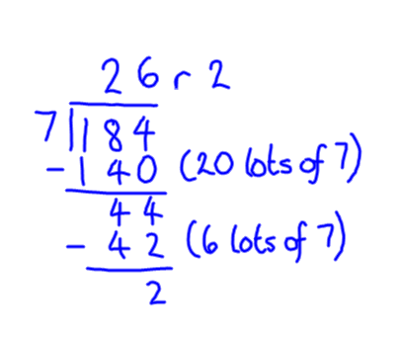 | This method is known as chunking. In this example, you are taking away chunks of seven. First subtract 140 (20 lots of 7) and you are left with 44. Then subtract 42 (six lots of seven) to leave 2. Altogether that is 26 sevens with a remainder of 2. So 26 rows are needed with either a small row of two or two rows with 8 chairs.
347 ÷ 24 =  24 apples can fit into a box. How many boxes are needed for 347 apples?  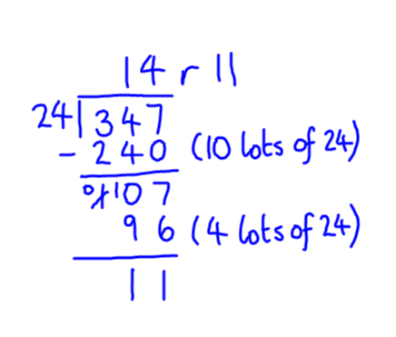 | The chunking method works equally well when dividing by a two digit number. This time you are taking away chunks of 24. First subtract 240 (10 lots of 24) and you are left with 107. Then subtract 96 (4 lots of 24) and you are left with 11. The answer to the problem then is 14 boxes are needed and 11 apples left over.

Counting Ideas

- Practise chanting the number names. Encourage your child to join in with you. When they are confident, try starting from different numbers – eg 4,5,6…. Also try counting backwards.

- Sing number rhymes together – there are lots of commercial CD’s available.

- Give your child the opportunity to count objects (coins, pasta, shapes, buttons etc.) Encourage them to move each object as they count them.

- Count things you cannot touch – window panes, jumps, claps, oranges in a bag.

- Play games that involve counting – eg snakes and ladders, dice games.

- Look for numerals in the environment – eg car number plates

- Make mistakes when chanting, counting or ordering numbers. Can your child spot what you have done wrong?

- Chose a number of the week e.g. 5. Practise counting in 5’s, up to 5, on from 5,collect groups of 5 items.

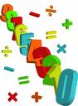

Practising Number Facts

- Play ‘ping pong’ to practise components with your child. You say a number and they reply with how much more is needed to make 10, 20, 100 or 1000. Encourage your child to answer quickly without counting or using fingers.

- Throw two dice. Ask your child to find the total of the numbers (+), the difference between them (-) or the product (x).

- Use a set of playing cards (without the picture cards). Turn over two cards and ask your child to add or multiply the numbers. If they answer correctly, they keep the cards. How many cards can they collect in two minutes?

- Play Bingo. Each player chooses five answers (e.g. numbers to 10 to practise simple addition, multiples of 5 to practise the five times table etc). Ask a question and if a player has the answer, they can cross it off. The winner is the first player to cross off all their answers.

- Give your child an answer. Ask them to write as many number sentences as they can with this answer. You could just ask for addition sentences or any type of calculation.

- Give your child a number fact – eg 5 + 8 = 13. Ask them what else they can find out from this fact – 50 + 80 = 130, 8 + 5 = 13, 13 – 8 = 5, 130 – 50 = 80 etc

- Look out for car number plates. What is the number on the plate? What is this to the nearest 10 or 100 or 1000? How many more would you need to reach the next multiple of 10, 100 or 1000?

- Make up rhymes together to help your child remember tricky times tables.

Real life Problems

- Go shopping with your child to buy two or three items. Ask them to work out the total amount spent and how much change you will get.

- Buy items with a percentage extra free. Help your child to calculate how much of the product is free.

- Plan an outing during the holidays. Ask your child to think about what time you will need to set off and how much money you will need to take.

- Use a bus or train timetable. Ask your child to work out how long a journey between two places should take. Go on the journey. Do you arrive earlier/later than expected? By how much?

- Help your child to scale a recipe up or down to feed the right amount of people.

Getting children involved in real situations where they are using mathematical skills is motivating and stimulating.

Shape and Measures

- Choose a shape of the week. Look for this shape in the environment. Ask your child to describe the shape to you.

- Play ‘guess my shape’. You think of shape. Your child asks questions to try to identify it but you can only answer ‘yes’ or ‘no’.

- Hunt for right angles around your home. Can your child spot angles that are bigger or smaller than a right angle?

- Look for symmetrical objects. Help your child to paint or draw symmetrical pictures/patterns.

- Make a model using different boxes/containers of different sizes. Ask your child to describe their model to you.

- Practise measuring the lengths and heights of objects in metric measurements. Help your child use different rulers or tape measures correctly. Encourage them to estimate before measuring. Compare measurements in metric and imperial.

- Let your child help with the cooking. Help them to measure ingredients accurately. Talk about what each division on a scale represents.

- Choose some food items out of the cupboard. Try to put the objects in order of weight by feel alone. Then check by looking at the weights on the packets.

- Practise telling the time with your child. Use both digital and analogue clocks. Ask your child to be a ‘timekeeper’ – e.g. tell me when it is half past four because we are going swimming.

- Use a stop clock to time how long it takes to do everyday tasks –e.g. how long does it take to get dressed. Encourage your child to estimate first.

- Use a TV guide. Ask your child to work out the length of their favourite programmes. Can they calculate how long they spend watching TV each day/week?

