**Subject Report for Governors - Oracy – Claire Walsh**

**SDP**

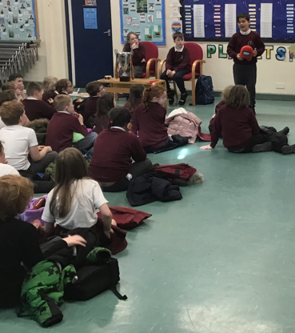I began the year by completing a self-evaluation form from Voice 21, a national Oracy framework organisation. Although a lot of work at Orrets is done through Oracy, there were many areas where we could hone our skills and really embed them into daily practice and the whole school curriculum. By the end of the school year, all areas were addressed and points to improve had been met. We ensured we had an ambitious vision for oracy, we had built a culture of oracy, our curriculum reflected our ambitions, we recognised oracy as central to learning, and we were accountable for the impact of oracy. Staff were fully on board and a collegiate approach to the oracy curriculum ensured that the project was a success.

**CPD**

Staff meetings

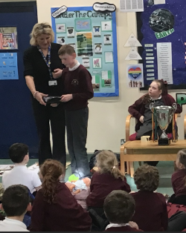Staff were introduced to the Oracy Framework document and the idea that there are four strands to Oracy teaching: physical, cognitive, linguistic and social/emotional. Staff filled in a baseline document for each child and then after data analysis on these results I gave staff feedback with their particular class focus to work on during the year.

Talking Partners was relaunched across the school after a successful staff meeting where staff shared ideas about how they get reluctant speakers to communicate.

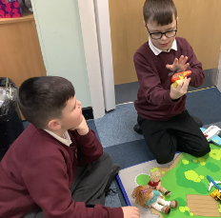Following on from the Noisy Classroom CPD, and after collecting the staff’s ideas about talking in the classroom, staff were given time to go through their Dimensions plans and annotate them with a variety of ideas to promote Oracy in the classroom, ensuring that staff are always mindful of Oracy in the afternoons as well as in English and Maths.

Noisy Classroom

A half day conference, shared with Hayfield was attended in January. The speakers consolidated a lot of Oracy ideas that staff were familiar with, but we did come away with the knowledge that Oracy has firm foundations at Orrets.

**Enrichments**

*Debate club was well attended and children discussed topics ranging from ‘Everyone should have a pet’ to ‘Pizza is the best food’. Debate club even got a mention in the Ofsted report.

*Show and Tell in assembly has been a wonderful addition to the already jam packed Friday afternoon showcase! The speakers have grown in confidence each week, and we have listened to talks about Pokemon cards, a cuddly toy, a crystal collection, the clarinet and gymnastics!

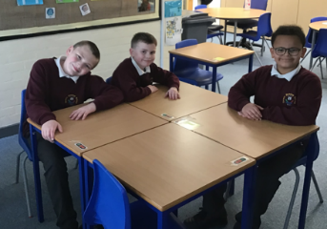*Staff have begun an oracy scrapbook, which is going to be rolled out to the children. They can fill it in with events from home and then bring it back to share with their classmates.

*Poetry showcase event on 7th June- this was a fantastic success. Every single child performed, and even those who had videoed themselves stood up and joined in with their class.

*Role play- staff have ensured that role play features across the school, in all subjects. Giraffe class children really improving their oracy skills playing with a street scene involving small world toys and figures, so this was brought up a s excellent practice in oracy, particularly in our younger classes.

**Learning walks**

Learning walks to all classes were a delight! I saw lessons in history, PE, English, Social Skills, PSHE, Topic. All children were engaged and being taught Oracy skills, whether it was turn taking, reading their work aloud or practising talking partners at an appropriate level. Oracy is fully embedded at Orrets Meadow.

**Pupil Voice**

100% of pupils take part in Talking Partners with their class

100% of them find it useful, with comments such as:

|  |  |  |
| --- | --- | --- |
| * Improves speaking and listening skills | | |
| * Working with a friend helps | |  |
| * They listen well and it's good to talk | | |
| * Hear other people's views | |  |
| * If I don't know something and they do | | |
| * They help you and explain things | | |
| * Share ideas |  |  |
| * I like sharing with my friends | |  |
| * Think about new ideas | |  |
| * Helps me do my work | |  |
| * Helps me remember | |  |
| * Get different ideas off each other | | |

All children responded that they regularly use and enjoy role play in lessons, and these opportunities were in all areas of the curriculum, eg; RE, English, Spanish, Maths, History.

Interestingly 9/15 pupils said they would like to do a ‘Show and Tell’ in assembly.

73% of pupils said they enjoy reading out their work in class.

**Staff Survey**

100% of staff use talking partners at least 4 times per week, with most using it multiple times per day. 100% of staff said ‘Show and Tell’ has been a positive addition to the school assembly with people saying: “Absolutely- it encourages self-esteem and has facilitated the opportunity to have a go.” “Yes. Lovely to see children gaining confidence.” “Yes. It has given the children the opportunity to push themselves out of their comfort zone.”

All teachers felt comfortable using drama and role play in their lessons.

**Ideas for future oracy initiatives:**

* Big Friend meet ups (older and younger children meeting up)
* Whole school forum for big discussions
* No Pens Day Wednesday
* Show and Tell in classroom

**In Summary**

The year long oracy project has been hugely successful, and it has been a privilege to work with such a talented team of staff, sharing ideas and ensuring that oracy is central to everything we do here at Orrets.