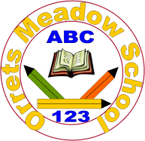
Governors Report – Summer 2022
Science
Gina MacGregor
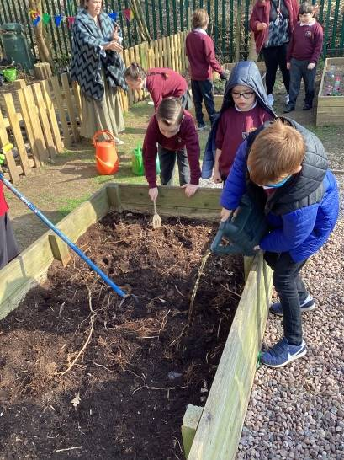
Achievements
During this academic year, I have worked towards achieving the Primary Science Quality Mark. Through RAG rating our Science provision, I was able to focus on key areas to develop in our science curriculum. We now have Science implemented through all aspects of our curriculum, not just in science focus weeks. During Science focus weeks, we explore topical Science, outdoor science, famous current scientists and we have all been on numerous science trips. Through achieving this award, I have implemented more practical science, which the staff and students have loved. Staff and students now look forward to the practical and outdoor element to our Science focus weeks.

CPD
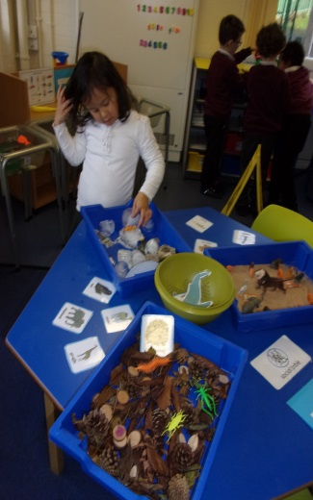
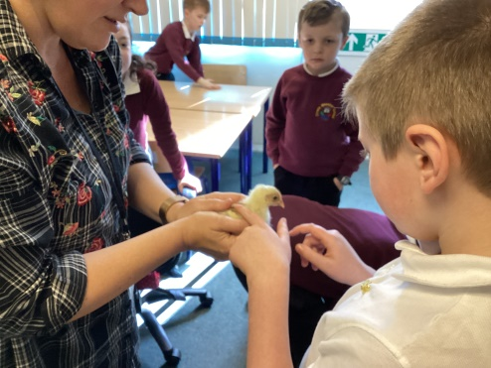
This year, I was granted a TLR3 for Science, to achieve the Primary Science Quality mark. Through this award, I did half termly zoom training days and was given tasks to work through. I was also granted half a day to work through my course and do any management activities for Science. This opportunity has been excellent and I really enjoyed having a leadership role in school.
I took part in the Liverpool Primary Science subject leader meetings each term that were very informative about any changes in the curriculum and allowing children to catch up. Although they were still via zoom, I was able to network with lots of different schools across the area.
In order to offer CPD to staff at Orrets, I led a staff meeting that focused on methods for encouraging more independence in science; particularly offering teaching styles which would encourage children accessing the pre-curriculum and KS1 curriculum to think of their own investigations in science. During this staff meeting, I also gave teachers the opportunity to think of ways that we could incorporate science outside of the classroom. We then ensured that we put these ideas into place during our Science focus weeks; I monitored this by conducting lesson observations and learning walks each half term.
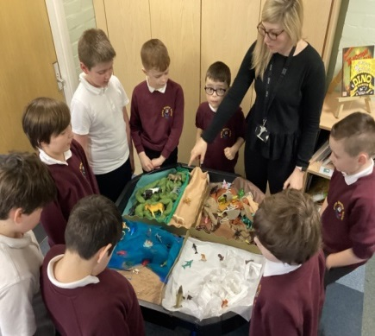
Quality of teaching learning
As the science subject leader, I have completed a range of activities to oversee science this year. During the autumn term, I began my RAG rating of our Science provision through my PSQM course, and created targets to achieve across the year. I also did initial staff and pupil surveys and a learning walk to assess how Science weeks look at the start of the academic year.
In the spring term, I conducted a book scrutiny to see the progress made from the first to second Science focus week. I also did various lesson observations in this week, particularly focusing on the youngest and oldest children in the school. The progress between the classes was truly outstanding! During the spring term, I also encouraged all staff to take their students on a Science trip; classes went to the farm, the zoo, New Brighton beach and the forest!
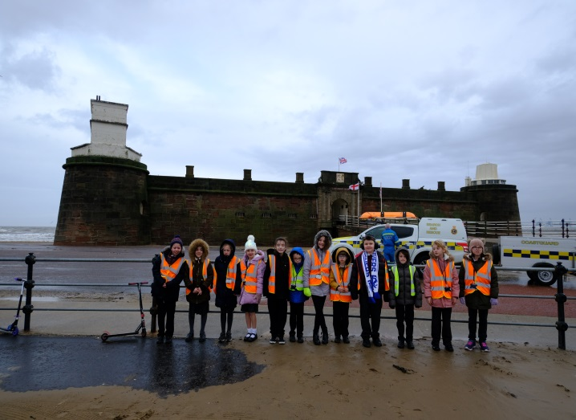
In the summer term, I conducted a learning walk during our final science week where I was able to see all classes doing a range of practical science activities. It was fantastic to see a range of lessons and excellent quality teaching which was adapted to suit the needs of our children. I also met with the school council and they had to ask which resources we needed in school. I then ordered lots of new resources and equipment to suit the needs of our children; a firm favourite was the laboratory jackets and goggles! Finally, I did a data analysis of progress across the school; I was able to see patterns in the data which showed how girls make less progress in science than boys, therefore, I will again monitor this target group next year.
Strengths
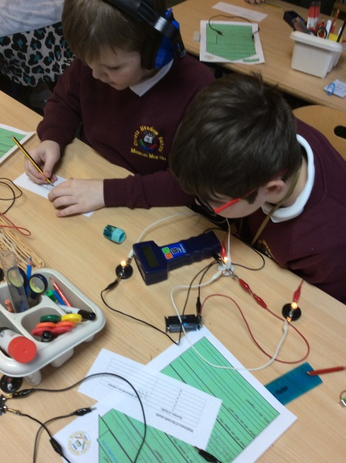
After completing the Primary Science Quality Mark, I have been able to see how Science really is a strong and enjoyed subject at Orrets Meadow by staff and students. A great strength is having discrete teaching of science through our Science focus weeks; they are stimulating, thought-provoking and allow children to retain a lot more information in one week rather than weekly lessons; we now assess the children’s progress by completing a Kahoot Quiz at the end of each week and all children could answer multiple questions from their quiz correctly. The teaching of Science is very strong and they all have excellent subject knowledge of what they are delivering. The teachers offer creative and inventive lessons which are adapted to suit all their students’ needs. Another strength is how all staff deliver multiple practical activities throughout the week; rather than last year where they focused on one investigation, now the children experience practical activities in every lesson. The introduction of Topical Science has been brilliant this year as children learn about something that’s happening in the world and they have to create solutions improve these issues, such as collecting litter on beaches.
Ways forward
Next year, I will be working towards gaining the Learning Outside the Classroom Quality Mark and so therefore a big focus will be on developing Science and other lessons outside the classroom. Working through the LOtC Mark framework ensures that Orrets Meadow; has put creative learning experiences at its heart and understands that students need to learn beyond the classroom to ensure they become well-rounded citizens, understands LOtC can enhance students’ academic attainment and personal development and finally supports students’ health and well-being, and their spiritual, moral, social and cultural needs.

2022-2023 targets
- To achieve the Learning Outside the Classroom Quality Mark (all year)
- To continue monitor girls progress in science (February and July)
- To lead a staff meeting about promoting Science outside the classroom (Autumn term)
- To ensure each class goes out on a Science trip (Each Science focus week)
- To improve Science capital by offering students the opportunity to meet Scientists and visit other school laboratories (all year)

