Orrets Meadow School



Inclusion Policy

Mission Statement

To raise the aspirations of every child and give them the confidence to fulfil their potential through positive learning experiences.

Signed _______________________________________ (Chair fo Governors)

Date _____________________________
School Aims and Implementation

Orrets Meadow School aims to enable all children the opportunity to achieve their best academically, emotionally and socially through:
- Providing high quality inclusive teaching to enable children to acquire the skills, knowledge and concepts relevant to their future;
- Promoting an ethos of care, mutual respect and support, where effort is valued and success celebrated;
- Enabling children to become active, responsible and caring members of the school and wider community.

The school works towards these aims by:
- Promoting high quality adapted and inclusive teaching.
- Providing high quality curriculum entitlement and a well- resourced, inclusive learning environment;
- Promoting the Orrets Meadow Core Values to enable the children to value themselves and each other; the Core Values are: Work hard, Be nice, Never Give up.
- Embedded within our core elements we promote:
  - We take responsibility for our actions and always make sure we do the right thing.
  - We show honesty and always make sure we are truthful and fair.
  - We show aspiration and always have a positive attitude about what we can all achieve.
  - We show respect and always have regard for ourselves and other people’s feelings, wishes and rights.
  - We show compassion towards others and always make sure we try to understand and support others.
- Promoting an effective partnership with parents and the wider community.

- Inclusion Policy Introduction

‘Inclusion is seen to involve the identification and minimising of barriers to learning and participation, and the maximising of resources to support learning participation’
Index for Inclusion –
Successful inclusion should result in every pupil feeling safe, confident and happy at school.
Successful inclusion should see every pupil making the best progress of which they are able and enjoying their time at school - be that in lessons, during their play or lunchtimes or when involved in any of our out of school activities.
Successful inclusion should promote every child’s belief in themselves as a learner and valued member of our school community.
- Successful inclusive provision at Orrets Meadow is seen as the responsibility of the whole school community, permeating all aspects of school life and applicable to all our pupils.

- Meeting Diverse Needs

At Orrets Meadow we recognise that in order to achieve the school aims we must actively seek to recognise and meet the very diverse needs of our pupils by:
- Monitoring the achievement and well-being of all our pupils and the quality/nature of the learning opportunities they are offered.
- Tracking each child’s progress and using the resulting knowledge to plan provision for the individual or groups of pupils.
- Correctly identifying and then seeking to overcome potential barriers to pupils’ learning or their full participation in school life.
- Developing and deploying our resources to best reflect the various levels of need experienced by pupils.
- Taking care to ensure that all are appropriately supported.
- Sharing any concerns we may have regarding a child with their parents or carers and then seeking to work together with them, for the good of the child.
- Liaising closely with professionals from other Children’s Services or Health agencies involved in the care and support of pupils.
- Providing teaching and non-teaching staff with the support and training they need in order that their work promotes the best outcomes for each child.

- Potentially vulnerable groups

There are a number of identified groups of pupils and families for whom this policy is particularly pertinent:
- Pupils with Special Educational Needs or Disabilities (SEND)
- Pupils whose home language is not English (EAL)
- Pupils who are Gifted, Able and/or talented (GAT)
- Pupils with physical or sensory impairments
- Pupils whose families may be Asylum Seekers or Refugees
- Pupils from Traveller families
- Pupils who might be subject to abuse or harassment, for whatever reason
- Pupils under the care of Social Services or pupils who may be in public care, or living with foster families
- Pupils who are young carers
- Pupils whose family are in crisis or under great stress
- Pupils at risk of significant harm
- Pupils with poor attendance
- Pupils who are at risk of disaffection and exclusion from school.

- Promoting and Supporting Inclusion

- Head Teacher, Senior Leaders and our Governing body:
- Overall responsibility for making Orrets Meadow a truly inclusive school lies with the Head Teacher, Senior Leaders and the Governing Body of the School. However, all staff are responsible for inclusive practises within the school.
- We aim to promote Inclusion at Orrets Meadow through all of our policies, systems and practices.

- Personalising the Curriculum
- School Leaders at all levels; including Governors, Head teacher, Deputy, and subject Leaders, are responsible for ensuring that the curriculum; in its narrow and broadest sense, is personalised to match the needs of the pupils who attend the School.
- The School uses the National Curriculum for academic guidance.
- The School has a long term Curriculum Map which is used by staff to plan appropriate, differentiated activities for all pupils.
- School Leaders also ensure that the principles of Inclusion are applied to all activities which pupils engage in at School or on Educational Visits; this includes the variety of extended schools activities that are offered at lunchtime.
- All members of the School Community are expected and encouraged to adopt behaviours which support the School’s Inclusive ethos within both the explicit and hidden curriculum.

- Inclusion Manager -Head teacher

- The Inclusion Manager takes the leading role in co-ordinating support and provision, particularly regarding pupils and families in the aforementioned groups.
- The Head Teacher, monitors, advises, evaluates and plans for the development of inclusive practice and provision across the school.

Special Educational Needs
- The school has specialist (teaching) staff who co-ordinate support and provide provision for children who require specialist provision; including support from outside agencies.

- Class Teachers

- All pupils at Orrets Meadow spend the majority of lesson times being taught alongside their class mates in their classroom. Class teachers / Teaching assistants take the lead role in managing and creating the classroom environment.
- Teachers have overall responsibility for the planning and delivery of lessons to their class. Teachers seek to provide pupils with learning opportunities which will allow all the pupils to access the subject taught, encounter appropriate challenge and promote progress. This differentiation is evidenced in their lesson plans though individual pupils may have targets particular to their own specific needs in certain areas or aspects of the curriculum. Such additional or different provision and its outcomes are recorded by the teacher by means of an Individual Education Plan (IEP). Parents are informed by their child’s teacher of any additional or different provision being made for their child.
- Additional Needs Group Provision. Teachers evaluate the needs of their class and in conjunction with the pupils EHCP / Statement additional needs groups are allocated. These are held from 12 -12:30 Mon-Thursday. The groups are different and relate to group or individual needs. The groups aim to support pupils in areas of need. In turn minimise barriers to learning.
- Teachers take the lead role in monitoring the attainment, learning, behaviour and well-being of pupils in their class. This information is recorded and pupils’ achievement and needs are discussed and further planning undertaken by way of a pupil progress meeting. This occurs at the end of a term. They are led by the Head teacher and identify areas to be further supported for the coming term. Class teachers have a pivotal role to play in achieving positive and supportive relationships with and between pupils. Class teachers are central to successful liaison with parents and colleagues.

- Teaching Assistants

- Teaching Assistants (TAs) work with individual or groups of pupils during lessons and break or lunch times to support pupils’ learning and promote their well- being. The work of a TA is directed by the teacher during lessons.
- Advice and training for specific work or duties may also come from an outside specialist, for example - a Speech and Language Therapist / OT or Educational psychologist
- To address very specific needs, pupils may be withdrawn for short periods during class times to work individually. Alternatively some work may occur alongside others within a small group, when the need is common to all.
- In order to best utilise their support for pupils’ learning, the deployment of Teaching Assistants within the school is strategically managed by Senior Leaders in consultation with Year Group Leaders and Class Teachers.

- School based Home school link worker

- The school has a home school link worker whose primary function is to offer support to pupils and families who may require social / emotional support or advice.
- The home school link worker will liaise with social services and other agencies as appropriate and ‘signpost’ and/or access other available services to families and the school.

- Inclusive practice:

- Staff are trained and frequently updated in supporting SEN conditions.
- The school environment lends itself to supporting small group classes.
- A sensory garden and physical play equipment help to structure and support independent play and free times.
- Sensory rooms support ASC / anger management and relaxation needs.
- Visual timetables
- Visual cue cards
- Differentiated activities in all sessions.
- Support at lunchtimes for quiet areas/ structured play/ stimulating activites i.e sewing, model making, netball, football, Wii club, magazine club, dance club, boccia, sitting volley ball etc.

- Special Educational Needs

- Identification of Special Educational Needs or Disabilities.

- Identification of SEND may have occurred prior to a pupil’s enrolment at school. If this is the case then school will seek appropriate advice and support from the relevant school and external agencies. This then informs the provision that is put in place for the pupil at Orrets Meadow.
- When a concern is evident the class teacher will liaise with the Headteacher and parents/carers to ensure all are aware and can plan the best ways forward together. This may involve the teacher adapting certain aspects of their classroom practice or requesting that the parent/carer seek the advice of the GP or Optician. Should standard provision not suffice to overcome the concern and a significant and/or persistent difficulty remains apparent, the pupil will be deemed as having an additional ‘Special Education Need’.
- Upon identification of such difficulties the school will seek to put in place additional educational provision. This may be long or short-term dependent upon the nature of the special need and the progress made by the pupil.
- There are four broad areas that give an overview of the difficulties a pupil may have. However it is important to note that a pupil’s needs may cross one or more of the following:
- Communication and interaction
- Cognition and learning
- Social, emotional and mental health difficulties
- Sensory and/or physical needs
- The SEN Code of Practice (2014) describes a 'graduated response' to identifying and removing barriers to learning in order to put effective special education provision in place. (see below)

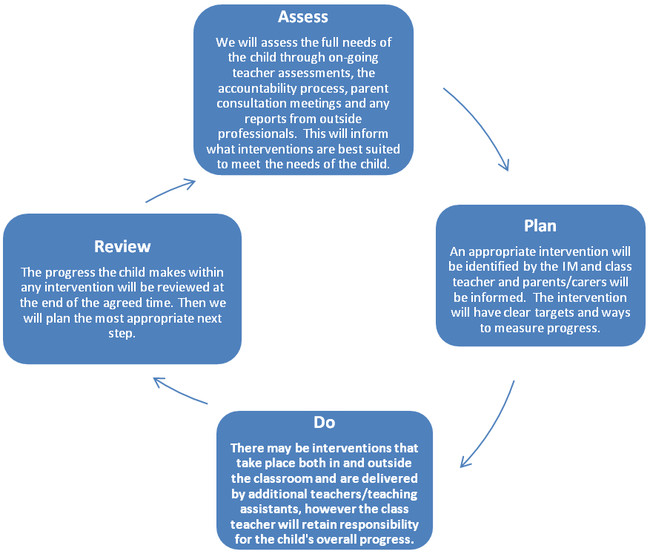

2. The kinds of interventions within this ‘graduated response’ are as follows:

- Universal – All pupils will benefit from:
- High quality learning through the provision of high quality teaching; both formal and informal.
- Formal learning and teaching that is differentiated to need and enables the vast majority of pupils to make good or better progress.
- On-going and timely assessments which inform any further provision needed.

Targeted Support – Some pupils may benefit from:
- Small-group intervention for pupils who may be expected to 'catch up' with their peers as a result of the intervention.
- Interventions where progress is monitored by the HT, DHT, Class teacher and the adult leading the intervention. If a pupil has not made the required progress then the appropriate referral will be made to outside professional support (see below).

Specialist Support – A few pupils may benefit:
- Specific targeted intervention for individuals. These pupils may have specific and/or exceptional needs that require the support from outside professionals. We will then incorporate appropriate advice and recommendations into any education plans for the pupil.

- Outside Agencies who help us achieve inclusive practice and meet specific needs

In achieving provision which will meet the wide range of pupils’ differing needs at Orrets Meadow, we are supported by a number of specialised health or educational bodies.

Those agencies most commonly involved in supporting pupils are:
- Health
- The Speech and Language Therapy Service to Schools (SALTs)
- The Occupational Health Therapy Service for Pupils (OTs)
- Child and Family mental health Consultation Service (CAMHS)
- The School Nursing Service
- Education
- The Educational Psychology Service (EPS)
- SENAAT

- Before making a referral

- Before making a referral to a specialised service the school consults with parents or carers. An exception to this practice occurs when the school has information which indicates that a pupil may be at risk of harm. In such circumstance we undertake our statutory duty by making a referral to the Children and Young People’s Services.
- The school then takes instruction from that team on how to proceed – whether to make a Child Protection referral and whether to inform parents/carers of that referral.

- English as an Additional Language

- Definition and Rationale.

- The term EAL (English as an Additional Language) is used to refer to pupils whose main language at home is other than English.
- EAL pupils, from complete beginners to those with considerable fluency, will have varying degrees of difficulty in accessing the full curriculum and in achieving their full potential. Research has shown that those new to English will acquire conversational fluency in two years, but will need a minimum of five years to achieve competence in academic English. Such pupils will need language support if they are to reach their full potential.
- Therefore our main aim is for all EAL pupils to become confident in speaking, listening, reading and writing to enable them to access the curriculum and communicate effectively with their peers and other adults.
- The provision of this support fulfils the requirements of the Race Relations Act of 1976 which seeks to promote Equality of Opportunity and to eliminate discrimination in the provision of education.

- Identification and Assessment

- Pupils who are EAL are identified upon starting the school. If it is clear that a pupil’s fluency levels are low then they will be assessed using the EAL Stages.
- This assessment will be done termly to record specific progress against EAL targets.

- Provision for EAL pupils

- EAL pupils on lower stages of English acquisition can be buddied with a more confident pupil who speaks the same language or with an English speaking pupil as appropriate.
- Classrooms are highly visualised environments – dual-language texts, labels and visual support within lessons.
- Speaking frames used within lessons to help English acquisition.

The teacher is responsible for:
- Monitoring EAL data and assessing progress within EAL Stages and other academic performance.
- Ensuring good EAL practices throughout the school.
- Ensuring appropriate resources are available for EAL pupils.
- Liaising and sharing monitoring with the Headteacher.

- Gifted, Able and Talented

- General Definitions

- Gifted pupils
Gifted refers to students who achieve, or have the ability to achieve, significantly above average in one or more of the National Curriculum subjects other than art, performing arts or physical education.
- Able pupils
‘Able pupils’ refers to students who achieve, or have the ability to achieve, above average in one or more of the National Curriculum subjects.
- Talented pupils
Talented refers to those students who achieve, or have the ability to achieve, significantly above average in art, performing arts, physical education or in areas requiring visio-spatial skills or practical abilities (these could include a range of non-traditional areas).

- Identification

- We use a range of strategies to identify more able and very able pupils. The identification process is on-going and begins when the pupil joins our school and involves staff, pupils, parents and carers.
- Data taken into account will include:
- Information from parents and carers
- Information from previous teachers or pre-school records
- Discussions with pupils
- Identification by staff using professional judgements, classwork and test and assessment results.
- Pupils gifted in English may be identified when they
- Demonstrate high levels of fluency and originality in their conversation.
- Use research skills effectively to synthesise information
- Enjoy reading and respond to a range of texts at an advanced level
- Use a wide vocabulary and enjoy working with words
- See issues from a range of perspectives
- Possess a creative and productive mind and use advanced skills when engaged in discussion
- Work confidently on objectives for year groups higher than their own
- Achieve levels in end of year tests above those expected for their year group.
- Pupils gifted in Mathematics may be identified when they
- Explore a range of strategies for solving a problem
- Are naturally curious when working with numbers and investigating problems
- See solutions quickly without needing to try a range of options
- Look beyond the question in order to hypothesise and explain
- Work flexibly and establish their own strategies
- Enjoy manipulating numbers in a variety of ways
- Work confidently on objectives for year groups higher than their own

- Pupils who are identified by the school as being, Gifted, Able or Talented are made known to subject leaders and opportunities offered to them to use their specialism in and out of school.

- Teaching, Learning Curriculum and Organisation

As appropriate, teachers will provide differentiated activities and a range of support and resources for gifted and talented pupils. A wide range of activities, clubs and interventions are facilitated at lunch time to meet, encourage and develop pupil’s progress.

Monitoring and Review

- The Head teacher and SLT will monitor the effectiveness of this policy on a regular basis. The Head teacher will report to the governing body on the effectiveness of the policy and, if necessary, makes recommendations for further improvements.

