**Governor Report - Summer 2024**

**Geography**

**Hannah Dunning**

**Achievements**

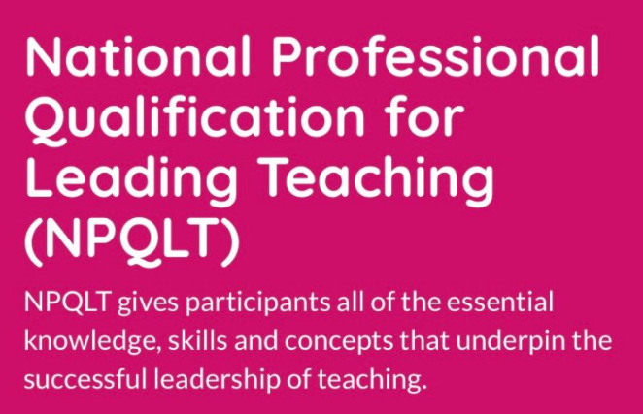Throughout the academic year, I have taken on the responsibility of leading Geography at Orrets Meadow with a sense of pride and dedication. As a newcomer to this role, I have made significant strides in understanding how Geography is currently taught at our school and have meticulously planned strategies to enhance the overall delivery of the subject.

To further support my role in subject leadership, I am also undertaking my NPQLT (National Professional Qualification for Leading Teaching). This has significantly contributed to my personal and professional development, equipping me with advanced skills and knowledge to effectively lead and improve our Geography curriculum.

By delving into the latest Ofsted findings, I have recognised the paramount importance of fieldwork in Geography education. Consequently, I have curated a tailored progression of skills in map-work and fieldwork that caters to the complex and evolving needs of our pupils. This structured approach ensures that our students engage meaningfully with geographical concepts and develop essential skills for lifelong learning.

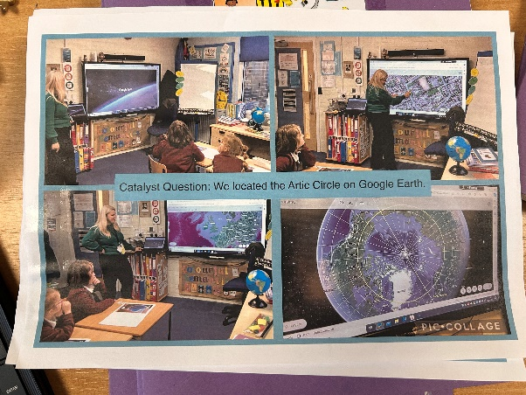Feedback from pupil surveys echoes the positive impact of our Geography curriculum, with students expressing enthusiasm for the subject. Their beautifully presented work and participation in a diverse range of activities provide tangible evidence of their engagement and progression in Geography.

During lesson observations, the implementation of multi-sensory and interactive teaching methodologies has proven to be particularly effective in captivating student interest and enhancing their learning experiences. By incorporating innovative approaches, Geography lessons at Orrets Meadow have become engaging and enriching opportunities for our pupils to explore the world around them.

Overall, the achievements in Geography throughout the school year reflect a commitment to excellence and a dedication to fostering a love for learning in our students through the dynamic and inclusive delivery of the subject. The skills and insights gained from my NPQLT have been instrumental in driving these improvements, ensuring that our Geography curriculum remains robust and inspiring.

**CPD**

* 19/10/2023 Geography Leadership meeting with Hayfield
* 22/11/2023 Geography online training (CLTA Training)
* 22/11/2023 Geography staff meeting
* 23/11/2023 Geography Subject Leader Briefing (SIL)
* 12/02/2024 Geography Subject Leader Briefing (SIL)
* 18/06/2024 Geography Fieldwork (CLTA Training)

**Quality of teaching and learning**

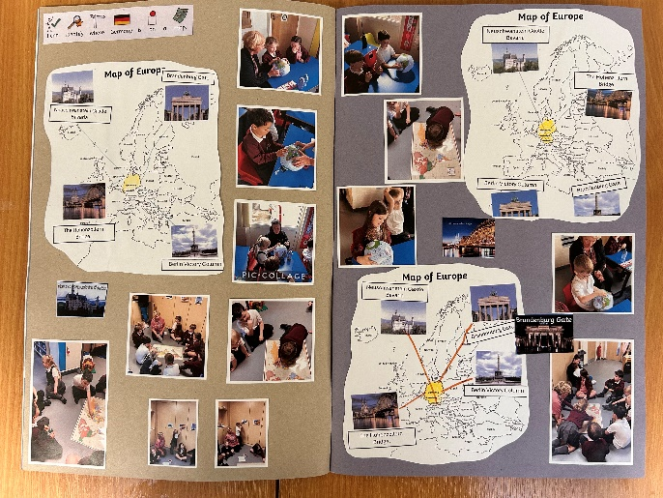As the Geography subject lead, I have aimed to instil pride in our subject and support teaching staff in enhancing their subject knowledge. We have completed a range of monitoring activities this year, and the subject leader file has been meticulously maintained, ensuring all important documents are available and up to date.

I conducted several learning walks over the year, observing a variety of lessons. Teachers demonstrated excellent quality of teaching, adapting their methods to meet the diverse needs of our students. This observation process has been instrumental in identifying and sharing best practices, further strengthening our teaching staff's confidence and expertise in Geography.

In the spring term, a book scrutiny was carried out to monitor the standards of Geography teaching and the progress students are making. The beautifully presented books showcased evidence of progress across all classes, from Wolves Class to Sharks Class, reflecting a well-structured and comprehensive curriculum.

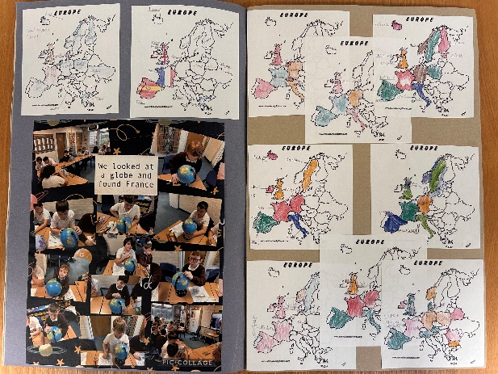A pupil and staff survey was conducted in the spring term to assess the enjoyment of Geography. Findings showed that both staff and pupils prefer Geography being taught through immersive, multi-sensory experiences rather than traditional written work. This approach has been effective in helping students retain learning and sticky knowledge.

Finally, a data analysis of progress made by different groups was carried out, showing consistent progression across the school. This will be closely monitored next year to ensure continued improvement in our Geography curriculum.

Overall, our achievements in Geography this year reflect a commitment to excellence and a dedication to fostering a love for learning in our students. By supporting our teaching staff and maintaining a high standard of subject knowledge, we ensure that Geography at Orrets Meadow remains engaging, dynamic, and inspiring for all.

**Strengths**

The Geography curriculum at Orrets Meadow is distinguished by its comprehensive approach, leveraging engaging multimedia resources and tailored assessments to cultivate students' geographical literacy and analytical expertise. Outlined below are the pivotal strengths inherent in our Geography curriculum for the academic year 2023/2024:

• Engages multiple senses to enhance learning experiences

• Facilitates sequential learning, building upon concepts progressively

• Establishes purposeful connections between different geographical topics

• Showcases the diverse geographical features and phenomena of the Wirral region through "Wonders of Wirral"

• Embraces inclusivity to accommodate the diverse learning needs of all students

• Promotes active participation and hands-on experiences to deepen understanding

**Ways forward**

In charting the future trajectory of the Geography curriculum at Orrets Meadow, we explore innovative pathways that integrate interdisciplinary perspectives, experiential learning, and digital technologies to foster a deeper understanding of global phenomena and local landscapes. Outlined below are the innovative pathways guiding the evolution of our Geography curriculum for the academic year 2024/2025:

• Expand fieldwork opportunities to immerse students in practical learning experiences

• Enhance map-work skills by presenting a diverse array of cartographic techniques

• Integrate real-world scenarios to provide context for understanding geographical concepts

• Incorporate hands-on projects to deepen students' spatial awareness and problem-solving abilities

• Utilise digital mapping tools to explore geospatial data and its applications

**Targets 2024-2025**

• Develop a structured progression plan for Geography curriculum implementation at steps level (Autumn 2024).

• Implement a dedicated "Geographical Skills Morning" to hone students' fieldwork, map-work, spatial awareness and analytical abilities (Spring 2025).

• Organise Geography-sponsored walks for each class, focusing on orienteering in the local area throughout the academic year, with proceeds contributing towards school trips (Summer 2025).

