
Orrets Meadow School

Design and Technology Policy

“To raise the aspirations of every child and give them confidence to fulfil their potential through positive experiences”

Orrets Meadow Curriculum Aims and Values
Aims
To ensure all our children are at the centre of a broad, varied and interesting learning experience that is enjoyable and relevant for the future. Our creative, multisensory curriculum will create a sense of awe and wonder and help to inspire a lifelong love of learning. The holistic nature of our practice will promote positive mental health and well-being and will enhance our children’s life skills, social skills and cultural awareness.
Values
Our curriculum will promote a range of values including:
- Respect
- Empathy
- Responsibility
- Equality
- Independence
- Happiness
- Resilience
- Gratitude
- Honesty
- Friendship
Intent
National Curriculum – Design and Technology
Purpose of study
Design and technology is an inspiring, rigorous and practical subject. Using creativity and imagination, pupils design and make products that solve real and relevant problems within a variety of contexts, considering their own and others’ needs, wants and values. They acquire a broad range of subject knowledge and draw on disciplines such as mathematics, science, engineering, computing and art. Pupils learn how to take risks, becoming resourceful, innovative, enterprising and capable citizens. Through the evaluation of past and present design and technology, they develop a critical understanding of its impact on daily life and the wider world. High-quality design and technology education makes an essential contribution to the creativity, culture, wealth and well-being of the nation.
Aims
The national curriculum for design and technology aims to ensure that all pupils:
- develop the creative, technical and practical expertise needed to perform everyday tasks confidently and to participate successfully in an increasingly technological world
- build and apply a repertoire of knowledge, understanding and skills in order to design and make high-quality prototypes and products for a wide range of users
- critique, evaluate and test their ideas and products and the work of others
- understand and apply the principles of nutrition and learn how to cook.
Orrets Meadow’s Curriculum
We teach a Global Curriculum called 'Learning means the World' (LMTW)for all our afternoon subjects. This curriculum is innovative, forward-thinking and highly relevant to our pupils' needs and thoroughly engages them as they tackle challenging and inspiring topics and issues.
LMTW curriculum has been written with world issues in mind and is centred on 4Cs:-
- Communication
History helps pupils gain a coherent knowledge and understanding of their country’s past and that of the wider world.

- Conflict
- Conservation
- Culture
Why did we choose 'Learning Means the World'?
As a school which is majority white British, we want our pupils to fully embrace cultural diversity, learning about, experiencing and celebrating a range of different cultural and faith heritages.
We believe that communication is key to accessing learning and securing pupils’ future success. As many of our pupils have Speech Language Communication Needs it is essential that opportunities are given to develop language for learning across the curriculum. With one of its 4 foci being on communication, this curriculum provides lots of opportunities for pupils to develop expressing themselves in discussion, debate and presentation, as well as enabling them to collaborate and exchange ideas.
We feel our pupils, as the future generation, need a greater awareness and appreciation of local, national and global conservation issues and initiatives. The need to learn that they have an important role to play in sustainability. This curriculum gives pupils opportunities to grow and develop spiritually, emotionally, physically and socially in the natural world around them. Our commitment to nurturing positive attitudes and values and developing life and social skills is promoted throughout the Learning Means The World (LMTW) curriculum.
It is theme based and broken down into the following phases:
- Explorers (Foundation level)
- Pathfinders (KS1 level)
- Adventurers (Lower KS2 level)
We have the freedom to teach the National Curriculum in line with our pupils' specific needs and believe that our whole curriculum meets the values and aims which our stakeholders requested at the start of the consultation.
SMSC

An important aspect of our curriculum at Orrets Meadow is the incorporation of all things SMSC. All staff in all subjects take any and every opportunity to humanise and contextualise aspects and issues of social, moral and other intrinsic events or concepts, be they past, present or potentially pending. We see the promotion of discussion and debate as a healthy part of life in school.

Design Technology gives pupils the opportunity to develop skills, knowledge and understanding of
designing and making
functional products.

Why is Design and Technology important?
Design Technology helps us to develop as reflective learners, as we work through the design process.

Through design technology, we are able to work collaboratively to solve problems and find solutions, teaching us to deal with uncertainty whilst developing communication, organisational and other practical life skills.

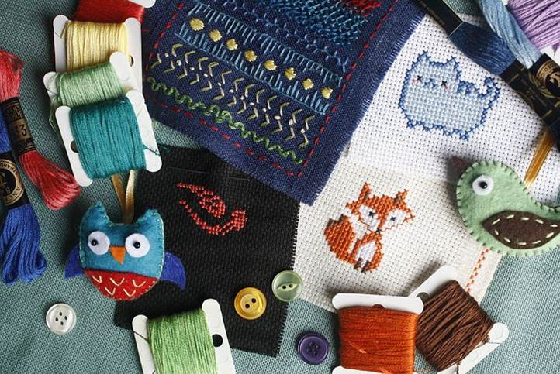
In design technology, we learn to appreciate the needs of others, the built environment and the likely impact of future technologies.

Pupils develop their
communication skills
through design technology, when they are sharing ideas and
explaining their thinking.
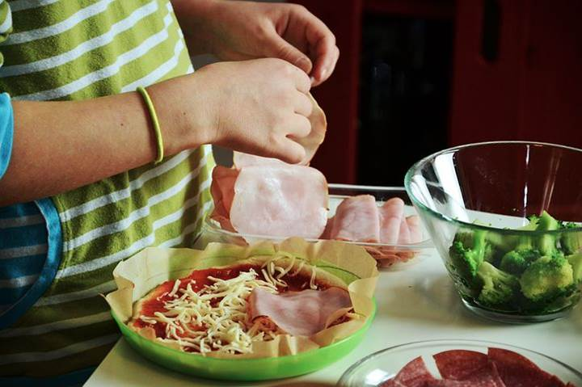

Design Technology teaches pupils to understand and apply the principles of nutrition and learn how to cook.

Implementation
Access to the Curriculum
Pupils at Orrets Meadow have a wide range of special needs, including ASD, SpLD, ADHD and SEMH. The majority of pupils are working at least two years behind their chronological age, some three or four years. The curriculum is therefore adapted to meet the stage the child is working at. Skills and knowledge are taught using strategies which help them learn effectively. Multi-sensory, over learning techniques are used to support pupils with their short- and long-term memory difficulties. Enrichment activities are used to bring the topics to life and make the learning more memorable.

When is Design Technology taught?
Design Technology is taught discreetly through thematic Dimensions units. The attached overview maps out which thematic units feature this subject. Focused tasks such as Mechanisms, Structures, Textiles and Cooking and Nutrition are planned in across each phase and taught during three whole school Design and Technology Days over the school year. The Long-Term Plan shows the skills taught through the Dimensions Curriculum.

How is Design Technology taught?

Design Technology is taught through a combination of subject knowledge, skill building and design and make projects. Food technology is taught through Life Skills, our 3D PSHE programme and through focused projects taught during the Cooking and Nutrition day. Learning takes place both inside and outside the classroom.

Pupils at Orrets Meadow have ASD and additional needs, so consideration needs to be given to how we teach DT. Many of our pupils have fine motor skills and sensory overload difficulties, so support is offered to these children to enable them to achieve. All of our pupils are working at least two years behind their chronological age and so the curriculum is adapted to meet the stage they are working at and strategies are used to best meet their needs.

What do we learn in Design Technology?

Through a variety of creative and practical activities, pupils are taught the knowledge, understanding and skills needed to engage in the process of designing, making, evaluating and gaining Technical Knowledge.

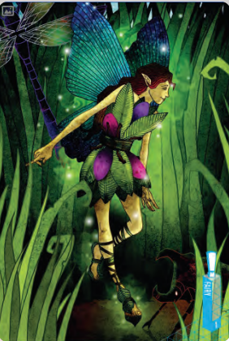
We complete design technology projects in each phase for specified clients in exciting contexts that do reflect real life situations. E.g. Designing a bag that is suitable for a Fairy to carry her things. A remote control for a one handed Pirate. A communication device for an Neurodiverse Evil Genius and a toy for a Tribal Child.
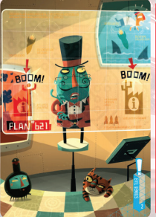
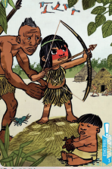
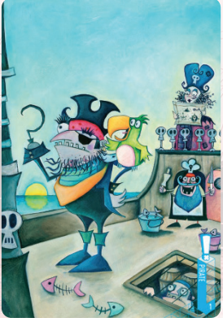

Design and Technology Topic Overview

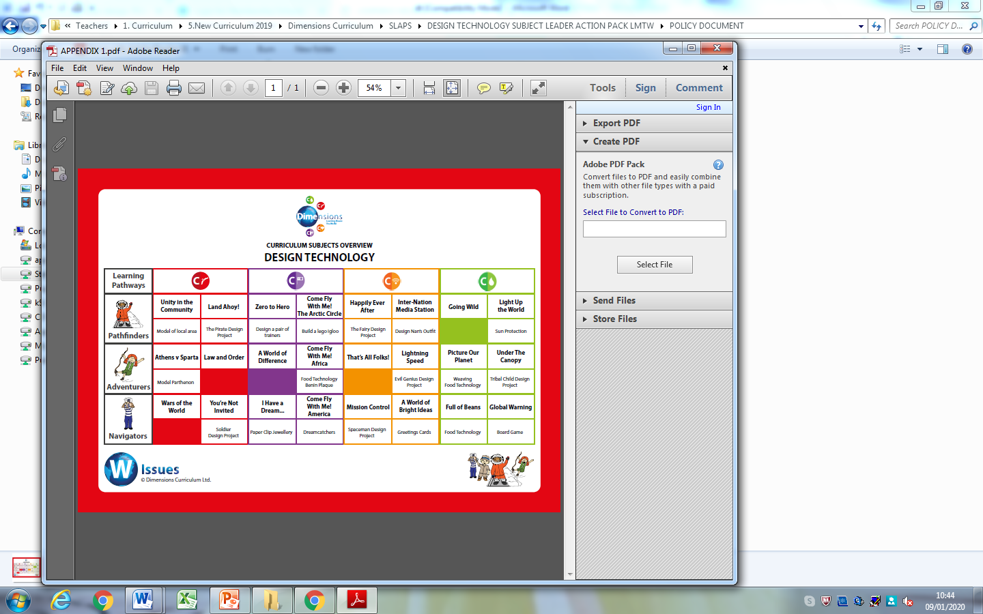


Design Technology helps children to problem-solve, making on-going changes and improvements during the design and make process.

Design Technology
teaches pupils how to
participate successfully in an increasingly
technological world.



Design and Technology knowledge builder across the school
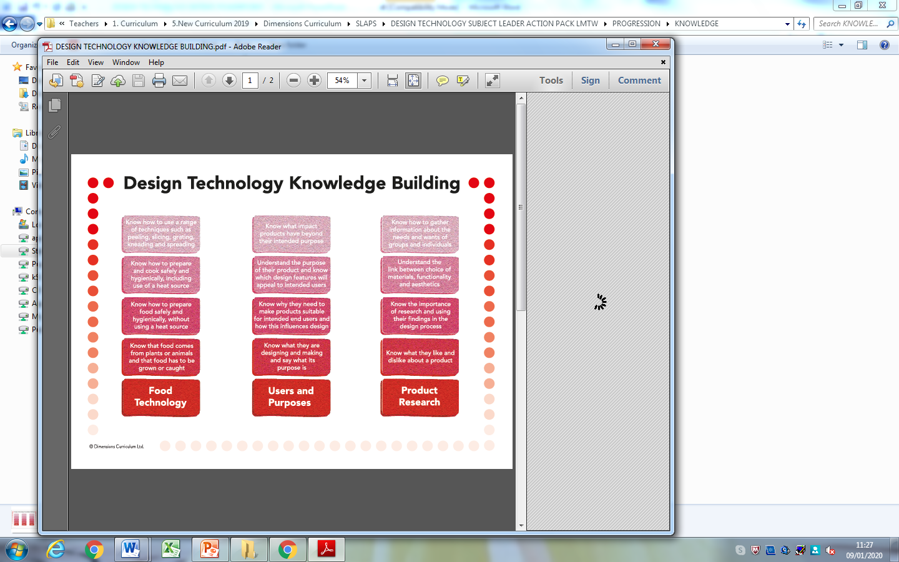

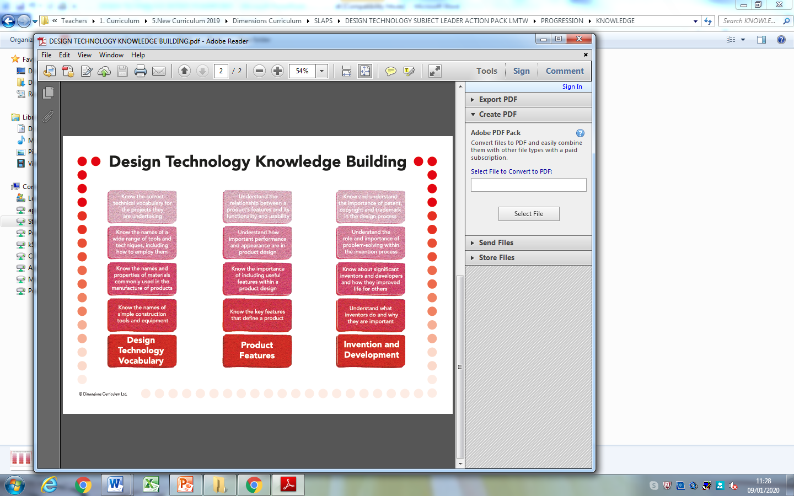

Long term plan – Progression of skills

Pre National Curriculum
Ages and Stages | Steps
 | Creating with Materials | Being Imaginative and Expressive
Birth to three  • Start to develop pretend play, pretending that one object represents another. For example, a child holds a wooden block to her ear and pretends it’s a phone.  • Explore different materials, using all their senses to investigate them. Manipulate and play with different materials.  • Use their imagination as they consider what they can do with different materials.  • Make simple models which express their ideas.  Three to four  Take part in simple pretend play, using an object to represent something else even though they are not similar.  • Make imaginative and complex ‘small worlds’ with blocks and construction kits, such as a city with different buildings and a park.  • Explore different materials freely, to develop their ideas about how to use them and what to make.  • Develop their own ideas and then decide which materials to use to express them.  • Join different materials and explore different textures.  Children in Reception  Explore, use and refine a variety of artistic effects to express their ideas and feelings.  • Return to and build on their previous learning, refining ideas and developing their ability to represent them.  • Create collaboratively, sharing ideas, resources and skills.  Early Learning Goal  • Safely use and explore a variety of materials, tools and techniques, experimenting with colour, design, texture, form and function.  • Share their creations, explaining the process they have used.  • Make use of props and materials when role playing characters in narratives and stories. | Step 2  - Experiments with a range of media – tools, materials, sound and whole body movement -- through multi-sensory exploration.  Step 3  - Continues to explore and experiment with an increasing range of media and movement through multi-sensory exploration and expression.  - Notices and becomes interested in the transformative effect of their action on materials and resources.  Step 4  - Uses 3D and 2D structures to explore materials and/or to express ideas  Step 5  - Uses various construction materials, e.g. joining pieces, stacking vertically and horizontally, balancing, making enclosures and creating spaces.  - Uses tools for a purpose.  Step 6  - Uses their increasing knowledge and understanding of tools and materials to explore their interests and enquiries and develop their thinking.  - Develops their own ideas through experimentation with diverse materials, e.g. light, projected image, loose parts, watercolours, powder paint, to express and communicate their discoveries and understanding.  Step 7  Children at the expected level of development will: -  - Safely use and explore a variety of materials, tools and techniques, experimenting with colour, design, texture, form and function.  - Share their creations, explaining the process they have used.  - Make use of props and materials when role playing characters in narratives and stories. | Step 2  - Responds to and engages with the world that  surrounds them, e.g.  sounds, movement,  people, objects,  sensations, emotions  (her own and others).  Step 3  - Pretends that one object represents another,  especially when  objects have  characteristics in  common.  Step 4  - Uses everyday materials to explore, understand  and represent their  world – their ideas,  interests and  fascinations.  Step 5.  - Notices what other children and adults do,  mirroring what is  observed, adding  variations and then  doing it spontaneously.  - Engages in imaginative play based on own ideas or first-hand or peer  experiences.  - Uses available resources to create props or creates imaginary ones to  support play.  - Plays alongside other children who are engaged in the same theme.  Step 6  - Creates representations of both imaginary and  real-life ideas,  events, people and  objects.  - Uses combinations of art forms, e.g. moving and  singing, making and  dramatic play,  drawing and talking,  constructing and  mapping.  - Plays cooperatively as part of a group to create,  develop and act out  an imaginary idea or  narrative.
Year 1 to 6
Year Group | Investigation | Observation | Application
1 | Dt 1 Explore the sensory qualities of materials  Dt 2 Explore ways to construct models | Dt3 Identify a target group for what they intend to design and make  Dt4 Recognise how structures can be made stronger, stiffer and more stable | Dt5 Generate and talk about their own ideas Dt6 Follow safe procedures Dt7 Take account of simple properties of materials when deciding how to cut, shape and join them Dt8 Use tools and materials with help
2 | Dt 9 Explore a range of existing products  Dt 10 Discover where foods come from in choosing, preparing and tasting different dishes | Dt11 Identify a purpose for what they intend to design and make  Dt12 Identify simple design criteria then plan what to do next, using a variety of methods.  Dt13 Observe and take account of properties of materials when deciding how to cut, shape, combine and join them  Dt14 Identify what they could have done differently or how they could improve their work in the future | Dt15 Evaluate a range of existing products Dt16 Communicate their ideas using a variety of methods e.g. drawing, making mock-ups, ICT  Dt17 Measure, mark, cut out and shape a range of materials Dt18 Use mechanisms in their products e.g wheels, sliders Dt19 Use simple finishing techniques Dt20 Talk about their ideas, saying what they like and dislike, and evaluate against their design criteria.
3 | Dt21 Generate, develop and explain ideas for products to meet a range of needs.  Dt22 Explore ways of meeting design challenges with a food focus using a range of techniques | Dt23 Identify a purpose and establish criteria for a successful product  Dt24 Evaluate work, adapting and improving where appropriate | Dt 25 Communicate design ideas in different ways e.g. discussion, annotated sketches, cross-sectional diagrams and prototypes Dt26 Selecting appropriate tools and techniques, name and describe them Dt27 Measure, mark, cut-out and shape a range of materials and assemble, join and combine components and materials with some accuracy
4 | Dt28 Use research to inform their design  Dt29 Explore ways of meeting design challenges with a textile focus. | Dt30 Evaluate work, adapting and improving through the views of others to improve their work | Dt31 Communicate design ideas in different ways e.g. discussion annotated sketches, cross-sectional diagrams and prototypes Dt32Select from and use a range of materials and components, including construction materials, textiles and ingredients according to their functional properties and aesthetic qualities Dt33 Join and combine materials and components accurately in temporary and permanent ways  Dt34 Measure, mark, cut-out and shape a range of materials with increasing accuracy
5 | Dt35 Investigate ways of meeting design challenges with a construction focus  Dt36 Investigate how the work of individuals in design and technology has helped to shape the world | Dt37 Identify users’ views and take these into account  Dt38 Analyse a range of existing products  Dt39 Estimate and measure using appropriate instruments and units | Dt40 Plan what they have to do, include how to use materials, equipment and processes  Dt41 Communicate design ideas in different ways e.g. discussion, annotated sketches, cross sectional and exploded diagrams, prototypes pattern pieces and CAD Dt42 Apply knowledge of mechanical and electrical control when designing and making functional products Dt43 Refine sequences of instructions to control events or make things happen
6 | Dt44 Explore alternative ways of making their products, if first attempts fail | Dt45 Check work as it develops and modify as necessary  Dt46 Evaluate their products, identifying strengths and areas for development, and make appropriate changes | Dt 47 Draw on and use various sources of information, including ICT sources Dt48 Generate and clarify ideas for products, considering intended purpose Dt49 Plan what they have to do, suggesting a sequence of actions and alternatives if needed  Dt50 Choose how to communicate design ideas as they develop, considering use and purpose  Dt51 Select from a wide range of tools and equipment to perform practical tasks accurately

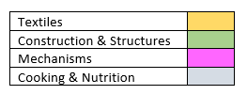
Orrets Meadow DT Long Term Plan 2023-24

 | Dimensions Extraordinaire Projects | Focus Day 1 | Focus Day 2 | Focus Day 3  Cooking & Nutrition
Explorers | Demonstrating ‘Creating with materials and Being imaginative and expressive’ where appropriate in Topics. | Fabric Faces | Design and make a magnetic fishing game | Sandwich Station
Pathfinders A | Textiles –  Happily Ever After  The Fairy Bag Design Project | Structures  Design, make and test a shelter | Mechanisms, pulleys and simple knobs  Rapunzel’s tower | Dips & Dippers
Pathfinders B | Construction –  Land Ahoy  Pirate remote control model | Textiles  Design, make and evaluate a puppet | Mechanisms, sliders and levers  Design, make and evaluate a picture with a moving part. | Sensational Salads
Adventurers A | Construction –  Lightning Speed  Evil Genius  Communication device using lights. | Levers and linkages  Design, make and evaluate a celebration card that includes a mechanical system | Textiles  Design, make and evaluate a soft toy to be sold at Chester Zoo | Edible Garden
Adventurers B | Textiles –  Under the Canopy  Tribal Child’s Toy | Structures  Design, make and evaluate Kites | Levers and linkages  Design, make and evaluate a ‘picker upper’ to be sold in the Natural History Museum | Seasonal Food

Impact

How do we assess and monitor DT

Using a simple decimal grading system for our assessment allows staff to record even the smallest steps of progress by our pupils. The first digit in the given number represents the year group that a child is working at and the second is the level at how they are achieving within that given grouping. Teachers can quickly identify where a given student is and how this related to their peerage in each class. This method of assessment is used twice yearly in March and July. It is recorded in the Foundation subject tracker where DT attainment can be assessed and analysed by SLT, subject leaders and teachers.

As many of our pupils have short term memory difficulties, they find retaining knowledge especially difficult, so we use Kahoot quizzes throughout the units to support them remember ‘Sticky Knowledge’. These quizzes make learning fun, engaging and impactful. Teachers can use the readymade quizzes created by Dimensions for each unit or they can create their own to introduce the topic, review and reinforce knowledge and use the information gained to help them identify which objectives have been achieved in Design and Technology.

SLT, teachers and subject leaders use assessment for learning to inform planning, teaching and learning and CPD opportunities.

SLT and subject leaders are continuously monitoring their subject to ensure it meets the needs of our pupils. They monitor using a variety of activities, including:

- Learning walks
- Book scrutiny
- Lesson observations
- Pupil survey and discussions
- Staff survey and discussions

We are excited to teach our Learning Means the World curriculum and know it will positively impact on our pupils’ academic and whole well-being.

