**

**Governors Report – Summer 2024**

***RE***

***Subject leader: Jane Gordon***

***Achievements***

In reflecting on the achievements over the past year, it is essential to acknowledge the concerted efforts made towards implementing the priorities outlined in the school development plan. The 'ways forward' identified in the previous year have been diligently pursued and translated into concrete actions to enhance the quality of education provided.

To review the Long-Term plan in line with the new schemes of work introduced by the Wirral LTRE HUB, significant emphasis has been placed on aligning our curriculum with the latest directives to ensure relevance and efficacy. The Orrets Progression of skills has undergone thorough scrutiny and adjustment in accordance with the updated Wirral schemes of work, aiming to facilitate seamless transitions in learning and progression for our students.

Furthermore, the RE Policy has been meticulously updated to accurately mirror the alterations in the Wirral RE scheme of work, guaranteeing that our religious education curriculum remains contemporary and comprehensive. A new long-term plan has been meticulously crafted, tailored to incorporate the revised Wirral schemes of work, thoughtfully adapted to cater to the diverse needs of our pupils.

The introduction of a new range of schemes of work has prompted the formulation of a refined progression of skills for RE, conscientiously considering and adjusting the delivery of knowledge and skills to cater to the specific demands of our children with SEND. The updated RE policy stands as a testament to our commitment to staying abreast of educational best practices whilst maintaining alignment with local directives.

These enhancements reflect our unwavering dedication to continuous improvement and the provision of a high-quality educational experience for all our students. The resolute efforts taken embody our collective vision for sustained academic excellence and holistic development within our school community.

***CPD***

As a subject leader I place a high value on continued professional development and collaboration with local subject leaders. Being a member of the Wirral LTLRE HUB has provided me with an excellent opportunity to connect with like-minded RE professionals, sharing innovative ideas and best practices.

Participating in the regular Zoom training meetings organised by Wirral LTLRE HUB and at Thingwall Primary School has enriched my teaching practices. I have utilised these sessions to guide teaching staff towards relevant courses that align with the six faiths emphasised by the Wirral SACRE. Additionally, our staff meetings have not only focused on promoting sensory teaching strategies but have also emphasised the implementation of new schemes of work, long-term planning, and the progression of knowledge and skills.

Furthermore, I have leveraged the wealth of knowledge acquired through visits from external visitors and trips to places of worship representing various faiths. Such experiences have provided valuable insights for teaching staff, allowing them to gain a deeper understanding of the daily lives and practices of individuals from Jewish, Buddhist, and Muslim backgrounds.

By actively engaging in professional development opportunities and fostering collaborations with local networks, I strive to enhance the quality of education provided to my students and create a more inclusive learning environment.

***Quality of Teaching and Learning***

As the subject leader for Religious Education in our school, I have been proactive in ensuring the maintenance of exceptional teaching and learning standards throughout the year. Through a variety of monitoring activities, I have overseen the quality of instruction and student progress in RE.

During Religion Week, a comprehensive Learning Walk allowed me to witness exemplary instances of Cultural Capital and enrichment activities. These included engaging exercises such as food tasting, role play scenarios, arts and crafts projects, and collaborative book sharing sessions. Particularly noteworthy was a class excursion to the local Buddhist Centre in Liverpool, which enriched students' understanding of different faiths first hand.

In addition to these observations, diligent book scrutinies, data analyses, and comprehensive surveys involving both pupils and staff were conducted and meticulously reviewed. These evaluations have provided valuable insights to further enhance the quality of teaching and learning practices within the classroom.

Overall, the outcomes from the monitoring activities carried out under my leadership indicate that our school continues to uphold a standard of excellence in RE education. The dedication of our staff, the enthusiasm of our students, and the support of our governors have collectively contributed to creating an environment conducive to optimal teaching and learning experiences in Religious Education.

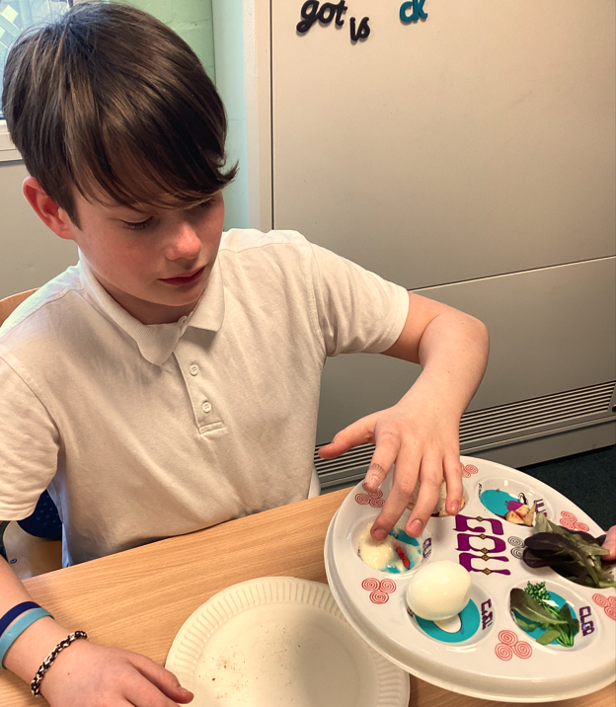 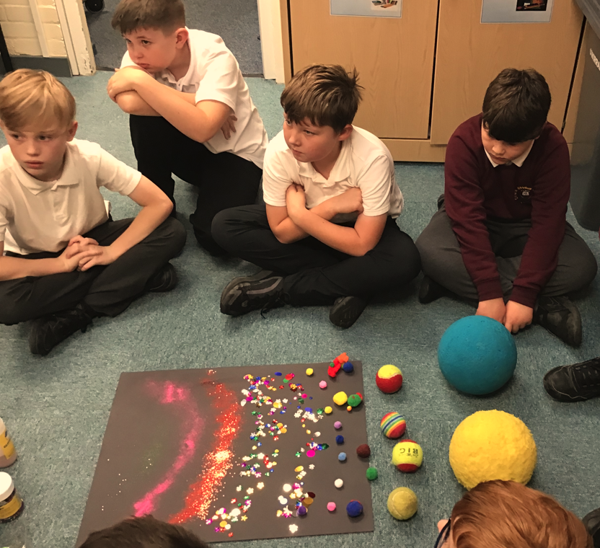

**What were the strengths in your subject you found this year from all your moderation activities?**

In reflecting on this academic year's moderation activities within the realm of Religious Education, several key strengths have emerged. Firstly, there has been a noticeable increase in the level of confidence and enjoyment among teachers in delivering RE lessons. This has been attributed to ongoing professional development opportunities and collaborative planning sessions.

Secondly, Religion Week was a resounding success. It provided a platform for students to engage deeply with various faith traditions, promoting mutual respect and understanding within the school community.

The engagement of Rector Ron in our school assemblies for Christian celebrations significantly enriched the students' religious experiences. These interactions not only enhanced their understanding of Christian beliefs but also fostered a sense of inclusivity and community spirit.

Furthermore, the comprehensive coverage of Christmas and Easter festivities proved to be engaging and meaningful for our students, enabling them to delve into the historical and cultural significance of these Christian celebrations.

The integration of multisensory and creative teaching strategies has been instrumental in making RE lessons more interactive and memorable for students. These approaches have catered to diverse learning styles, ensuring that every student can effectively engage with the curriculum.

Lastly, the implementation of class floor books to record learning has facilitated student reflection and assessment of their own progress within the subject. This innovative tool has promoted a sense of ownership and pride in their learning journey, contributing to overall academic success.

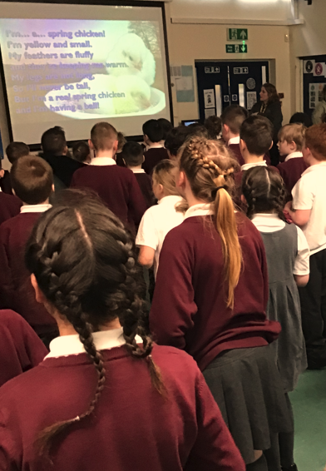 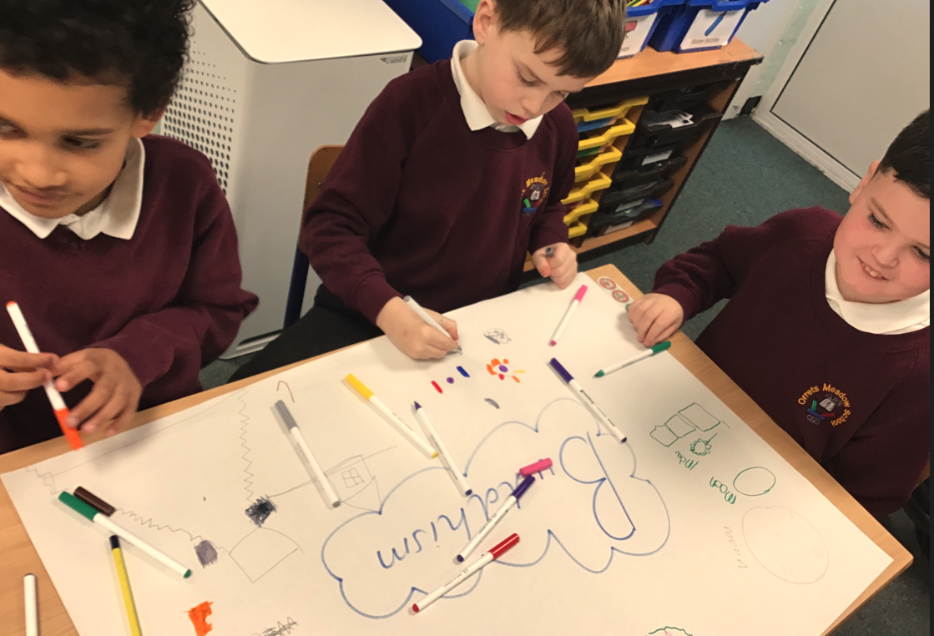

**Ways forward**

* Monitor And support the implementation of the new schemes of work – Sept - July
* Audit and purchase the new schemes of work Spring Term 2
* Review and create Steps levels for RE Autumn Term 2
* Implement new schemes of work for Explorers A/B - when they become available