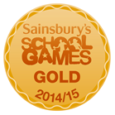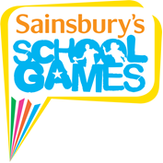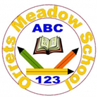

**World Cup Tag Rugby Festival**

On the 17th of September 2015 Orrets Meadow took part in Tag Rugby festival in celebration of the forthcoming Rugby World Cup. A selection of year 5 and 6 pupils were selected to compete in the competition. The festival was held at New Brighton Rugby Club and organised by the RFU and Clare Mount Specialist Sports College.

Each school entering the competition was given a country to represent. Orrets Meadow were representing Fiji! At the beginning of the festival there was an opening cermeony which allowed the pupils to proudly fly the flag of the country they were representing. Following this, every team took part in a mass Haka.

Orrets Meadow played 4 matches, winning 2 and narrowly missing out of victories in their other 2 games. This then placed us in the playoffs for a possible 3rd or 4th finish. The pupils rallied together and after an exceptional performance full of quick running and accurate passing they won the game, finishing in a very respectable 3rd place.

Congratulations to all the pupils and staff involved for this achievement.

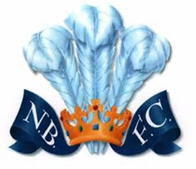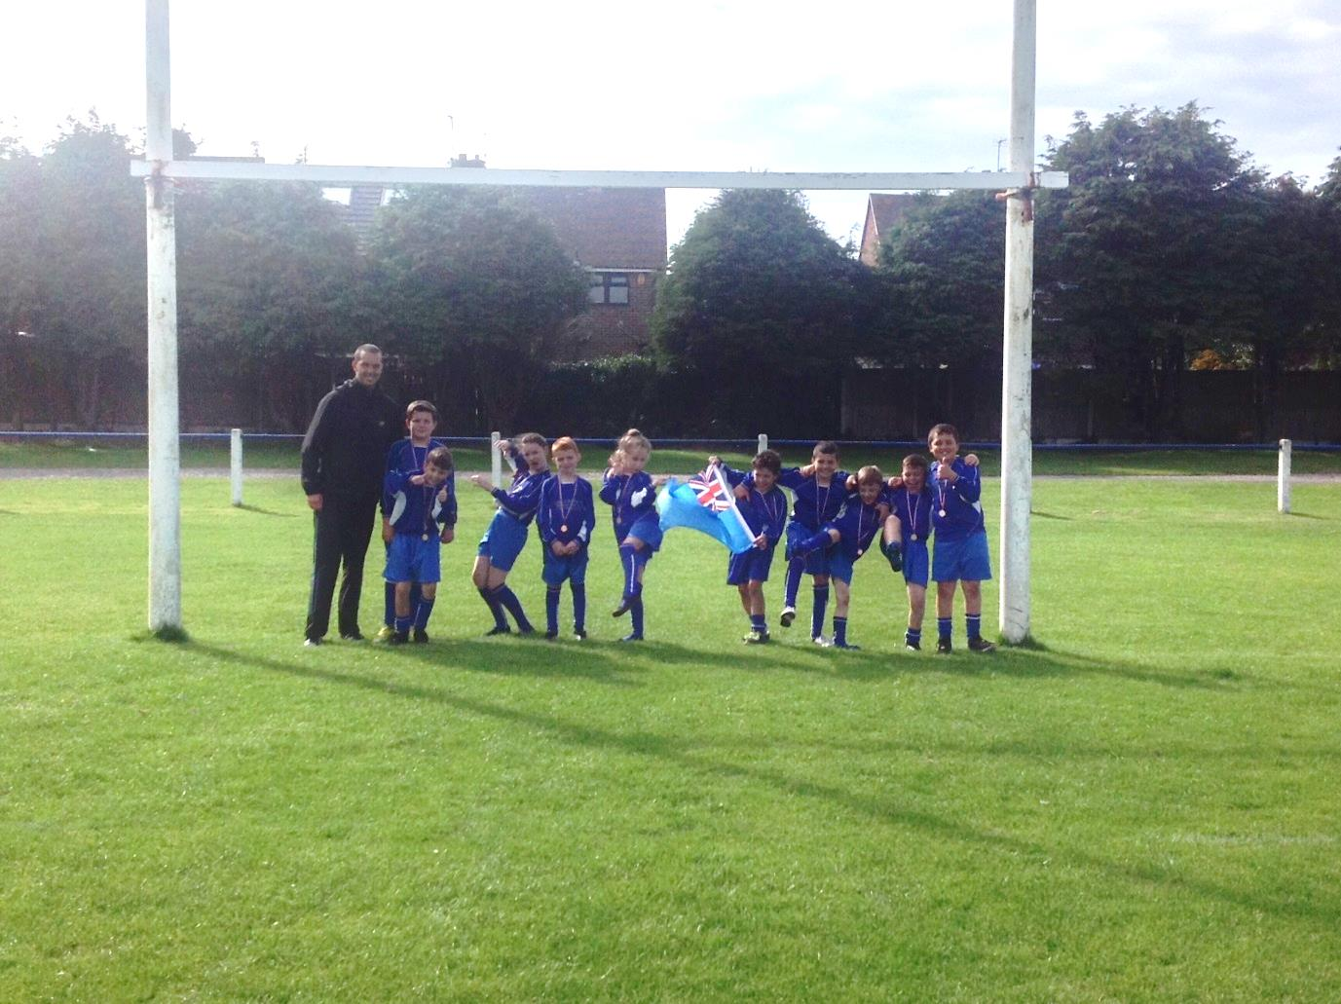

All the pupils represented the school excellently and followed the RFU’s philosophy of Teamwork, Respect, Enjoyment, Discipline and Sportsmanship.

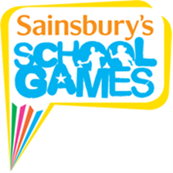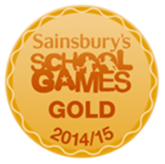

**Barnstondale**

Classes 3, 6 and 7 went to Barnstondale in September to get involved in all the exciting outdoor adventurous activities it has to offer. Pupils enjoyed activities such as: abseiling, climbing, archery and a variety of team-building activities.

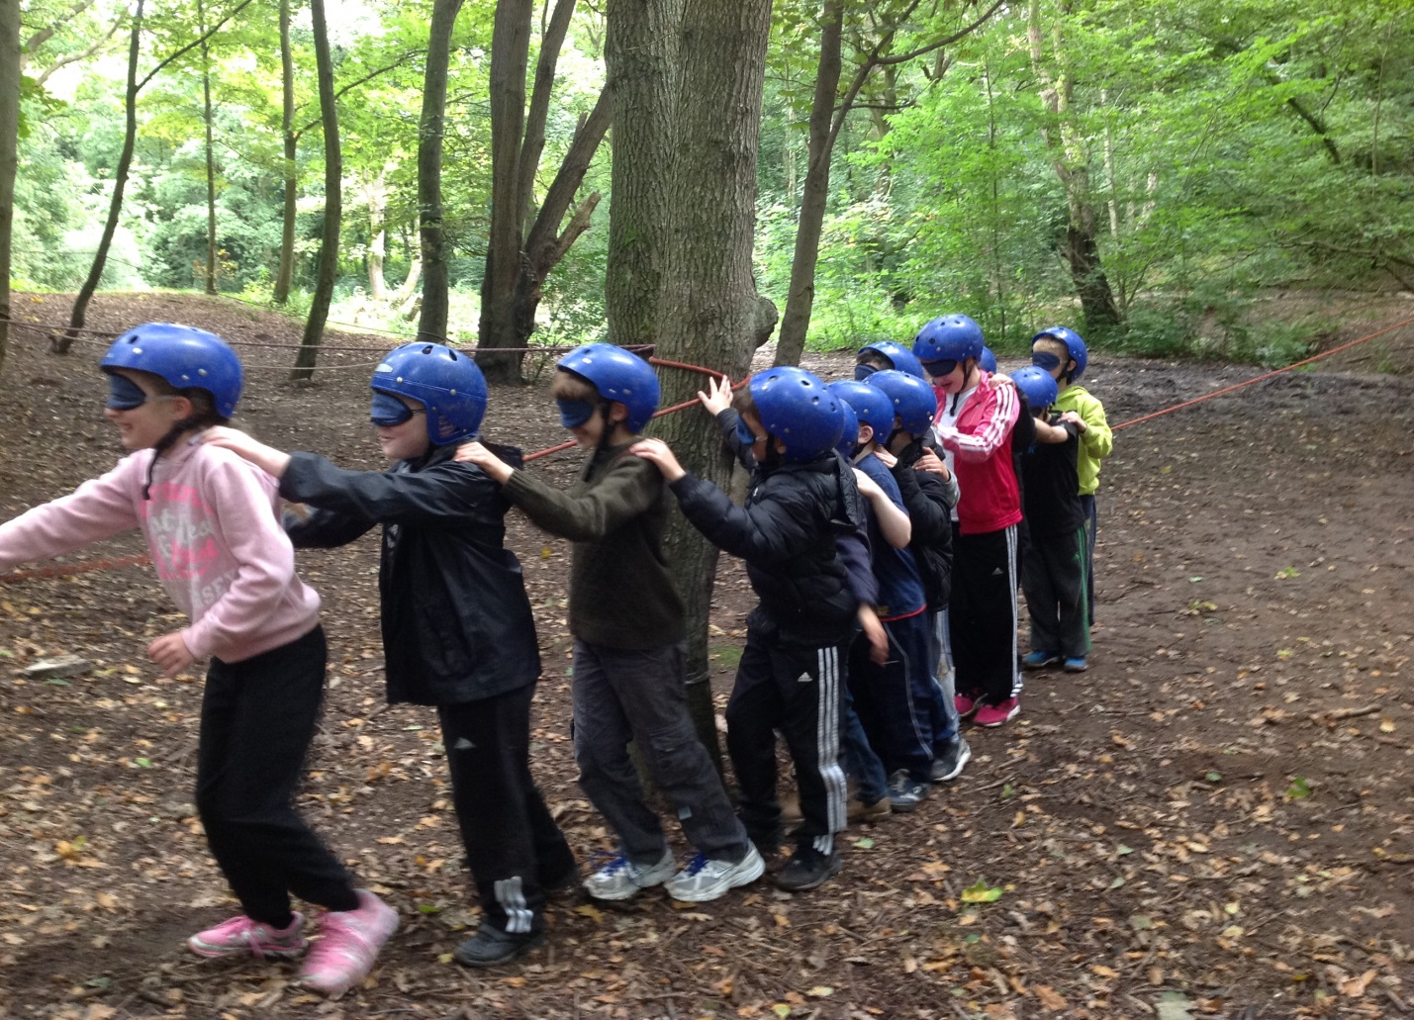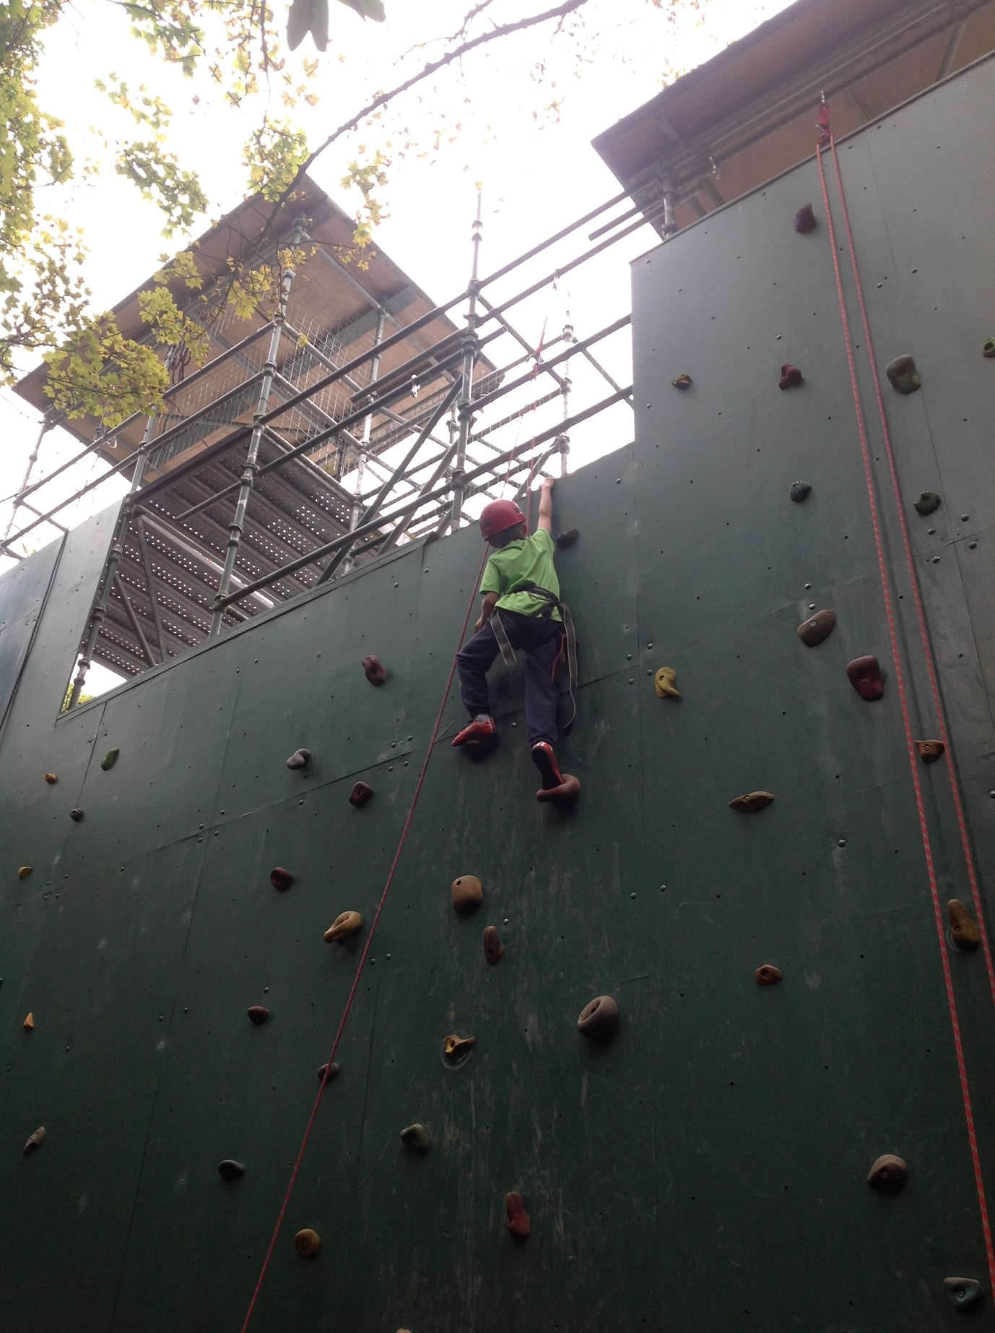The year 6 pupils thoroughly enjoyed the experience and look forward to the 3-day residential trip in May.

