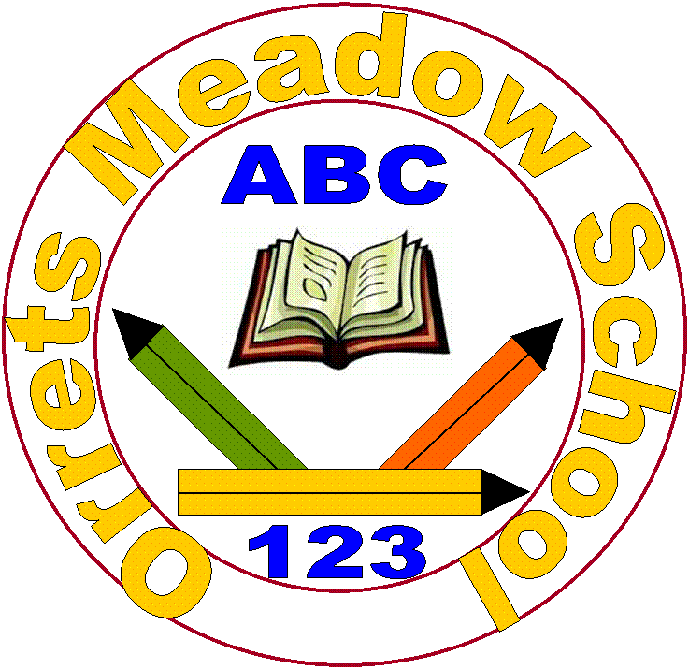
Orrets Meadow School
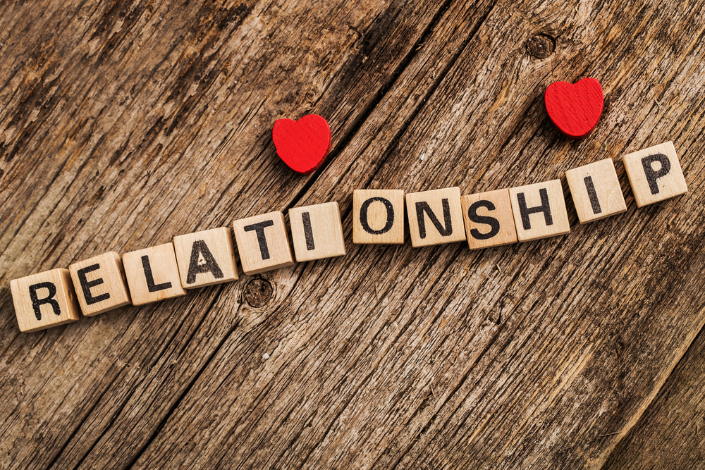
Relationships Sex Education Policy

“To raise the aspirations of every child and give them confidence to fulfil their potential through positive experiences”

Content

- School Setting
- Policy Development
- Definition of RSE
- School and curriculum values
- SMSC
- Aims and Objectives of Policy
- Equal Opportunities Statement
- Delivery of RSE
- RSE Curriculum (Dimensions Curriculum)
- Relationships and Sex Education
- Why do we teach Sex Education?
- Other specific issues within RSE including withdrawal
- Roles and Responsibilities
- Monitoring arrangements
- Review of Policy

School Setting
Orrets Meadow School is a maintained special school for pupils between five and eleven years old who have social communication difficulties and or specific learning difficulties. The school has approximately 70 pupils, all of whom have an EHCP. The majority of pupils have additional needs, including pupils with difficulties with motor skills, speech and language, sensory processing, behaviour and attention deficit disorders. Pupils who attend Orrets Meadow come from all areas of the Wirral.
Orrets Meadow School and Curriculum Values
The RSE programme at Orrets Meadow Primary reflects the school ethos and demonstrates and encourages the following school values of:

- Be nice
- work hard
- never give up

Alongside the curriculum values that were written in consultation with staff, parents and children:
- Respect
- Empathy
- Responsibility
- Equality
- Independence
- Happiness
- Resilience
- Gratitude
- Honesty
- Friendship
SMSC
Social, moral, spiritual and cultural values are also interwoven throughout the curriculum at every possible opportunity.

Policy Development
The Government has committed to making the health education and relationships education/RSE (Relationships Sex Education) aspects of PSHE compulsory from September 2020.

This policy was developed by Roz Warren the PSHE Lead, a parent working party, SLT and Teaching staff.
Different views were taken into account when developing this policy and the Relationships and Sex Education (RSE) programme. The consultation and policy development process involved the following steps:
- Review – Roz Warren pulled together all relevant information including relevant national and local guidance.
- A parent working party was invited to attend a meeting about the policy and the best way to relay information to parents.
- A document went out to all parents giving information about RSE and the adaptations required by law.
- Staff consultation – staff were given the opportunity to look at information and make recommendations.
- Senior Leadership Team – to look through policy and see if it meets the stated guidelines and checklist provided.
- Governor’s consultation – to share information on the policy.
- Parent working party to review policy and make recommendations and look at policy against the checklist provided.
- Staff consultation to look at final version of policy.
- Ratification – once amendments were made, the policy was shared to governors and ratified.

Aims and Objectives of policy
This policy is a working document which provides guidance and information on all aspects of RSE in the school for staff, parents/carers and governors. To be accessible to all of these groups the document needs to be available on request and presented in a way that is easy to understand. Other related policies and documents include the PSHE & Citizenship policy, Anti-Bullying Policy, Child Protection Policy and the Promoting Race Equality document.

Definition of RSE
RSE is lifelong learning process of acquiring information, developing skills and forming positive beliefs and attitudes about sex, sexuality, relationships and feelings (Sex Education Forum 1999).
Effective RSE can make a significant contribution to the development of the personal skills needed by pupils if they are to establish and maintain relationships. It also enables young people to make responsible and informed decisions about their health and well-being.
The Relationships Education, Relationships and Sex Education and Health Education (England) Regulations 2019, made under sections 34 and 35 of the Children and Social Work Act 2017, make Relationships Education compulsory for all pupils receiving primary education. They also make Health Education compulsory in all schools except independent schools. Schools are free to determine how to deliver the content set out in this guidance, in the context of a broad and balanced curriculum.
By the end of Primary school:
Families and people who care for me
Pupils should know
• that families are important for children growing up because they can give love, security and stability.
• the characteristics of healthy family life, commitment to each other, including in times of difficulty, protection and care for children and other family members, the importance of spending time together and sharing each other’s lives.
• that others’ families, either in school or in the wider world, sometimes look different from their family, but that they should respect those differences and know that other children’s families are also characterised by love and care.
• that stable, caring relationships, which may be of different types, are at the heart of happy families, and are important for children’s security as they grow up.
• that marriage13 represents a formal and legally recognised commitment of two people to each other which is intended to be lifelong.
• how to recognise if family relationships are making them feel unhappy or unsafe, and how to seek help or advice from others if needed.

Caring friendships
Pupils should know
• how important friendships are in making us feel happy and secure, and how people choose and make friends.
• the characteristics of friendships, including mutual respect, truthfulness, trustworthiness, loyalty, kindness, generosity, trust, sharing interests and experiences and support with problems and difficulties.
• that healthy friendships are positive and welcoming towards others, and do not make others feel lonely or excluded.
• that most friendships have ups and downs, and that these can often be worked through so that the friendship is repaired or even strengthened, and that resorting to violence is never right.
• how to recognise who to trust and who not to trust, how to judge when a friendship is making them feel unhappy or uncomfortable, managing conflict, how to manage these situations and how to seek help or advice from others, if needed.

Respectful relationships
Pupils should know
• the importance of respecting others, even when they are very different from them (for example, physically, in character, personality or backgrounds), or make different choices or have different preferences or beliefs.
• practical steps they can take in a range of different contexts to improve or support respectful relationships. • the conventions of courtesy and manners.
• the importance of self-respect and how this links to their own happiness.
• that in school and in wider society they can expect to be treated with respect by others, and that in turn they should show due respect to others, including those in positions of authority.
• about different types of bullying (including cyberbullying), the impact of bullying, responsibilities of bystanders (primarily reporting bullying to an adult) and how to get help.
• what a stereotype is, and how stereotypes can be unfair, negative or destructive.
• the importance of permission-seeking and giving in relationships with friends, peers and adults.

Online relationships
Pupils should know
• that people sometimes behave differently online, including by pretending to be someone they are not.
• that the same principles apply to online relationships as to face-toface relationships, including the importance of respect for others online including when we are anonymous.
• the rules and principles for keeping safe online, how to recognise risks, harmful content and contact, and how to report them.
• how to critically consider their online friendships and sources of information including awareness of the risks associated with people they have never met.
• how information and data is shared and used online.

Being safe
Pupils should know
• what sorts of boundaries are appropriate in friendships with peers and others (including in a digital context).
• about the concept of privacy and the implications of it for both children and adults; including that it is not always right to keep secrets if they relate to being safe.
• that each person’s body belongs to them, and the differences between appropriate and inappropriate or unsafe physical, and other, contact.
• how to respond safely and appropriately to adults they may encounter (in all contexts, including online) whom they do not know.
• how to recognise and report feelings of being unsafe or feeling bad about any adult.
• how to ask for advice or help for themselves or others, and to keep trying until they are heard.
• how to report concerns or abuse, and the vocabulary and confidence needed to do so.
• where to get advice e.g. family, school and/or other sources.

Mental wellbeing
Pupils should know
• that mental wellbeing is a normal part of daily life, in the same way as physical health.
• that there is a normal range of emotions (e.g. happiness, sadness, anger, fear, surprise, nervousness) and scale of emotions that all humans experience in relation to different experiences and situations.
• how to recognise and talk about their emotions, including having a varied vocabulary of words to use when talking about their own and others’ feelings.
• how to judge whether what they are feeling and how they are behaving is appropriate and proportionate.
• the benefits of physical exercise, time outdoors, community participation, voluntary and service-based activity on mental wellbeing and happiness.
• simple self-care techniques, including the importance of rest, time spent with friends and family and the benefits of hobbies and interests.
• isolation and loneliness can affect children and that it is very important for children to discuss their feelings with an adult and seek support.
• that bullying (including cyberbullying) has a negative and often lasting impact on mental wellbeing.
• where and how to seek support (including recognising the triggers for seeking support), including whom in school they should speak to if they are worried about their own or someone else’s mental wellbeing or ability to control their emotions (including issues arising online).
• it is common for people to experience mental ill health. For many people who do, the problems can be resolved if the right support is made available, especially if accessed early enough.

Internet safety and harms
Pupils should know
• that for most people the internet is an integral part of life and has many benefits.
• about the benefits of rationing time spent online, the risks of excessive time spent on electronic devices and the impact of positive and negative content online on their own and others’ mental and physical wellbeing.
• how to consider the effect of their online actions on others and know how to recognise and display respectful behaviour online and the importance of keeping personal information private.
• why social media, some computer games and online gaming, for example, are age restricted.
• that the internet can also be a negative place where online abuse, trolling, bullying and harassment can take place, which can have a negative impact on mental health.
• how to be a discerning consumer of information online including understanding that information, including that from search engines, is ranked, selected and targeted.
• where and how to report concerns and get support with issues online.

Physical health and fitness
Pupils should know
• the characteristics and mental and physical benefits of an active lifestyle.
• the importance of building regular exercise into daily and weekly routines and how to achieve this; for example walking or cycling to school, a daily active mile or other forms of regular, vigorous exercise.
• the risks associated with an inactive lifestyle (including obesity).
• how and when to seek support including which adults to speak to in school if they are worried about their health.

Healthy eating
Pupils should know
• what constitutes a healthy diet (including understanding calories and other nutritional content).
• the principles of planning and preparing a range of healthy meals.
• the characteristics of a poor diet and risks associated with unhealthy eating (including, for example, obesity and tooth decay) and other behaviours (e.g. the impact of alcohol on diet or health). Drugs, alcohol and tobacco Pupils should know
• the facts about legal and illegal harmful substances and associated risks, including smoking, alcohol use and drug-taking.

Health and prevention
Pupils should know
• how to recognise early signs of physical illness, such as weight loss, or unexplained changes to the body.
• about safe and unsafe exposure to the sun, and how to reduce the risk of sun damage, including skin cancer.
• the importance of sufficient good quality sleep for good health and that a lack of sleep can affect weight, mood and ability to learn.
• about dental health and the benefits of good oral hygiene and dental flossing, including regular check-ups at the dentist.
• about personal hygiene and germs including bacteria, viruses, how they are spread and treated, and the importance of handwashing.
• the facts and science relating to allergies, immunisation and vaccination.

Basic first aid
Pupils should know:
• how to make a clear and efficient call to emergency services if necessary.
• concepts of basic first-aid, for example dealing with common injuries, including head injuries.

Changing adolescent body
Pupils should know:
• key facts about puberty and the changing adolescent body, particularly from age 9 through to age 11, including physical and emotional changes.
• about menstrual wellbeing including the key facts about the menstrual cycle.

Equal Opportunities Statement
Relationships Education, RSE and Health Education must be accessible for all pupils and this is particularly important when teaching pupils with special educational needs and disabilities. High quality teaching that is differentiated and personalised will be the starting point to ensure accessibility. We are aware that some pupils are more vulnerable to exploitation, bullying and other issues due to the nature of their SEND. We tailor content and teaching to meet the specific needs of our pupils who are at different developmental stages. We ensure that their teaching is sensitive, age-appropriate, developmentally appropriate and delivered with reference to the law. Our programme aims to respond to the diversity of children’s cultures, faiths and family backgrounds. Equal time and provision is allocated to all groups but there may be occasions where certain children are given extra support from staff.

Delivery of RSE
RSE is taught within the personal, social, health, economic (PSHE) education curriculum and it is firmly embedded in all areas of the curriculum. Along with the sex education from Year 4 there are stand-alone drug and substance misuse and First Aid sessions.

RSE is normally delivered by the class teacher/school nurse in mixed gender groups other than when it is deemed more appropriate for topics to be covered in single sex groups. Active learning methods which involve children’s full participation are used.

Occasionally, appropriate and suitably experienced and/or knowledgeable visitors from outside school may be invited to contribute to the delivery of RSE in school.

- Visitors are invited in to school because of the particular expertise or contribution they are able to make. Eg. First Aid is delivered to our pupils by qualified first aiders.

- All visitors are familiar with and understand the school’s RSE policy and work within it;

- All input to PSHE lessons are part of a planned programme and negotiated and agreed with staff in advance;

- All visitors are supervised/supported by a member of staff at all times;

- The input of visitors is monitored and evaluated by staff and pupils. This evaluation informs future planning.

RSE Curriculum (Dimensions Curriculum)
At Orrets Meadow we use the ‘3D Dimensions’ syllabus which contains many units relating to current issues within today’s world and society, while providing full coverage for all areas of PSHE (See PSHE Policy). Lessons are taught through a variety of teaching and learning styles such as role-play, storytelling and games and these are extremely effective when engaging pupils and making learning purposeful. In addition to this, elements of PSHE are taught subtly and embedding throughout. RSE will be taught through the 3D Dimensions in discrete lessons as part of our curriculum. Age and cultural backgrounds of the pupils were regarded in relation to images used. The range of material used is available to parents/carers.
At Orrets Meadow due to the children’s emotional literacy and social understanding being lower than age expected we base their learning at a lower and more appropriate age level. Our Year 6 children however do cover elements of the Year 6 syllabus to ensure they have the knowledge and support they need to move to Secondary School.
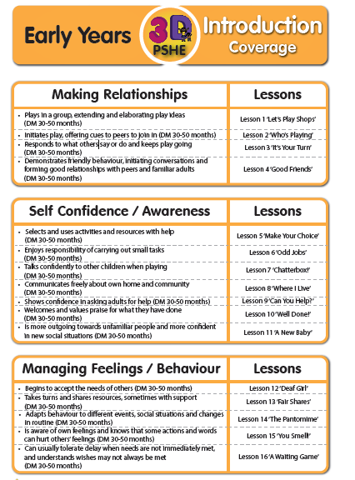
Early Years Coverage of RSE:
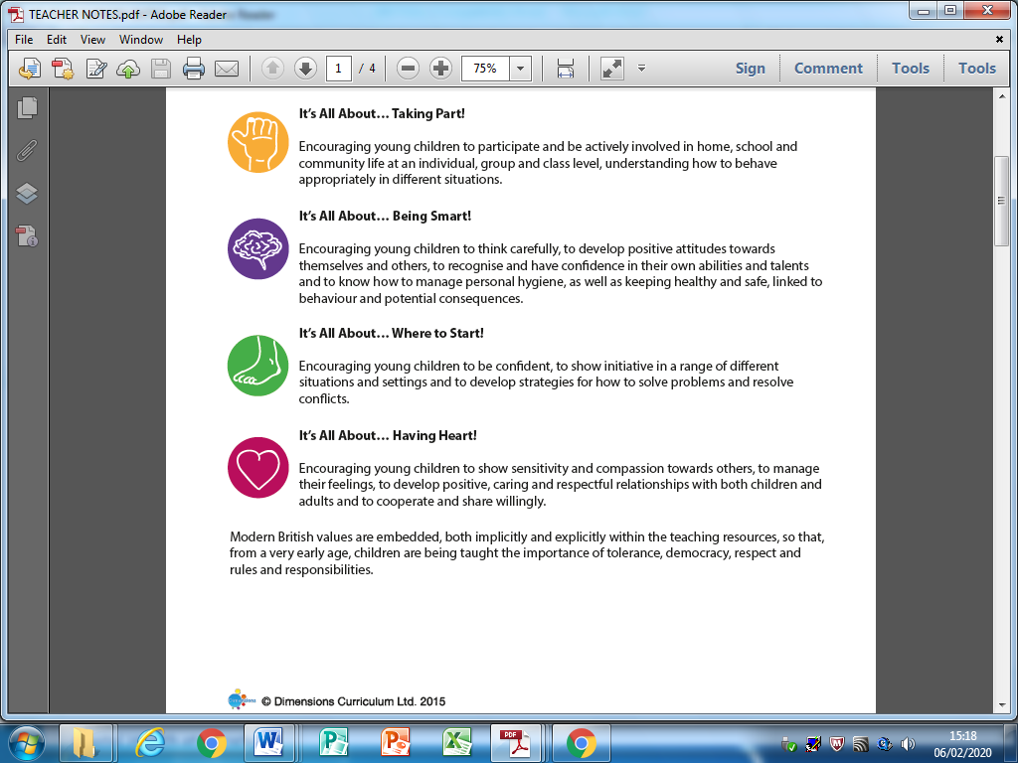

Key Stage 1 Coverage for Relationships:
The Dimensions KS1 relationships curriculum covers the areas; communication, bullying, fairness and family and friends.
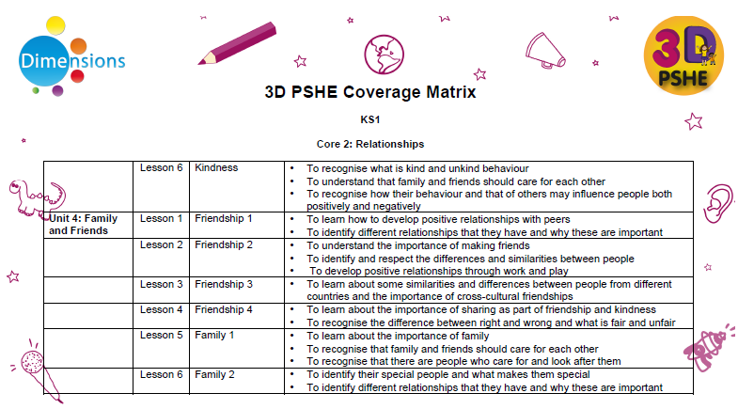
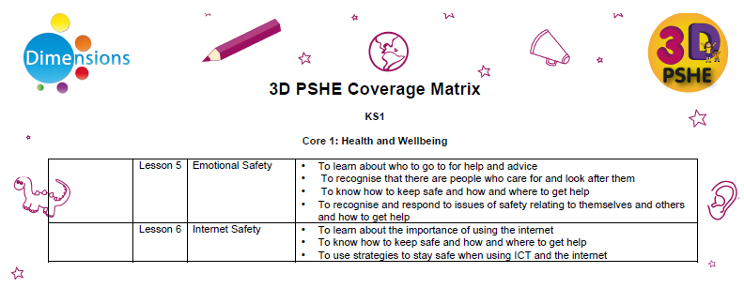
Key Stage 1 Coverage for Health and Wellbeing:

Lower Key Stage 2 Coverage of Relationships:
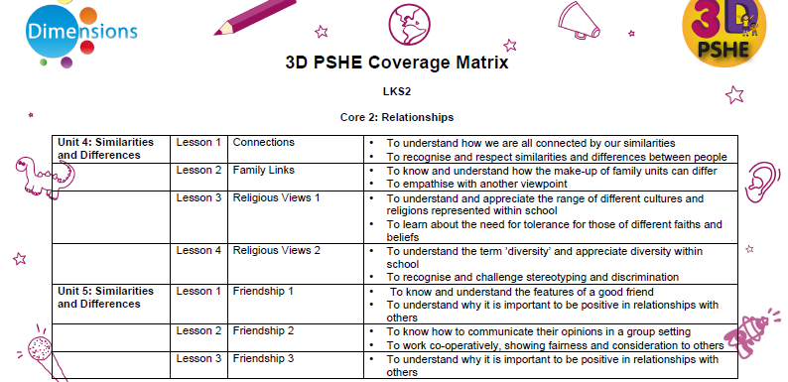
The Dimensions Lower KS2 relationships curriculum covers the areas; communication, collaboration, bullying, similarities and differences and healthy relationships.

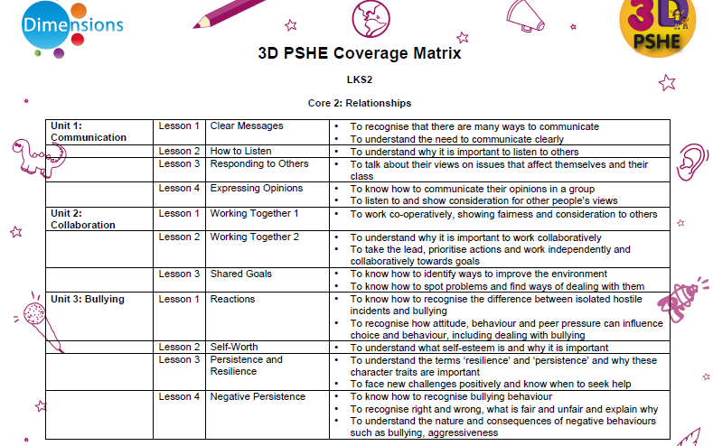

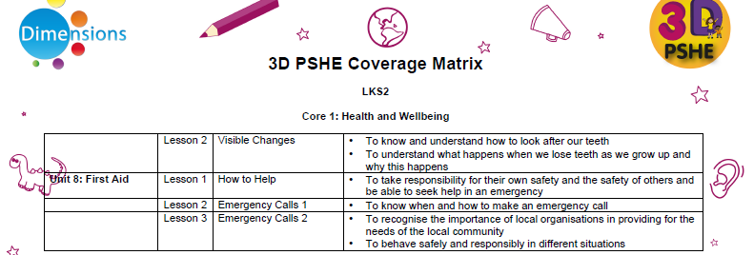
Lower Key Stage 2 Health and Wellbeing:

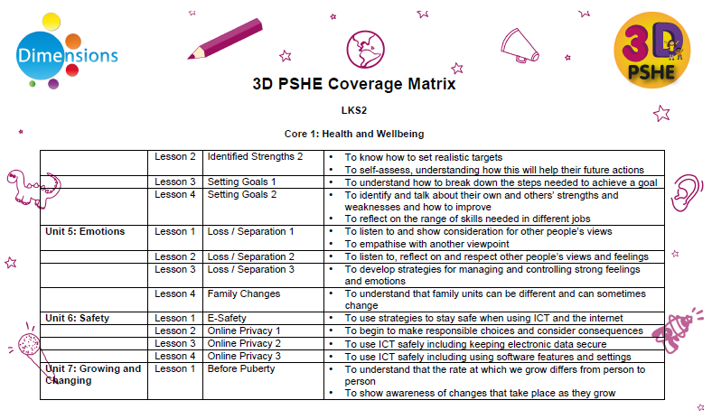

Upper Key Stage 2 Relationships
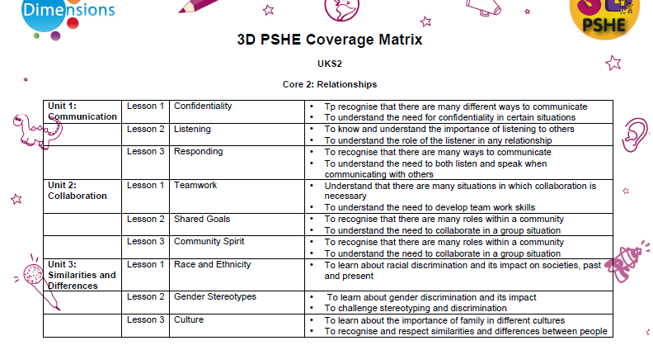
The Dimensions Upper KS2 relationships curriculum covers the areas; communication, collaboration, similarities and differences and healthy relationships.

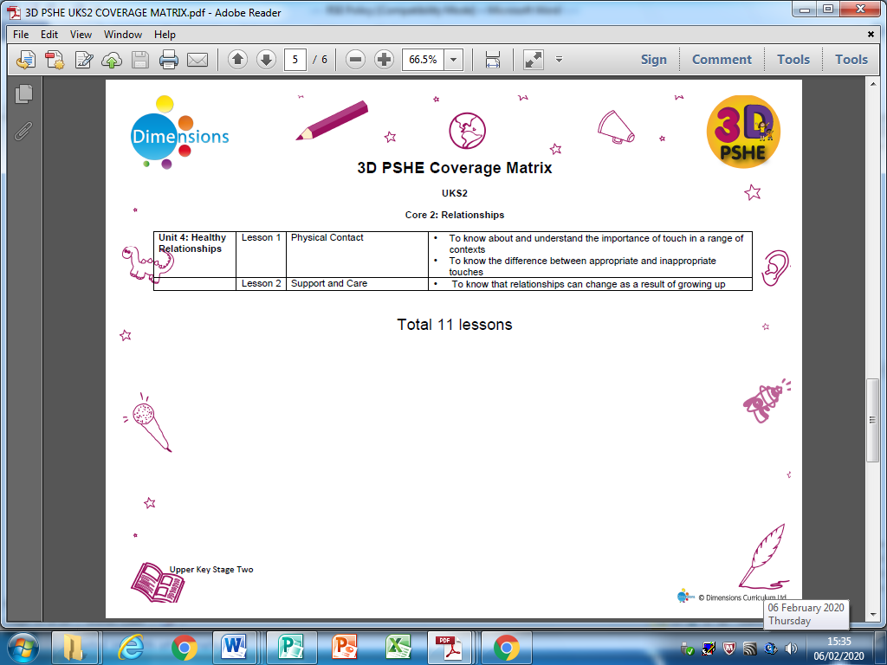

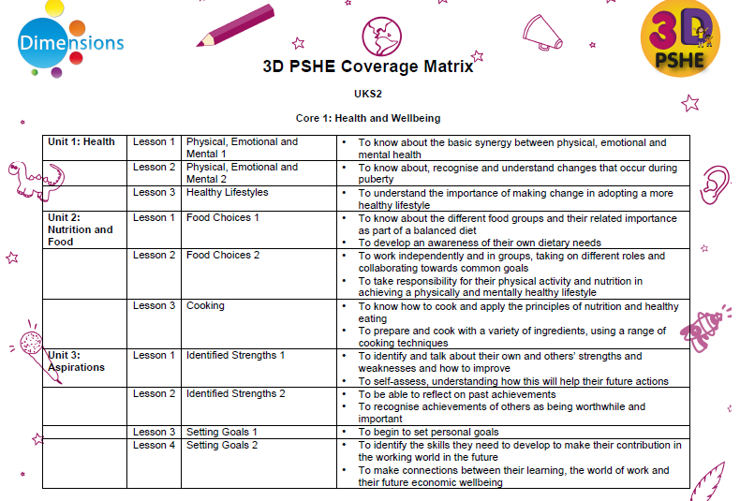
Upper Key Stage 2 Health and Wellbeing

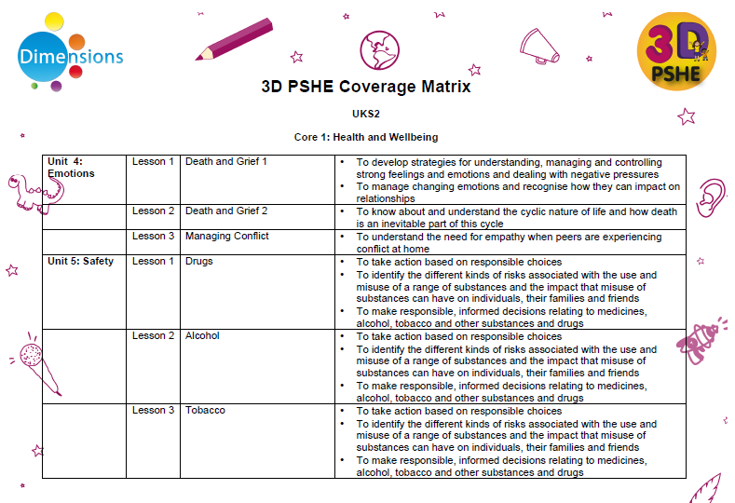
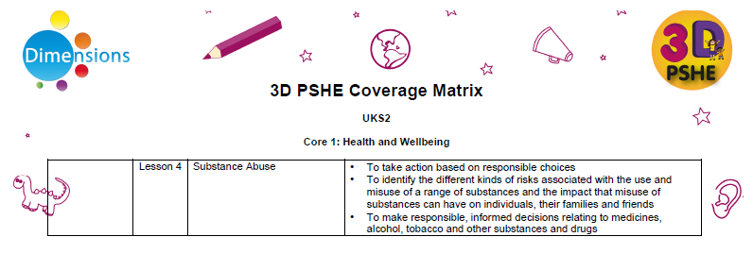
Discrete lesson additional unit overview:
Health and Wellbeing
3D PSHE Safe Zone Coverage Matrix KS1 Year 1
Lesson 1 | Copyright and Ownership | - I can explain why work I create using technology belongs to me (e.g ‘It’s my idea’ or ‘I designed it’)  - I can save my work so that others know it belongs to me (e.g. filename, name or content).
Lesson 2 | Self-Image and Identity | - I can recognise that there are many people online who could make me feel sad, embarrassed and upset.  - If something happens that makes me feel sad, embarrassed or upset, worried, uncomfortable or frightened I can give examples of when and how I can speak to an adult I trust.
Lesson 3 | Managing online information | - I can use the internet to find things out.  - I can use simple keywords in search engines.  - I can describe and demonstrate how to get help from a trusted adult or helpline if I find content that makes me feel sad, uncomfortable, worried or frightened.
Lesson 4 | Privacy and Security | - I can recognise more detailed examples of information that is personal to me (e.g. where I live, my family’s name, where I go to school).  - I can explain why I should always ask a trusted adult before I share any information about myself online.  - I can explain how passwords can be used to protect information and devices.
3D PSHE Safe Zone Coverage Matrix KS1 Year 2
Lesson 1 | Self-Image and Identity | - I can explain how other people’s identity online can be different to their identity in real life.  - I can describe ways in which people might make themselves look different online.  - I can give examples of issues online that might make me feel sad, worried, uncomfortable or frightened.  - I can give examples of how I might get help.
Lesson 2 | Online Relationships | - I can use the internet to communicate with people I don’t know well (e.g. email a pen pal in another school/country).  - I can give examples of how I might use technology to communicate with others I don’t know well.
Lesson 3 | Online Reputation | - I can explain how information put online about me can last for a long time.  - I know who to talk to if I think someone has made a mistake about putting something online.
Lesson 4 | Online Bullying | - I can give examples of bullying behaviour and how it could look online.  - I understand how bullying can make someone feel.  - I can talk about how someone can/would get help about being bullied online or offline.
Lesson 5 | Managing Online Information | - I can use keywords in search engines.  - I can demonstrate how to navigate a simple webpage to get to information I need (e.g. home, forward, back buttons, links, tabs and sections).  - I can explain what voice activated searching is and how it might be used (e.g. Alexsa, Siri, Google Now).
Lesson 6 | Copyright and Ownership | - I can describe why other people’s work belongs to them.  - I can recognise that content on the internet may belong to other people.
Lesson 7 | Privacy and Security | - I can explain what passwords are and can use passwords or my account and devices.  - I can explain how many devices in my home could be connected to the internet and can list some of those devices.
3D PSHE Substance Abuse Additional Units KS2
Lesson 1 | Keeping Safe | - Understand why it is important to focus on keeping healthy and take appropriate action by making healthy choices.
Lesson 2 | Taking Risks | - Understand the term ‘risk’ and how it links to consequence.
Lesson 3 | Taking Drugs | - Understand the term ‘addiction’ and know some of the different forms it can take.  - Recognise the link between choice and consequence.
Lesson 4 | Drug Awareness | - Become familiar with the names of the most common drugs.
Lesson 5 | Substance Abuse | - Understand how advertising influences our choices.

Relationships and Sex Education
We teach sex education in the summer term. During these sessions we may invite pupils from earlier year groups who show early signs of puberty to join in if we feel this is appropriate. If we do not feel it is appropriate for a child to take part then we will discuss this with the parent or carer.
Biological aspects of RSE are taught within the science curriculum. Year 6 pupils also receive stand-alone sex education taught through the 3D Dimensions.

Elements of the sex education in the science curriculum are assessed formally. Evaluation of the RSE programme outside the science order is conducted using a variety of informal activities which have been built into the programme. Teachers are required to keep their own personal evaluations which are used by the coordinator to inform future planning.

3D PSHE Relationships and Sex Education Additional Units KS2
Lesson 1 | Forming Relationships | - Know how and understand why close relationships are formed, especially during adolescence.  - Understand why friendship is important in the establishment of close relationships
Lesson 2 | Sexual Relationships | - Know about and understand the physical, mental and emotional changes that take place during puberty  - Learn about sex (and bust some myths!)
Lesson 3 | Healthy Relationships | - Understand why friendship is important in the establishment of close relationships  - Know the features of a healthy relation
Lesson 4 | Unhealthy Relationships | - Understand what an unhealthy relationship is and know how to deal with relationship issues.
Lesson 5 | Gender Issues Relationships | - Know about gender identities and have an awareness of transgender issues  - Understand the difference between being transgender and transvestite
Why do we feel it is important to teach Sex Education at Orrets Meadow.
We feel that it is essential to teach our children Sex Education in Year 6 due to the following reasons:
- More than ever, children are exposed to representations of sex and sexuality through media/social media and the social culture around them, so we need to present a balanced view of RSE at Orrets Meadow to help our children to be discerning and stay safe.
- Research shows that effective RSE delays first sexual experiences and reduces risk-taking.
- Surveys of children and young people, as well as Ofsted, have repeatedly told us that RSE tends to be too little, too late and too biological.
- They are extremely vulnerable children with a spectrum of special educational needs.
- Our children often require overlearning to understand information fully, therefore if we start Sex Education early they have opportunities to revisit the content at Secondary rather than learning it for the first time.
- By Year 6 we have formed trustworthy, positive and close relationships with the children at Orrets so RSE is delivered in a safe and secure environment for them.
- ASD children (girls in particular) start puberty and periods at an earlier than average age.
Other Specific Issues within RSE

Withdrawal
Parents/Carers cannot withdraw their children from the statutory National Curriculum relationships education and health and well-being lessons. This content will be taught in our weekly PSHE sessions. However, they have the right to withdraw their children from all or part of the sex and relationships education provided at school. Those parents/carers wishing to exercise this right are invited to discuss this with the Head teacher or Deputy Head teacher who will explore any concerns and discuss any impact that withdrawal may have on the child. Once a child has been withdrawn they cannot take part in the RSE programme until the request for withdrawal has been removed. A letter to parents is sent before the start of the topic.

Materials are available to parents/carers who wish to supplement the school RSE programme or who wish to deliver RSE to their children at home.

Confidentiality
As a general rule a child’s confidentiality is maintained by the teacher or member of staff concerned. If this person believes that the child is at risk or in danger, she/he talks to the named child protection coordinator the Head teacher before any decision is made.

The child concerned will be informed that confidentiality is being breached and reasons why. The child will be supported by the teacher throughout the process.

Safeguarding Pupils

The school has a separate Safeguarding Policy. Effective RSE may bring about disclosures of child protection issues and staff should follow procedures to report their concerns.
Controversial and Sensitive Issues
Staff are aware that views around RSE related issues are varied. However, while personal views are respected, all RSE issues are taught without bias. Topics are presented using a variety of views and beliefs so that pupils are able to form their own, informed opinions but also respect others that may have different opinions.

Dealing with Questions
Both formal and informal RSE arising from pupils’ questions are answered according to the age and maturity of the pupil concerned. Questions do not have to be answered directly, and can be addressed individually later. The school believes that individual teachers must use their skill and discretion in this area and refer to the Child Protection Coordinator if they are concerned.

Sexual Identity and Sexual Orientation
Orrets Meadow Primary School believes that RSE should meet the needs of all pupils regardless of their developing sexuality (LGBT) and be able to deal honestly and sensitively with sexual orientation, answer appropriate questions and offer support. Homophobic bullying is dealt with strongly yet sensitively. The school liaises with parents on this issue, to reassure them of the content and context.

CPD
Orrets Meadow Primary School believes in the importance of training for staff delivering RSE. Staff are encouraged to access appropriate training and support to help them deliver effective RSE if they feel they require it.

The Headteacher or Deputy Headteacher invites visitors from outside the school, such as school nurses, first aiders and sexual health professionals to provide support and training to staff teaching RSE.

Roles and Responsibilities

The Governing Body
Cindy Cooper, Vice Chair, is the Safeguarding Governor for Orrets Meadow. The governing body were involved in the consultation for the RSE policy and it was ratified at the Full Governors’ meeting.

The Head teacher
The Head teacher is responsible for ensuring that RSE is taught consistently across the school, and for managing requests to withdraw pupils from non-statutory/non science components of RSE.

The Staff
Staff are responsible for:
- Delivering RSE in a sensitive way
- Modelling positive attitudes to RSE
- Monitoring progress
- Responding to the needs of individual pupils
- Responding appropriately to pupils whose parents wish to withdraw from the non-statutory/non science components of RSE

Monitoring Arrangements
The delivery of RSE is monitored by Roz Warren (Deputy Head) through:
Learning Walks
Monitoring of PSHE Class Books
Lesson Observations
Pupil discussions
Staff discussions
Parent, pupil and staff surveys

Review of Policy
This policy will be reviewed by the PSHE Co-ordinator annually. At every review the policy will be ratified by the governing body.

