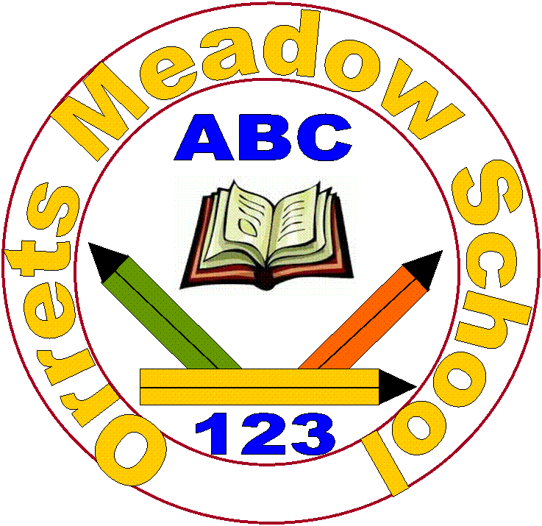

ORRETS MEADOW SCHOOL

School Uniform Policy

This policy was approved by the Governing Body on ______

SCHOOL MISSION STATEMENT

To raise the aspirations of every child and give them the confidence to fulfil their potential through positive learning experiences.

Orrets Meadow

Introduction

At Orrets Meadow we pride ourselves in being smart, well presented and ready for learning. It is our school policy that all children wear school uniform when attending school. We ask children to take a pride in their personal appearance.

Some items of uniform can be bought from school, whilst others are easily available, at very competitive prices, at local shops including supermarkets and uniform shops. A complete list of the items needed for school uniform including those for Physical Education, is printed overleaf.

Aims and objectives

Our policy on school uniform is based on the belief that we are pleased to wear a uniform that:
- Promotes a sense of pride in our school
- Helps to create a sense of community and belonging towards the school
- Identifies pupils with the school
- Supports the school’s commitment to inclusion
- Prevents pupils from wearing ‘fashion clothes’ that could be distracting in class
- Is practical, smart, and designed with health and safety in mind
- Is considered to be good value for money

Jewellery and Hair

For many reasons, including safety, we do not allow children to wear jewellery. Children are required to remove any items during P.E. lessons to prevent them from causing injury. Extreme hairstyles are not appropriate for school and long hair should be tied back if possible.

Footwear

Black shoes are requested, however due to many of the children having autism we understand shoes can cause some children sensory issues and so we allow black trainers as well. Children are allowed to take their shoes off in school and slippers are allowed to be worn. Children should not walk around the classroom or school in bare feet or just socks.

The Role of Parents

We believe that one of the responsibilities of parents is to ensure that their child comes to school in our school uniform and that they make sure their child has a PE kit in school each day which is clean. We request that parents ensure the child’s name is visibly labelled on all items.

If a parent has difficulties for any reason with fulfilling this request they are asked to speak confidentially to a senior member of staff to discuss the issues. Parents should be assured that we will do all we can to help.

We understand that as many of the children have autism that clothing can bring sensory issues and meltdowns. Due to this, in discussion with the parent, we are flexible on items of clothing eg. Children can wear a white t-shirt instead of a polo shirt with buttons.

If a child forgets an item of clothing eg their jumper or their PE kit then we will loan them the necessary items from our school stock of second hand clothes.

The school welcomes children from all backgrounds and faith communities. If there are reasons, for example on religious grounds, why parents want their child to wear clothes that differ from the school uniform, we will consider such requests sympathetically. If any parent would like to request an exception to the uniform policy they should, in the first instance, contact the headteacher and then the Governors.

The Role of Governors

The governing body supports the headteacher in implementing the school uniform policy. It considers all representations from parents regarding the uniform policy and liaises with the headteacher to ensure that the policy is implemented fairly and with sensitivity. It is the governors’ responsibility to ensure that the school uniform meets all regulations concerning equal Monitoring and Review opportunities. Governors ensure that the school uniform policy enables children to dress sensibly, in clothing that is hardwearing, safe and practical.

Monitoring and Review

The governing body monitors and reviews the school uniform policy through its committee work by:
• seeking the views of parents, to ensure that they agree with and support the policy;
• considering, with the headteacher, any requests from parents for individual children to have special dispensation with regard to school uniform.
School Uniform List

Please note we do not request any brand of clothing and actively encourage parents to shop around for the best value clothing they can find.

Our school uniform at Orrets Meadow that consists of:

- Burgundy Sweatshirt or cardigan with Orrets Meadow badge
- Plain dark grey trousers, skirt or pinafore
- Plain white shirt, blouse or polo shirt
- White, grey or black socks or tights
- Black sensible shoes
- Summer school dresses are optional – red or burgundy gingham.
- School coat – any style and colour
- School bag with logo – we give you this for free when you join our school
- Water bottle with logo – we give you this for free when you join our school.
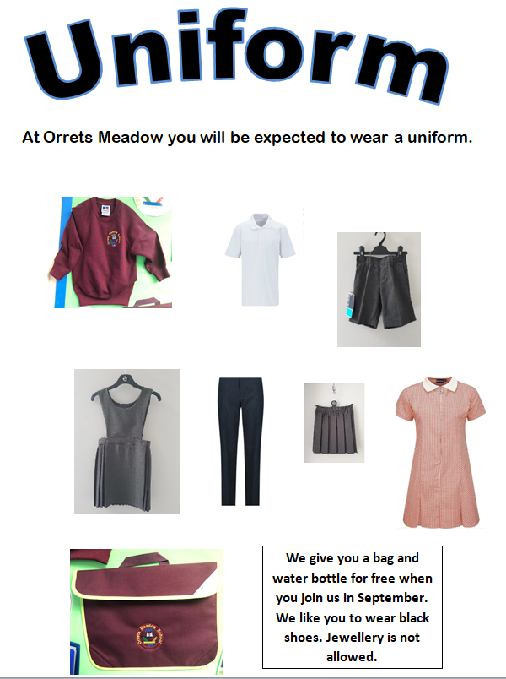

PE Kit

Children need a change of clothes and footwear for PE (for health and hygiene reasons) and a bag in which to keep the kit at school. PE kit MUST be named. Children can become upset as a result of lost clothing; please help us by naming everything.

PE Uniform is:

- White t-shirt, vest or polo shirt
- Dark shorts
- Pumps or trainers
- Track suit may be worn if they get cold

All items may have the Orrets Meadow logo on them if the parent wishes.

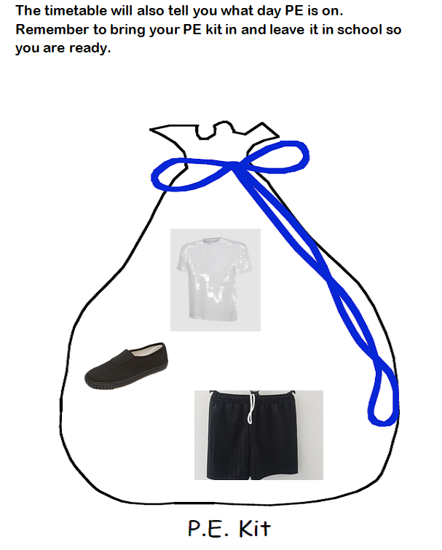

Parents can buy school jumpers and cardigans with the school logo from the school office or they can source them themselves from any uniform shop. We can arrange for our school logo to be sent to any uniform shop the parent requests.

We purchase our school jumpers from a local school uniform shop on the Wirral. We regularly (every 2 years) check prices with other suppliers to check we are getting the best value and we sell the jumpers/cardigans at the same price as we pay for them.

We have lots of second hand uniform available in school. If parents are concerned they cannot afford all or any items of our school uniform, then they should contact either Michelle, our home school link worker, the school office or the Headteacher, and one of us will discretely make arrangements for the child. At all times we will take a mindful and considerate approach to resolve the situation.

We have kept our school uniform as simple as possible to ensure parents can shop around for best value and we are flexible due to the needs of the pupils if parents discuss any concerns with us.

