
Governors Report – Summer 2024
Science
Gina MacGregor
Achievements
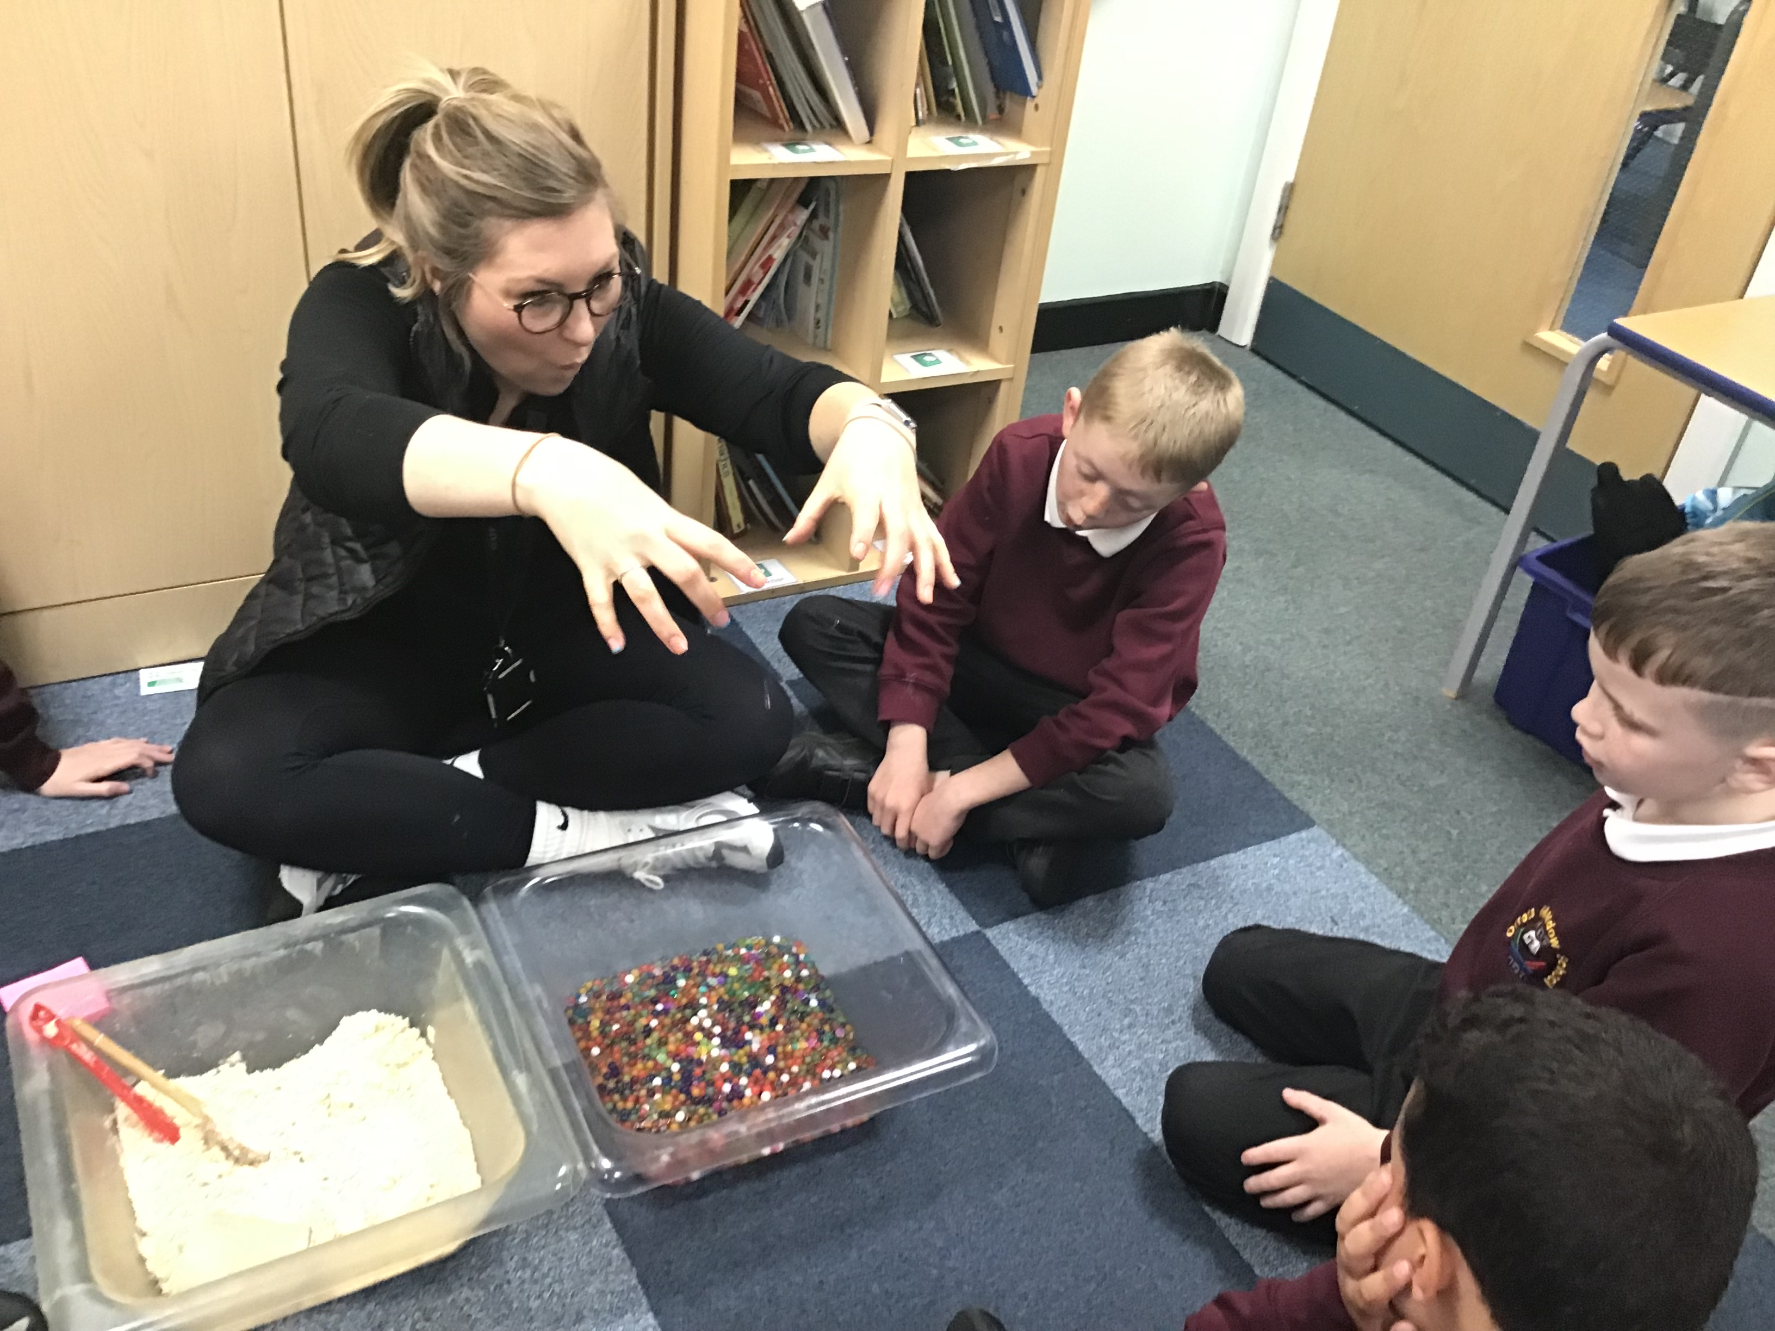
During this academic year, I have worked towards achieving the Learning Outside the Classroom Quality Mark. Through RAG rating our curriculum, in particular our Science provision, I was able to focus on key areas to develop in our science outdoor learning curriculum. We now have outdoor learning implemented through all aspects of our curriculum, not just in science focus weeks. During Science focus weeks, we now explore scientific vocabulary, work through our science book spine, study topical Science, outdoor science, famous current scientists and we all aim to do a variety of science trips. Through achieving this award, I have implemented more practical science, which the staff and students have loved. Staff and students now look forward to the practical and outdoor element to our Science focus weeks.

CPD
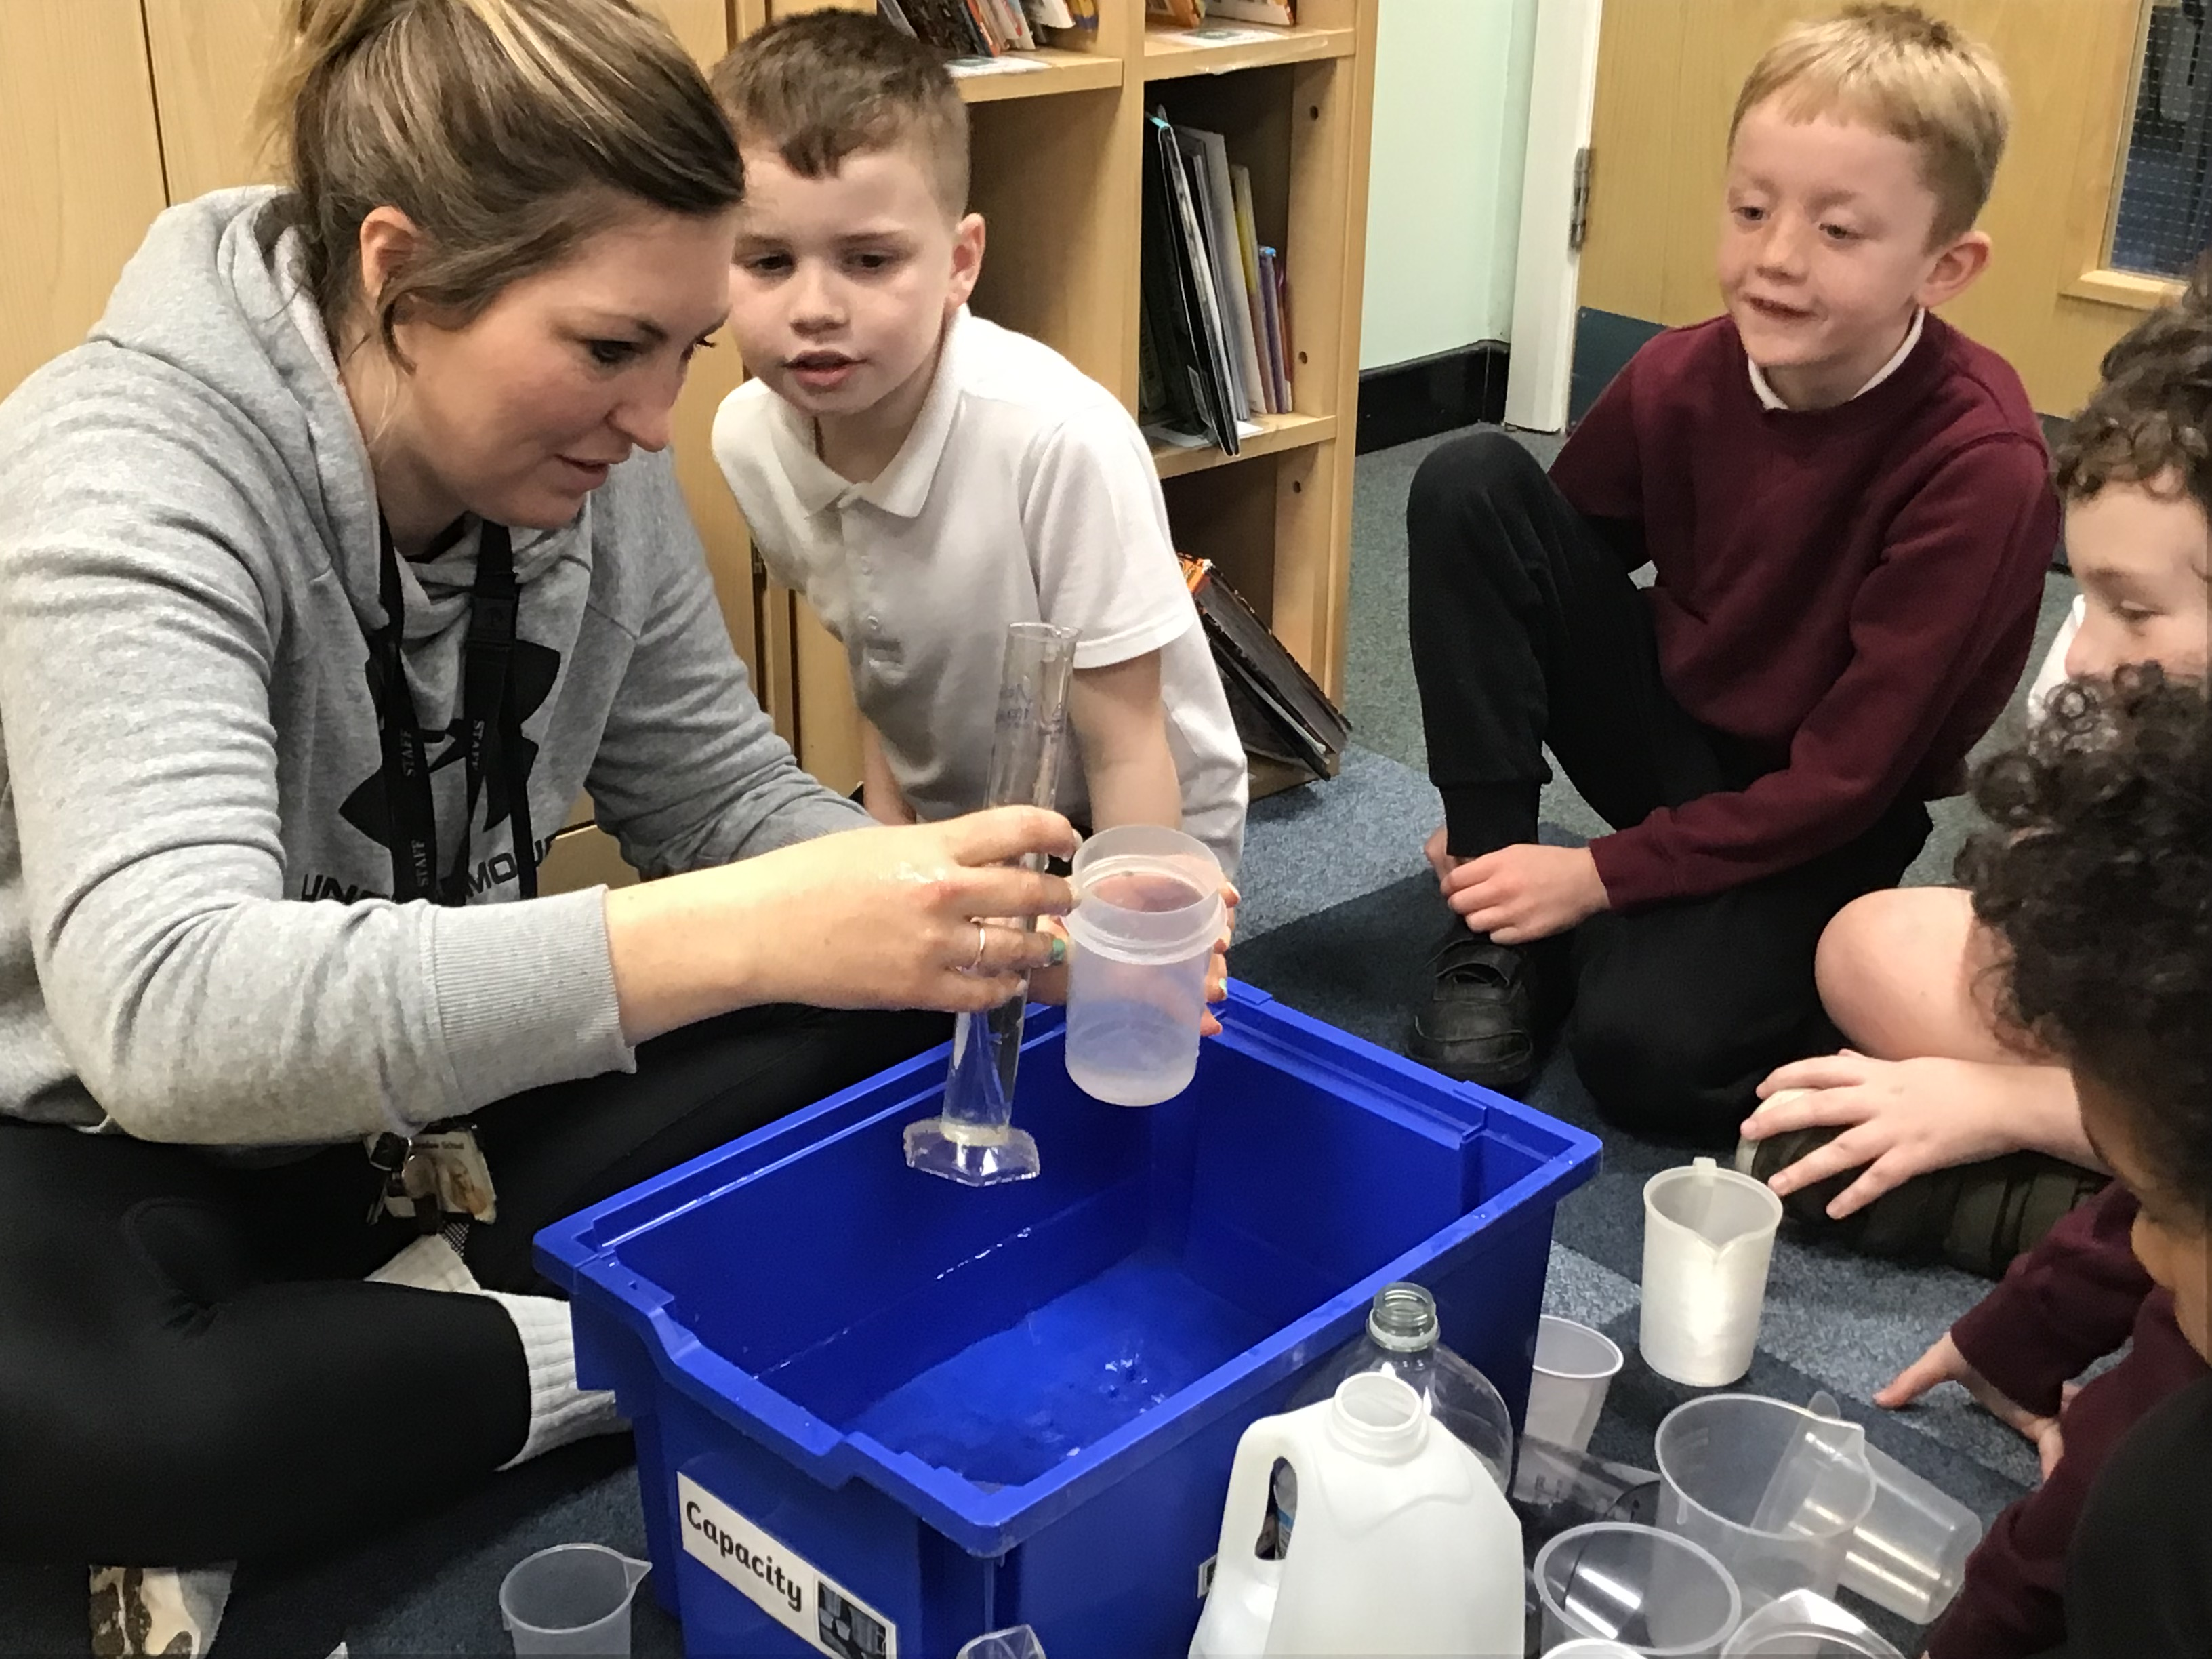
This year, I was granted a TLR3 for Science, to achieve the Learning Outside the Classroom quality mark; I achieved the gold level which is the highest mark availible. Through this award, I did half termly zoom training days and was given tasks to work through. I was also granted half a day to work through my course and do any management activities for Science. This opportunity has been excellent and I really enjoyed having a leadership role in school.
I took part in the Liverpool Primary Science subject leader meetings each term that were very informative about any changes in the curriculum and allowing children to catch up. Although they were still via zoom, I was able to network with lots of different schools across the area.
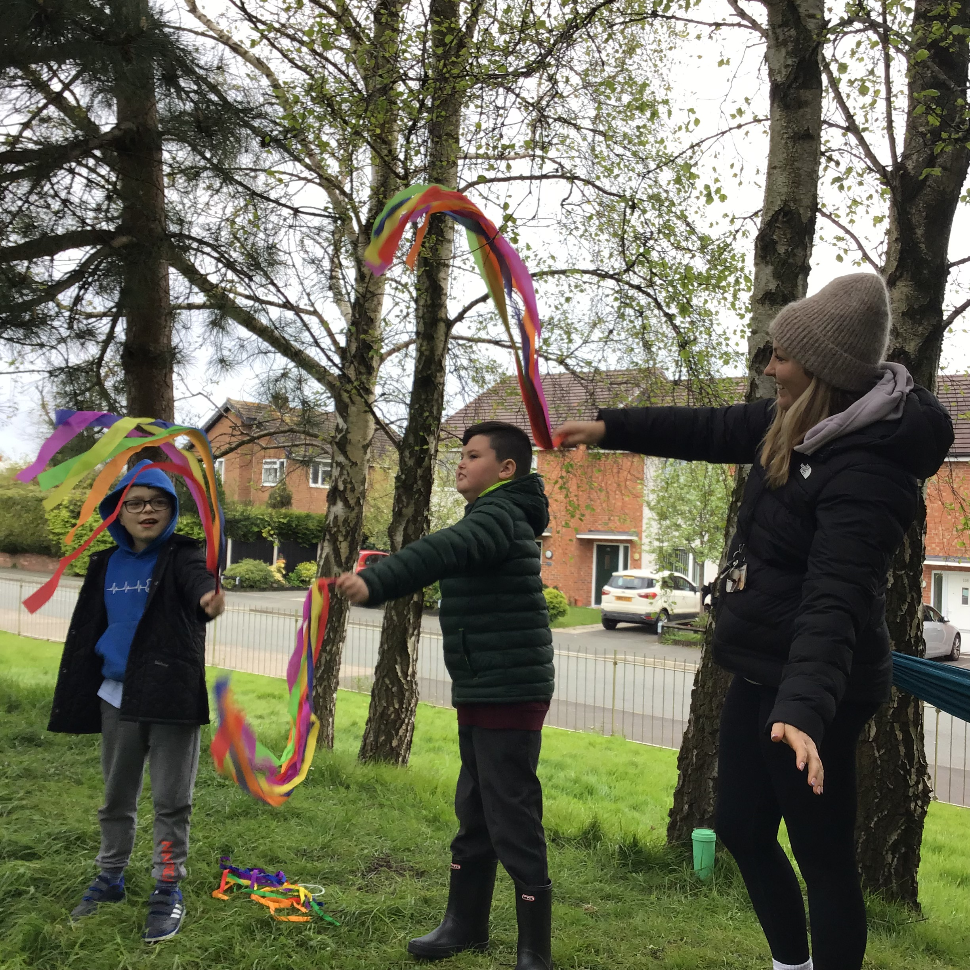
In order to offer CPD to staff at Orrets, I led two staff meetings focusing on Learning Outside the Classroom. During this staff meeting, I also gave teachers the opportunity to take part in a range of practical activities which could be used inside and outside the classroom. We then ensured that we put these ideas into place during our Science focus weeks; I monitored this by conducting short lesson observations and learning walks each half term. Children are very proud of their work and often come visit my classroom during science week to show me their hard work. I saw some fabulous facts from the Bear class this year and some brilliant outdoor learning from the Tiger class!
Quality of teaching learning
As the science subject leader, I have completed a range of activities to oversee science this year. During the autumn term, I began my RAG rating of our Science provision through my LOTC course, and created targets to achieve across the year. I also did initial staff and pupil surveys and a learning walk to assess how Science weeks look at the start of the academic year. Feedback from the staff was that they enjoyed teaching Science in discrete weeks alongside their Dimensions curriculum. Staff asked for some additional CPD on how to develop Science outside the classroom. Findings from the pupil survey suggested that all children enjoyed science lessons, in particular when they could take part in practical activities. Some children said that science lessons would be better if they could go on more trips to bring science to life so I ensured children in those classes went on a trip during their next science week. I also introduced a new pre-curriculum level to our long term plan so that children in the wolf class could access science lessons better suited to their working ability.
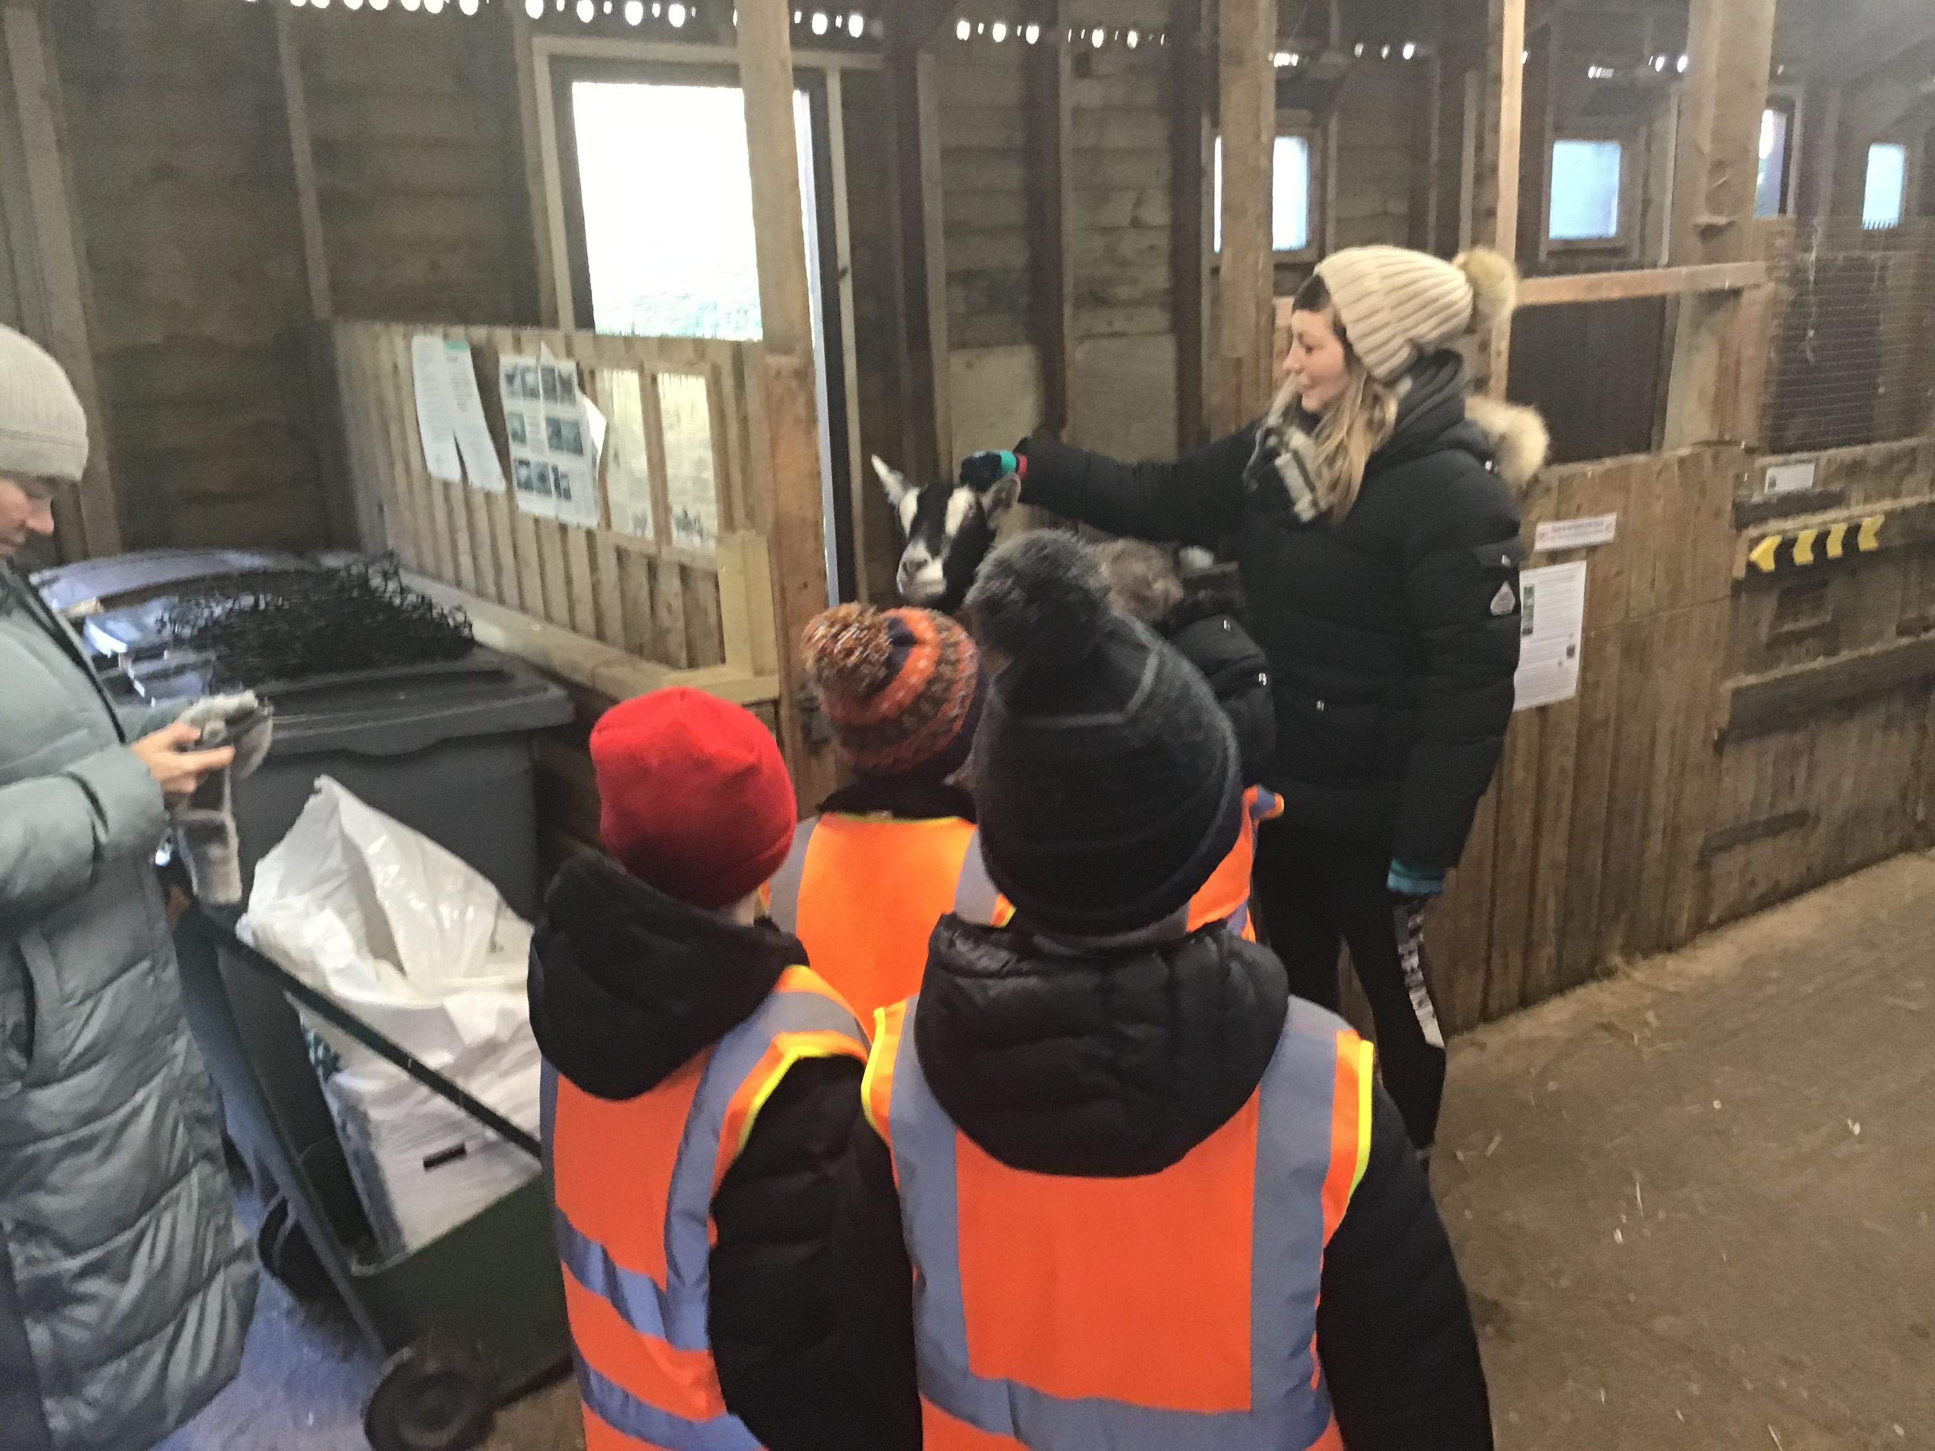
In the spring term, I conducted a book scrutiny to see the progress made from the first to second Science focus week. I also did various lesson observations in this week, particularly focusing on the youngest and oldest children in the school. The progress between the classes was truly outstanding! The children all took part in an online live lesson about sharks which was developed by the BBC, it was brilliant for the children to take part in something online with children from across the UK. During the spring term, I also encouraged all staff to take their students on a Science trip if they had not been able to go on one during autumn term; classes went to the farm, Blue Planet Aquarium, the zoo, New Brighton beach and the forest!
In the summer term, I conducted a learning walk during our final science week where I was able to see all classes doing a range of practical science activities. It was fantastic to see a range of lessons and excellent quality teaching which was adapted to suit the needs of our children. I organised for ‘Mad Science Assemblies’ to come into school to lead an assembly for all children to experience a real life scientist who taught them the importance of water. During our final science week, I organised for a scientist from Liverpool Royal Hospital to speak to the older children in school about what it is like to be a female scientist in 2024. Finally, I did a data analysis of progress across the school; I was able to see patterns in the data which showed how girls make less progress in science than boys which could be due to the percentage of girls in the school being less than boys. Only 42% of FSM children are working below the class average which suggests that FSM has little impact on the progress of our children at Orrets Meadow.
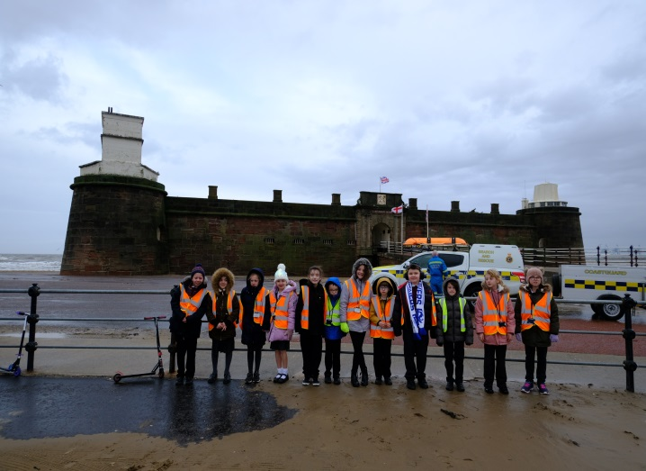
Strengths
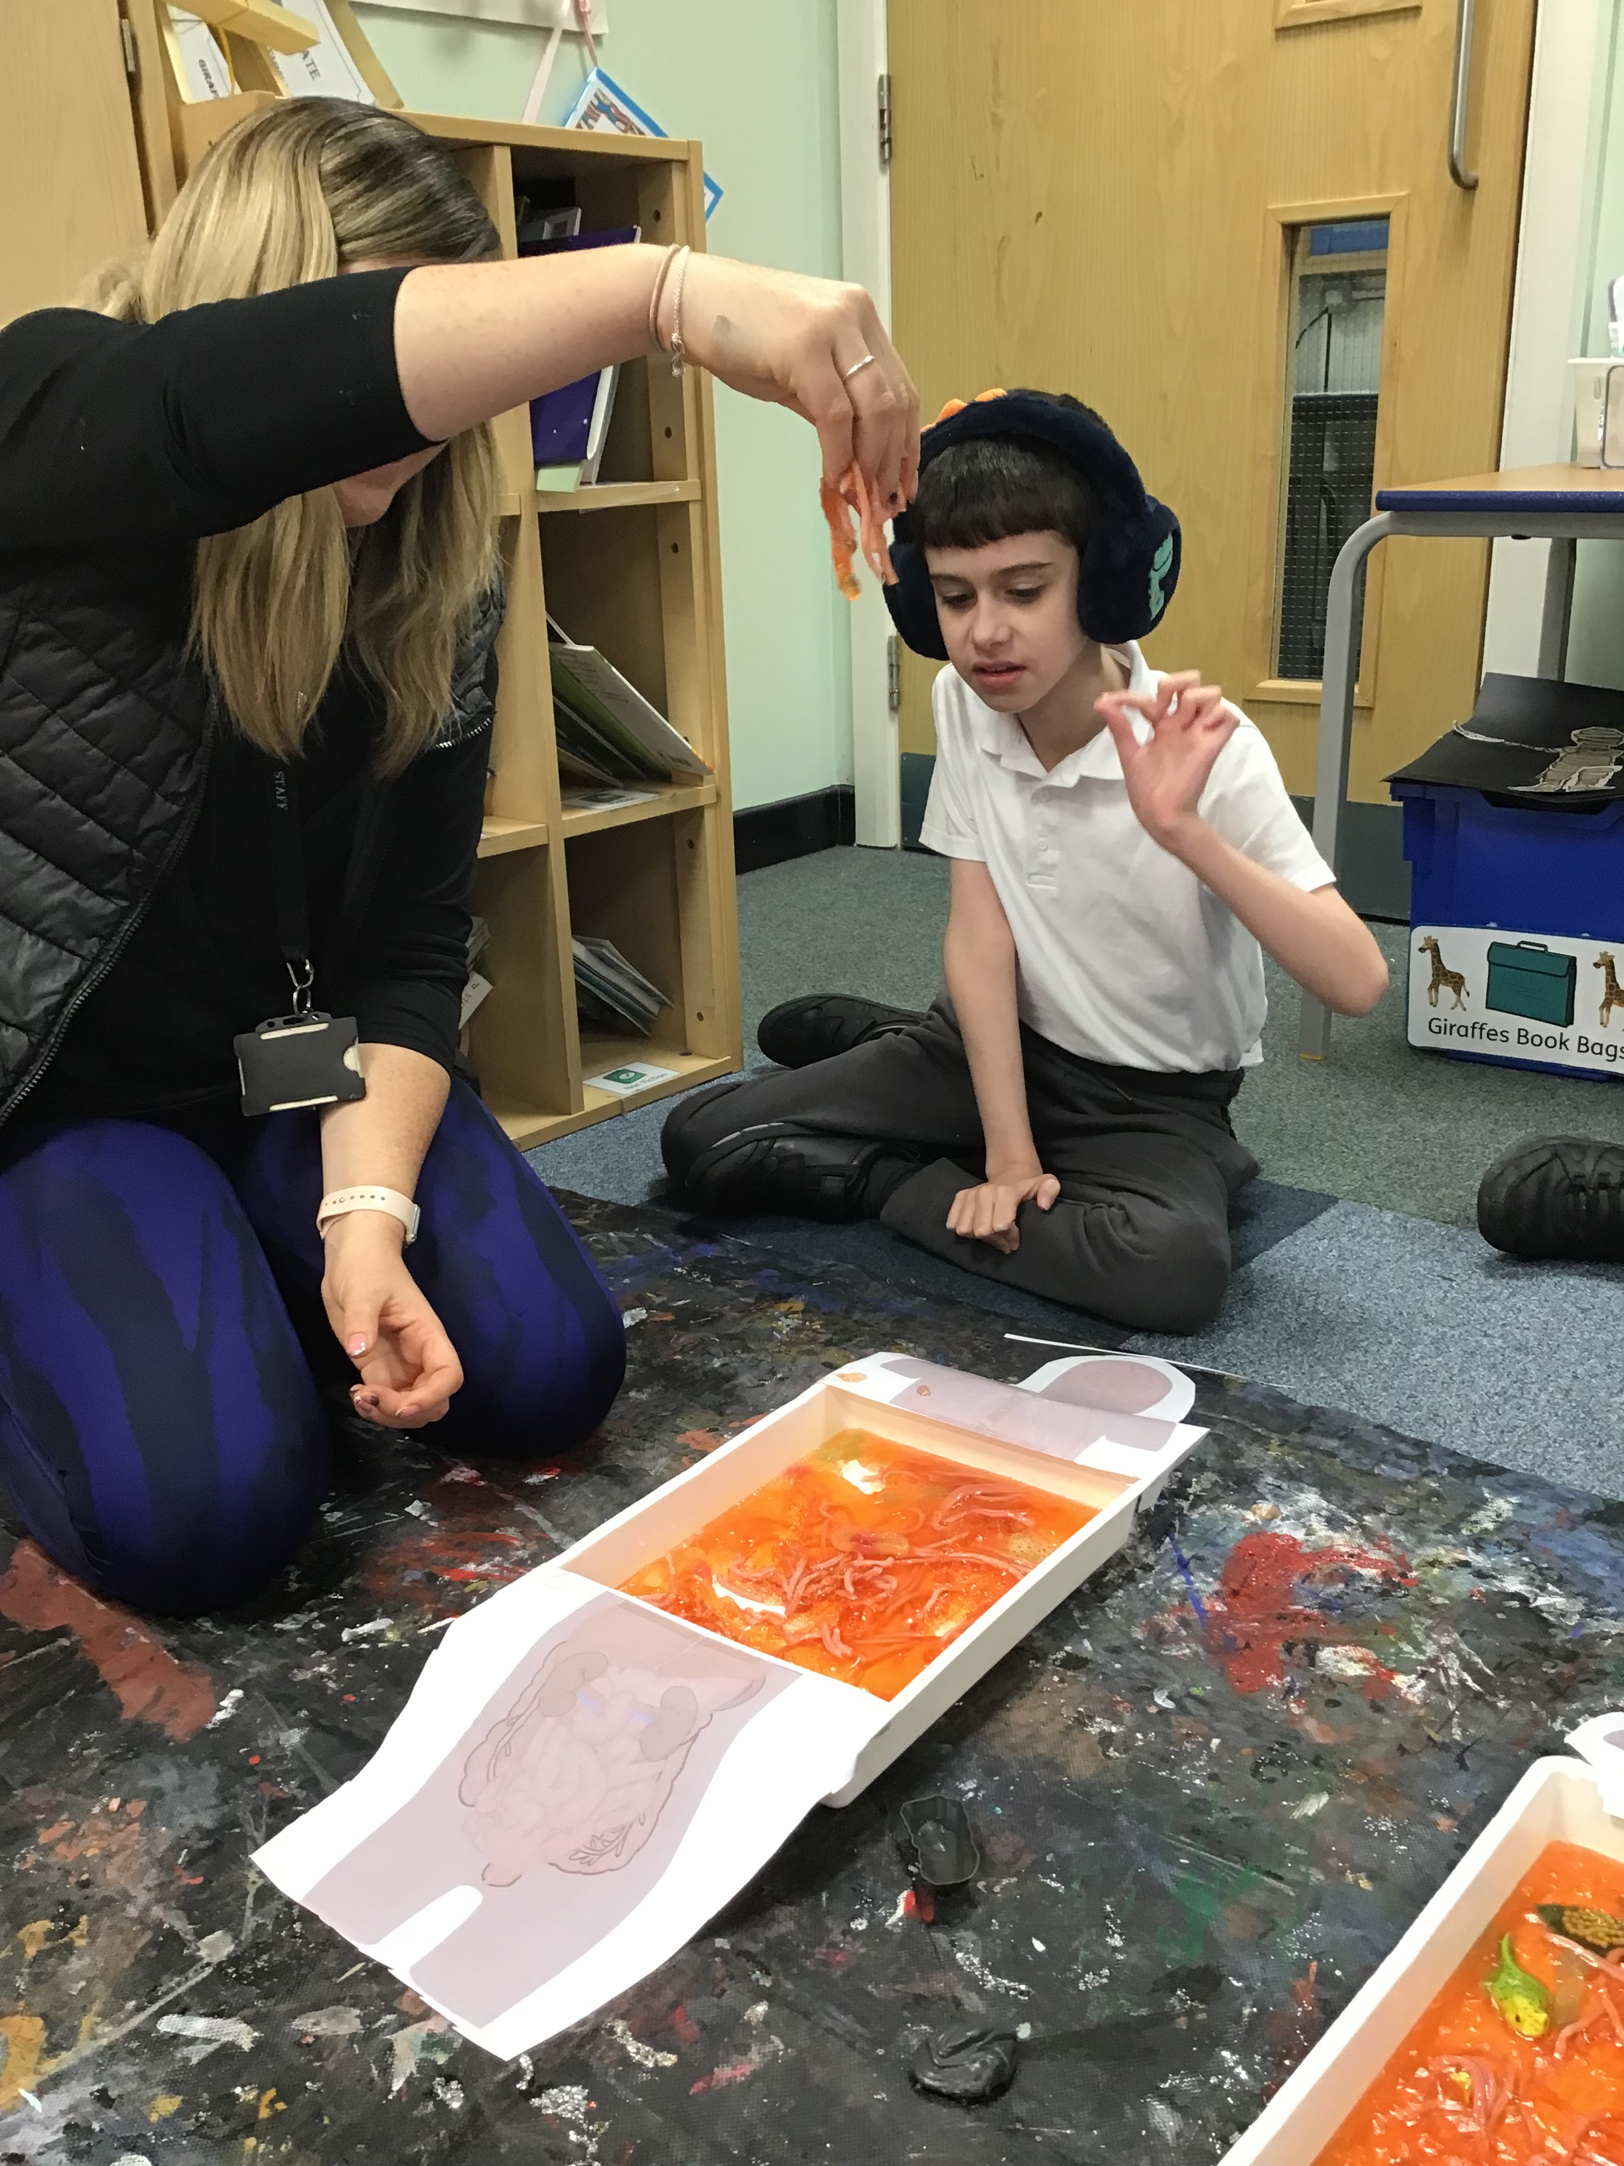
Science is a really strong and enjoyed subject at Orrets Meadow by staff and students. A great strength is having discrete teaching of science through our Science focus weeks; they are stimulating, thought-provoking and allow children to retain a lot more information in one week rather than weekly lessons; we now assess the children’s progress by completing a Kahoot Quiz at the end of each week and all children could answer multiple questions from their quiz correctly. The teaching of Science is very strong and they all have excellent subject knowledge of what they are delivering. The teachers offer creative and inventive lessons which are adapted to suit all their students’ needs. Another strength is how all staff delivers multiple practical activities throughout the week; rather than last year where they focused on one investigation, now the children experience practical activities in every lesson. The development of Learning Outside the Classroom has been brilliant this year as children learn about something that’s happening in the real world and develops life and social skills alongside scientific knowledge.
Ways forward
Next year, there will be a greater focus on developing the STEPS skills ladder to ensure all our children can work through the skills curriculum at their own working ability. I have created a new assessment criteria for STEPS which will be implemented next year for our teachers to use.

2023-2024 targets
- To improve Science capital by offering students the opportunity to meet Scientists and visit other school laboratories (all year)
- To continue developing our Learning Outside the Classroom curriculum through Science lessons.
- To implement the STEPS objectives into our lessons.

