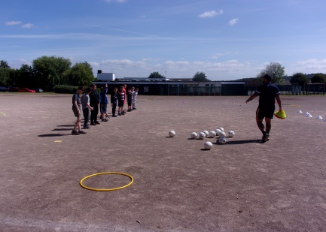
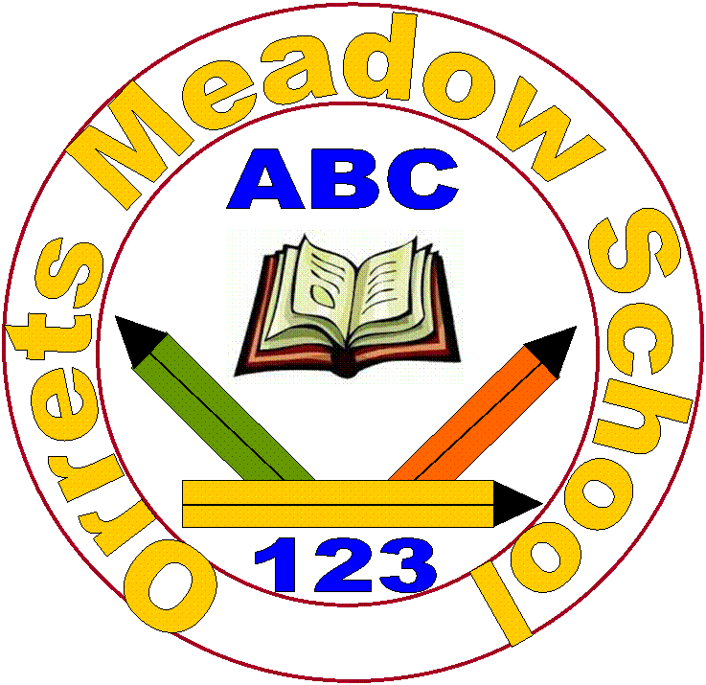
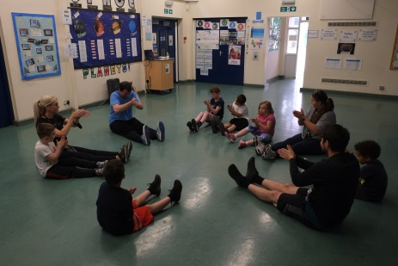
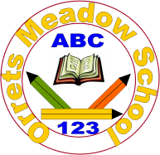

Governors Report – Summer 2021
PSHE
Roz Warren
Achievements
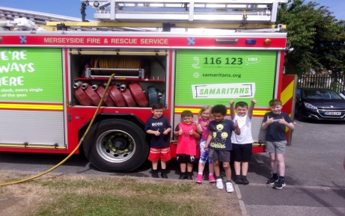
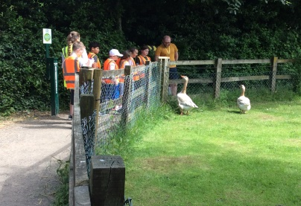
The priority for September 2020 was to create an RSE policy which went through a process of consultation and met our children’s needs. The process started by consulting all stakeolders to build a shared vision and understanding of the expectation for change. A focus group consisting of staff members, parents and a School Governor met to evaluate the policy and mind map ideas for the best way to implement the changes. Following the meeting an information leaflet was produced to share with our parent community the new guidelines on RSE. The Staff where consulted through a staff meeting and the parents through a questionnaire to gather different views and opinions. I attended a Curriculum Governors meeting to present information on RSE, gather views and to share the viewpoints of other stakeholders. A new RSE Policy was written to support the changes and a draft was delivered to all staff and shared with the parents and Governors on the school website for a consultation period. After the consultation period had finished the new RSE Policy was ratified by the Governing Body as an official document. Child friendly RSE leaflets were produced to visually show the children through widgits the areas that would be covered during their RSE sessions. Pupil Voice took place at the end of the year to establish how the children responded to the changes made.

During this academic year, despite Covid restrictions, all classes have completed the full statutory RSE coverage from the long term PSHE plan. Staff and children’s feedback, alongside a learning walk and book scrutiny show a positive picture of the content taught and its delivery.

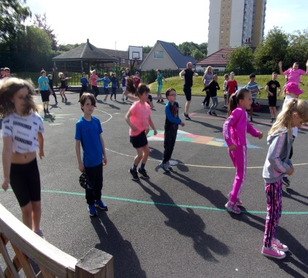
The Being Healthy and Safe Week was a huge success and the pupil surveys reflected that the children enjoyed the week immensely. We had a range of visitors including; Claremount Wake Up and Shake Up, St Helens Rugby Club, MW Multi-Sports, Yoga, Margarita Dance, MDI Dance, Dentist, the Fire Brigade and Police. We also all went on our first class school trips to the farm to promote well-being and mindfulness. Internally we did the magic mile, art sessions, smoothie making, pet corner, litter picking and circuit training. It was a fun packed week which we have evidenced through photographs on Face Book.

The ‘Autism Framework Tracker’ which we use as an assessment tool to support and track the children’s additional needs; social communication, social interaction, social imagination and flexibility, sensory processing, emotional understanding of self-awareness, learning and independence and community participation is now fully embedded. Its data analysis provides us with areas that are successful and highlights our development needs.

CPD
A staff meeting was held in April to reflect on the PSHE updates, refresh staff on the changes to the RSE Policy and to give feedback from the Autumn and Spring book scrutiny and staff survey. It was an opportunity to share good practice and discuss and share different activities that had been successful in our delivery of PSHE.
Several members of staff including myself took part in ‘Adverse Childhood Experiences and Trauma Informed Approaches’ by Wirral Universal Training to support the needs of the children in our care.
Quality of teaching learning
As the PSHE subject leader, I have completed a range of activities to oversee the teaching and learning of PSHE this year. I have collated and analysed the ASD Framework Data, Scrutinised the PSHE books against the planning, been on a learning walk and conducted staff and pupil voice surveys on RSE, Dimensions, Being Healthy Week and the Year 6 children and teachers on the Sex and Health Education lessons taught.
ASD Framework
The ASD Framework continues to give us supportive data on the children. All new children were baselined during the Autumn term and existing children’s ASD Frameworks have been updated accordingly. The IEP (Individual Education Plan) has changed to reflect this and therefore gives future targets for children in the highlighted areas of need.

PSHE Book Scutiny
PSHE books include photographic evidence of lessons taught through a range of activities including art, card making, debates, making cakes and power points. PSHE book scrutinises have taken place each term to moderate coverage and work evidenced. As stated above the statutory RSE content is demonstrated for each class within their books.

Learning Walk
My learning walk was an extremely positive experience. The vast majority of children were engaged, actively involved, enthusiastic and benefiting from the activities being taught. I witnessed a range of multi-sensory activities from singing, poster making, feely bags, voting and budgets. There was a lovely ‘learning buzz’ across the school.
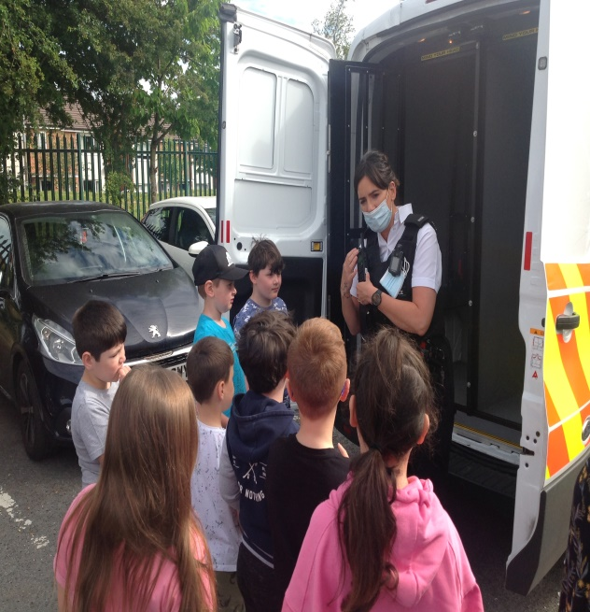
Pupil Voice
Out of the children that were surveyed:
100% said they enjoyed the PSHE sessions.
100% could say about what they had learnt about i.e. taking turns, friendships, safety, fair and not fair etc (The PSHE book was used to visually support for some children).
100% could talk about their favourite PSHE session.

Staff Voice
100% of staff feel happy teaching the new revised RSE content.
88% of staff like the Dimensions Curriculum and resources available for the sessions.
100% of staff said it engaged our children.
100% of staff feel confident teaching the different areas of PSHE.

Year 6 staff Sex and Health Education Questionniare
- Staff felt confident teaching Sex and Health Education.
- Staff felt Dimensions sessions were easy and straight forward to teach but needed supplementing with PowerPoints and resources.
- Staff felt some lessons needed adapting due to being too old.
- Staff felt children reacted well to the content, showed maturity and found the information very useful.

Strengths
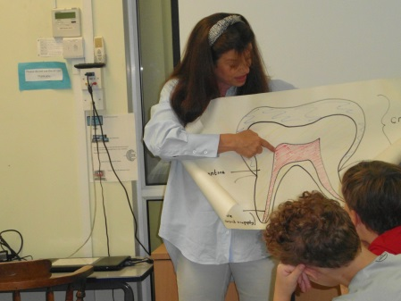
From the moderation, pupil and staff voice and learning walks that I have conducted, I have observed huge strengths in the teaching and children’s response to PSHE across the school. The books demonstrate the creative lessons through photographic evidence and a range of multi-sensory learning activities. The learning walk demonstrated that the lessons and activities were adapted to meet the needs of the children. The Dimensions Curriculum for PSHE is a good starting point for teachers to support them in their delivery of the lessons and all staff feel confident teaching them.
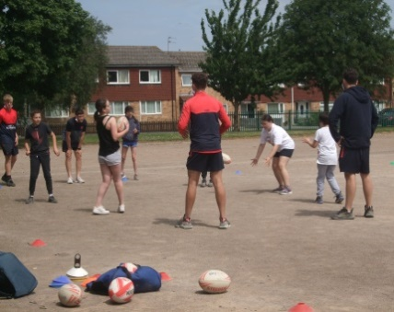
My highlight as PSHE lead was the successful Being Healthy and Well Week when children came off their structured timetable to take part in a variety of new and exciting sessions. The children had fun whilst learning new skills including resilience.
Ways forward
Next year I am going to explore and research if there are any resources to support younger minded children in learning about their bodies, sex and health. This will be done through research, speaking to the SEN Secondary schools and consulting with the Autism Accreditation team.
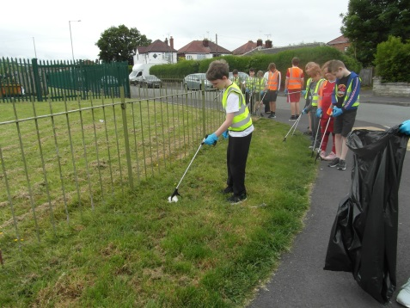
Our ASD Framework tracker highlighted that the area that requires development is independence. Therefore I will look into providing more opportunities for the children to develop their independence skills. This area is also a focus priority for the SDP 2021-2022 for the curriculum. This will be an area I will build into the ‘Being Healthy and Safe Week’ next year. Also I will approach the local SEN Schools to see if we can access some of their resources i.e. child ran café, house etc. I will hold a staff meeting on this in the Spring Term.
Targets for 2021-2022
- To purchase resources to support the teaching of bodies, sex and health to younger minded children (Autumn Term).
- To support the development of independence skills across the school (Spring Term).
- To hold a staff meeting on developing independence skills (Spring Term).

