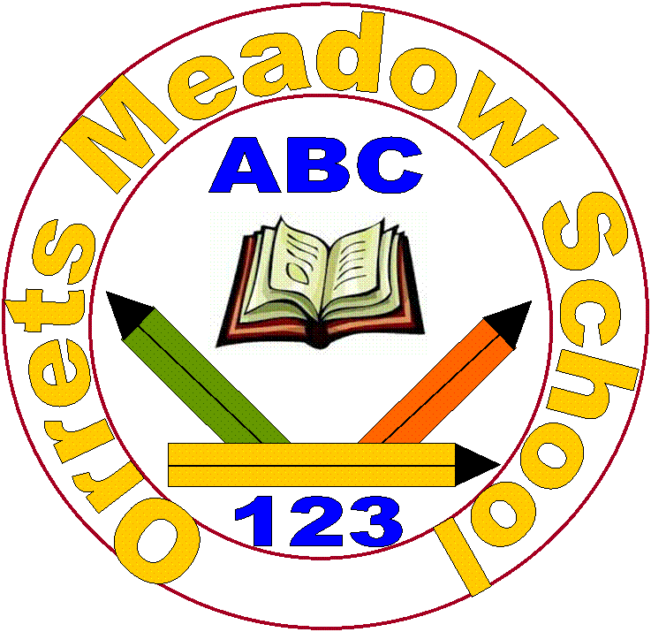

**Governors Report – Summer 2024**

**History**

**Mr Eóin M Campbell**

**Achievements**

While composing this 2024 summary report, we had the ‘visit from our friends’ at OFSTED. This was much anticipated and yet, given the level of confidence but never complacency, the Orrets team believed that our Dimensions topic subjects were and are a highlight of the curriculum. This proved to concur with OFSTED’s findings. The following are just some statements by the lead HMI inspector:

“Pupils experience many trips which bring the curriculum to life for them” – “The school’s curriculum is expertly crafted”. Given that virtually every trip, be that to Speke Hall, Birkenhead Park and the Docks, Port Sunlight and even West Kirby and Parkgate all have rich historical stories which intermingle perfectly in a cross curricular manner suited to our Dimensions topic curriculum.

OFSTED also recognised the detail and tenacity of our school’s topic/History decimal assessment process, tailored to our pupils’ more ‘refined’ levels of learning steps. “Staff use the systematic assessment strategies for different subjects to expertly check on pupils’ knowledge and understanding.” All things considered, the achievements of Orrets students is indeed outstanding.

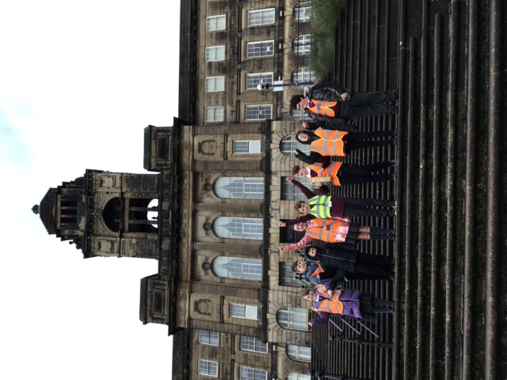 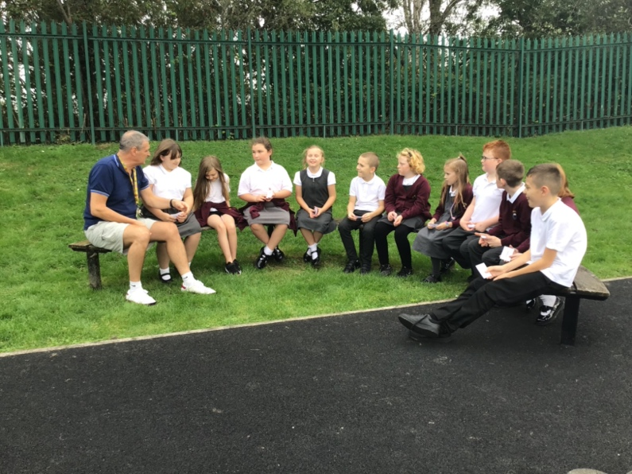

**CPD**

The Merseyside hub Zoom sessions continue to provide me with updated curriculum news and information. Also, any changes or adaptations to the curriculum are presented and discussed. Candidates on these courses tend to offer experiences an suggested resources that have worked well for them in their own practices.

History INSET has been provided regularly throughout the academic year with a focus on sharing resources, experiences of what worked well in Topic sessions and suggestions and strategies to heighten our already enthusiastic student population in History.

**Quality of teaching & learning**

The quality of teaching and learning at Orrets is indeed outstanding, but don’t take my word for it; just read what the OFSTED HMI stated in his recent report: “The school has soaring expectations for pupils’ achievement.” – “From their individual starting points, pupils make exceptional strides in their learning”. This not only refers to History but indeed all subjects. The ‘deep dives’ included a scrutiny of Topic books from pupils right through the age and ability range and focused on History. “The standard of History was commensurately high with the core subjects at Orrets Meadow.” High accolade indeed!

Book scrutinies and learning walk/observations provide enough sample information of the quality of teaching and learning here which galvanises the inspector’s assessment. Books a beautiful! They show great standards of progression and the levels of imagination and ingenuity demonstrated by the team of teachers and teaching assistants, the variety of resources and the enthusiasm demonstrated by colleagues in delivering History makes one proud to be part of the journey.

**Reviews and survey samples**

Pupil and Staff Voices remain my main sources of feedback from practitioners and learners alike. They provide me with the seed I need to review and improve the History Policy for the following year, each year. The samples returned demonstrated that the educational staff at Orrets are both enthusiastic and knowledgeable in the subject area. Staff know, should the need ever arise, where to source information and resources and that as subject lead, I’m always available to offer any subsequent guidance.

Students remain, for the whole part, highly motivated and not just in the formal subject content in any given theme or topic, but entertained by anecdotal and supplementary knowledge and information provided by staff. The fact that Emelia Earhart not only crossed the Atlantic Ocean, but that Mr Campbell’s own Grannie Burke was photographed standing by her aeroplane in Derry the day after it landed in 1932. Such nuggets of ‘sticky knowledge’ are part and parcel of what is offered at Orrets. It’s such supplementary information which brings History to life here. This is reflected in the returned Pupils Voice samples.

**Strengths in History**

History is traditionally an interesting subject for the majority of students nationally and Orrets is no exception. If interested and engaged, pupils will thrive. Such is the case with our pupil populations. Whether it be seeing photographs of the old railway station and escarpment, the machinegun turrets and the fact that Handel docked there after his first performance of The Messiah in Dublin way back in 1742; all these at Parkgate alone. Students can tell you that New Yorks’ Central Park was a copy of the world’s first ever municipal park in Birkenhead and that the first ever ferry ‘cross the Mersey was from the Priory at Birkenhead nearly a thousand years ago. This knowledge isn’t retained because it’s necessary but rather because it’s of interest to our children; and made interesting to them by the enthusiasm of our teaching team.

**Ways forward**

With a new History Lead Teacher assuming the reins in September, much of the way forward will depend on their vision for the future of History as a subject at Orrets meadow.

Therefore, my initial counsel would be to get to grips with the contents of the SL folder and acclimatise to the fundamental requirements of the leader’s role in History through the Dimensions Curriculum.

I would propose looking into local historical venues for shorter morning field trips; locations such as Bidston Hill, windmill & Observatory, Moreton Lighthouse, Fort Perch Rock in New Brighton, Woodside Ferry, the transport restoration museum at the docks and the wonderful Birkenhead Priory. Given that many of these sites have irregular and sometimes sporadic opening days and times, I would urge some flexibility on school’s behalf, given that most venues are staffed by volunteers. Their time, hence, is no doubt more appreciated.

Furthermore, each of these venues offers wholly rich historical and cross curricular content. The question would therefore be ‘how to fit everything in?’ in a morning session rather than ‘how does this fit into the curriculum?’ We have the best teaching team on the Wirral and we can more than satisfy our pupils’ historical requirements.

**Targets for 2024-2025**

|  |  |  |
| --- | --- | --- |
| **Outcomes** | **Actions Required** | **Complete by:** |
| * Extend pre curriculum offer for history | * Review the current history curriculum. * Using the EYFS framework explore opportunities to extend historical knowledge and skills. * Explore the national curriculum objectives for history to ensure smooth transition onto curriculum targets. | Ongoing Autumn and Spring |
| * Propose a History ‘learning walk schedule’ to satisfy school’s SL criteria aimed at streamlining the subject moderation process. | * Use long term plan to schedule learning walks | Autumn 24 |
| * Lead CPD to offer current best practice in history in primary; this will result in enriching, engaging and effective history lessons across the school and will include multi sensory approaches. | * Staff meeting * Monitoring of books * Pupil voice * Staff voice * Learning walks * audit of resources | Autumn 24  Spring 25  Summer 25 |
| * Ensure there is a ‘golden thread’ running through the history curriculum by focusing on one main historical idea for the whole school, eg; royalty; religion; transport (TBA) | * Staff meeting * Liverpool SI discussions * Own research | Summer 25 |
| * Investigate outside professionals for CPD (Mr T does history for example) to focus on specific areas. | * Research online * Liverpool SI discussions | Summer 25 |
| * Focus on resourcing classes in inventive ways with minimal budget, so that their classrooms are immersive for the children during their history weeks | * Put requests out on social media * possible fundraising * ask PTA | Summer 25 |