Dear Parents/Carers

My favourite half term has arrived, the one leading up to Christmas! We have a packed half term of activities, so please take note of the dates below.

Covid
Covid is still around so can I remind you that if your child has symptoms they must get a PCR test and isolate until the result. If negative they can return to school. All adults are being recommended to test twice weekly using lateral tests. These can be picked up locally or ordered online. Staff are testing twice a week at home.

Bikeability and learn to ride

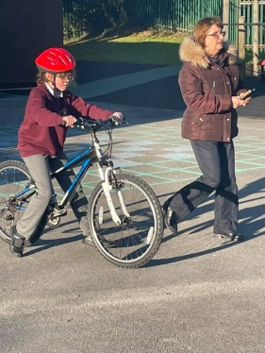
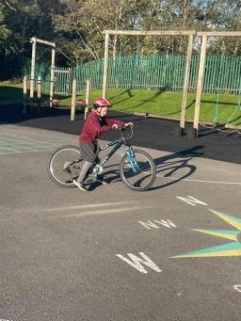
We began the week with some children learning to ride. By the end of the day the majority of them were riding independently! What a brilliant life skill! The rest of the week, the confident riders are transferring their skills to cycling safely on the roads around school.
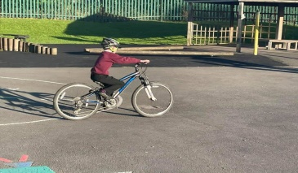

Bidston Observatory
All classes are visiting Bidston Observatory and taking part in workshops as part of bringing Science alive. Letters are going home and permission slips, plus £3.50, is required for them to attend.

Our Values
We have a new display outside of school on the wall celebrating our school values. I hope you agree that these values are what Orrets Meadow and its curriculum promote. New topics begin on Monday and so curriculum overview sheets will be coming home so you can see what your child is learning in school.

Children in Need
Friday 19th November is Children in Need day and we are inviting children to come to school in something yellow or spotty, or both if you are creative! In return can you send in £1. All money raised will go to Children in Need.

Poppies
In school we are selling poppies, slap bands, rubbers, pencils, sharpeners and reflective poppies. All are 50p except for the slap bands which are £1.50. All money goes straight to the poppy appeal.

Parent Meetings
Next week are our parent meetings. Please try to attend the appointment as it is a chance to meet your teacher and look at the fantastic work your child has produced up to now. You will be amazed by the progress they make in a short amount of time. Appointments have been sent home to you. Please return the attached slip to school.

Photographs
On Friday 12th November Tempest will be in school taking individual photographs. If your child has a sibling at school then we will take a photo of both of them, along with individual ones.

Christmas Cards and gifts
The Christmas and gift orders have arrived in school. Cards will be sent home with the children, however if you have ordered mugs and items which could break we will call you and ask you to pick them up. Thank you supporting school buying items. It raised £150 for school funds which will be spent on the children.

Medicine
Please remember if your child requires calpol, we are only allowed to administer it in school for up to 3 days, then you should visit a doctor. A short term medicine form needs signing and you are required to send a bottle of calpol in. We have an emergency bottle in school, but we can only give this if we can contact you and we know if they have already had calpol, when and how much. We cannot give Ibuprofen in school.

Important Dates for November

1st November Bikeability for Year 6 – Tues, Wed, Thurs, Fri
8th November New topics begin – curriculum letter will be sent home
Giraffes and Foxes to Bidston Observatory – letter and £3.50
Full of Beans starts for Wolves, Bears and Giraffes (6 wks)
10th November Sharks and Tigers to Bidston Observatory – letter and £3.50
11th November Judo starts for Sharks and Year 6 pupils in final year in Foxes (5wks)
12th November Individual photographs
18th November DT Day – whole school
19th November DT Day – whole school
Children in Need – wear yellow and/or spots - £1
22nd November Owls to Bidston Observatory – letter and £3.50
24th November Wolves and Bears to Bidston Observatory – letter and £3.50
Michelle’s coffee morning 10am
29th November Owls to Chester Zoo - £1

Thank you for your continued support,

Yours Sincerely

