Governors Report – Summer 2021
Design and Technology
Mrs Gordon
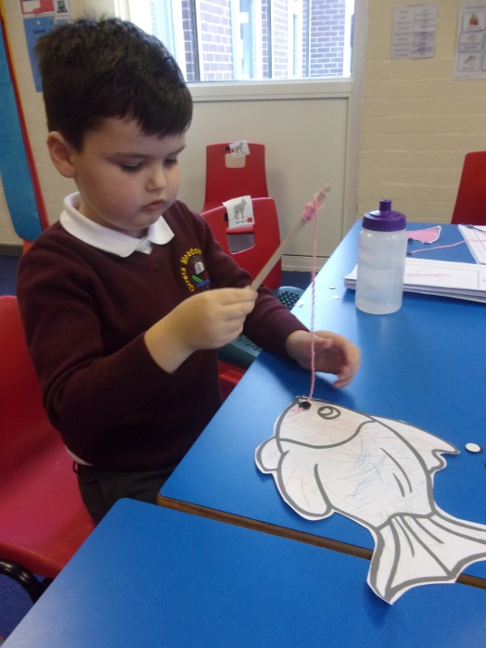
Achievements
During this year Design and Technology has become more embedded in the afternoon curriculum through the delivery of the Dimensions Curriculum where Design and Technology is implemented through a series of focused projects that engage and excite pupils and staff.
The two Design and Technology days in the Autumn Term were a fantastic opportunity for the pupils to really get to grips with the design process though to making finished products they could take home to show and talk about to parents and carers. These days also provided the time to cover aspects of Design and Technology that enriched the current Dimensions content such as Levers and Linkages, structures, mechanisms and Textiles. Pupils could really let their imaginations run wild to create moving pictures, pop up cards and investigate how toys work.

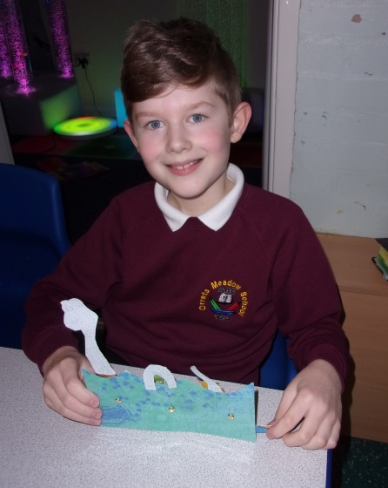
Quality of teaching and learning
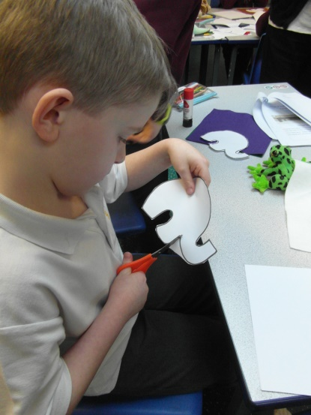
As subject leader I have completed a range of outcomes to oversee DT this year to ensure the high quality of teaching and learning . I have created a detailed and comprehensive subject leader file that contains the new DT policy and progression of skills that I created in June 2020. I have carried out a lesson Key Stage 1 observation, staff and pupil voice including analysis. Book scrutiny's of DT coverage in Dimensions and the Design and Technology days teaching enabled me to monitor the quality and ensure teaching followed the long term plan as accurately as possible during this challenging year.

Finally I carried out a data analysis of progress across the school. From this I was able to see patterns in the data which showed how boys and pupil premium pupils made less progress in DT therefore I will monitor this target group next year.

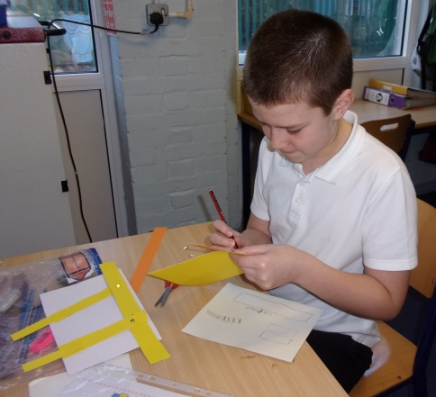
CPD
Due to Covid restrictions CPD opportunities became available on line via Zoom. I attended the Subject Leader Briefings each term provided by the School Improvement Liverpool Hub. These were an excellent opportunity to reflect on what Design and Technology looks like in school and how to move forward with areas such as Diversity and Inclusion in Design and Design Appreciation.

Strengths
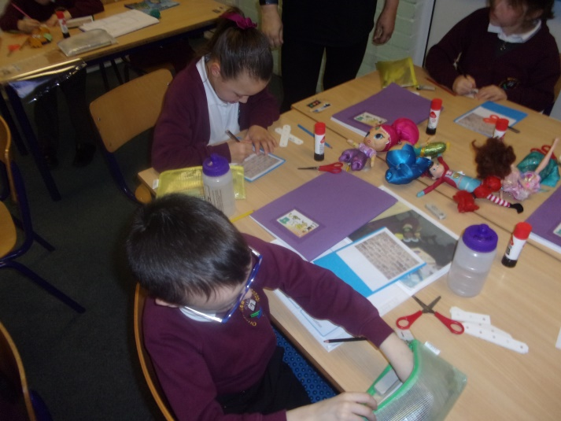
The two specific Design and Technology Days in the Autumn term demonstrated how enthusiastic and receptive the pupils are to learning in DT. This is due to the creative approaches to teaching and excellent differentiation to the pupils’ levels. Pupils could verbalise what they have learnt and enjoyed in DT on these days and a powerful 100% of pupils voiced they enjoyed their DT days. Staff were equally as positive through the staff voice questionnaire about their confidence in teaching DT and have chosen to cover additional DT in their Wonders of Wirral Scheme of work to address any gaps in learning due to Covid restrictions.

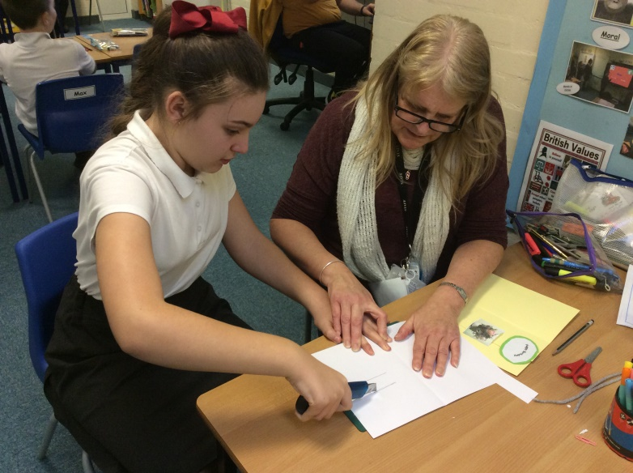
2021-2022 targets
• To promote the awareness of diversity and inclusion in DT Dimensions Curriculum (across the year)
• To monitor boys and pupil premium groups progress in DT (February and July)
• To lead a staff meeting to support teaching staff with delivery of DT days (3/11/21)

