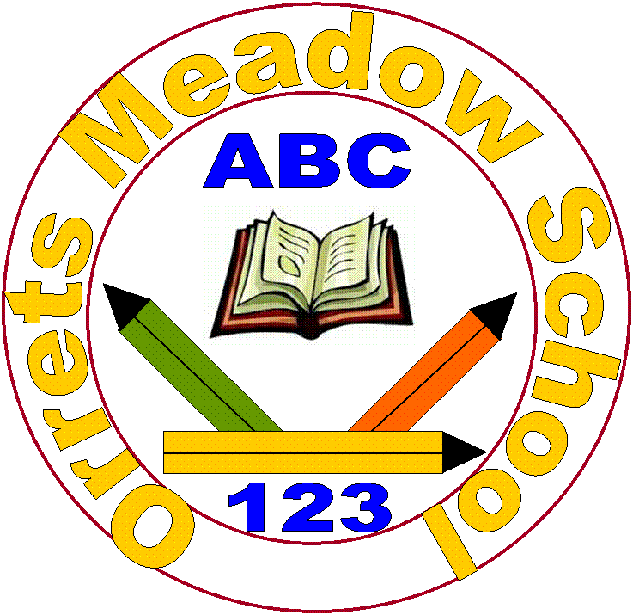
Orrets Meadow School
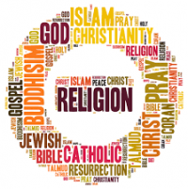
Religious Education Policy

“To raise the aspirations of every child and give them confidence to fulfil their potential through positive experiences”

Orrets Meadow Curriculum Aims and Values
Aims
To ensure all our children are at the centre of a broad, varied and interesting learning experience that is enjoyable and relevant for the future. Our creative, multisensory curriculum will create a sense of awe and wonder and help to inspire a lifelong love of learning. The holistic nature of our practice will promote positive mental health and well-being and will enhance our children’s life skills, social skills and cultural awareness.
Values
Our curriculum will promote a range of values including:
- Respect
- Empathy
- Responsibility
- Equality
- Independence
- Happiness
- Resilience
- Gratitude
- Honesty
- Friendship
Intent
Introduction
Religious Education plays an important role in the curriculum since every pupil in a maintained school has a statutory entitlement to religious education. This entitlement must be for all pupils regardless of their faith or belief. In the teaching of RE and Worldviews, we should ensure that all pupils ensure that all pupils enjoy their learning and have opportunities to succeed, whatever their individual needs or barriers to learning may be. Pupils need to understand the role and significance of religion in the modern world, the important beliefs and values that shape it; and the impact religion has on many people’s lives, and especially on communities.

Aims
- To support the development of children’s own values and to contribute to their spiritual, moral, social and cultural development.
- To encourage interpretation of and response to a variety of religious concepts, beliefs and practice within their own and others cultural and life experiences.
- To encourage the fostering of a responsible and caring attitude towards each other, through an awareness of themselves and their relationships with others in the community.
- To prepare children for the responsibilities, opportunities and experiences of later life.
- To provide equality of opportunity for all children, regardless of age, ability, ethnicity, gender or race.
Implementation

When is Religious Education taught?
Religious Education is taught through discrete weekly sessions every other half term. The Long Term Plan maps out the topics taught in these weekly sessions for each year group. We follow the schemes of work from the Wirral Agreed Syllabus.
World Religions are taught at KS2 through the Dimensions Topic: A World of Difference and every Spring Term each class spends a whole week studying a world religion and experiencing the faith through visits to religious building or welcoming visitors from that faith to their class.
The themed Christmas week is planned to include Christmas around the world where each class learn how Christmas is celebrated in different cultures. The Christian Christmas story is also studied from different perspectives through the classes to enable a progression of understanding through the school.
We enjoy many planned trips to Liverpool Cathedrals, Wirral Deen Centre and other religious buildings to give the children the opportunity to experience different religious buildings and enhance Cultural Capital in RE.

SMSC contributes significantly to the Religious Education curriculum. It promotes spiritual development through discussion and reflections. Moral development is promoted through studying key beliefs and teachings from religion and philosophy, values and ethical codes of practice. Social development is enhanced by investigating social issues from religious perspectives, recognizing the diversity of viewpoints within and between religions. Cultural development by promoting racial and interfaith harmony, respect for all, combating prejudice and discrimination and awareness how interfaith co-operation can support the pursuit of the common good.
Religious Education enhances PSHE, Citizenship and British Values by developing understanding to facilitate discussion
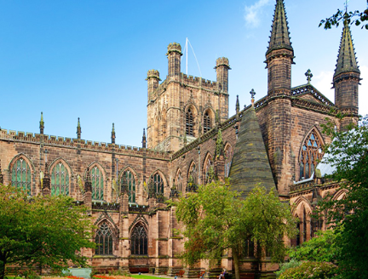
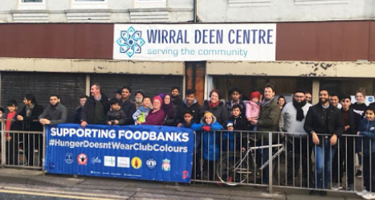

How is Religious Education taught?

Learning about religion from religion
The knowledge, skills and understanding identify the key aspects of learning in Religious Education. These are described as ‘learning about religion’ and ‘learning from religion.’ These two strands are incorporated into the single attainment target in the Wirral Agreed Syllabus for Religious Education.

Learning about religion includes enquiry into the nature of religion, including diverse beliefs, teaching, ways of life, sources, practices and forms of expression. It includes the skills of interpretation, analysis and explanation. Pupils learn to communicate their knowledge and understanding using specialist vocabulary. In the Wirral Agreed Syllabus for Religious Education ‘learning about religion’ covers pupils’ knowledge and understanding of individual religions, and how they relate to each other.

Learning from religion is concerned with developing pupils’ reflection on and response to their own and others’ experiences in the light of their learning about religion. It develops pupils’ skills of application, interpretation and evaluation of what they learn about religion. Pupils learn to develop and communicate their own ideas, particularly in relation to the questions of identity and belonging, meaning, purpose, faith/belief, values and commitments.

Pupils at Orrets Meadow have ASD and additional needs, so consideration needs to be given to how we teach Religious Education. All of our pupils are working at least two years behind their chronological age and so the curriculum is adapted to meet the stage they are working at and strategies are used to best meet their needs.
We acknowledge our children’s different learning styles and encourage learning through active participation in drama, stories, song, video clips, interactive teaching walls, scrap book making, ICT, art and all creative ways which extend and embed RE skills.




“Science without religion is lame,
Religion without science is blind”
Albert Einstein
“I believe that religious education must be the sole concern of religious associations.”
Ghandi

Religious Education Long Term Plan

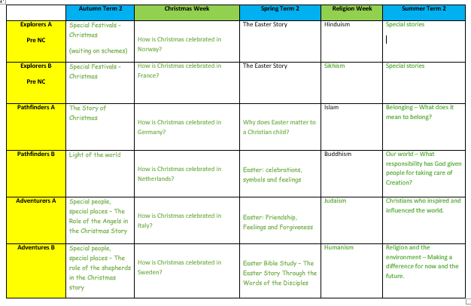

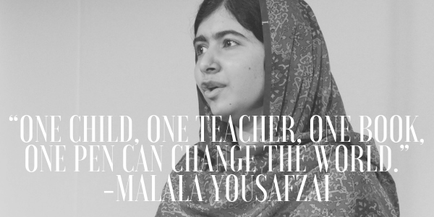

Skills Progression

Explorers | Recognise that people have different beliefs and celebrate special times in different ways.  Know some similarities and differences between different religious and cultural communities in this country.
Pathfinders  A & B | Begin to identify the importance of religion and special beliefs to some people.  Identify and begin to suggest meanings for religious symbols.  Begin to use a range of religious and moral words.  Begin to identify religious and spiritual feelings and concepts.  Name and explore a range of celebrations.  Begin to recognise the importance of celebrations and worship to communities, families and individuals.  Begin to reflect on how moral and spiritual values relate to their own behaviour.  Begin to respond to a range of religious stories and scared texts.
Adventurers  A & B | Interpret how symbols are used to express beliefs.  Recognise that some people can have different identities, beliefs and practices and different ways of belonging.  Develop the use religious and moral words.  Explore and discuss religious and moral stories and sacred texts.  Investigate the similarities and differences of celebrations, worship and rituals across different religions and faiths.  Respond to questions around beliefs and give opinions
Navigators  A & B | Recognise, describe and discuss some key aspects of religions and beliefs.  Recognise and explore the significance and impact of religion and belief in some local, national and global communities.  Consider the meaning of a range of forms of religious expression, identifying why they are important in religion and noting links between them.  Reflect on the challenges of belonging and commitment in their own lives and within traditions.  Reflect on ideas of right and wrong and their own and others’ responses to them.  Respond to the meaning of a range of forms of religious expression, identifying why they are important in religion and noting links between them.

Impact

How do we assess and monitor Religious Education

Using a simple decimal grading system for our assessment allows staff to record even the smallest steps of progress by our pupils. The first digit in the given number represents the year group that a child is working at and the second is the level at how they are achieving within that given grouping. Teachers can quickly identify where a given student is and how this related to their peerage in each class. This method of assessment is used twice yearly in March and July. It is recorded in the Foundation subject tracker where RE attainment can be assessed and analysed by SLT, subject leaders and teachers.

As many of our pupils have short term memory difficulties, they find retaining knowledge especially difficult, so we use Kahoot quizzes throughout the units to support them remember ‘Sticky Knowledge’. These quizzes make learning fun, engaging and impactful. Teachers can create their own to introduce the topic, review and reinforce knowledge and use the information gained to help them identify which objectives have been achieved.

SLT, teachers and subject leaders use assessment for learning to inform planning, teaching and learning and CPD opportunities.

SLT and subject leaders are continuously monitoring their subject to ensure it meets the needs of our pupils. They monitor using a variety of activities, including:

- Learning walks
- Book scrutiny
- Lesson observations
- Pupil survey and discussions
- Staff survey and discussions

