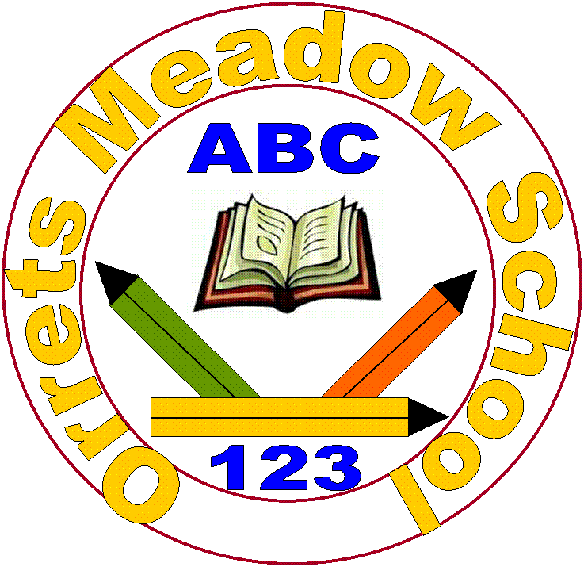

Progression in Grammar
Pre NC | Sentence  - Combining words to make labels, captions, lists, phrases and short sentences.  - Joining words using and joining words and clauses using ‘and’  Text  - Sequence spoken sentences to form short narrative orally.  - Help retell stories orally by  - Using repeated story language  - Using time adverbials eg. First, then, next, suddenly  Punctuation  - Letter formation  - Separation of words with spaces  - Personal pronoun I  - Capital letters  - Full stops  - Capital letters for names
Y1 | Sentence Structure  - How words can combine to make sentences  - Joining words and joining sentences using and  Text Structure  - Sequencing sentences to form short narratives  Punctuation  - Separation of words with spaces  - Introduction of capital letters, full stops, question marks and exclamation marks to demarcate sentences.  - Capital letters for names and the personal pronoun I
Y2 | Sentence Structure  - Subordination (using when, if, that, because) and co-ordination (using or, and, or but).  - Expanded noun phrases for description and specification  - How the grammatical patterns in a sentence indicate its function as a statement, question, exclamation or command.  Text Structure  - Correct choice and consistent use of present tense and past tense throughout writing.  - Use of the progressive form of verbs in the present and past tense to mark actions in progress  Punctuation  - Use of capital letters, full stops, question marks and exclamation marks to demarcate sentences.  - Commas to separate items in a list.  - Apostrophes to mark where letters are missing in spelling and to mark singular possession in nouns.
Y3 | Sentence Structure  - Expressing time, place and course using conjunction, adverbs or prepositions  Text Structure  - Introduction to paragraphs as a way to group related material  - Headings and sub-headings to aid presentations  - Use of the present perfect form of verbs instead of the simple past  Punctuation  - Introduction to inverted commas to punctuation direct speech
Y4 | Sentence Structure  - Noun phases expanded by the addition of modifying adjectives, nouns and preposition phrases (e.g. the teacher expanded to: the strict maths teacher with curly hair).  - Fronted adverbials (e.g. Later that day, I heard bad news).  Text Structure  - Use paragraphs to organise ideas around a theme.  - Appropriate choice of pronoun and noun within and across sentences to aid cohesion and avoid repetition.  Punctuation  - Use of inverted commas and other punctuation to indicate direct speech.  - Apostrophes to mark plural possession.  - Use of commas after fronted adverbials.

