**Governor Report- Summer 2024**

**Music**

**Charlotte O’Brien**

**Achievements**

In September all children took part in a Musical Monday Body Percussion afternoon. Each class listened to a song, created body percussion rhythms and patterns and performed their creations for their class. The children had the opportunity to work through the four strands of musical learning on a short project.

All teachers, supported by TAs, continue to contribute video evidence of their children’s achievements in music to demonstrate progression across the music curriculum. We are building up a video collection that demonstrates the progress children make in Music at Orrets Meadow.

In the Autumn Term I added pre-curriculum objectives to the Music Progression document, which will be developed further next year into Pre-curriculum Musical Steps.

Musician of the Month was launched in classes in October and has proven quite popular, particularly with staff! So far, we have investigated artist as diverse as Reem Kelani a Traditional Palestinian Artist, by way of Fisherman’s Friend to Mozart, covering a wide range of musical genres from across the world.

During June Year 6 children attended the KS2 Concert at the Liverpool Philharmonic Hall to enhance their curriculum. The children loved listening to a live orchestra and singing a shared song with a large group of people.

In Cultural Week children explored Music from different cultures. In PSHE Week children all had the opportunity to explore Music and Mindfulness and make links between their emotions and music using BBC Mood boosters amongst other resources.

Throughout the year children have enjoyed Music Club and Karaoke Club. Children have attended the lunch club and played a variety of instruments, played percussion, played simple tunes on chime bars and boom whackers, sang karaoke and made-up dances to music.

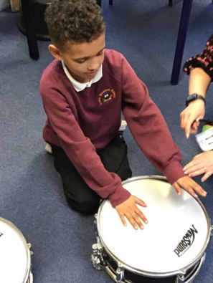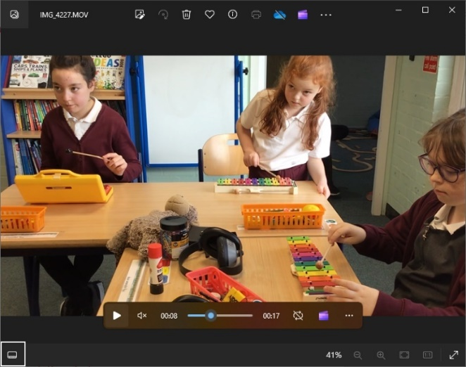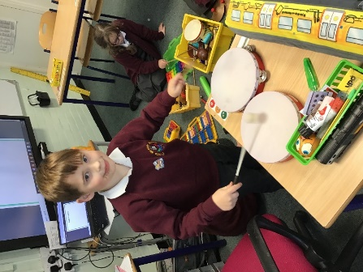

**CPD**

1. **Musical Monday Briefing**

Prior to the Musical Monday afternoon in September, staff took part in training to develop knowledge and ideas bout Body Percussion and musical vocabulary.

1. **Introduction the Charanga Workshop 22/11/24**

I attended the Charanga Workshop at Thingwall Primary School to review the Interactive resources before proposing we buy in the product to enhance our curriculum. Charanga is a very thorough programme which supports non-specialist teachers to deliver high level Music with confidence. In consultation with Mrs Duncan, it has been agreed that we will use Charanga to teach Musical Mondays once each term next academic year.

1. **Digit Music: Digital Music for a Modern Music Curriculum 17/1/24 (watched on catch up)**

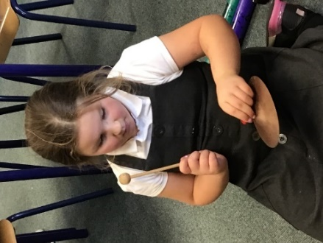Through Music Mark, I was able to attend a Digit Music Workshop via Zoom with a view to extending our digital Musical offer in the future.

1. **Music Update Staff Meeting 8/5/24**

Early in the Summer Term I led a Music Update Staff Meeting. We reviewed the latest research and looked at the Ofsted Music Curriculum Summary. We discussed the summaries of both the Staff and Children’s voice surveys and the ways forward arising from the February data analysis. Staff were introduced to the new plan for Musical Mondays and then given time to explore Charanga which they will be using to teach next year.

**Quality of teaching and learning**

To monitor the quality of teaching and learning in Music, a Music Leader’s file is kept updated. All the relevant policies and documents are kept in one central place. The Dimensions Curriculum has been reviewed to ensure the objectives from the national curriculum are met. An audit of musical instruments available for composition and performance in school is shared with all staff. The music policy has been updated to include suggestions from the Model Music Curriculum.

This year we met with teachers from Hayfield School to moderate our curricula and share best practice in music.

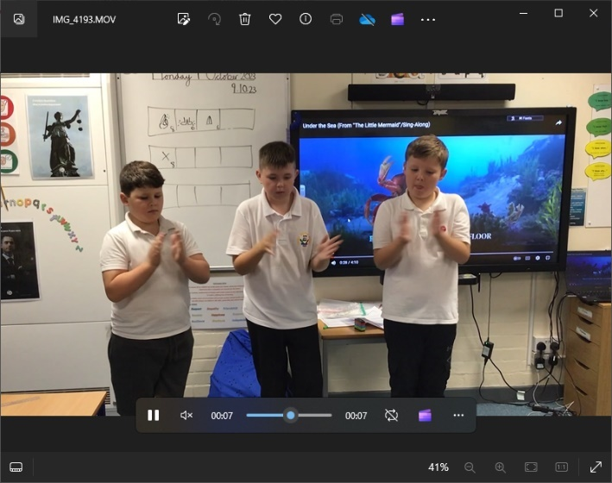The Children’s Music Survey showed that Music is a popular subject across school with 88% of children saying they like Music a lot. The Teachers Surveys showed that they are all confident in teaching music in their classrooms and enjoy delivering a wide variety of music genres and eras. As requested by teachers, Charanga has been bought to enhance their teaching of music and plans are underway to include additional Music Afternoons in the next academic year. Live Music Now, who have hosted Zoom meetings with music professionals will be hosting live in-person visits for musician to schools.

During the Musical Monday afternoon in the Autumn Term, I was able to conduct a Learning Walk to observe music being taught throughout school. It was delightful to see the range activities going on adapted to the ages and stages of the classes. Progression of skill was clear in the activities being accessed and achievements made by the children in these sessions.

Over the year children have accessed a wide range of songs and music from across the world via the Dimensions curriculum. Book scrutiny and show progress across the school that meets the objectives of the National Curriculum. Biannual reviews of music assessment data show children made steady progress in music as they progress through school.

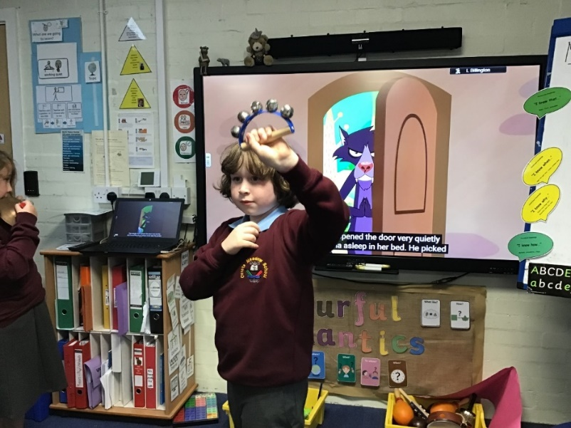Strengths

* Robust curriculum that meets all the demands of the National Curriculum and beyond.
* Confident, enthusiastic teachers who adapt the curriculum to meet the needs of their pupils.
* Wide range of multisensory resources to support skill development across the school.

Ways forward

* Implement Musical Monday’s using Charanga to supplement teaching and learning in Music.
* Liaise with Edsential to organise ‘First Access Drumming’ Unit in Autumn Term.
* Attend Expressive Arts SEN Subject Leader Group to build links with other special school and support each other best practice.
* Explore the possibility of visiting musicians.

**Targets 2024-2025**

* Implement Musical Mondays each term
  + Live Music Now Concerts
  + Teacher Lead based on Charanga Units (Beginning Autumn 2024)
* Liaise Edsential to organise ‘First Access Drumming Project’ (Autumn 2024)
* Explore Hullabaloo Music as an alternative for Charnaga <https://teachhullabaloomusic.com/>
* Increase and update Instrument Inventory (September 2024)
* Class set of Djembe Drums <https://www.drumsforschools.com/primary-school-music/>
* Book Philharmonic Concerts for KS1 and KS2 Classes (Autumn 2024)
* Develop Pre-Curriculum Steps for Music based on Sounds of Intent (Spring 2025)
* Continue to support Music for Mindfulness and Music from different cultures. (Spring and Summer 2025)
* Update the Music Offer (Summer 2025)

