 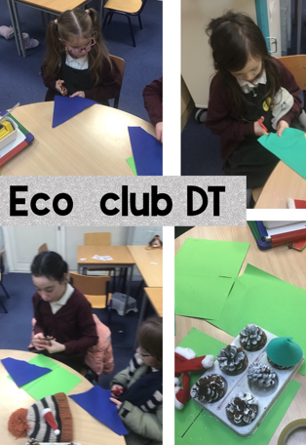

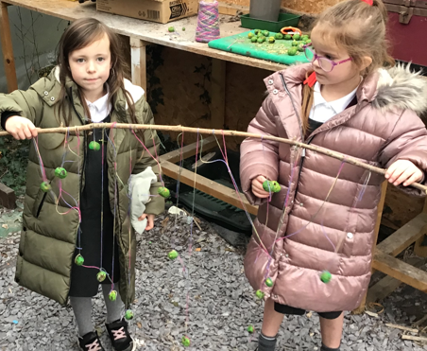

**Governors Report – Summer 2024**

***Design and Technology***

***Subject leader: Jane Gordon***

**Achievements**

The ‘ways forward’ identified last year from this year’s school development plan and the actions taken:

* **To build fluency in Design and Technology lessons.**

During my staff meeting in the Autumn term, I focused on practical activities designed to help teaching staff plan and create fluency skills to enhance our Design and Technology lessons. We aimed to equip ourselves with the necessary tools and strategies to ensure our students develop the practical skills necessary achieve robust practical outcomes. We enjoyed working collaboratively to cultivate a culture of creativity and innovation within our school!

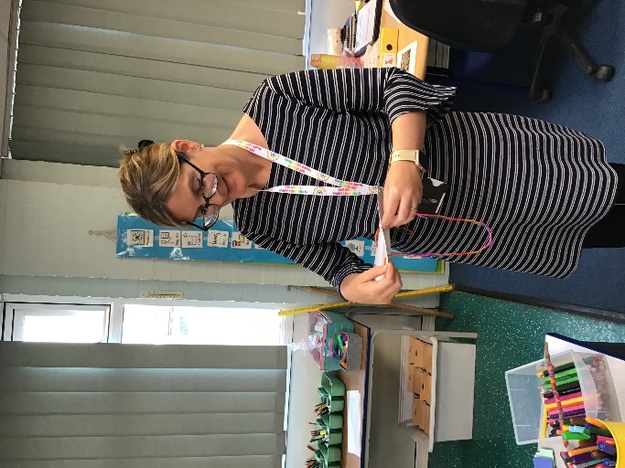 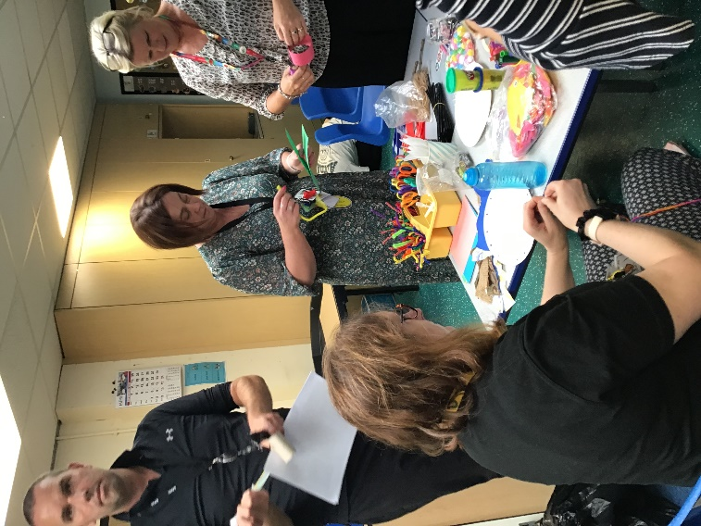 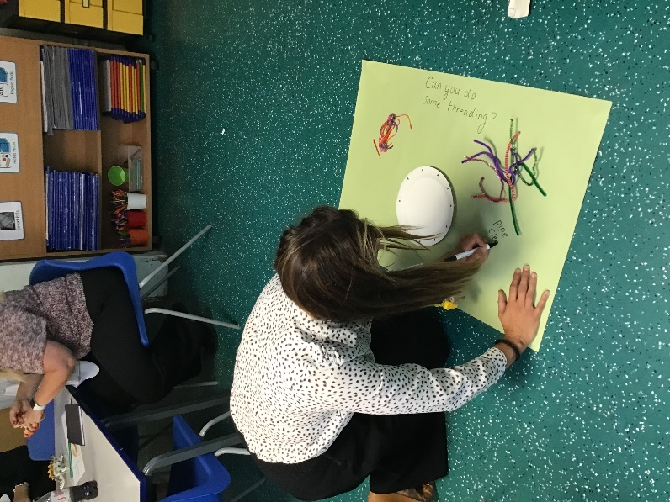

* **Create a bank of ideas to promote how Design and Technology is adapted to meet our children’s needs.**

As subject leader, I created a bank of ideas on how staff can adapt their teaching of Design and Technology to meet the varying needs of their student cohorts. By conducting a staff survey, we are utilising the wealth of knowledge and experience within our team to enhance our lessons and activities. Exploring different materials and equipment options enables us to cater to the diverse learning styles of our students. Additionally, we continue to leverage the support of our teaching assistants to ensure we effectively meet the individual needs of our learners.

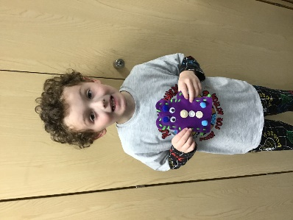 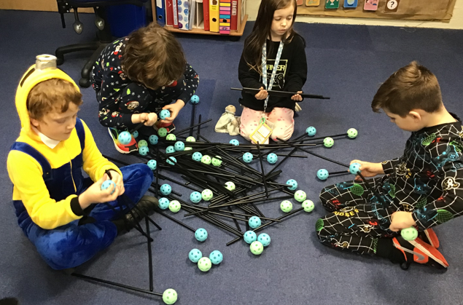 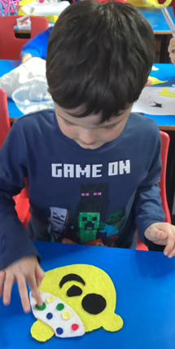 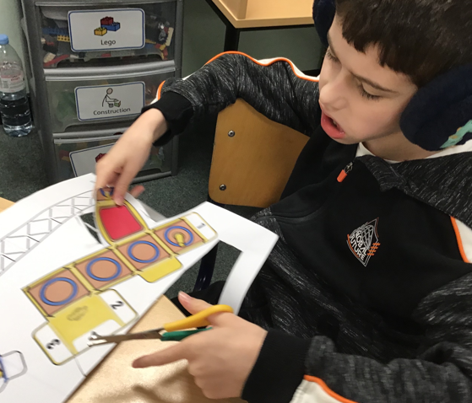

* **To create a tool kit document to sequence the learning in Design and Technology that enables our children to recognise the different elements of the design process.**

I have successfully devised a toolkit to structure the Design and Technology learning experience for our students to understand the various design process components. Additionally, I have constructed a straightforward classroom display accessible to all classes during DT lessons. This display aids pupils in tracking and comprehending their progress within the design stages.

* **For Design and Technology Focus Days to be celebrated throgh class hall displays.**

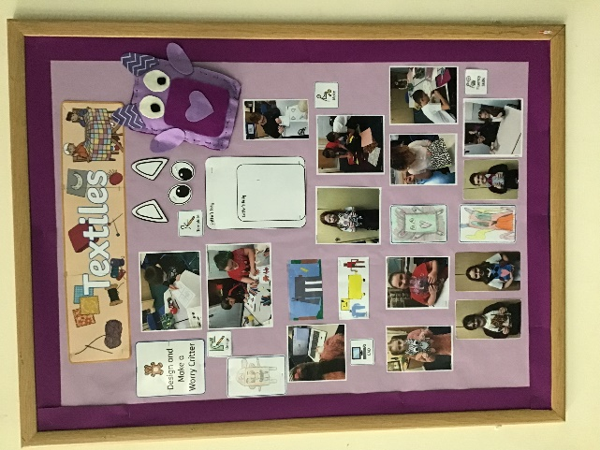Governors have acknowledged the successful implementation of Design and Technology Focus Days across classes, with each class teacher creating a hall display showcasing their students' outstanding achievements in DT. These displays not only celebrate the innovative work undertaken during DT focus days but also reflect the dedication and creativity of our students. Such initiatives play a crucial role in promoting excellence in design and technology education within our school community.

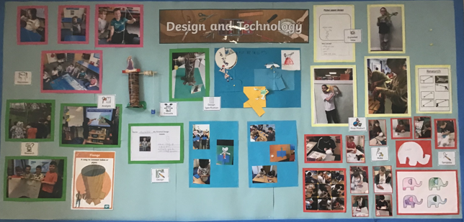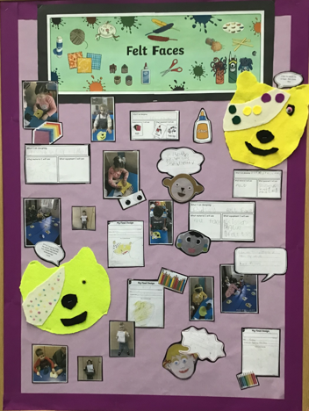

**CPD**

This year, I have engaged in termly online training in art through the School Improvement Liverpool Design and Technology Subject Leader Briefing. These briefings have provided valuable insights and up-to-date information on the effective teaching and learning practices in design and technology. Furthermore, my membership in the Design and Technology Association (DATA) has facilitated the initiation of the application process for the design and technology award, following the completion of a subject audit using their Self Review tool last year. As part of our continuous professional development, all teaching staff have access to a range of resources and online training opportunities through DATA to meet their specific teaching and developmental needs. Staff meetings have also emphasised the importance of fluency activities, creating adaptations for enhanced teaching and learning experiences, and maintaining high standards in the coverage and documentation of design and technology to further elevate our educational standards.

**Quality of teaching learning**

As subject leader, I have conducted various monitoring activities this academic year to uphold the exemplary standard of teaching and learning in Design and Technology. Notably, I undertook a Key Stage 2 lesson observation, during which I witnessed a fabulous lesson on the creation and evaluation of a 'Hairy Trousers for the Vikings' project. This lesson showcased a diverse set of creative and interactive tasks tailored to cater to the varying learning preferences of the pupils. Additionally, throughout DT Focus Days, I conducted learning walks and observed the enhancement of practical skills and building fluency, cultural knowledge, and enrichment activities such as food tasting, understanding food origins, healthy meal concepts, and architectural explorations leading to the construction of personal dens and shelters. The academic year also saw engaging activities such as kite making, puppet designing and sewing, and crafting stuffed animals for a charity sale at the Zoo gift shop. Thorough scrutiny of books, data analysis, as well as surveys involving both pupils and staff were diligently carried out and examined to reinforce the ongoing delivery of excellent teaching practices and effective learning experiences within the classroom.

**What were the strengths in your subject you found this year from all your moderation activities?**

• The DT Focus days show a clear development of children’s designing, making, and evaluating skills, fostering resilience and self-esteem.

• High-quality work in dimensions and class DT floor books.

• Staff create opportunities for building fluency in DT

• Staff enthusiasm in delivering Focus days and the Dimensions DT curriculum.

• Eye-catching hall displays celebrating DT focus days.

Design and Technology has excelled this year in developing students' design and problem-solving skills through DT Focus days. The high standard of work in DT floor books reflects outstanding craftsmanship. Staff have effectively nurtured students' fluency in DT and delivered the curriculum with enthusiasm. The visually striking hall displays celebrating DT focus days have highlighted students' achievements.

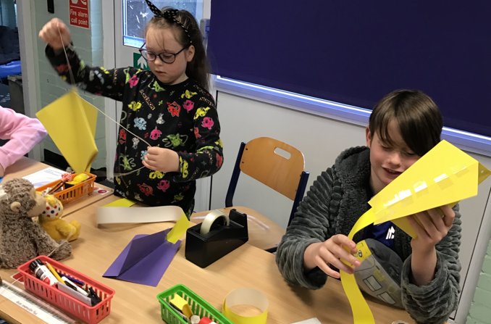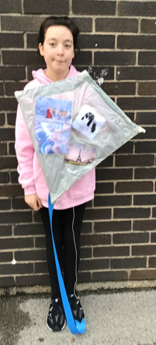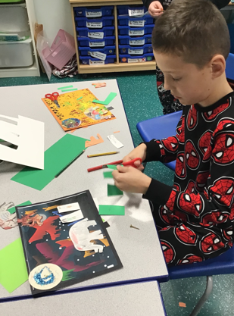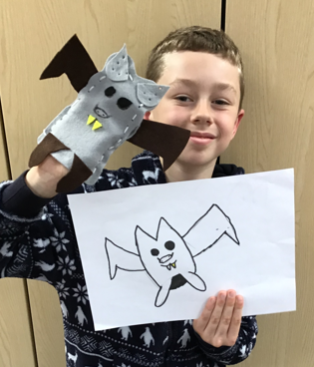

**Ways forward**

* Develop Steps levels for Design and Technology progression of skills – Autumn 2
* Introduce and support the use of risk assessments when carrying out DT lessons – Spring 1 staff meeting
* Research and cost updated CAD teaching opportunities and training – Summer 1
* To audit teaching and learning resources and aids - Autumn 1
* Research and purchase construction kit opportunities for school – Autumn 1