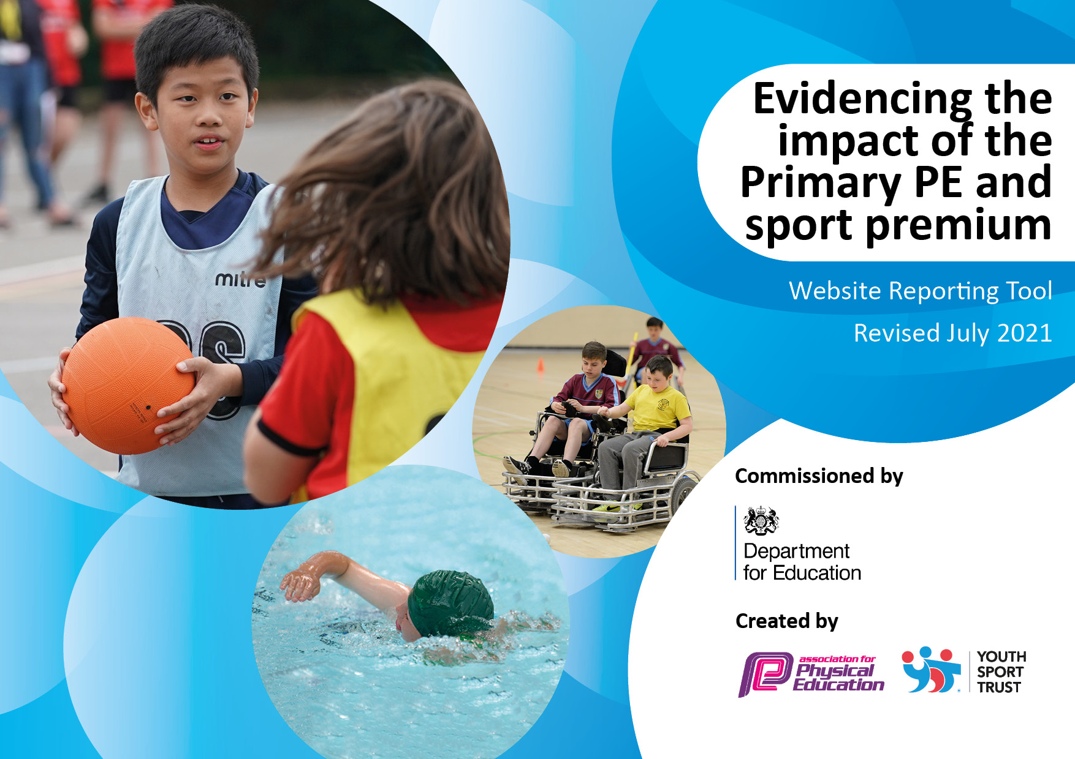
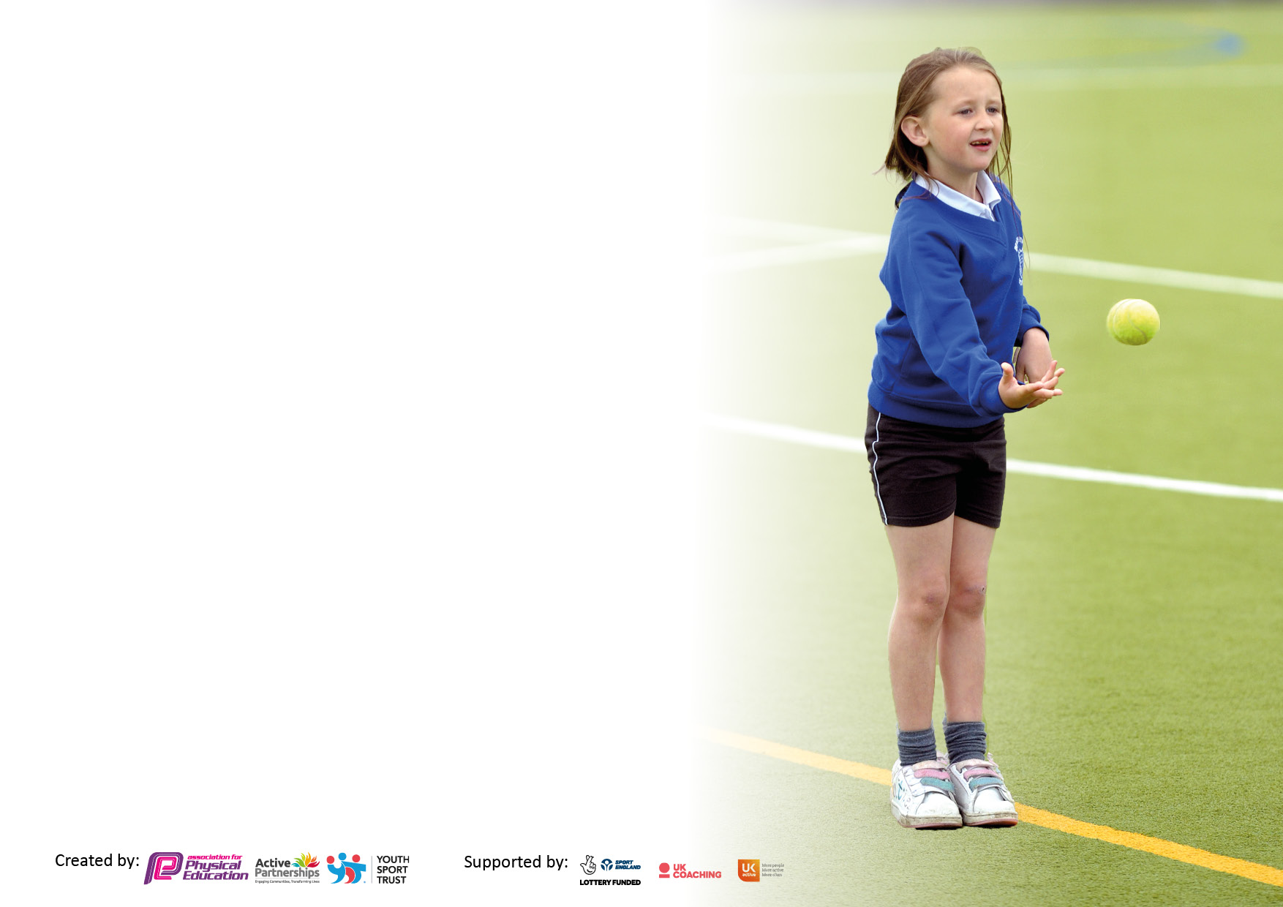

It is important that your grant is used effectively and based on school need. The Education Inspection Framework makes clear there will be a focus on ‘whether leaders and those responsible for governors all understand their respective roles and perform these in a way that enhances the effectiveness of the school’.

Under the Quality of Education Ofsted inspectors consider:
Intent - Curriculum design, coverage and appropriateness
Implementation - Curriculum delivery, Teaching (pedagogy) and Assessment
Impact - Attainment and progress

To assist schools with common transferable language this template has been developed to utilise the same three headings which should make your plans easily transferable between working documents.

Schools must use the funding to make additional and sustainable improvements to the quality of Physical Education, School Sport and Physical Activity (PESSPA) they offer. This means that you should use the Primary PE and sport premium to:

- Develop or add to the PESSPA activities that your school already offer
- Build capacity and capability within the school to ensure that improvements made now will benefit pupils joining the school in future years
- The Primary PE and sport premium should not be used to fund capital spend projects; the school’s budget should fund these.

Pleasevisitgov.ukfortherevisedDfEguidanceincludingthe5keyindicatorsacrosswhichschoolsshoulddemonstrate animprovement.Thisdocumentwillhelpyoutoreviewyourprovisionandtoreportyourspend.DfEencouragesschools to use this template as an effective way of meeting the reporting requirements of the Primary PE and sport premium.

We recommend you start by reflecting on the impact of current provision and reviewing the previous spend.

Schools are required to publish details of how they spend this funding, including any under-spend from 2019/2020, as well as on the impact it has on pupils’ PE and sport participation and attainment. All funding must be spent by 31st July 2022.

We recommend regularly updating the table and publishing it on your website throughout the year. This evidences your ongoing self-evaluation of how you are using the funding to secure maximum, sustainable impact. Final copy must be posted on your website by the end of the academic year and no later than the 31st July 2021. To see an example of how to complete the table please click HERE.
Created by: Supported by:

Details with regard to funding
Please complete the table below.

Total amount carried over from 2020/21 | £0
Total amount allocated for 2021/22 | £16330
How much (if any) do you intend to carry over from this total fund into 2022/23? | £0
Total amount allocated for 2022/23 | £16700
Total amount of funding for 2022/23. To be spent and reported on by 31st July 2023. | £16700
Swimming Data
Please report on your Swimming Data below.

Meeting national curriculum requirements for swimming and water safety.

N.B. Complete this section to your best ability. For example you might have practised safe self-rescue techniques on dry land which you can then transfer to the pool when school swimming restarts.
Due to exceptional circumstances priority should be given to ensuring that pupils can perform safe self rescue even if they do not fully meet the first two requirements of the NC programme of study
What percentage of your current Year 6 cohort swim competently, confidently and proficiently over a distance of at least 25 metres?  N.B. Even though your pupils may swim in another year please report on their attainment on leaving primary school at the end of the summer term 2021.  Please see note above | 70%
What percentage of your current Year 6 cohort use a range of strokes effectively [for example, front crawl, backstroke and breaststroke]?  Please see note above | 45%
What percentage of your current Year 6 cohort perform safe self-rescue in different water-based situations? | 40%
Schools can choose to use the Primary PE and sport premium to provide additional provision for swimming but this must be for activity over and above the national curriculum requirements. Have you used it in this way? | No

Action Plan and Budget Tracking
Capture your intended annual spend against the 5 key indicators. Clarify the success criteria and evidence of impact that you intend to measure to evaluate for pupils today and for the future.

Academic Year: 2022/23 | Total fund allocated: £16,700 | Date Updated: December 2022
Key indicator 1: The engagement of all pupils in regular physical activity – Chief Medical Officers guidelines recommend that primary school pupils undertake at least 30 minutes of physical activity a day in school |  |  |  | Percentage of total allocation:
 |  |  |  | Approx. 20%
Intent | Implementation |  | Impact
Your school focus should be clear what you want the pupils to know and be able to do and about  what they need to learn and to  consolidate through practice: | Make sure your actions to achieve are linked to your intentions: | Funding allocated: | Evidence of impact: what do pupils now know and what can they now do? What has changed?: | Sustainability and suggested next steps:
Increase physical activity levels of children across the whole-school | - Pitch Hire  - Use SHEU survey to offer new clubs to less active children  - Fit Fun Fests in partnership with Clare Mount Specialist Sports College designed for less active pupils  - Continue to provide a wide range of PE and sport activities (informed by SHEU and pupil voice)  - Magic Mile  - Launch 60 second physical activity challenges (YST) | £1800  £300  Clare Mount Specialist Sports College SLA (£3500)  £300 | - Fit Fun Fest October 2022: 10 children enjoyed a rugby festival - a carousel of inclusive activities with Rugby World Cup theme. The activities on offer supported personal development through exploring communication, confidence, self esteem and resilience.  - Fit Fun Fest December 2022: 15 children enjoyed a carousel of inclusive activities with a Christmas theme. Children were highly engaged and physically active.  - ‘Magic Mile’ – children and staff taken part in minimum of 15mins walk/run x3 per week. Positive feedback from children and staff. Evidence of improved fitness and wellbeing. | - Physical Literacy project with Edge Hill University 2022-23  - Extend intra-school competitions
Key indicator 2: The profile of PESSPA being raised across the school as a tool for whole school improvement |  |  |  | Percentage of total allocation:
 |  |  |  | Approx. 20%
Intent | Implementation |  | Impact
Your school focus should be clear what you want the pupils to know and be able to do and about  what they need to learn and to  consolidate through practice: | Make sure your actions to achieve are linked to your intentions: | Funding allocated: | Evidence of impact: what do pupils now know and what can they now do? What has changed?: | Sustainability and suggested next steps:
Maintain high profile of PESSPA: further develop provision of PE and mental health (on SDP 2021-22)  Improve and support physical health, fitness and well-being of all pupils  Further develop leadership opportunities (main focus on girls) | - SDP includes PE and mental health as a priority  - PE report at governor’s meetings  - Termly PE staff meetings (focusing on different areas of CPD e.g. leadership, autism in PE, My Personal Best etc.)  - Mental Health Champions training (children)  - SHEU survey to highlight issues and trends and target support  - Mental Health and Keep Safe Week  - PE TA (Level 1) to help co-ordinate and lead range of extra-curricular sports clubs and support during PE lessons  - Girls Active (YST) with aim of leading whole-school fun fitness sessions and raise activity levels | £2500 TLR  £2500 TLR release time  £3500 (SLA)  £295  £300  £400  £4000+ | - JW and DS led staff CPD on the ‘Orrets Meadow PE ethos and culture’ - best practice (November 2022). Re-cap on planning, resourcing and adapting learning (using STEP, inclusion spectrum etc.) New staff more knowledgeable about schemes of work, planning and inclusion. Staff also know what priorities for OM are and signposted to resources. | - Continue to provide a wide range of PE and sport activities (informed by SHEU and pupil voice)  - Active in Mind refresher (Spring 2023)

Key indicator 3: Increased confidence, knowledge and skills of all staff in teaching PE and sport |  |  |  | Percentage of total allocation:
 |  |  |  | Approx. 20%
Intent | Implementation |  | Impact
Your school focus should be clear | Make sure your actions to | Funding | Evidence of impact: what do | Sustainability and suggested
what you want the pupils to know | achieve are linked to your | allocated: | pupils now know and what | next steps:
and be able to do and about | intentions: |  | can they now do? What has
what they need to learn and to |  |  | changed?:
consolidate through practice:
To further develop the confidence, knowledge and skills of all staff.  To provide bespoke targeted support of PE and sport to meet the needs of staff. | - CPD: staff meetings and from external agencies through partnership with Clare Mount Specialist Sports College  - Coaching and mentoring from TLR and specialist PE staff  - New PE Scheme of Work (Edsential) and CPD from January 2023  - Opportunities for peer lesson observations (Spring/Summer 2023) | £3500 (SLA)  £3500 (SLA)  £3500 (included in SLA) | - JW and DS led staff CPD on the ‘Orrets Meadow PE ethos and culture’ - best practice (November 2022). Re-cap on planning, resourcing and adapting learning (using STEP, inclusion spectrum etc.) New staff more knowledgeable about schemes of work, planning and inclusion. Staff also know what priorities for OM are and signposted to resources.  - New teachers and TAs being supported in PE lessons by JW, using coaching model. Lesson observations showing positive impact in knowledge and confidence. Planning, delivery, lesson observations and feedback focusing on TA use of inclusion spectrum, STEP etc. | - SEND Shooting Stars - 2 teachers received training, piloted materials and will roll out in spring 2023.
Key indicator 4: Broader experience of a range of sports and activities offered to all pupils |  |  |  | Percentage of total allocation:
 |  |  |  | Approx. 20%
Intent | Implementation |  | Impact
Your school focus should be clear | Make sure your actions to | Funding | Evidence of impact: what do | Sustainability and suggested
what you want the pupils to know | achieve are linked to your | allocated: | pupils now know and what | next steps:
and be able to do and about | intentions: |  | can they now do? What has
what they need to learn and to |  |  | changed?:
consolidate through practice:
Provide a range of sports and  activities for all pupils.  Offer a range of opportunities which some children may never experience out of school.  Offer activities and links which promote lifelong physical activity and positive mental health. | - Curriculum enrichment (e.g. judo, bikeability, fencing, OAA etc.)  - Little Hobbits Forest School  - Extra-curricular festivals and event held by Clare Mount Sports College (e.g. BMX, in-line skating etc.)  - Full of Beans – 6x multi-skills sessions for 3 classes in spring and repeated in summer  - PE TA (Level 1) to help co-ordinate and lead range of extra-curricular sports clubs and support during PE lessons  - Barnstondale residential Y6  - PE Equipment | £1000  £4500  £3500 (SLA)  £300  £4000+  £500 | - Judo – Year 6 children enjoyed a 6 week block of Judo with expert coach. Extremely positive feedback. Children displayed confidence, respect and responsibility.  - Bikeability: Y6 children received cycling tuition teaching practical cycling skills and road safety. Majority of Y6 children attained Level 2 qualification.  - Extra-curricular lunch clubs e.g. football, cycling, dodgeball etc.  - Little Hobbits: 4 classes so far have had opportunity for OAA sessions including activities such as: sensory play, messy play , tree climbing, bug hunting, wood carving , campfire cooking , water play  and tool use

Key indicator 5: Increased participation in competitive sport |  |  |  | Percentage of total allocation:
 |  |  |  | Approx. 20%
Intent | Implementation |  | Impact
Your school focus should be clear | Make sure your actions to | Funding | Evidence of impact: what do | Sustainability and suggested
what you want the pupils to know | achieve are linked to your | allocated: | pupils now know and what | next steps:
and be able to do and about | intentions: |  | can they now do? What has
what they need to learn and to |  |  | changed?:
consolidate through practice:
Increase the overall number of children participating in competitive sport.  Increase physical activity levels and make a positive impact on children’s health and wellbeing. | - SHEU survey results to signpost children to their favourite activities and help design programme of events  - Clare Mount Sports College events  - Fit Fun Fests  - School Games Day and Level 1/2 events  - Local cluster events  Girls Active programme | £150  £3500 (SLA) | - Fit Fun Fest October 2022: 10 children enjoyed a rugby festival - a carousel of inclusive activities with Rugby World Cup theme. The activities on offer supported personal development through exploring communication, confidence, self esteem and resilience.  - Fit Fun Fest December 2022: 15 children enjoyed a carousel of inclusive activities with a Christmas theme. Children were highly engaged and physically active. | - Continue to offer wide range of activities and use SHEU survey data to inform planning of event  - SSOC (School Sport Organising Committee) training to help child-centred provision and planning  - Re-integrate with local cluster, holding face-to-face sports events  - Extend intra-school house competition

Signed off by
Head Teacher:
Date:
Subject Leader:
Date:
Governor:
Date:

