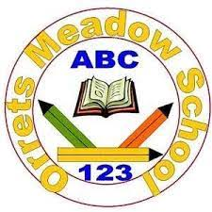
Our Science Principles
Through science, our lives are changed for the better. We believe all pupils should be taught about the role that science plays in positive advancements, as well as scientific knowledge, methods and processes!
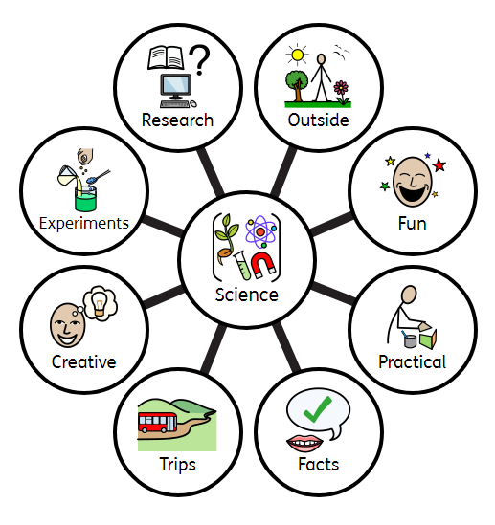
Our staff and pupils believe that all these things make Science outstanding!

Science is an important and valued subject because it is highly relevant; an integral part of daily life, from cooking and checking the weather, to recycling and nature walks. Through our school values and creative teaching, we aspire to promote a love of learning in all aspects of science!

