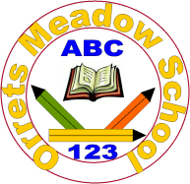
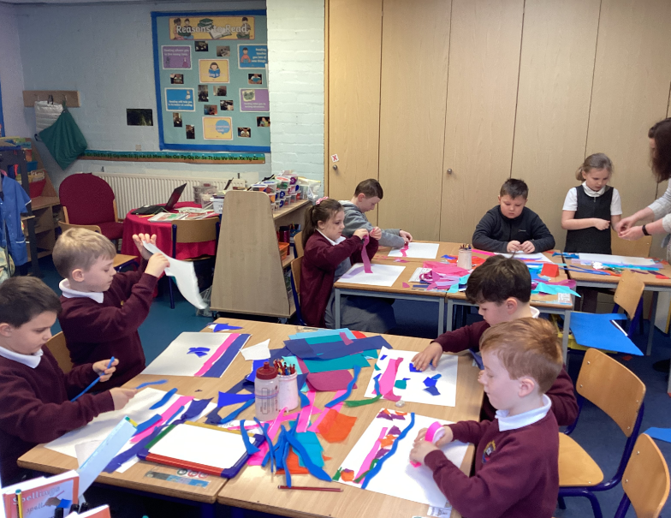
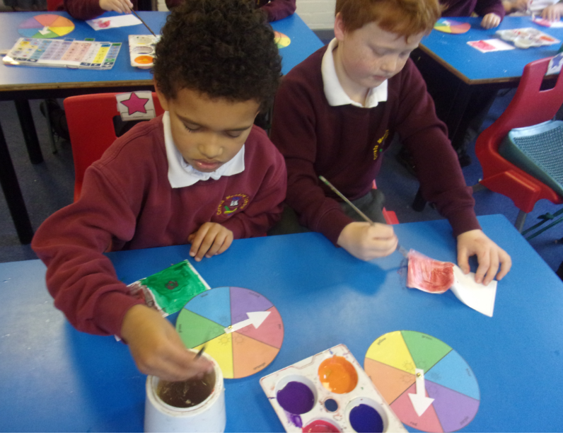
Governors Report – Summer 2022
Art
Subject leader: Roz Warren
Achievements
The ‘ways forward’ identified last year from this year’s school development plan and the actions taken:
Promote the use of sketchbooks to show progression of art skills
This year there has been an emphasis on developing a skill based sketch book which shows the child’s individual art journey through school. Discrete art days have concentrated on different art techniques which promote the development of skills throughout the day. The day ends with a final piece to demonstrate the skills the child has learnt through the day. This year 3 skill based art days have occurred in raising awareness of different artists, mixed media collage and drawing. The sketch books have a clear purpose and the work produced is of a high quality.

Raise awareness of different artists and their techniques – Art Day - 24th /9/2021
The first art day had a focus on raising awareness of different artists and their techniques. Each class had a different artist to research and apply their techniques. The following artists were used:

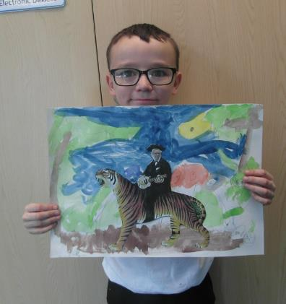

Wolves: Kandinsky
Bears: Mondrian
Giraffes: Van Gogh
Foxes: Matisse
Tigers: Henri Rousseau
Sharks: Andy Warhol
Owls: Paul Klee

The day was very successful and during a learning walk I witnessed a real learning buzz, where children were focused and enjoying the creativity.

Monitor children’s progress and look for patterns in performance

Class | Class Average | FSM | Non FSM | Girls | Boys
Wolves | 0.9 | 0.6 | 0.5 | 0.6 | 0.6
Bears | 1.2 | 0.8 | 1.1 | 1.1 | 0.8
Giraffes | 1.2 | 1.0 | 1.3 | 1.2 | 0.6
Foxes | 1.1 | 0.9 | 1.3 | 1.3 | 1.1
Tigers | 2.0 | 2.3 | 1.9 | 2.2 | 2.0
Sharks | 3.1 | 3.2 | 3.0 | 3.2 | 3.0
Owls | 3.7 | 3.8 | 3.7 | - | 3.7
On analysing the art data it is noted that boys do not achieve as high as girls but it must be remembered that there are 72% of boys to 28% of girls.

In two of the classes the FSM did not do as well as the non FSM children. This is something that will be monitored. Next year there will be an emphasis on promoting cultural capital in art through giving children real life cultural experiences i.e. visiting art galleries. This is going to be a whole school objective that will hopefully benefit all children and hopefully help to support narrowing the gap between the FSM and non FSM classes in these two classes.

Lead CPD staff meeting on progression of an Art skill, ready for Art Day – 5/1/22
During the mixed media collage staff meeting I delivered and modelled using and creating a mixed media collage. The staff then got creative and produced art pieces of their own. The CPD supported the staff in delivering a full day on this in January 2022.
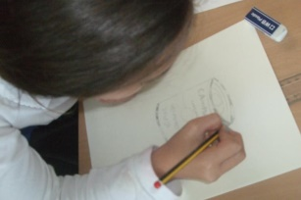
Continue to run discreet Art Days – focus on progression of skills.
An extra art day was added to support progression of art skills. There is now one a term. This year the art days concentrated on:
Term 1: Raising Awareness of different artists
Term 2: Mixed Media Collage
Term 3: Drawing
The sketch books evidence these days and show clear progression of skills.

CPD
This year I have undertaken termly online training in art through the School Improvement Liverpool Art and Design Subject Leader Briefing. The briefings have been really informative and given lots of ideas and current information on the teaching and learning of art. I also attended an Art and Design CPD in Mixed Media Collage with Gayle Forshaw. This was a practical based session to model good practise. After this session I came back and replicated it in a staff meeting for staff to support them to teach their mix media collage art day. I have used staff meetings to feedback on book scrutiny and learning walks.

Quality of teaching learning
Monitor children’s progress and look for patterns in performance
See analysis of Art data above.

Art Book Scutiny
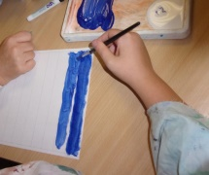
Art work is split into two books. The dimensions art work is in the topic books and art files and the art sketch books demonstrate the work from the art skill developing days. Art book scrutinises have taken place each term to moderate coverage and skill development. On monitoring the art books the coverage of art is good and the art books show clear progression of skills.

Learning Walk
My learning walks were an extremely positive experience. The vast majority of children were engaged, actively involved, enthusiastic and benefiting from the activities being taught. All children appeared to love the art days and were creating some lovely pieces of art. There was a lovely ‘learning buzz’ across the school and the progression of skills was clear to see with the majority of children.

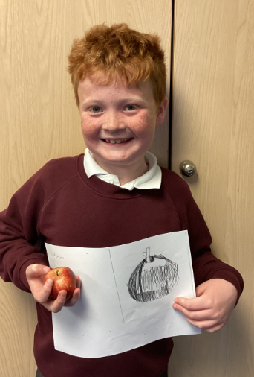
Pupil Voice
Out of the children that were surveyed (14):
100% found art lessons enjoyable.
100% could name some skills they had developed in art.
79% could name a famous artist.
28% had not been to an art gallery – this will be a development point for next year to Promote cultural capital.

Staff Voice
100% of staff commented positively about teaching art.
89% of staff enjoy teaching the art days. The remaining member (11%)has not taught one yet due to being out of class on Fridays.
100% of staff said they found the school curriculum documentation for art and design helpful.
The area that came out the least confident to teach is printing – this will be a focus for
CPD and a future art day.

Strengths
What were the strengths in your subject you found this year from all your moderation activities?
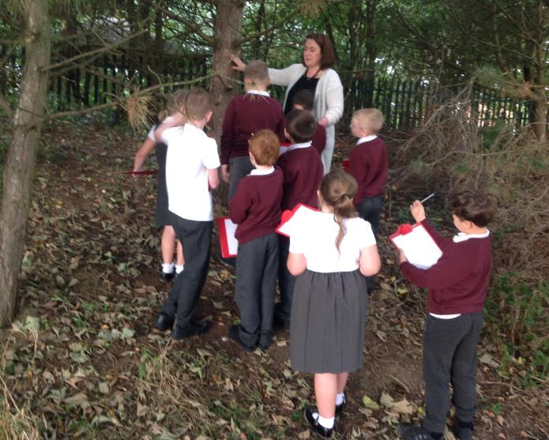
- The discrete art days show clear progression of art skills in the identified areas.
- The quality of work produced in dimensions and in the art sketch books.
- The variety and diversity of famous artists looked at.
- The enthusiasm of staff delivering the art days and the Dimensions art curriculum.
Ways forward
- To arrange a visiting artist to support cultural capital and give children a different take on art.
- To further theme the art days to support the children’s diverse art experiences.
- To do a staff meeting focusing on printing for staff CPD in art.
- Promote enrichment activities to support culture capital – i.e. each class take a trip to Williamson Art Gallery.

