

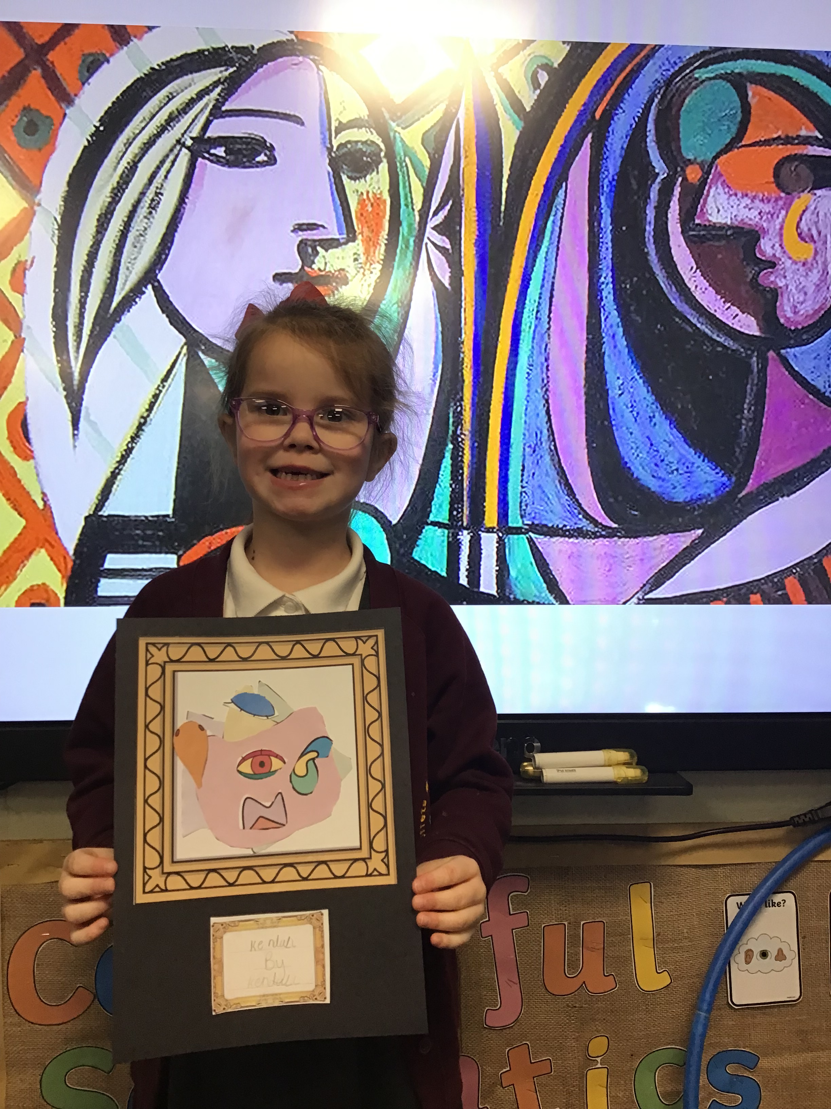

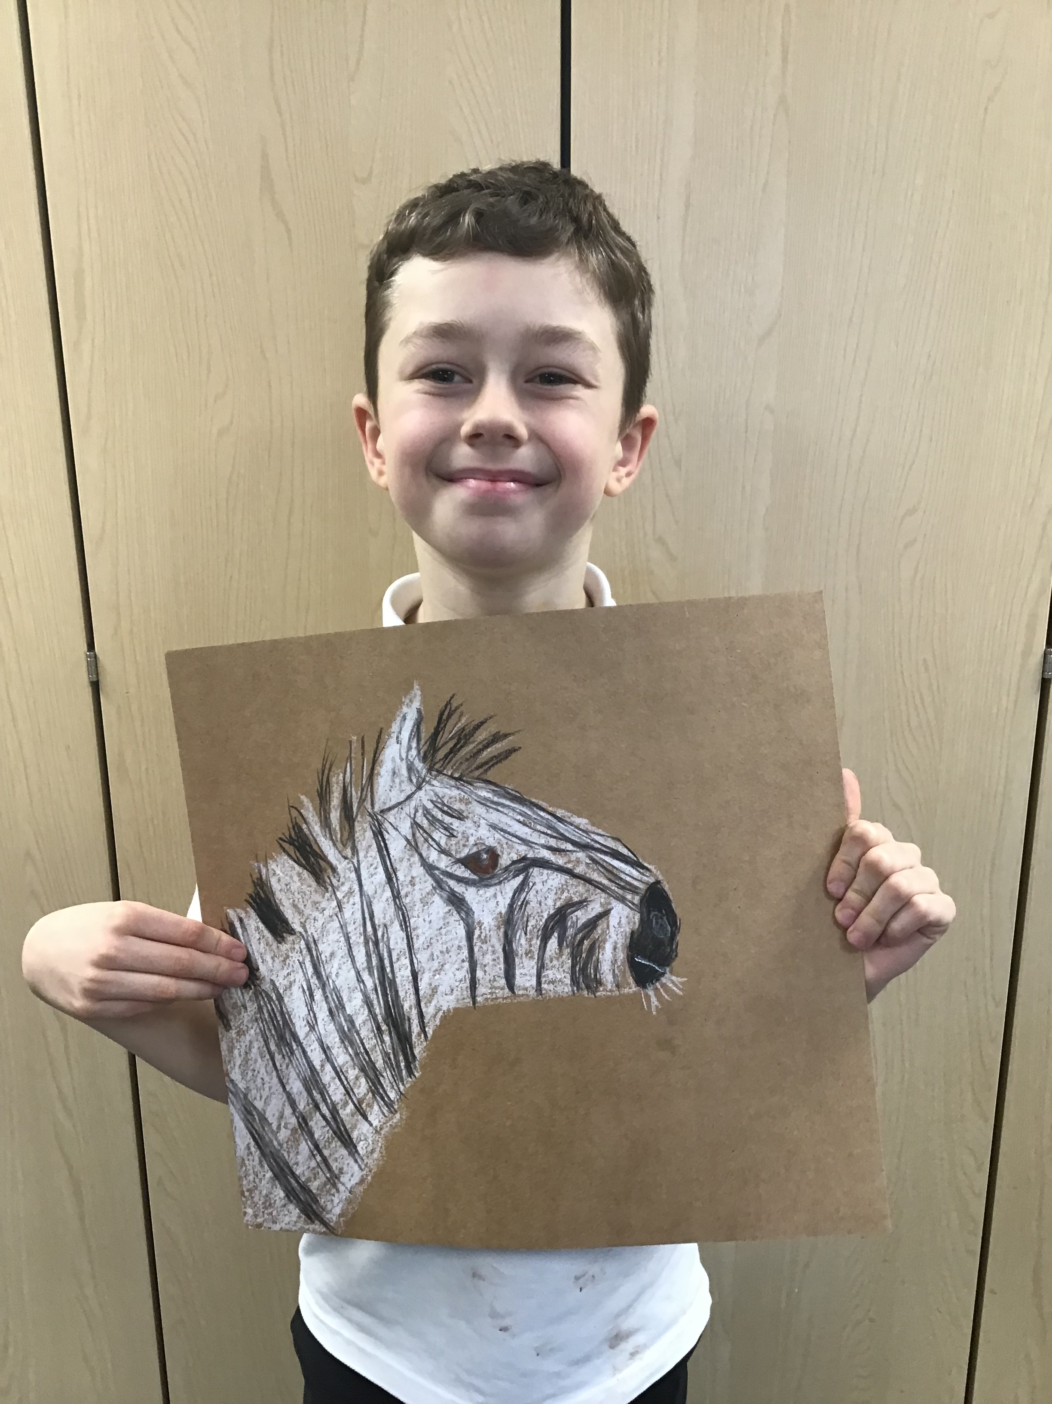

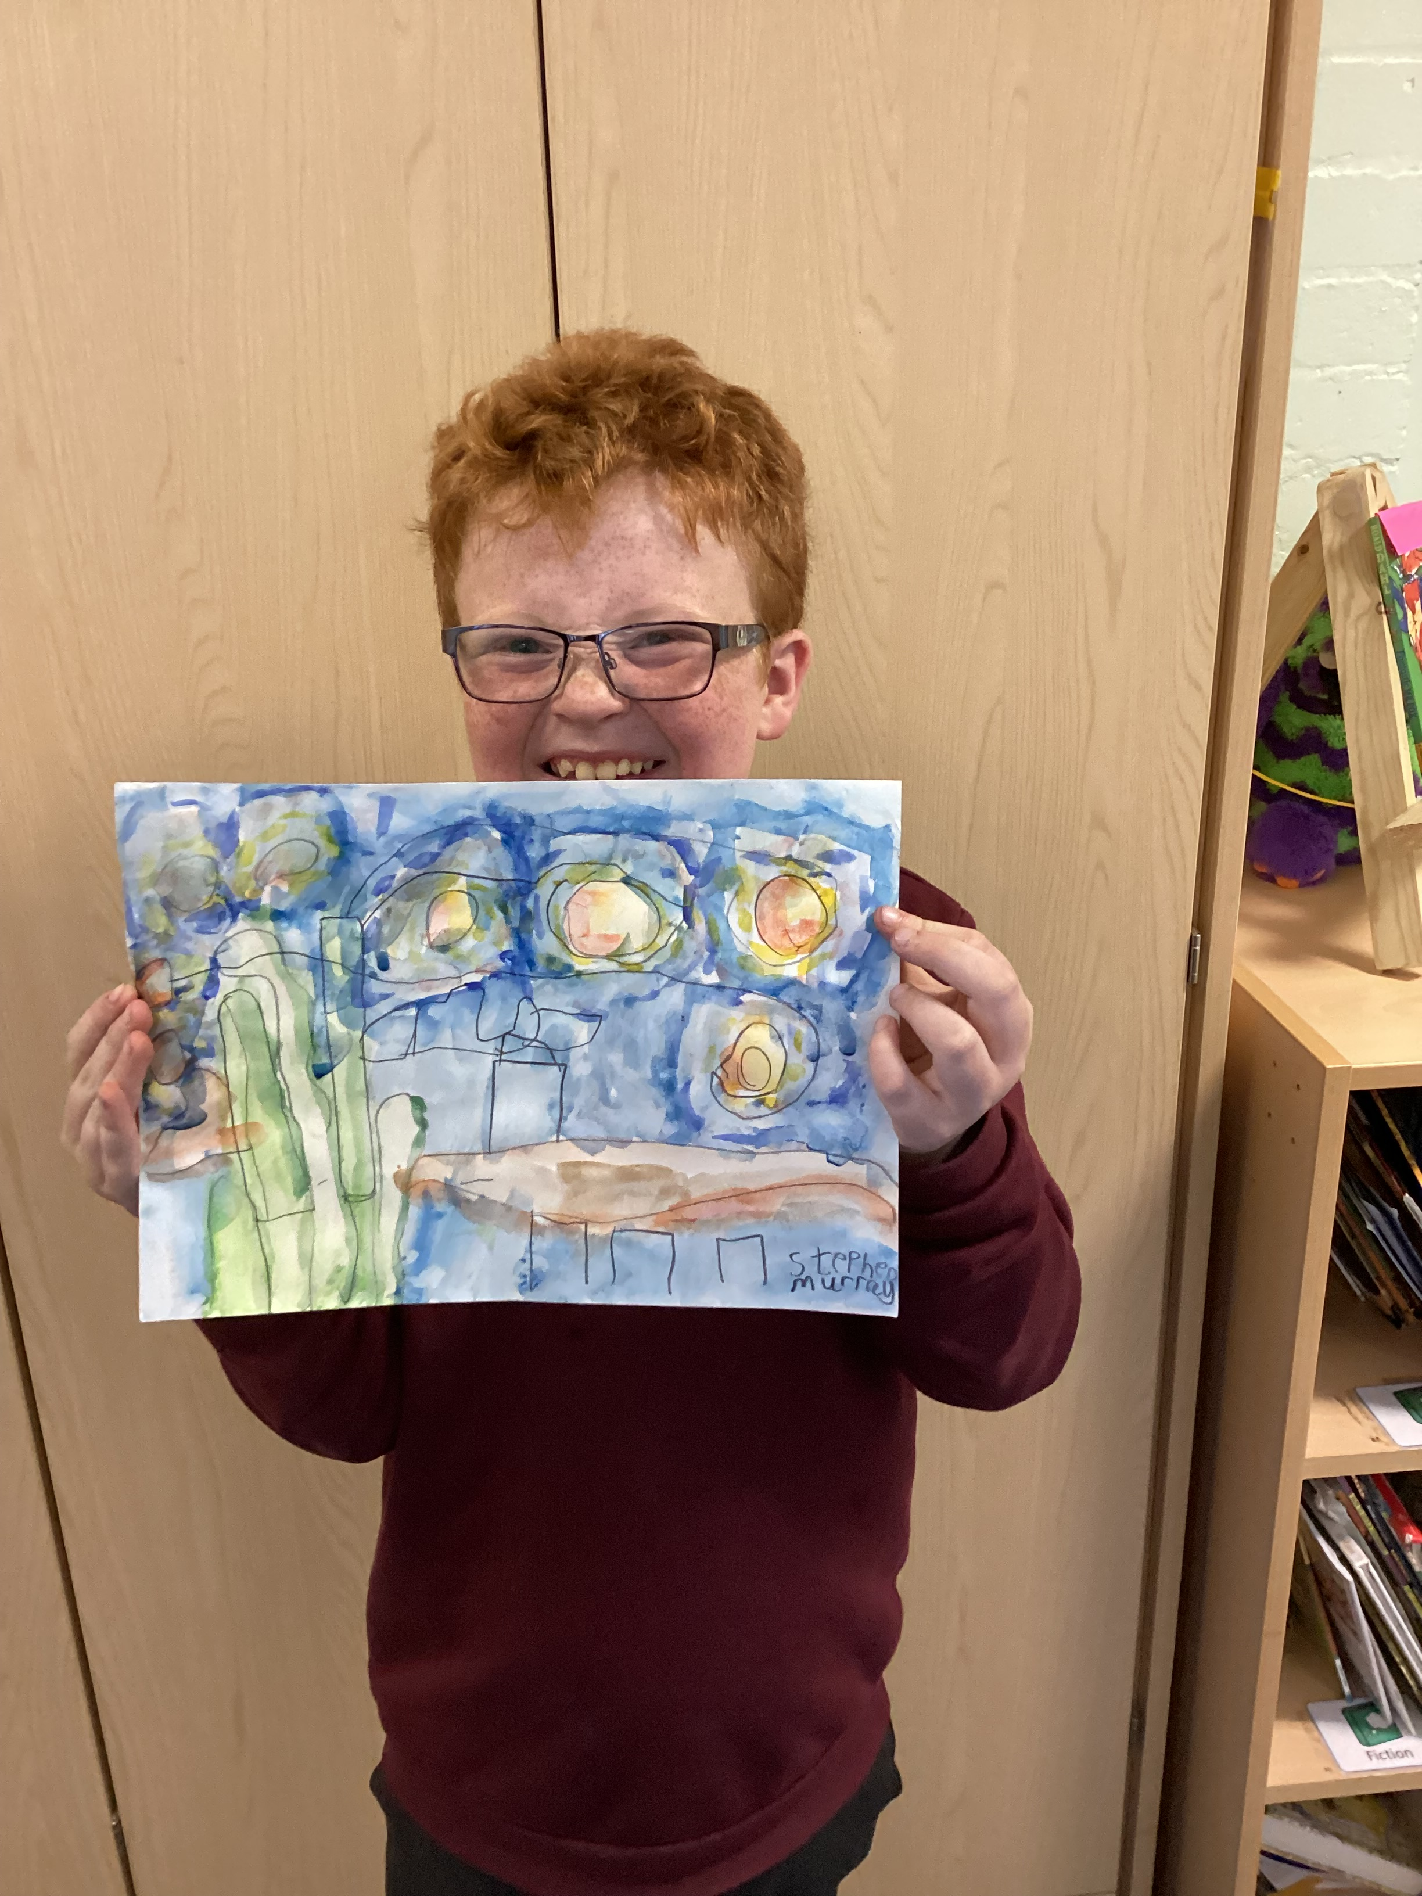

**Governors Report – Summer 2024**

***Art Subject leader: Roz***

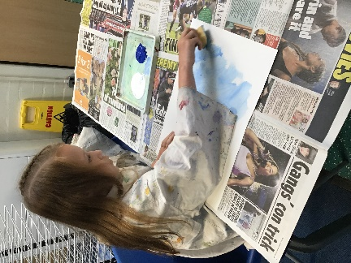

**Achievements**

The ‘ways forward’ identified last year from this year’s school development plan and the actions taken:

**To book an artist (drawing) to support cultural capital and support Art lead and staff CPD – Inset (Jan 24)**

Artist Katie Lloyd delivered an Inset day for all staff on drawing. All staff were given practical experience and support to plan an art day delivering drawing sessions to the children themed around their class animal. This had great impact as the staff felt more confident in delivering drawing and had amazing scaffolding material to help them. The children produced some fantastic drawings during this time which can be found on Facebook.

**To further theme the art days to support the children’s diverse art experiences.**

The above inset on drawing by Katie Lloyd has allowed us to add drawing to our repertoire of art days. We will continue to access training in areas that the staff are under confident in delivering to give a more diverse experiences in art.

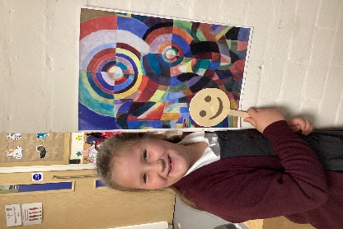 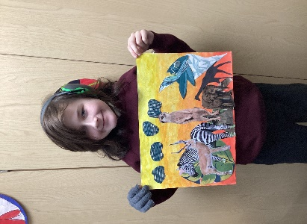 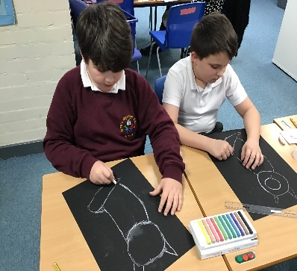

**To subscribe to Kopow to support step by step tutorials (from Teacher survey)**

We booked a trial session of Kopow to run over for a week during our first art day. The staff were given logins so they could access the resource. Feedback suggested that it wasn’t really utilised and therefore we decided not to buy in to the resource.

**To continue to promote enrichment activities to support culture capital – i.e. each class take a trip to an Art Gallery.**

4/8 classes attended art galleries this year to support culture capital they attended the Williamson Art Gallery. It was the older cohort that attended the hour session. We decided this year that the art gallery was more appropriate to the older cohort and all children will meet the art gallery pledge in year 5/6.

**Art Days**

We have completed 3 art days again this year to give the children the opportunity to work on their skills and knowledge and use their sketch books to develop ideas during these focused day.

**Art Day 1 - raise awareness of art history – 22rd September 2023**

Our first art day focused on art history. Each class had a different artist to research (based on last year’s choice) and apply their techniques. The following artists were used:

Wolves: Kandinsky

Bears: Mondrian

Giraffes: Van Gogh

Zebras: Yayoi Kusama

Foxes: Matisse

Tigers: Henri Rousseau

Sharks: Andy Warhol

Owls: Paul Klee

During this day I completed a learning walk round the classes. It was lovely to see the children building knowledge and skills throughout the day before completion of their final piece in the style of the chosen artist.

**Art Day 2 – Mixed Media Art 3rd December 2023**

|  |  |  |  |  |  |  |  |
| --- | --- | --- | --- | --- | --- | --- | --- |
| **Wolves** | **Bears** | **Giraffes** | **Foxes** | **Zebras** | **Sharks** | **Tigers** | **Owls** |
| **Joseph Cornell**  **American**  Type of artist:  **Shadow boxes, pictorial and sculpture combined** | **Picasso**  **Spanish**  Type of artist:  **Painter, sculpture, printmaker, ceramicist, theatre design** | **Nikki Farquharason**  **English**  Type of artist:  **Graphic artist** | **Romare Bearden**  **(American)**  Type of artist:  **Mixed media, cartoons, oils and collages** | **Kate Borcherding**  **(American)**  Type of artist:  **Mixed media – human focus** | **John Piper**  **(English)**  Type of artist:  **Painter, print maker, designer of stain glass window** | **Matisse**  **(French)**  Type of artist:  Visual art, printmaker and sculptor | **Njideka Akunyili**  **Crosby**  **(Nigerian)**  Type of artist:  **Collage, photo transfer based paintings** |

Art Day 2 focused on Mixed Media. The below table shows which artists the different classes focused on for inspiration. Children used a range of collage materials to build up a mixed media creation.

**Art Day 3 Drawing – 26th January 2024**

Katie Lloyd provided another excellent Inset this time with the focus of drawing. She delivered an afternoon of modelling, copying and practicing core skills and knowledge. All teachers and TAs took part and felt confident and prepared to deliver the session to the children. She provided books for each class as a starting point and then step by step power point slides as guidance. Each class drew their class animal the work produced was phenomenal.

**Monitor children’s progress and look for patterns in performance**

|  |  |  |  |  |  |
| --- | --- | --- | --- | --- | --- |
| **Class** | **Class Average** | **FSM** | **Non FSM** | **Girls** | **Boys** |
| Wolves | 0.7 | 0.7 | 0.6 | 0.6 | 0.7 |
| Bears | 0.9 | 0.8 | 0.9 | 0.9 | 0.8 |
| Giraffes | 1.4 | 1.3 | 1.4 | - | All boys |
| Zebras | 2.2 | 2.1 | 2.2 | - | All boys |
| Foxes | 2.4 | 2.2 | 2.7 | - | All boys |
| Tigers | 2.2 | 2.1 | 2.2 | 2.2 | 2.1 |
| Sharks | 3.7 | 4.0 | 3.5 | 3.9 | 3.7 |
| Owls | 2.5 | 2.3 | 2.7 | 2.6 | 2.5 |

On analysing the art data it is noted that the gap between the girls and boys is not significant enough to cause concern. There is only one class that FSM pupils’ had a significant enough difference this will be monitored (highlighted above). This year we will continue to plan sessions with visiting artists as well as organising trips to art galleries to promote all aspects of art.

**CPD**

This year I have undertaken termly online training in art through the School Improvement Liverpool Art and Design Subject Leader Briefing. The briefings have been really informative and given lots of ideas and current information on the teaching and learning of art. Katie Lloyd trained myself alongside the staff she delivered a practical based session in drawing to model good practise. After this I have provided staff with feedback on a book scrutiny conducted and a learning walks.

**Quality of teaching learning**

**Art Book Scrutiny**

Art work continues to be split into two books. The dimensions art work is in the topic books and art files and the art sketch books demonstrate the work from the art skill developing days. Art book scrutinises have taken place each term to moderate coverage and skill development. On monitoring the art books the coverage of art is good and the art books show clear progression of skills.

**Learning Walk**

Mrs Duncan and I conducted learning walks during the art days this year. We both witnessed high quality teaching which resulted in some fantastic pieces of art. All children were engaged in the activities being taught and were proud of their accomplishments. The training from Katie gave clear structure for the final art day and there was a consistency of teaching style and production across the school.

**Pupil Voice**

Out of the children that were surveyed (2 children from each class):

100% found art lessons enjoyable.

93% could name some skills they had developed in art (one named picture produced).

93% could name a famous artist.

*47% have not been to an art gallery. During Being Healthy Week 4 of our classes will be attending an art gallery so this number should increase.*

**Staff Voice**

**100% of staff commented positively about teaching art.**

‘The step by step process has supported our pupil’s – they have been creating some outstanding pieces of art’.

‘We love art lessons, great ideas for focus – supported by art lead’.

‘I love the art in Dimensions’

‘The Dimensions lessons are straight forward to teach. The art days are always well prepared with excellent outcomes. My class really enjoy them’.

‘The children love art days. They are such a creative bunch’.

‘Increases mental health’.

‘Relaxing and enjoyable days for all there are always lots of new skills developed during the day. Children are always proud of their work’.

‘Children have been engaged in lessons and art days. CPD was good and helped build drawing skills’.

**100% of staff enjoyed teaching the art days and found it useful having time to compete a longer art project.**

‘Yes – always well sourced and good ideas’.

‘Yes art day is always fun to teach and the pupils are engaged’.

‘Yes – always excellent CPD before and plenty of time to prepare’.

‘Yes’

**Suggestions for further development:**

‘Artist invited into school could create a whole class piece of art’

‘More in topic’

‘More CPD and teaching resources’

‘More resources’

**(Some of these will feed into development points).**

**Strengths**

**What were the strengths in your subject you found this year from all your moderation activities?**

* The Inset held by Katie Lloyd on drawing.
* The discrete art days continue to be a strength and show clear progression of art skills in the identified areas.
* The quality of work produced by the children.
* The variety and diversity of famous artists looked at. .

**Ways forward**

* To place an art order with the requested resources. (September ’24)
* To concentrate on Dimension Art lessons to analyse the effective teaching of art through the thematic afternoon topics. (November ’24)
* To rewrite pre curricular targets for Art to ensure clear steps of progression for the lower cohort. (January ’25)
* To book an artist (Katie Lloyd) to produce a large scale art piece which all children contribute to – for collaboration and CPD. (Being Healthy Week – June’25).