3rd March 2024
Dear Parent and Carers

Its hard to believe we are half way through the year! Here are main events to the end of term.

Child and parent session
Thank you to all the parents who attended the child/parent session in December and looked at their books with them. I think you will all agree the amount of work and progress they are making is unbelievable and it does show that when the provision is right their learning flourishes. We are planning on another child/parent session in the Summer term, so you will then be able to clearly see the progress made from the beginning of the year to the end.

Ready for school
Please can you make sure your child is ready for school and learning each day by remembering to send in their school bag with their communication book and reading book in it. The children should also have their PE bags in school every day.

Forest Schools
Foxes and Owls continue with their Forest School sessions. Please remember to send them in old clothes and with a warm coat. Once each class has had their 5 week block each class has an additional 3 weeks to earn their Forest Skill badges!

Photos of the sessions go on Facebook and I think many children will say it has been a brilliant experience for them, both in terms of enjoying the outdoors but also in supporting them develop their social and life skills.

Year 6 Hoodies
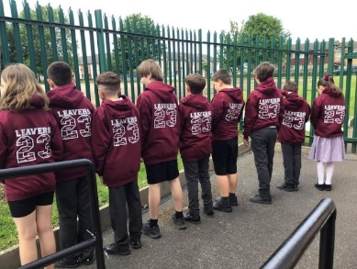
Kate Jones has ordered the school hoodies for the Year 6s to take to Barnstondale in June and they can wear them in school. So thank you Kate.

Hoodies will be handed out as soon as they arrive.

Sponsored Walks
Every child has taken home a sponsor form to collect money from their sponsored walk. All money raised will go towards each class going on a trip in the Summer Term. The more money raised the better the trip. Please send all money collected into the school office once your class has completed their sponsored walk (see below for dates).

Secret Auction
In a couple of weeks we will be sending home our secret auction, filled with exciting items, experiences for you to bid on. Highest bidder wins the item! One of the items is a signed Everton football, complete with letter of authentication.

Comic Relief
This year Comic Relief is on Friday 21st March. Children can come to school in own clothes if they wish and please send in a donation – all money should be passed to the escort. All money raised will go to Comic Relief.

Important Dates
3rd March Giraffes sponsored walk to the local park
Musical Monday – all classes
6th March World Book Day – come to school dressed a book character
Forest Schools – Foxes & Owls
7th March Wolves trip to Carr Farm
12th March Sharks sponsored walk in New Brighton
13th March Forest Schools - Foxes & Owls
14th March DT day – whole school
19th March Owls sponsored walk in New Brighton
20th March Forest schools – Foxes & Sharks
21st March Comic Relief – own clothes day – send in donation
Lemurs sponsored walk in Birkenhead Park
Wolves sponsored walk to the local park
24th March Science Week – whole school
Foxes sponsored walk in Delamere Forest
25th March Tigers sponsored walk in Delamere Forest
26th March Zebras sponsored walk in Delamere Forest
27th March Forest Schools – Foxes & Sharks
31st March Language and Culture Week – whole school
3rd April Easter and Prize Assembly – will be recorded and sent out to parents
Forest schools – Zebras & Sharks
4th April School finishes for Easter at 3.30pm

22nd April Inset day – School is closed to pupils
23rd April School opens for the Summer Term

Thanks for all your support.
If you have any questions about any of the above, please contact me.

Mrs Duncan

