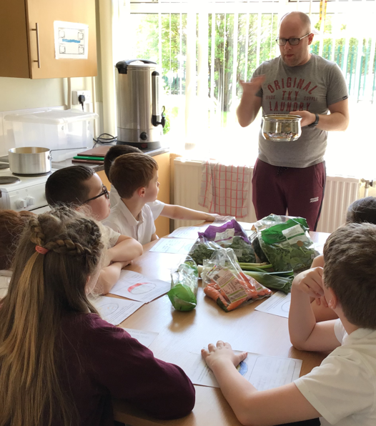
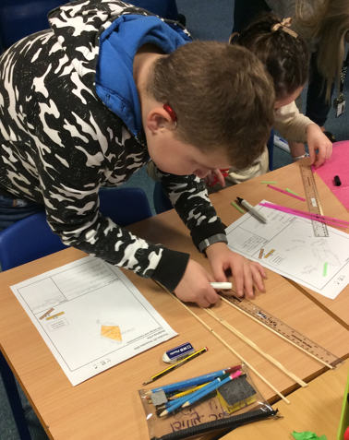
Governors Report – Summer 2023
Design and Technology
Subject leader: Jane Gordon
Achievements
The ‘ways forward’ identified last year from this year’s school development plan and the actions taken:
To review coverage of each Dimensions DT topics across the school to ensure coverage is evidenced.
This year I held a staff meeting in Autumn Term 1 where I introduced the new Design and Technology long term plan that ensures coverage of across the year for each class. All classes have one significant design and make opportunity in their afternoon Dimensions topic and three Design and Technology Days throughout the year to ensure coverage and progression in Cooking and Nutrition, Textiles and Structures / Mechanisms, Sliders and Levers.
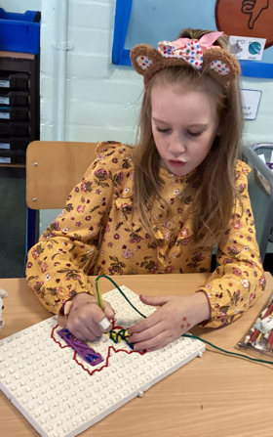
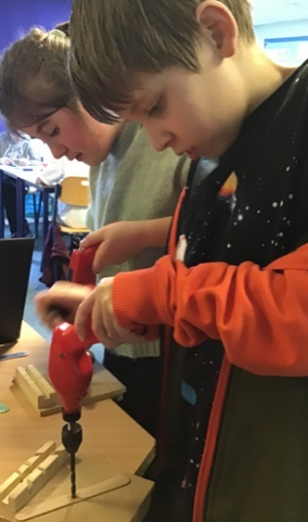
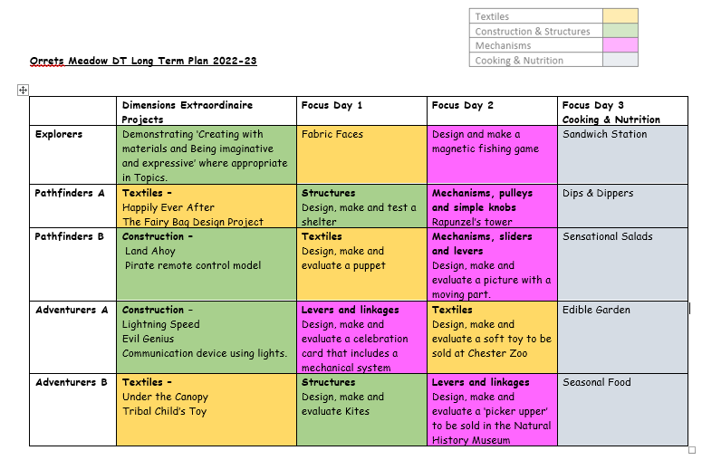
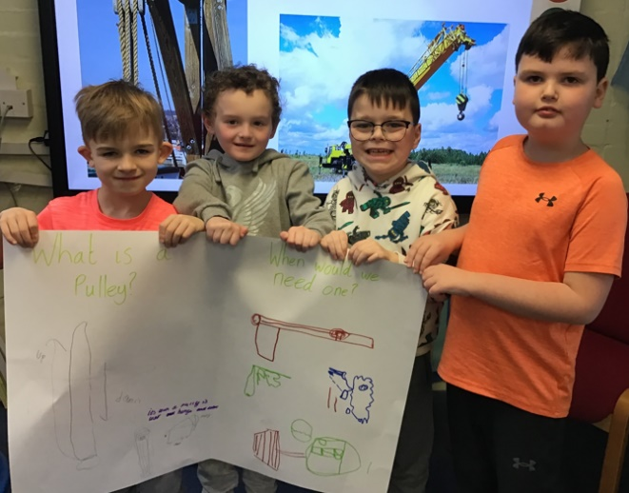
To establish a clearer evidencing structure for the design process to ensure a consistent whole school approach.
During my Staff meeting I rolled out the document I have made that links each Design and Technology project with the Orrets Meadow progression of skills with the National Curriculum objectives.
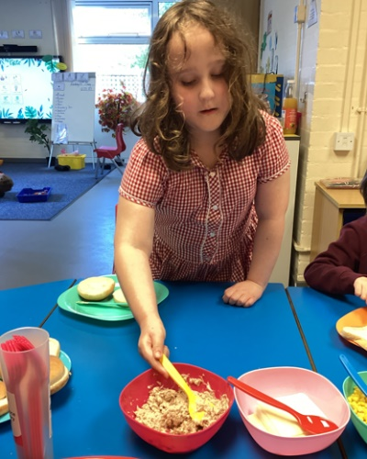
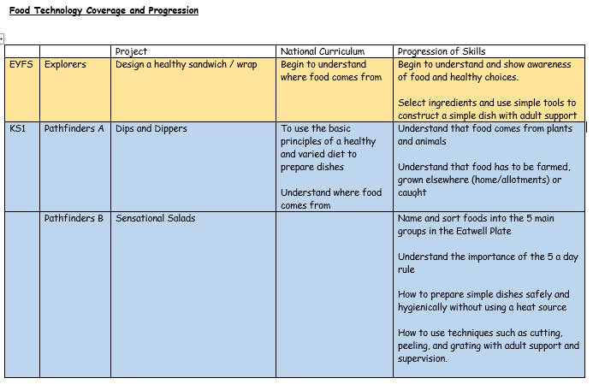
Staff were also given training and direction when presenting work in their class Design and Technology floor books to use the design process widgits to clearly evidence the coverage of the Design, Make and Evaluate process.
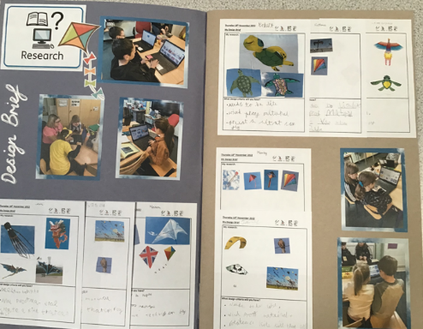
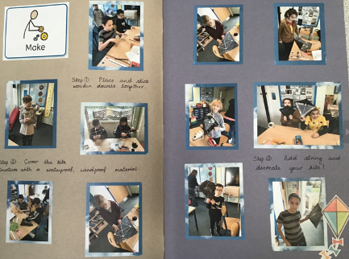
- Research
- Design Specification
- Design
- CAD
- Make
- Evaluate
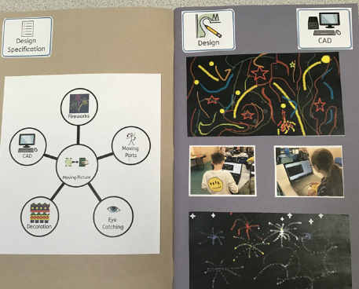

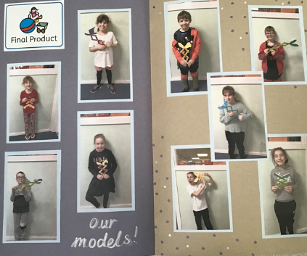

To purchase resources linked to each Dimensions project.
Staff were given time during the Design and Technology staff meeting to work in small teams with staff who teach the same Design and Technology projects. During this time I asked them to complete the Staff survey which contained the focus about the resource requirements for the projects. The feedback gave me the opportunity to check future equipment and resource needs against the inventory of existing resources and equipment and purchase resources to support the delivery of Dimensions Design and Technology Projects.
To create Cultural Capital opportunities for each class to experience DT in the real world.
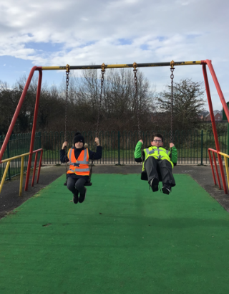
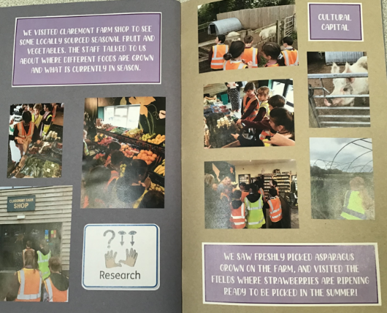

Classes were encouraged to record Cultural Capital evidence of the children learning about and experiencing how Design and Technology is all around us in the real world. Staff have organised trips to Aldi to see how a shop is designed, Claremont Farm shop to learn about seasonal food and the local play park to see how they are designed and how the equipment works.

CPD
This year I have undertaken termly online training in art through the School Improvement Liverpool Design and Technology Subject Leader Briefing. The briefings have been informative and given lots of ideas and current information on the teaching and learning of design and technology. I am also a member of the Design and Technology Association (DATA) which has enabled me to carry out a subject audit using their Self Review tool. From this I can identify areas of strengths and ways forwards for our schools Design and Technology curriculum. All teaching staff have been given access to dip into a wealth of resources and online training opportunities through this membership of the DATA if applicable to their teaching and professional development needs. Staff meetings this year have, in addition to promoting progression of skills and technology processes, also focused on maintaining and highlighting good practise in the drive to continue to raise standards in the coverage and recording of DT.
Quality of teaching learning
As subject leader I have completed a range of monitoring activities this year to oversee the continuing high quality of teaching and learning in DT. I have carried out a Key Stage 2 lesson observation where I was delighted to watch an outstanding lesson on designing, making and evaluating a toy for the Tribal Child Dimensions project which demonstrated a range of creative and interactive activities designed to meet the children’s learning styles. During Iearning walks on DT Focus Days I observed examples of Cultural Capital and enrichment activities such as tasting and testing foods, learning where our food comes from, what makes a healthy meal and learning about architects and building their own dens/shelters. Further successful experiences were observed during these weeks where the children made kites, tested and evaluated their flying success, designed and sewed their very own puppets for a puppet show and made stuffed animals to be sold in the Zoo gift shop! Book scrutiny’s, data analysis, pupil and staff surveys were all carried out over the year and analysed to support high quality teaching and learning which is taking place in the classroom.
Strengths
What were the strengths in your subject you found this year from all your moderation activities?
- The Design and Technology Focus days show a clear development of children’s designing, making and evaluating skills. Problem solving and taking risks in these days also build resilience and self-esteem.
- The quality of work produced in dimensions and in the class Design and Technology floor books.
- The opportunities staff have created for Cultural Capital in Design and Technology.
- The enthusiasm of staff delivering the Focus days and the Dimensions Design and Technology curriculum.
- The development of children using computer aided design in the designing and making process.

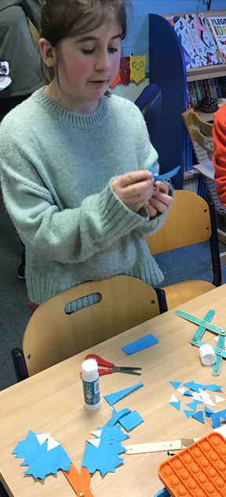
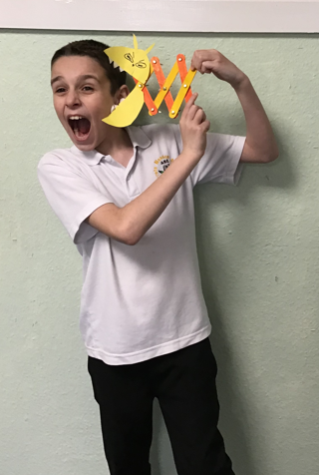
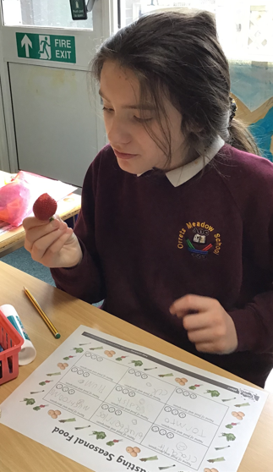

Ways forward
- Create a bank of ideas to promote how Design and Technology is adapted to meet our children’s needs. Staff meeting Autumn Term 2
- To create a tool kit document to sequence of learning in Design and Technology that enables our children to recognise the different elements of the design process. Autumn Term 1
- To build fluency in Design and Technology lessons. Staff meeting Autumn Term 2
- For Design and Technology Focus Days to be celebrated through class hall displays. Spring Term 2

