2024 PE Funding

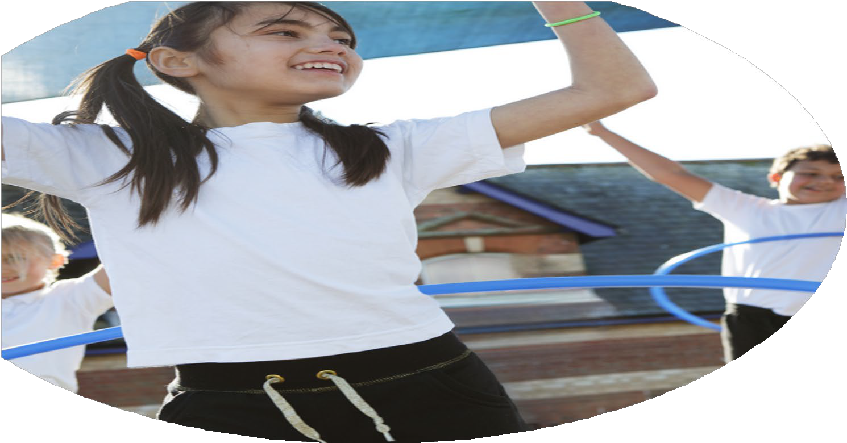

Evaluation Form

**Commissioned by**

**Created by**

Images courtesy of Youth Sport Trust

**PE Funding Evaluation Form**

 It is intended that this template should be used as preparation for the completion of the statutory digital reporting tool being introduced this academic year. You can upload data (including swimming) from this template onto this platform once it becomes accessible.

 Before you decide how you are going to use the funding for this academic year you should reflect and evaluate the impact of your use of the funding in 2023/24.

 All spending of the funding must conform with the terms outlined in the Conditions of Grant document.  The template is a working document that you can amend/update during the year.

 Based on your evaluation of last year’s funding you should decide what you intend to do this academic year, how you will do it, and what impact you expect it to have.

It is important that the funding is used effectively and based on your school’s needs.

 You must use the funding to make additional and sustainable improvements to the PE and sport in your school.  You must develop and add to the PESSPA activities that your school already offers.

*Summative digital reporting from June 2025 will continue to include swimming and water safety information therefore funding can be used to provide top-up lessons where necessary to ensure pupils meet national curriculum swimming requirements.*

**We recommend that you start by reflecting on the impact of current provision and reviewing your previous spend**

|  |  |  |  |
| --- | --- | --- | --- |
| What went well? | How do you know? | What didn’t go well? | How do you know? |
| * Wellbeing interventions * New PE scheme of work * Magic Mile * Enrichment Activities | * Lunchtime Clubs, PE interventions and PSHE week (Spring/Summer 2023) have helped to encourage **less active children to become more active**: * 93% enjoyed the physical activity intervention sessions * 100% enjoy PE and sport * 100% feel more confident in PE * 93% think they are now physically fit * 100% feel they are better at physical activity * 100% now feel PE and sport are important * Increased teacher and support staff subject knowledge, skills and confidence. Up-skilling of staff leaves legacy of high quality PE for years to come. The Total PE+ scheme of work is now embedded throughout the school. Next steps will be to include inclusive activities/disability sports within long-term PE plans * ‘Magic Mile’ – children and staff taken part in minimum of 15mins walk/run x3 per week. Positive feedback from children and staff. Evidence of improved fitness and wellbeing. * Judo – Year 6 children enjoyed a 6 week block of Judo with expert coach. Extremely positive feedback. Children displayed confidence, respect and responsibility. * Bikeability: Y6 children received cycling tuition teaching practical cycling skills and road safety. Majority of Y6 children attained Level 2 qualification. * Taekwondo (June 24) Y5 have enjoyed 6 weeks of taekwondo, learning discipline, respect and responsibility. * Barnstondale Residential Trip (May 24). 22 Y6 children enjoyed OAA opportunities building confidence, resilience, teamwork etc. * Children dancing at Wirral School Games Dance Festival (Jul 24) showed great courage and passion as they performed in front of a huge crowd. They performed brilliantly as a team. * Nestlings Forest School: all children have had opportunity for OAA sessions including activities such as: sensory play, messy play, tree climbing, bug hunting, wood carving , campfire cooking , water play and tool use. | * Inter-house competitions * Leadership opportunities | * Number of events and participation lower than previous year. Relaunch academic year 24/25. * Number of regular participants in leadership opportunities lower than previous year. Relaunch academic year 24/25. |

|  |  |
| --- | --- |
| What are your plans for 2024/25? | How are you going to action and achieve these plans? |
| Intent | Implementation |
| 1. Embed inclusive activities into PE scheme of work (Total PE+) 2. Support adaptation and teaching of new scheme of work 3. Coach and mentor teaching staff and teaching assistants 4. Further collaborate and moderate with other schools on new scheme of work 5. Year 6 Mental Health Champions – online and full day training for pupils 6. Provide sports-specific CPD opportunities for staff from recognised National Governing Bodies 7. SHEU online survey: pupils to be surveyed on their mental and physical health and well-being 8. Wellbeing interventions – linked to SHEU survey 9. Relaunch regular intra-school competitions with calendar linked to PE long-term plan 10. Introduce further enrichment sports and activity coaching for younger children in school 11. Update Pyramid of Need – whole school mental health identification tool 12. Staff meetings to be led with Clare Mount each term linked to PE and school sport e.g. Total PE+, STEP, autism in PE etc. 13. Active in Mind – Neil Danns (YST) Mental health programme including mentoring 14. Extend Disney Shooting Stars Programme to wider teaching staff 15. Leadership club to be relaunched 16. Dance Celebration @ Floral – July 25 with weekly sessions at lunchtime | 1. 2. and 3. Jon White (JW) and David Saul (DS) to help embed inclusive activities into PE scheme of work (Total PE+) through range of methods  4. DS to collaborate and moderate Total PE+ with local schools  5. November 2024 – Mental Health Champions Training for Year 6 pupils @Orrets Meadow. Full day course.  6. DS to audit staff about courses – online or face-to-face options.  7. SHEU survey (bespoke) to be completed and analysed by December 2024. 8. Interventions to be carried out during spring and summer term.  9. Intra-school competitions to run spring and summer term on a regular basis – mirroring PE long-term plan and informed by SHEU survey. Jo Patten (JP) to lead in consultation with DS.  10. Multi-skills for younger children to run spring/summer term  11. DS to collect relevant data and produce Pyramid of Need. Information cascading across staff to highlight mental health risk levels and feed into mental health intervention offer.  12. Termly staff meetings for CPD run by DS and JW, assisted by JP.  13. Neil Danns (YST Athlete Mentor) to run mental health programme in summer term.  14. Will Thomas (WT) booked to run extra-curricular Disney Shooting Stars programme in spring term for min. 6 weeks, targeting less-active children.  15. Leadership led by JP in consultation with DS. Vehicles for leadership include Girls Active, inter-house competition etc.  16. Kate Walsh to lead assisted by Gemma Corcoran (Clare Mount) - summer |

|  |  |
| --- | --- |
| What impact/intended impact/sustainability are you  expecting? | How will you know? What **evidence** do you have or  expect to have? |
| * Does the SHEU survey positive trends in physical health, fitness and wellbeing data? * Have wellbeing interventions made a positive impact on children’s wellbeing? * Has the RISE Up programme been successfully implemented? * Have we embedded inclusive activities into Total PE+ scheme of work successfully throughout the school? * Have new staff received support to increase their subject knowledge and confidence in teaching and supporting PE? * Have teaching and support staff undertaken high-quality training courses (accredited by NGBs) across a wide range of activity areas? * Have we continued to share PE and sport practices and facilities with other schools across a range of contexts? * Have we further developed our moderation of assessment in PE? | * Positive trends in SHEU survey data * Positive feedback and survey data from children involved in physical activity intervention data * Positive feedback from staff and pupils involved with RISE Up programme * Positive staff and pupil perception of inclusive activities in PE lessons * Staff audit showing increased subject knowledge and confidence * Teaching and support achieving accredited qualifications in PE and Sport * Evidence of sharing of good practice with other schools * Assessment records and CPD meetings showing increase understanding and application of moderation in PE |

|  |  |
| --- | --- |
| What **impact/sustainability** have you seen? | What **evidence** do you have? |
|  |  |