
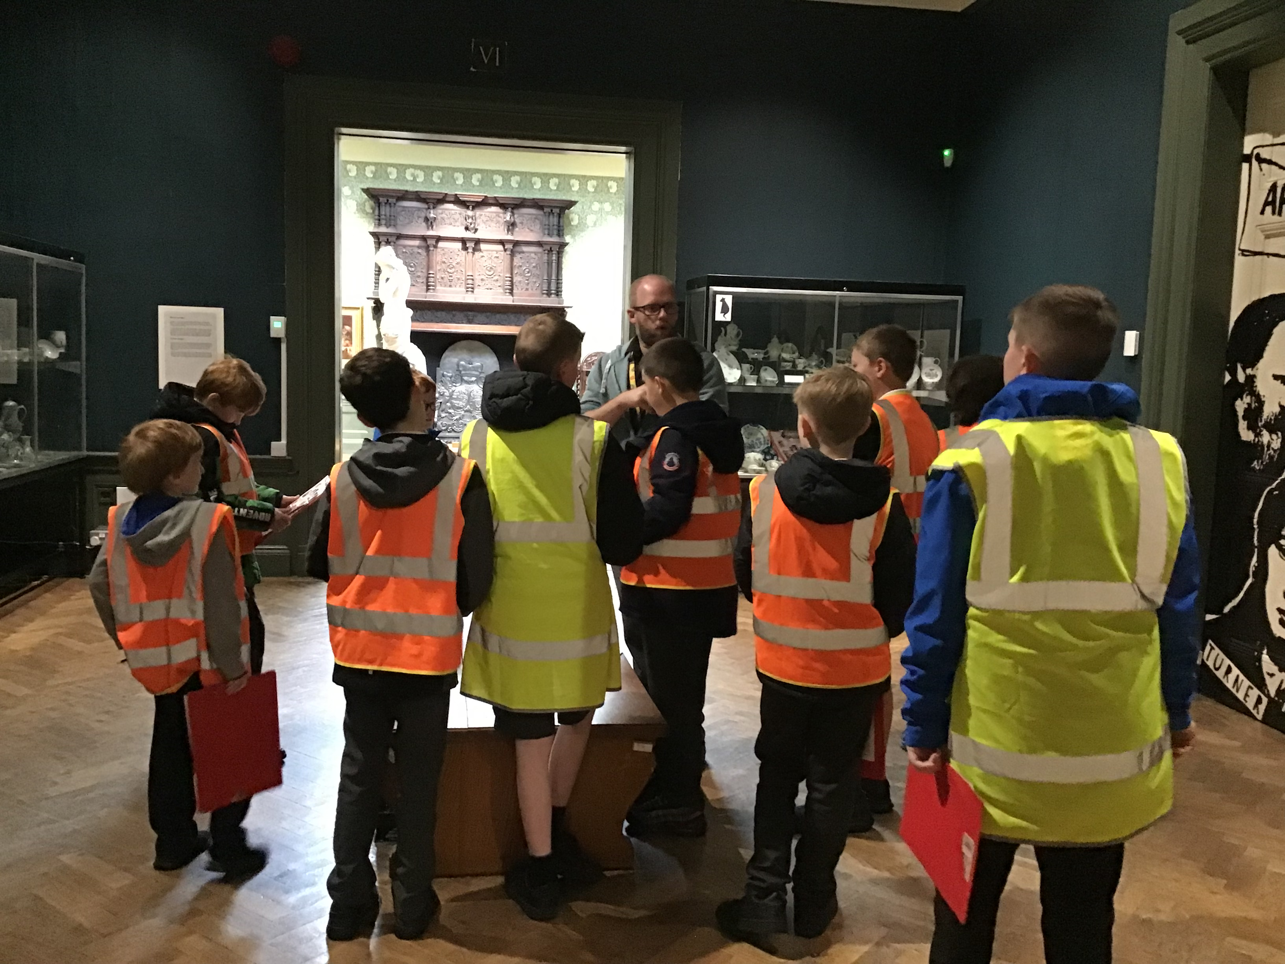
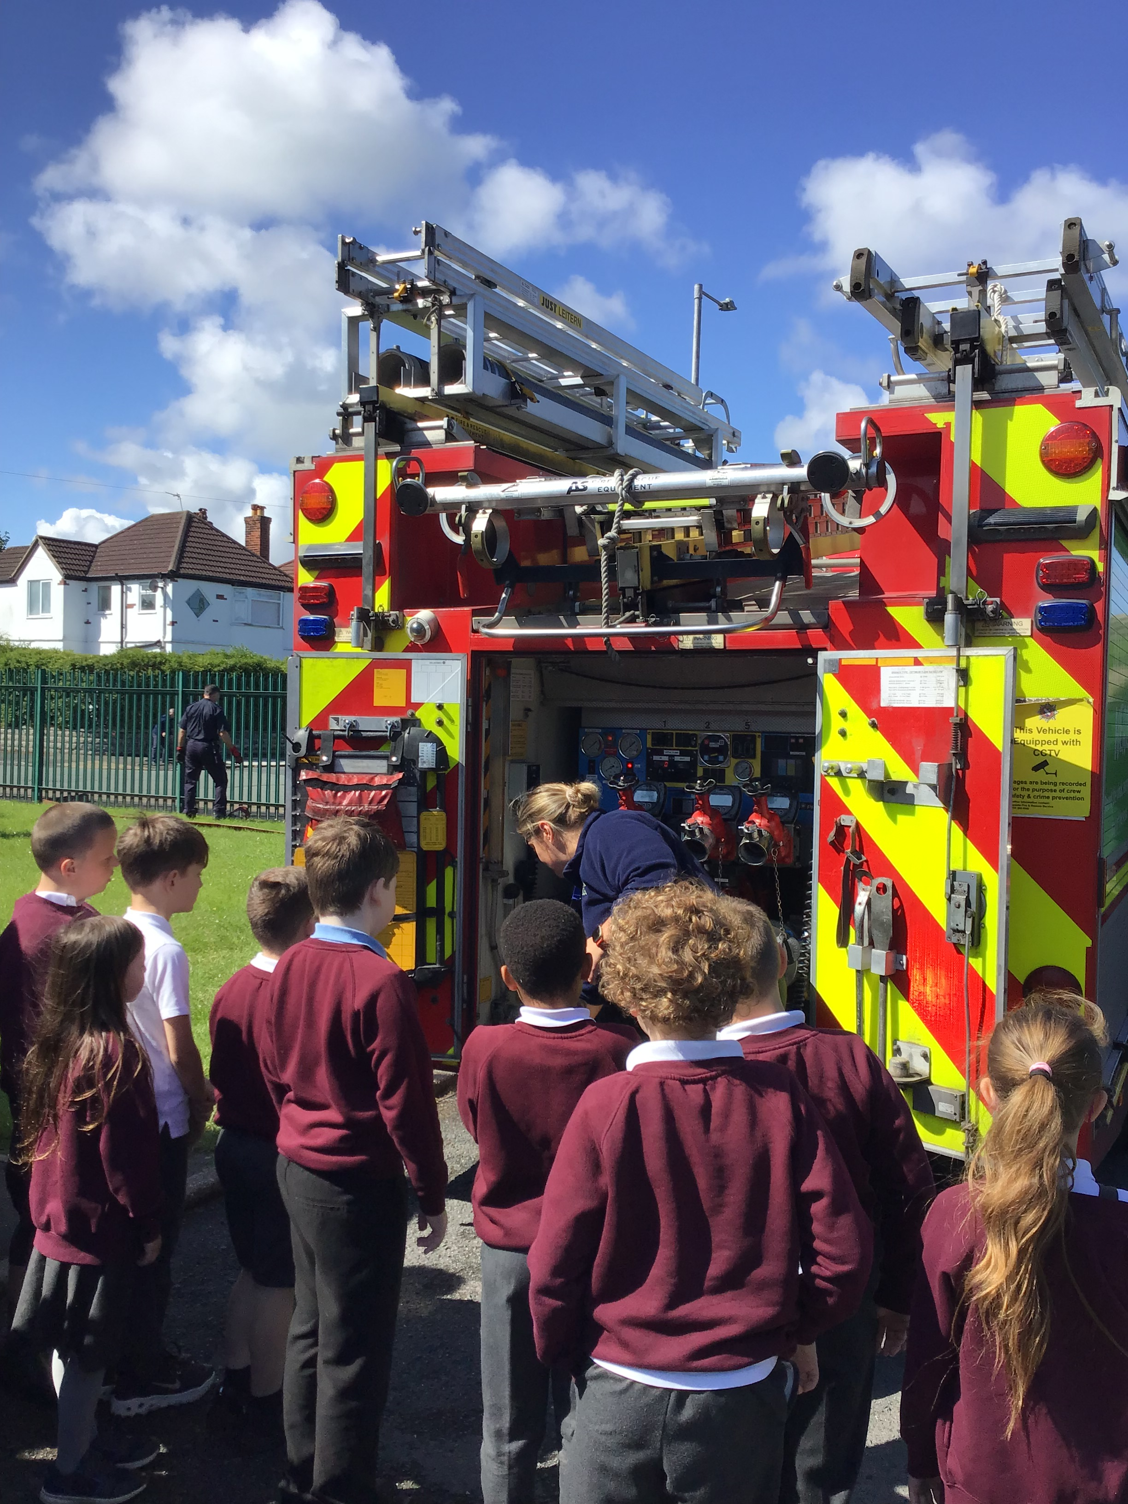

Governors Report – Summer 2024
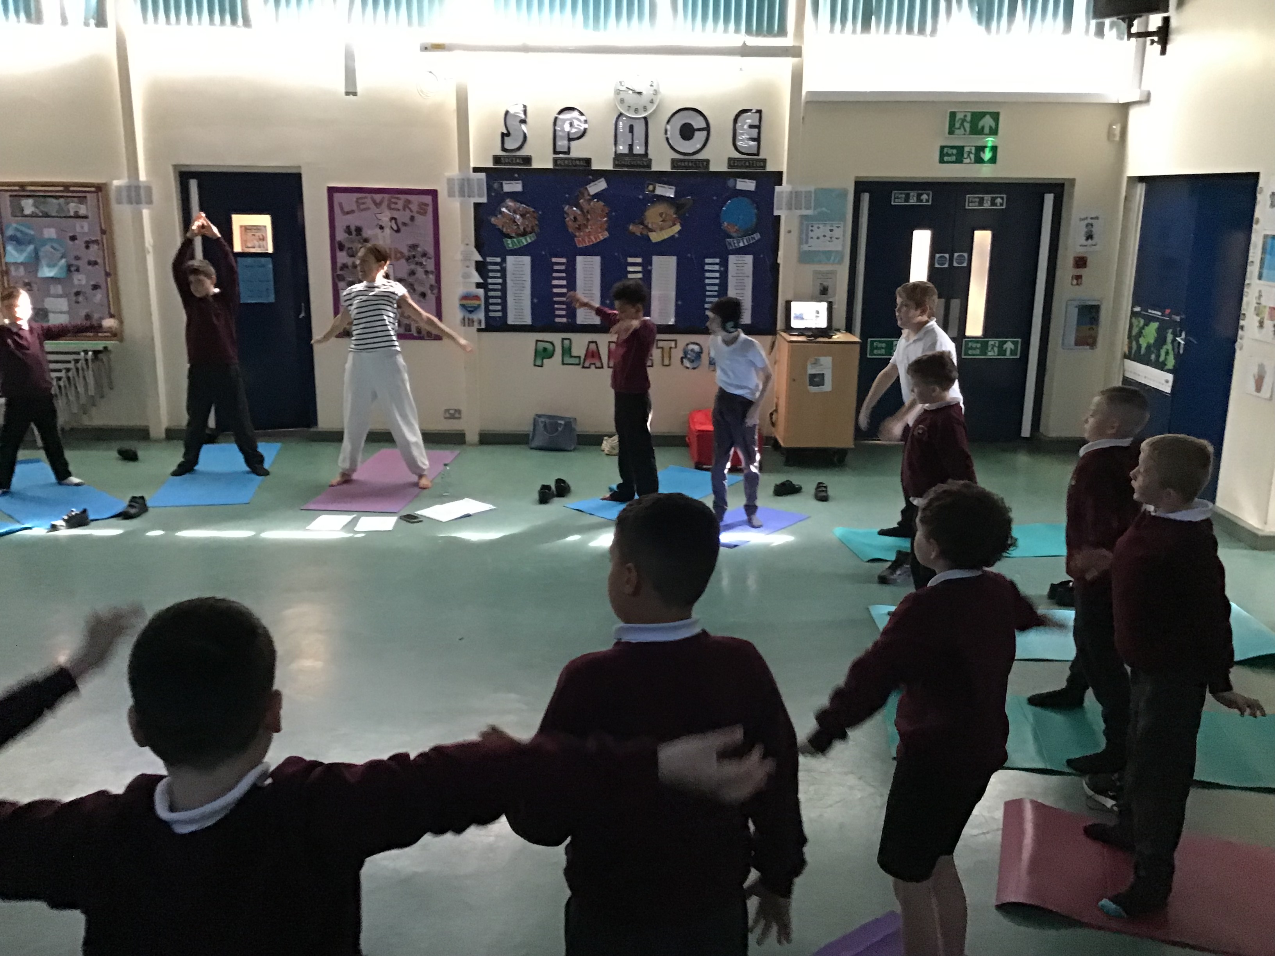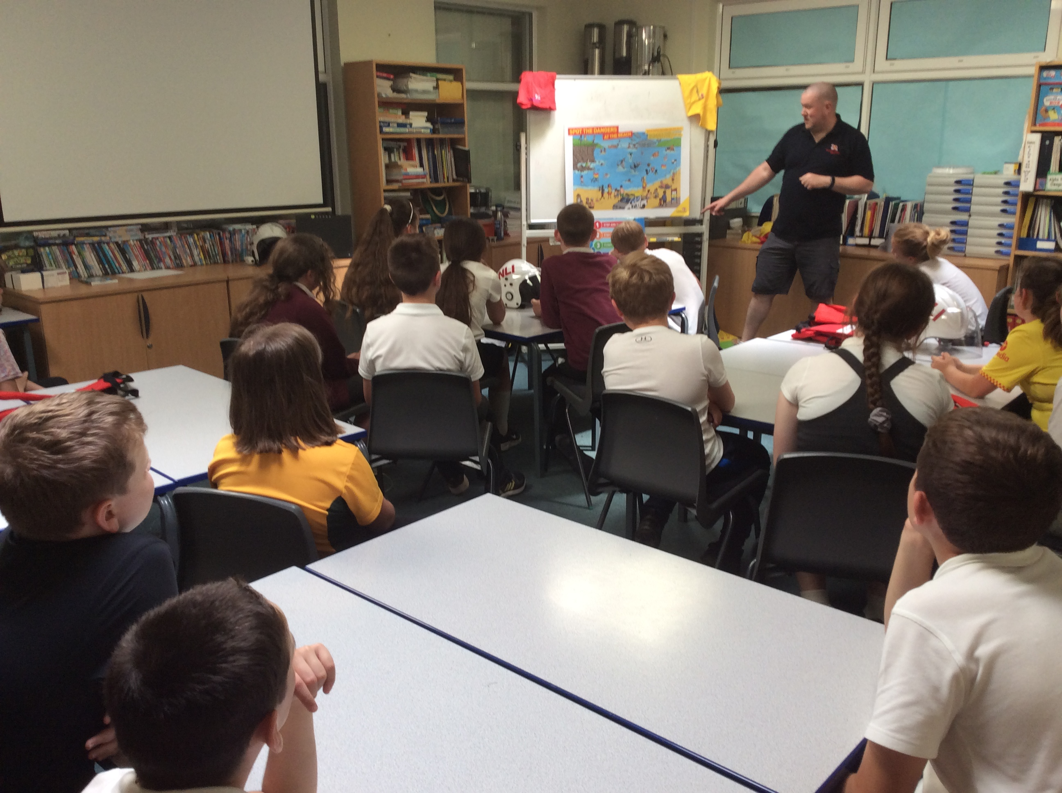
PSHE
Roz Warren
Achievements
The ‘ways forward’ identified last year from this year’s school development plan and the actions taken:
To train to be a Feelings Detective and run interventions.
R Warren was trained in the Feelings Detectives intervention in November ‘22. Since training she has delivered Feelings Detective training to 3 groups. Each child is baselined on the Spence Children’s Anxiety Scale http://scaswebsite.com at the start of the process and then the same data is collected at the end. So far 100% of the children have made progress from their initial baseline on the Spence Children’s Anxiety Scale following the training.

To continue to hold independent sessions throughout the school year.
This year we have completed two successful independent days for the children. Activities included; making a drink, washing dishes, tying shoe laces, wrapping presents, hanging out washing, writing a card, sorting washing by colour and laying a table. The children enjoyed these sessions and it gave them a chance to practice these vital skills.

To look at the resources for PSHE sessions (from the survey 33% of staff found it difficult to resource certain lessons)
A wish list was sent out to all staff to fill in regarding the requirement for additional resources for PSHE after it was flagged on the staff survey. Several staff returned the wish list and we managed to source all of the requested items including. The resources purchased included child friendly books on sex education, PSHE games including on friendship, responsibility, mental health and confidence.

To source some PSHE games (from the survey several children would like more games)
We sourced PSHE games in responsibility, friendship and diversity. Examples of games we purchased are: Block Happy, Fink Healthy Friendships, Jenga, A Recipe for Friendship and Happy Confident Me – Feel it!

To rewrite lesson 2 of the Year 6 sex education to make it more appropriate for our cohort.
R Warren consulted with C O’Brien (Y6 teacher) to talk about how lesson 2 needed to be changed or adapted to support the lower cohort of children. The lesson has been rewritten and based around the book ‘What Makes a Baby?’ by Cory Silverberg. It gives a good starting point to the topic and gives room for questions and provides discussion points.
CPD for PSHE Lead
This year as subject lead R Warren have accessed the termly Liverpool School Improvement PSHE briefing. Hayfield and Orrets also had Subject Leader meetings, R Warren met with the PSHE leads to discuss processes, assessment and coverage.

Staff Training
During staff meetings I have reflected on PSHE updates, given book scrutiny feedback and discussed any adaptation to the planning.
Quality of teaching and learning - Ofsted
PSHE was a deep dive focus during Ofsted. In their report they quoted:
‘The personal, social, health and economic (PSHE) curriculum is central to the school. Weekly curriculum enrichment sessions provide an extensive range of opportunities to learn about different cultures, religions or beliefs. There are a plethora of lunchtime clubs in which pupils’ confidence and interests flourish. Pupils’ ability to speak in public situations about different, current issues is enhanced magnificently by the debating club. The school ensures that pupils value the diversity of the wider world. For example, pupils’ deep understanding of different disabilities was enhanced through a visit from a disabled athlete. Pupils understand the need to help others when they can. They provide support to others in their local community. In addition, pupils experience well-designed lessons around developing their life skills’.
The outcome of our Ofsted was outstanding. During the deep dive we discussed the book scrutinise, lesson observations, staff questionnaire, pupil voice and about the RSE curriculum which all formed part of the judgement. I also conducted a learning walk with one of the inspectors observing PSHE, Life Skills and Social Skills lessons. After the walk round it was concluded that we both agreed that the standards on teaching and learning are high.
ASD Framework
The ASD Framework continues to give us supportive data on the children. All new children were baselined during the autumn term and existing children’s ASD Frameworks have been updated accordingly. The IEP (Individual Education Plan) continue to reflect this and therefore gives future targets for children in the highlighted areas of need. The whole school area of strength this year came out a social interaction and the area for development came out as Independence and community. We continue to promote independent skills as mentioned above.

PSHE Book Scrutiny
PSHE books continue to showcase the excellent breathe of study, the progression of skills and knowledge across the year groups and the creative way it is taught. Photographs evidence the different lessons and the books demonstrate a variety of multisensory teaching it also evidences pupil engagement. PSHE book scrutinises have taken place each term to moderate coverage and work evidenced. The statutory RSE content is demonstrated for each class within their books and the coverage of legal requirements.

Learning Walk and Lesson Observations
This year R Warren completed several learning walks of PSHE (including with Ofsted) and completed lesson observations with a focus on emotions. It was a pleasure to see PSHE being taught sequentially, using multisensory teaching and showing a high level of pupil engagement.
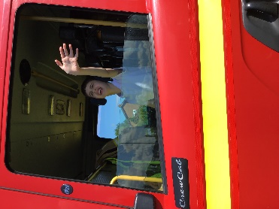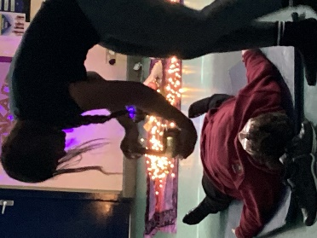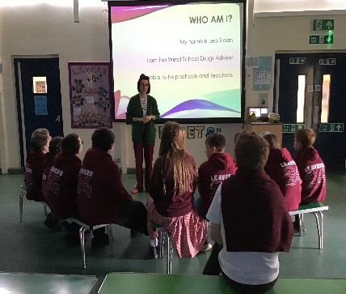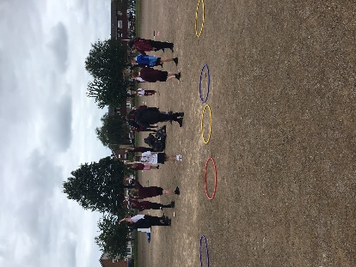

Pupil Voice

A cross section (2 per class) of pupil voice was taken from each class to find out pupil’s opinion about PSHE:

I enjoy PSHE lessons | 88% of pupil’s enjoy PSHE
I can tell my teacher some of the things I learn in PSHE (using book) | 94% of pupil’s could tell their teachers something they have learnt about in PSHE
My teacher teaches PSHE using lots of different activities | 100% of pupil’s feel that PSHE is taught through lots of different resources
The activities in PSHE are interesting and engaging | 100% of pupil’s find PSHE interesting and engaging.
I feel comfortable sharing my ideas, views and opinions in PSHE | 94% of pupils feel comfortable sharing their views

Some of the pupil comments:
‘PSHE lessons are lots of fun’
‘I like sharing my ideas with my class’
‘I like the role-play, videos, trips and worksheets’
‘I liked doing the friendship session where we received certificates’

Staff Voice

Does the Dimensions curriculum support you to teach the children in PSHE? | 100% of teachers agreed that Dimensions supported the teaching of RSE.
Do you feel confident teaching the revised RSE content? | 100% of teachers feel confident teaching RSE.
Are the majority of RSE lessons easy and straight forward to deliver? | 100% of teachers agreed that the RSE lessons were easy and straight forward to deliver.
Is it easy to resource your PSHE sessions? | 100% of teachers agreed it was easy to resource PSHE.
Do the children demonstrate a positive attitude and engagement with the PSHE curriculum? | 100% of teachers say that children demonstrate a positive attitude and engagement with the PSHE curriculum.
Do you feel confident in teaching the different areas of PSHE? | 100% of teachers feel confident teaching the different areas.
Do you need any support in PSHE? | 100% of teachers do not require support

Year 6 staff Sex and Health Education Questionnaire
- Staff continue to feel confident teaching Sex and Health Education.
- Staff continue to feel that Dimensions sessions were easy and straight forward to teach.
- Staff felt the new lesson 2 provoked discussion and expanded children’s understanding. It was felt to be more appropriate.
- Staff felt children were engaged with the topics in an age appropriate manner and with good humour and the information shared was appropriate to their age and stage of development and useful to them. They coped very well and were mature and engaged.

Year 6 pupil Sex and Health Education Questionnaire
- Children could list what makes a healthy relationship.
- The vast majority of children recapped unhealthy relationships in a cartoon.
- All children felt they understood more about sexual relationships.
- All children listed how the male and female body changed overtime.

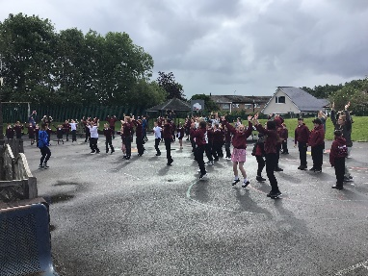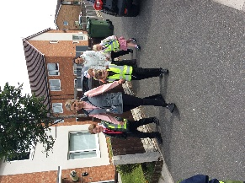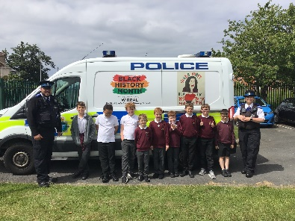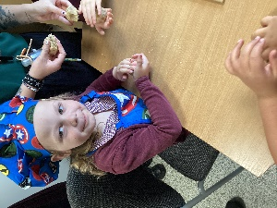

Strengths
- PSHE deep dive PSHE was recognised as having breath of study, progression of skills/knowledge and an accessible curriculum that the children could eloquently talk about to Ofsted
- Feelings Detectives intervention
- Autism Tracker
- Being Healthy and Safe Week
- Visitors coming in to promote different area i.e. Firefighters, Police, Yoga, Nurse
- The enthusiasm for teaching PSHE and the children’s response
- Autism Accreditation Advanced status
Ways forward - Targets
- To keep up to date with the legal requirements of PSHE and ensure that Orrets Meadow curriculum adapts accordingly. (Autumn 1 ’24)
- To adapt the Autism Tracker Independence Section to make it more school based rather than home based. (Autumn 1 ’24)
- To get outside speakers to give first-hand experience and expertise in different areas of the PSHE curriculum. (Ongoing)
- To arrange for the Police to come in and discuss e-safety and sending inappropriate images and the legalities of what you can do in and out of school (Y5/6). (Spring 1 ‘25)
- To organise and deliver an Being Healthy Week. (Summer 2 ‘25)

