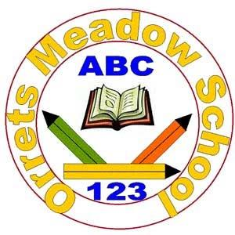
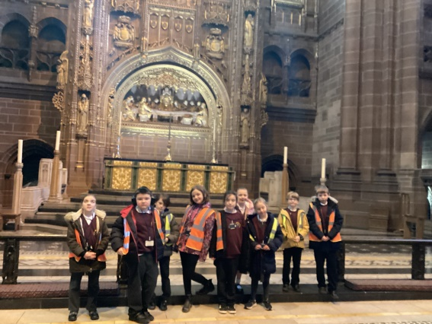
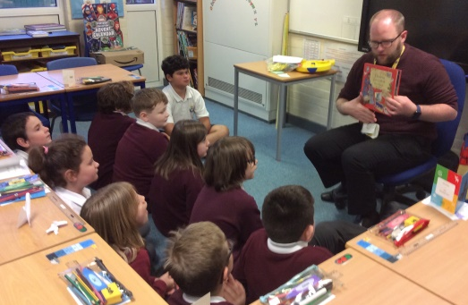

Governors Report
Summer 2022
RE
Jane Gordon
Achievements
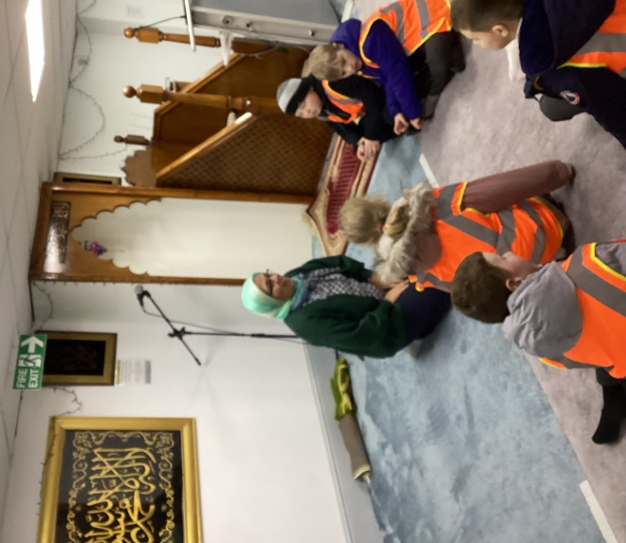
Reflecting on targets set last year I have implemented the promotion of key religious celebrations across the six faiths promoted by the Wirral SACRE through a series of whole school assemblies. We were very fortunate to have Reverend Cousins led collective acts of worship at Christmas via Zoom and in school at Easter before his well-deserved retirement.
The Orrets Meadow RE curriculum has had many fabulous opportunities to be brought to life through trips to various religious buildings and meeting people from different faiths. From these trips and experiences we have been able to form exciting links with educators from the Jewish, Muslim and Buddhist faiths.
Class teachers have continued to implement teaching RE through multi-sensory teaching strategies especially during our highly successful Religion week. Where they embraced a range of creative routes such as singing, dancing, cooking, art work and role play.
CPD
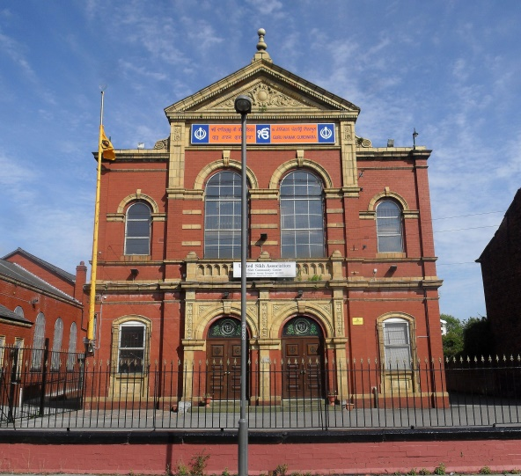
I am a member of the Wirral LTLRE HUB which is an excellent opportunity to keep in touch with the local RE subject leaders and share ideas and good practice. Through this channel I have accessed regular Zoom training meetings led by Wirral LTLRE HUB.
I have sign posted teaching staff to relevant courses covering aspects of the six faiths promoted by the Wirral SACRE.
Staff meetings this year have, in addition to promoting sensory teaching strategies, also focused on maintaining and highlighting good practise in the drive to continue to raise standards in the coverage and recording of RE.

Quality of Teaching and Learning
As subject leader I have completed a range of monitoring activities this year to oversee the continuing high quality of teaching and learning in RE. I have carried out a Year 6 lesson observation where I was delighted to watch an outstanding lesson on Peter and Forgiveness demonstrating a range of activities designed to meet the children’s learning styles. During Iearning walks I observed examples of Cultural Capital and enrichment activities such as Zoom meetings with people from Sweden, food tasting, role play, Arts and craft activities and sharing books such as Leah’s Story where the nativity is explored from the Inn keeper’s daughter’s perspective. Further successful experiences were observed during Religion week with trips to the local Mosque where the children experienced learning about Islam through a real life experience. A wonderful Jewish ex head teacher visited our school to teach us all about Judaism in a very entertaining way. A class even visited the Buddhist Centre in Liverpool to look at the architecture of the building and were warmly welcomed in by the Monks and invited back again next year! Book scrutiny, data analysis, pupil and staff surveys were all carried out over the year and analysed. These monitoring activities support that high quality teaching and learning of RE is taking place in the classroom.
Strengths
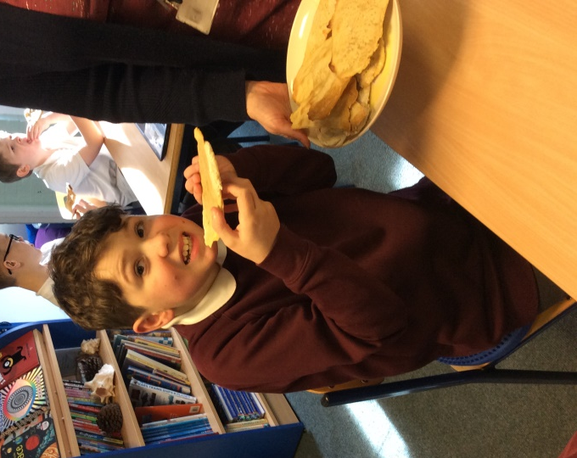
The strengths in RE that I have found through carrying out my moderation activities are the amazing, rich and varied Cultural Capital and enrichment gained through religious visitors and trips to visit religious centres. Teaching staff were able to use my list of contacts gained from my involvement with the Wirral LTRE HUB to plan and organise experiences for their class during Religion week. Staff survey analysis shows that teachers are enjoying a more creative approach to teaching; such as incorporating drama into Bible stories, Christmas week and learning about Christmas in other countries. This finding was also echoed in the pupil survey analysis where all the children enjoyed RE. Their feedback about what they were proud of learning was overwhelmingly positive and demonstrates the high quality multi-sensory teaching opportunities being created for all.
Ways Forward 2022-2023
• To review how classes with a largely pre curriculum cohort record evidence. (Staff survey Autumn 1)
• Introduce the use of objectives from the progression of skills into class books to ensure clear progression of coverage in Christmas and Easter topics. (Staff meetings in Autumn 1 and Spring 1 and monitoring activities.)
• To introduce new unit of study into KS2 on Humanism and religious and non-religious world views as prescribed by the Wirral SACRE. Autumn 2 and Summer 2. (JG to seek guidance from Wirral LTRE HUB and source appropriate materials and resources.)

