Governors Report – Summer 2022
Maths
Lorna Billington
Intent:
The focus of the whole school this year was to incorporate as many strategies to ensure ‘Pupil voice’ as we could. In line with this initiative the focus for Maths was language. To ensure that children were accessing their lessons with a better understanding of the words being used.
School Development Plan
Focused Priority 4 | Title | To reinforce mathematics through, supporting, monitoring and developing the use of mathematical vocabulary throughout the maths lesson.
Many pupils at Orrets Meadow have speech and language difficulties / ASD / ADHD and dyspraxia. As a result, many children have processing, memory and retention difficulties.

Why Children Should Learn the Language of Mathematics ?
- Language plays a critical role in learning mathematics. Students need to correctly read, write, and talk about mathematical concepts. ...
- Students need multiple experiences to learn, practice, and apply academic language. Students who have limited experiences or background knowledge may struggle to comprehend new concepts.
- The use of mathematics vocabulary is a strong indicator of student success. Language skills and comfort with mathematics vocabulary can have great impact on students’ achievements.

Implementation
A range of initiatives were incorporated into the school year to support our aim:
- The year began with on- site training for the whole school from a maths specialist advisory teacher for ‘Talking Maths’
- An audit into the topics taught throughout the school. The focus was on the vocabulary used to support understanding.
- Lists were collated of the relevant language and made available to both staff and parents (via school website). For example: whilst teaching addition, words related to addition (addition, total, plus, more than,) were highlighted and discussed within the classroom.
- Parents received a letter to explain the schools focus and where to access the vocabulary for each subject and year group with some examples of how to support a child with maths language.
- Staff were encouraged to challenge children over the words and their meanings. Children were asked to say sentences using the words to demonstrate a greater understanding.
- Maths Planning sheets now have a discrete section to add words that will be discussed and explored by pupils to support learning, understanding and recall.
- The policy was updated in light of the introduction of ‘talking maths’.
- Talking Maths was allocated a discrete time during additional needs and each pupil took part in a ‘talking maths’ intervention for four weeks.
- Class Maths vocabulary books were started that will continue to be built on.

OFSTED New terminology
- Declarative knowledge – this consists of facts, formulae, concepts, principles and rules; it can be prefaced with the sentence stem, ‘I know that…’.
- Procedural knowledge – this involves recall as a sequence of steps. This category includes methods , algorithms and procedures, for example for long division or multiplication. It can be prefaced with the sentence stem, ‘I know how…’.
- Conditional knowledge – this gives pupils the ability to reason and solve problems, using declarative and procedural knowledge to choose successful strategies. It can be prefaced with the sentence stem, ‘I know when…’

All staff have been made laminated bubbles to display in class to support the implementation of this new terminology and to begin questioning pupils that reflects the new terminology involved.
Staff Training
Inset day: Whole school Training: Talking Maths by Sarah Tenant (Maths advisory specialist) (independent)

Staff meetings:
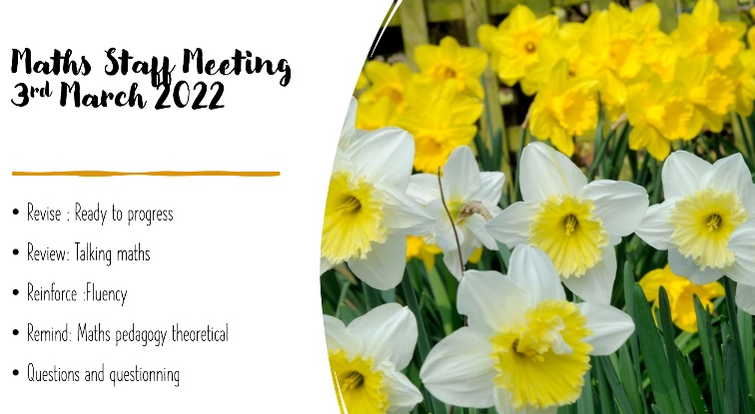

Throughout the staff meetings this year as well as ‘Talking Maths’ we discussed the term ‘Fluency’ in light of our pupils. As a staff we decided that as the original initiative of adding fifteen minutes of discrete teaching of multiplication to the maths day had worked very well we would extend the focus for these sessions to incorporate other elements of maths to support fluency (see table)
Mental Maths Bonds Arithmetic Fluency 10:45-11am
Monday | Tuesday | Wednesday | Thursday | Friday
Multiplication/Division  Facts and relationships | Addition and subtraction  Relationships | Multiplication and Division  Recall Fluency | Number Bonds  Inverse relationships | Problem solving  Master

‘Ready to Progress’
The ready to progress criteria has also been reviewed and added to the progression planning sheets.
As the maths lead and in light of our ever- changing co-horts, I decided to further research methods and approaches to suit our pupils. In response as a staff, we then considered pedagogies that reflected our own teaching styles that we know work. (Related to maths teaching and Autism). I felt that a clear theoretical plan of our teaching and learning approach would be useful for both staff and parents to relate to.

CPD : Staff Meeting:
Courses: I have attended all maths subject leader courses as facilitated through ‘Sarah Squared’. These include the latest findings, updates, advice and recommendations. Staff meeting reflect advice shared at these meetings.
STAFF CPD
This year we have used funding for maths to buy in: White Rose Hub Staff training. The training is directly related to the application of the National curriculum objectives as presented through The White Rose Hub.
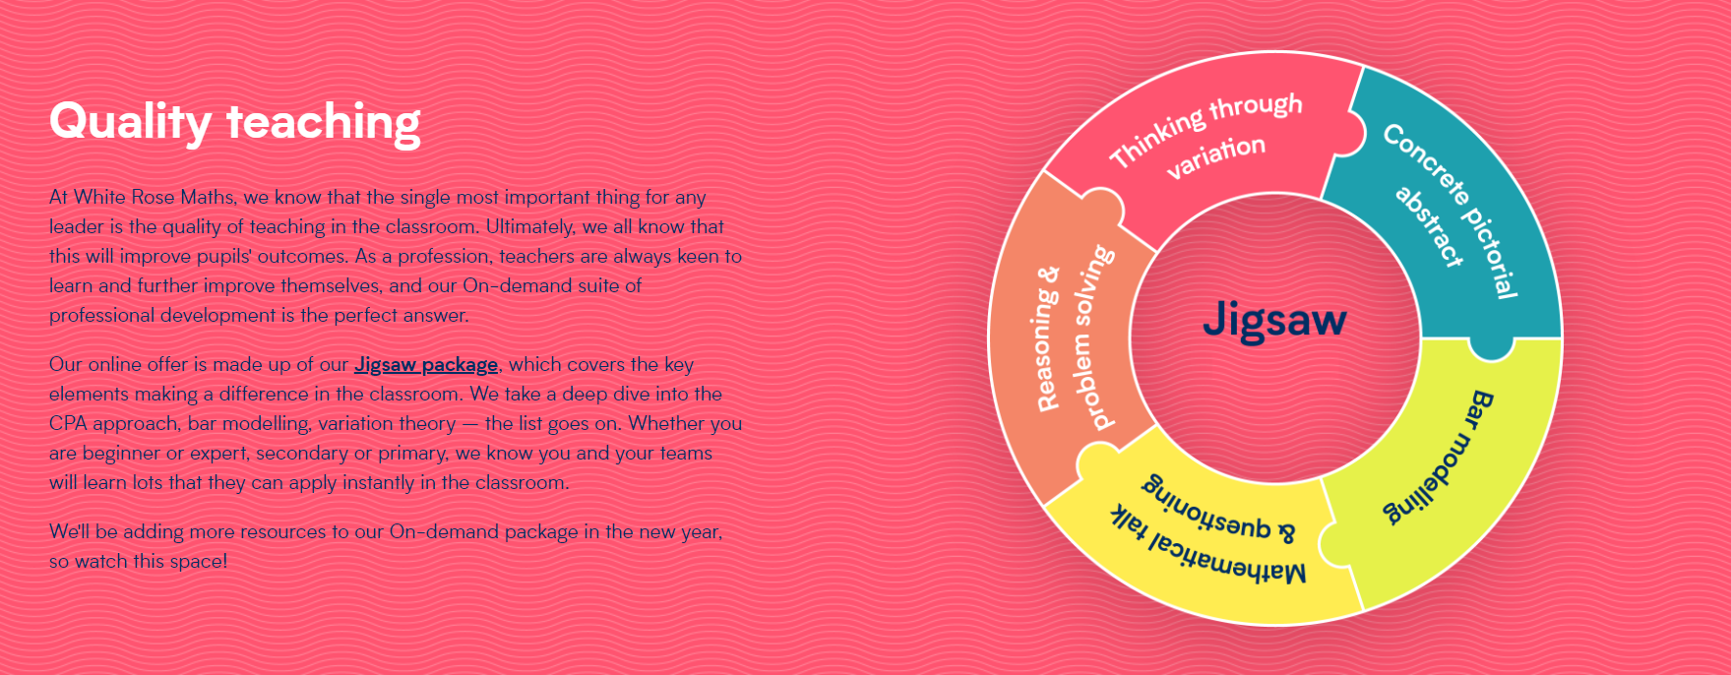
All staff have an individual log in which allows them to work through sections of online training to support their needs.

MATHS MODERATION
Within School we carry out maths moderation. Here all teachers attend and bring with them work from their class to share and moderate according to the National Curriculum objectives. Teachers discuss the pupil as a whole and reflect on how the pupil has met the objectives and address any worries or concerns related to their additional needs.

Quality of teaching learning : Assessment / Review

Impact
Pupil voice demonstrated that all children had really enjoyed their talking maths lessons. They felt that they better understood the terms being used during their lessons and felt that this had helped their overall understanding.
Staff voice reported that they too had enjoyed teaching ‘Talking Maths’ both as an’ additional needs’ intervention but also within their daily class lessons. They enjoyed the fact that time had been set aside just to ‘Talk Maths’ and that because there was no pressure to achieve a calculation etc they could explore maths words in a less pressured way. Staff felt that facilitating the time for children to use the words many times in different scenarios helped them to understand the words and what they really mean but also helped pupils self esteem and confidence.
All staff could see an observed improvement in pupil confidence and engagement. This is a wonderful outcome for our pupils and staff alike.

Assessment
This continues to be made through Assertive mentoring and the White Rose Hub assessments at the end of each term. We also assess mental maths using ‘ Animals Awards’. This year data is being collected to record whole school data using a different format, (trialled last year). This format makes progression easier to see and where they may be areas of concern they can be seen through academic results. Areas are then discussed at the pupil progress meetings and interventions put in place as and when necessary.
Example of recording Maths testing data (names have been removed)
Assessing pupil progress
At the end of each term teachers assess pupils overall progress using the maths data as a guide to highlight National Curriculum objectives.

Learning Walks

Book Scrutiny x 2
Focussed on the school marking approach, talking maths, elements of real life, work produced, presentation and progression. The books evidenced a clear marking approach, talking maths interventions, well presented work and evidence of progression with maths.
Strengths:
- Pupils make progress. (Assessment data raw scores/ Assessing pupil progress / Pupil progress/ observations/ book scrutiny/ staff voice/ pupil voice/ additional needs reviews/ parent questionnaire)
- The staff continue to feel confident delivering a range of activities to meet the diverse needs of our pupils. The staff feel that the White Rose Hub programme of study along with extras from a range of sources supports teaching and learning.
- Real life maths continues to be well supported through maths, social skills and life skills.
- Talking Maths was well delivered and supported our pupils’ understanding and application of maths.
- Fluency is discretely taught, this has been observed by staff as a positive step to increase fluency and overall maths application.
- Whole staff CPD has been put in place and well received.
Governor Visits
It has been lovely to meet with Mrs Cooper during the year to share classroom practice, the children’s work, updates and initiatives. School really values our close links with our governors and the support they give us.
Please also find
Appendix 1 Review of Maths input since last OFSTED
Appendix 2 Review of Maths application at ORRETS MEADOW with respect to latest OFSTED REVIEW

Ways forward
As the school co-hort continues to change and a greater proportion of pupils with speech, processing, language and communication difficulties are attending the school, the impact of such difficulties continues to be an ongoing need that the school must continually address in relation to the knowledge, comprehension and understanding of maths. This year we focussed on Talking maths which visibly helped our pupils in all areas of maths. The focus for 22/23 will build on this initiative and centre around problem solving. We want the pupils to continue to develop confidence when solving problems.

I look forward to developing this focus over the coming academic year.

Thank you for your time and continued support
Lorna Billington

Appendix 1 Review of Maths input via School Development Plans since the last OFSTED

SDP | Focus
2017 -2018  Background priority 1 | To extend children’s mathematical skills with a focus on measure, mental maths and problem solving strategies. | FOCUS: MASTERY WRH introduction / trial  ASSERTIVE MATHS  15 MINS additional intervention  -Staff training INSET Mastery in Maths.  -Onset of WRH monitoring.  -Mastery of subtraction and division.  -Focus of Assertive mentoring tests weekly.  - Summer term introduction of discrete 15 mins mental maths (multiplication) session.
2018 – 2019  Focused Priority 3 | To further develop the mastery of maths at OM across the school, including the mastery of times tables and arithmetic skills. | FOCUS: Embedding WRH mastery curriculum  -Review of last years introduction of WRH.  -Staff meeting /training: Arithmetic: Methods and questions expectations of the four operations.  -P levels cluster group to ensure moderation across schools for P levels.  -Scrutiny linking learning objectives to WRH  - reviews and assessment of multiplication demonstrated progress and engagement  -evidenced in staff and pupil surveys.
2019-2020  Focused priority 4 | Develop real life skills of money, time and measure to increase mastery in Maths and social skills of our pupils.  Orrets Meadow follows a structured learning programme supported by the White Rose Hub for Mathematics. In light of our new pupil cohorts we wish to facilitate a greater emphasis on life skills. | FOCUS: REAL LIFE MATHS  -TAs Numicon – Training  -Staff Meeting REAL LIFE MATHs  -Amended the WRH to meet the needs of our SEN pupils in light of REAL- LIFE maths.  - Staff training REAL LIFE Maths.  -Sarah squared – moderation and subject leads
2020- 2021  Focused priority 4 | As above continued due to lockdown. | FOCUS: continued REAL LIFE MATHS  READY TO PROGRESS CRITERIA  - REAL LIFE parent support group  - REAL LIFE opportunity in class shop measure etc
2021 -2022  Focused Priority 4 | To reinforce mathematics through: supporting, monitoring and developing the use of mathematical vocabulary throughout the maths lesson. | FOCUS: The LANGUAGE OF MATHS  -Staff Meeting : Vocabulary; the language of maths.  -Ready to progress criteria update.  -STAFF Training on the language of maths progression throughout KS1 and KS2 – Sarah T  - Mathematical vocabulary / parent workshop  -introduction of Talking maths as an additional needs intervention.  -Planning addition of READY TO PROGRESS  - Maths language identification for lessons.  Change to the 15 minute session :now integrating multiplication, division addition and subtraction /fact families /bonds and problem solving to enhance the development of fluency.

Appendix 2
Review of ORRETS MEADOW MATHS Application in light of recent OFSTED review.
Summary of Maths Research Review/Notes for Subject Action Plan
Mathematics
Pupils are more likely to develop a positive attitude towards mathematics if they are successful in it, especially if they are aware of this success. The report indicates that teachers should be aware of this process and avoid the use of games to motivate students. When a pupil becomes anxious about mathematics, this is not because of the subject but is instead due to their failure to acquire knowledge. Once pupils acquire core knowledge, it is likely that they will associate the subject with enjoyment and success. We should be aware of the differences between infrequent mistakes and consistent mistakes that are likely to make pupils anxious about maths. Consistent mistakes are likely to be caused by weak foundational knowledge. A proficiency first approach is likely to prevent students from becoming anxious.

The report also focuses on the importance of early acquisition of knowledge and how that can impact on later success. By securing core facts at an early age, children are less likely to overload their working memory and are able to acquire confidence in and enjoyment of maths.
New terminology
- Declarative knowledge – this consists of facts, formulae, concepts, principles and rules; it can be prefaced with the sentence stem, ‘I know that…’.
- Procedural knowledge – this involves recall as a sequence of steps. This category includes methods , algorithms and procedures, for example for long division or multiplication. It can be prefaced with the sentence stem, ‘I know how…’.
- Conditional knowledge – this gives pupils the ability to reason and solve problems, using declarative and procedural knowledge to choose successful strategies. It can be prefaced with the sentence stem, ‘I know when…’
Key headlines from document | What do we already have in place? | Continued action and How can we improve? (Suggestions for the action plan)
Curriculum progression is planned from the beginning of a pupil’s education through focusing on core content, to develop pupils’ motivation and to allow more breadth and depth later.  The planned curriculum details the core facts, concepts, methods and strategies that give pupils the best chance of succeeding in the subject. | We use primarily White Rose Hub, a DfE approved scheme to support the delivery of our mathematics curriculum. This incorporates planned progression through year groups.  Core facts are taught in all year groups through fluency lessons.  A fifteen minute slot (10:45 -11 AM ) is dedicated to the enhancement of multiplication and mental maths facts fluency.  During this time pupils are engaged in active maths, singing, and shared activities.  Initial testing on entry to Orrets meadow involves an Assertive mentoring test or Teacher assessment depending on the ability of the child.  Throughout the pupil’s journey through Orrets Meadow children are assessed by initially assertive mentoring test as well as end of block White Rose Hub tests. Weekly assessment sare used to reinforce and diagnose areas that need support. | Review of fluency provision throughout school.  Learning walks  Book scrutinies.
Schools should prioritise children’s enjoyment of maths which will lead to a positive attitude and decreased anxiety about the subject.  There should be less emphasis on ‘learning through mistakes’ and more emphasis on securing early sound foundations in core knowledge. | All pupils are assessed to establish areas that needs support. Pupils in classes are regularly reviewed through testing and pupil progress meetings.  Pupils are taught at the levels assessed and the curriculum is amended. Therefore, a pupil who is chronologically aged at year 3 for example but working at Step 6 will be taught at step 6.  Small classes and a high proportion of TA support allows for this pupil centred approach.  Basic maths skills are reinforced through class lessons. Time is given for pupils to share paired and group activities as well as songs and games.  Mathletics /purple mash/ Education City and other online games are used to enhance and support the love of maths. Pupils are supported in these activities. | Regular learning walks and lesson observations.  Class co-horts  Pupil progress meetings
Declarative knowledge should be prioritised particularly in EYFS and Year 1. Gaps which children arrive with (for example those children who have not encountered early maths concepts before starting school) should be identified and filled early in a child’s school life. | Children have access to a maths rich environment in all classes through their lessons.  Resources are updated when requested.  Oral fluency Maths language and communication is prioritised through ‘ Talking Maths’ Additional needs groups and enhancement of all maths lessons with a Talking maths approach.  (Training Sept 21)  5 fluency sessions per week support fluency, basic skills and shared problem solving throughout each week.  Animal Awards encourage and enhance development of mental maths and fluency. Children are rewarded with certificates of achievement and they progress through each award.  Where a child’s need is such that to achieve a full award is too much awards are broken down into smaller learning goals to ensure the sense of progression and achievement is continued. | Investment during Covid in Education City and renewed use of Mathletics and Purple mash support learning and reinforcement both at home and at school.
Procedural knowledge - as children progress through school they should rely less and less on visual resources and manipulatives and move towards abstract representations | Due to the nature of our pupils’ it does not always follow that the older they get the less manipulatives or practical resources they use.  It may be that children use a decreasing number of manipulatives as their understanding increases.  At Orrets Meadow many children may continue to need visual prompts, practical resources and manipulatives throughout their time at school, depending on their social, communication and academic stages.  Mental maths approaches and maths strategies do not follow a year group link but will be dependent on the needs of pupil’s not year groups. | Continue to ensure calculation policy is representing practice in each year group and that all teaching and learning staff are aware of its contents.
Conditional knowledge – do children have the strategies to help them unpick mathematical problems and then solve them?  Strategies should be taught explicitly to children to avoid strategies such as ‘trial and ‘error’. | Problem solving is taught through delivery of the White Rose hub Scheme. The mastery and depth of lessons is observed and differentiated by staff who know their classes well. The White rose Hub scheme facilitates overlearning and reviews of a range of strategies to support basic understanding.  Ready to progress criteria and maths pedagogy are regularly discussed at Staff meetings.  In school moderation has always and will continue to take place. Regular Moderation involving cluster groups including mainstream and special schools took place regualry. This will hopefully start up again as the Covid crisis lessens.  Years 1-6 are using Ready to Progress materials to ensure that children are being taught the correct word problems which will enable them to access the next year group’s learning.  This is taken into account during planning.  Children working at a Pre NC level use STEPS to ensure progression of skills. Where pupils have a spiky profile Teachers may use objectives from later or previous year group objectives to ensure that gaps are being met and reinforced.  . | Continued regular Maths Staff meeting and CPD when required.  Book scrutinies and discussions with staff  Moderation exercises.  Learning walks.
Make sure children have the time to fully grasp core concepts. Do not rush them through ‘tasks’ – make sure their learning is secure. | Small class sizes and a curriculum led by pupil need is established at Orrets Meadow.  Overlearning and reinforcement is a priority due to the nature and needs of the pupils.  Work is differentiated and learning supported by TA’s  Introduction of Talking Maths as a whole school intervention to support the language of maths. This is through practical lessons as well as specific individualised groups for additional needs. | Continued use of Talking maths during lessons and through additional needs interventions.  Learning walks /observation
Teachers should plan frequent, low-stakes testing to help pupils to remember content and lessons incorporate timed testing to help pupils learn maths facts to automaticity. (these should not be conflated with past papers). | Currently all pupils are assessed using assertive maths mentoring weekly for diagnostic purposes and end of term White Rose Hub tests to again assess a pupils gaps in progression and learning. | Continue to use teacher voice to establish where and when such assessments could be used.  Assessment review Oct 21 staff meeting
Textbooks/Workbooks can be a valuable way for lower attaining children to practice their maths. This can work well when books are sent home for practice to be continued there. Does not have to be the scheme book used in class. | Due to the nature and needs of the children White Rose Hub objectives and scheme are used in conjunction with a range of other resources included Teacher created work, activities and worksheets. | Continue to reinforce work through homework for those who can access it.  Considerations for Parental special needs. / child parent mental health / ASD conditions / social communication needs.
Clear expectations of presentation should be established for calculations – children are less likely to make mistakes and more likely to spot patterns if presentaion is systematic. | Class lessons use clear strategies : Part whole model / Bar model / numberline as well as those set out in the calculation policy. | Continue to ensure consistency through book monitoring.
Opportunities should be created to support ECT teachers and to make sure staff knowledge is up to date. | Regular Staff meetings and Requests for training.  Training from Specialist providers Sarah Squared.  Maths Lead attends Regular Maths updates and cascades information to all staff. | Continue to enhance teaching through support and regular discussions at maths staff meetings.

