Governor Report- Summer 2022
Music
Charlotte O’Brien
Achievements
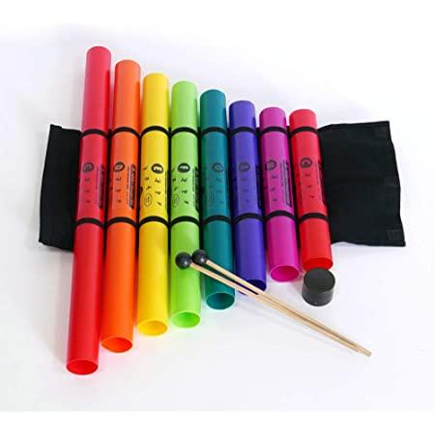
All teachers, supported by TAs, have contributed video evidence of their children’s achievements in music to demonstrate progression across the music curriculum. We can now demonstrate more clearly, beyond photographs that children at Orrets Meadow build on their skills and progress through the curriculum.
Boomwhakers were purchased in the Autumn Term and introduced to the staff at the Music Update Staff Meeting in January. Owl and Fox Classes have experimented with them and played along to a variety of seasonal songs including Jingle Bells and We Wish You a Merry Christmas for Christmas and Land of Hope and Glory for the Jubilee celebrations in June.
The Music Spine was created using the music suggestions in the Model Music Curriculum and shared with staff in January. Classes were provided with a list of music to include in their daily listening in the classroom. Each classes suggestions covered a range of eras and genres of music. Several teachers mentioned they enjoyed exploring the different suggestions with their class in the Staff Survey.
During June Year 5 children attended the KS1 Concert at the Liverpool Philharmonic Hall to enhance their curriculum. The children loved listening to a live orchestra and singing a shared song with a large group of people.
This year both children’s and adult curriculum surveys were focussed around the four primary strands from the Model Music Curriculum. To ensure all children have a voice the children’s survey was created using ‘Widgets’ from Widgetonline.com so that children who communicate non-verbally could take part.
In the wider curriculum the children enjoyed listening to Jewish Songs and singing with Eric Cohen who visited school during Religion Week to share his faith with the children and brought his guitar. In the summer term, a group of children attended the Shadow Dance, Inclusive Dance Festival at the Floral Pavilion to perform a choreographed chair dance for large audience of their peers, family and friends.
Over the year children have accessed a wide range of songs and music from across the world via the Dimensions curriculum. Book scrutiny and lesson observations show progress across the school that meets the objectives of the National Curriculum.
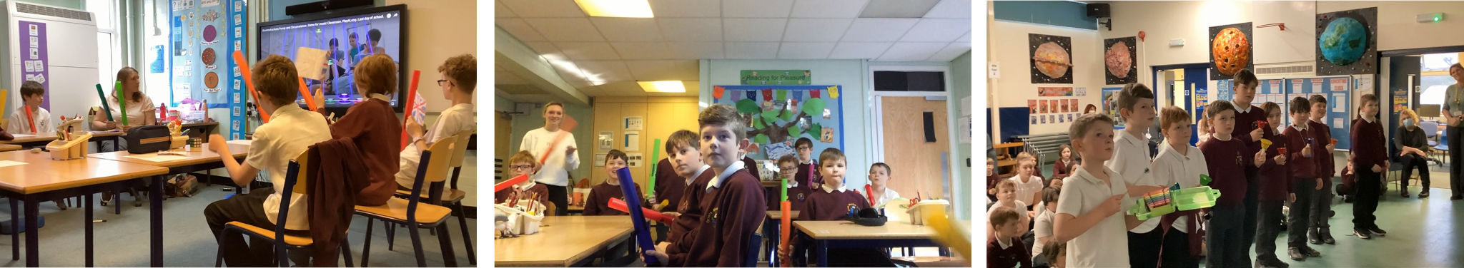
Land of Hope and Glory We Wish You a Merry Christmas Jingle Bells

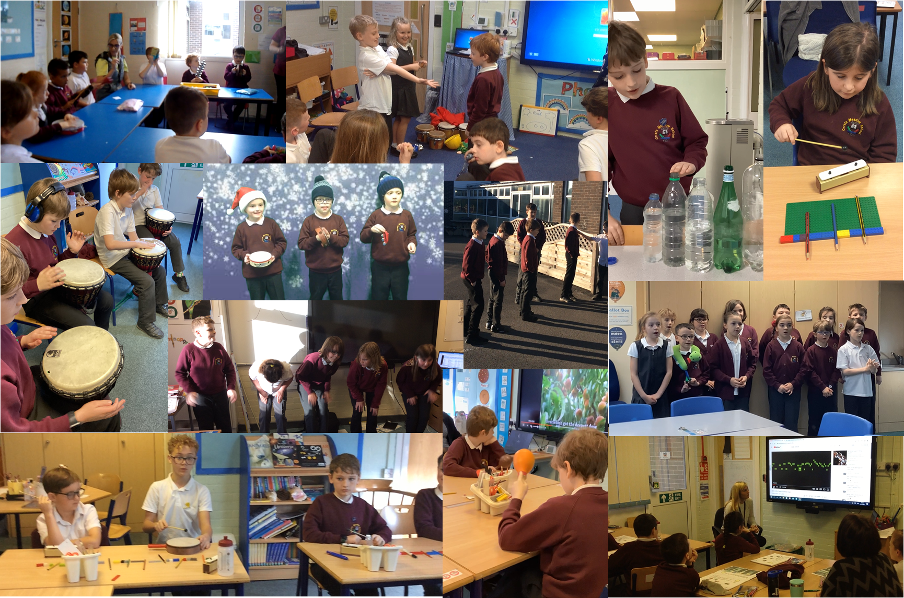 Music for stories, recycled instruments, creating rhythms, African drumming, Christmas music, listening to nature walks, making sounds with our bodies, singing Ner Li for Chanukah, making sounds for performance poetry, listening to sounds for science
CPD
- Music Update COB 12/1/21
As Music Lead, I led an update about Music at Orrets Meadow. Staff were introduced to the new tuned instruments (Boomwhakers, Bells and Chimes Bars) that are colour coded in a pentatonic scale. They were given the Music Listening Spine to ensure children are able to listen to a wide variety of music from different eras and genres.
- Music Curriculum Conference 18/3/22
I attended a Zoom Music Curriculum Conference in March
- Philharmonic Pre-Visit Prep 21/3/22
Mrs Gordon and Miss McGregor attended the Philharmonic Visit Preparation training via Zoom. Both teachers fed back that the training was interesting and useful preparation for the visit and had transferable skills to enhance their classroom teaching.
- Dimensions Music: Composition and Performance 30/3/22
All teachers attended a Progression in Composition Staff Meeting led by the Edsential Music Hub. Feedback said that most teachers valued the training and it reassured them that what they are pitching their teaching of composition at the right level for their children to make progress.

Quality of teaching and learning
To monitor the quality of teaching and learning in Music, a Music Leader’s file is kept updated. All the relevant policies and documents are kept in one central place. The Dimensions Curriculum has been reviewed to ensure the objectives from the national curriculum are met. An audit of musical instruments available for composition and performance in school is shared with all staff. The music policy has been updated to include suggestions from the Model Music Curriculum.
In the Spring Term the Teachers Survey showed that 8 out of 9 teachers are confident delivering all four elements of the music curriculum, with one teacher lacking confidence leading lessons in composition at their stage. Further support and training will be provided. Teacher’s have requested we add we add to the music inventory and have more musicians visit the school.
The Pupil Survey was completed in the summer term. They showed ‘sticky knowledge’ of the things they had been taught by recalling songs they have sung, music they have listened to, what instruments they have played and where they have played music. Children had a positive attitude to music.
Over the year I have had the delight of visiting two lessons to see music in different part of the curriculum. In the Autumn Term I visited Foxes who are ‘Adventurers’ at the higher end of the skills ladders at Orrets Meadow to see the ‘Lego Composition.’ Children composed their own bars of music on chime bars representing the length of the note by the length of the Lego brick. Children were confident and engaged in their activity and proud of their compositions.
In the Spring Term I visited the Tigers who are ‘Pathfinders’ in the middle of the skills ladders at Orrets Meadow. Children were actively listening to the tempo of Celtic Music linked to their topic. Children were all engaged and able to identify the tempo of the music. Both teachers demonstrated secure knowledge of the music theory being taught and had adapted the curriculum to engage and excite the children.
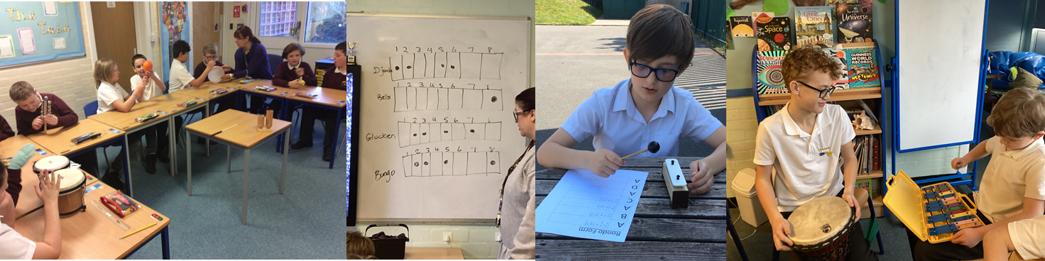
Strengths
- Robust curriculum that meets all the demands of the National Curriculum and beyond.
- Confident, enthusiastic teachers who adapt the curriculum to meet the needs of their pupils.
- Wide range of multisensory resources to support skill development across the school.
Ways forward
- Create more opportunity for playing and performing music in different places.
- Organise First Access Music lessons from Edsential.
- Explore extending our music curriculum beyond Dimensions.

Targets 2022-2023
- Organise a ‘Musical Monday’ afternoon to extend our music curriculum beyond the Dimension Curriculum (Autumn 1 2022)
- Organise ‘First Access’ music lessons from Edsential (Sept 2022)
- Purchase listening scarves/ribbons (September 2022)
- Increase and update Instrument Inventory (September 2022)
- Write the Music offer for Website advised in the ‘The Power of Music to Change Lives’ Document, June 2022 (Autumn 2 2022)
- Explore the Music Man and Sound of Intent inclusive resource websites for Music (Spring 2023)
- Staff Meeting- What does Music look like at Orrets Meadow? (Explore progression of skills through the curriculum) (Spring 2023)
- Make Music activity suggestions for Cultural Week linked the country being studied. (Spring 2023)
- Explore Music for Mindfulness in PSHE Week (Summer 2023)

