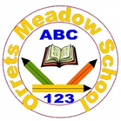
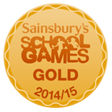
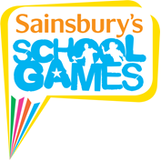

SNAG Golf
Class 4 were lucky to be invited to take part in a SNAG Golf day at Clare Mount Specialist Sports College. The format provides an introduction to golf for beginners through a range of fun activities and challenges. The children had a fantastic time and all came back keen to take up further opportunities for golf in the future.
