

Wirral school named Primary of the Year at annual Merseyside Sporting Awards
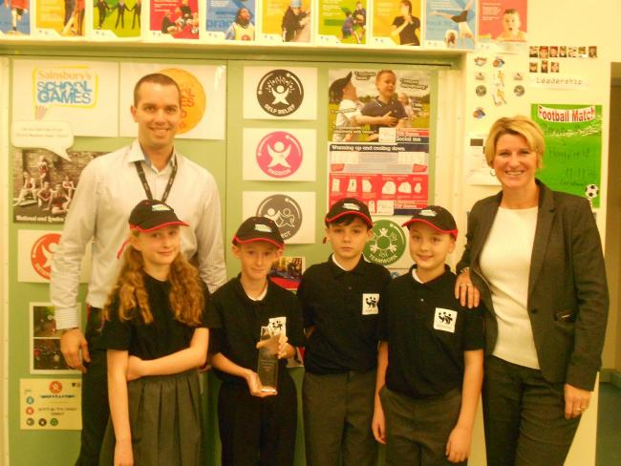
(From left to right) PE leader David Saul, pupils Josie McMahon, Sam Davies, Lewis Cullen, Ellis Campbell and Head teacher Carolyn Duncan with the award.

A Wirral school has scooped up the title of Primary School of the Year at this year’s Merseyside Sporting Awards held at Aintree Racecourse.

Orrets Meadow Primary School in Moreton won the award on Friday night for their excellent delivery of physical education to their students.
The event was designed to celebrate the county’s sporting talent and the people who make sport and physical activity happen here on Merseyside.
Offering support for children with specific learning difficulties or social communication difficulties Orretts Meadow and PE leader David Saul ensure all children, regardless of disability participate and engage in PE with 91 percent of their pupils taking part in extra-curricular activities.
Head teacher, Carolyn Duncan said: “I am extremely proud of how team Orrets have worked together to achieve this award.
“It recognises the endless enthusiasm and hard work of the pupils, staff and parents over the last few years and how committed we are at making a difference with the PE Premium funding. This award is the icing on the cake!
“This award shows the difference Orrets are making to pupils’ physical and mental wellbeing. The children are fantastic and so enthusiastic - they engage in everything we offer.”

Lauren Jones , Multimedia Reporter

