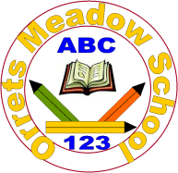

**Governors Report – June 2024**

***English***

***Matthew Ferris-Rice***

**Achievements:**

This year English has continued to excel at Orrets Meadow. This year has seen many exciting changes and the beginning of future change for the betterment of the curriculum access for our pupils. The main focus for this year, as detailed in the 23/24 SDP, was to ‘Adapt the English curriculum to ensure there are writing opportunities for all, particularly the most complex pupils.’ This has several steps in order to get to implementation stating with the continuation of promoting reading for pleasure and exposing the pupils to a range of high quality texts. I have worked closely with all staff to develop their confidence in developing writing and understanding of each stage of the reading and writing journey.

There have been some real strengths and highlights throughout English this year. These include;

* A brand new library has been installed.

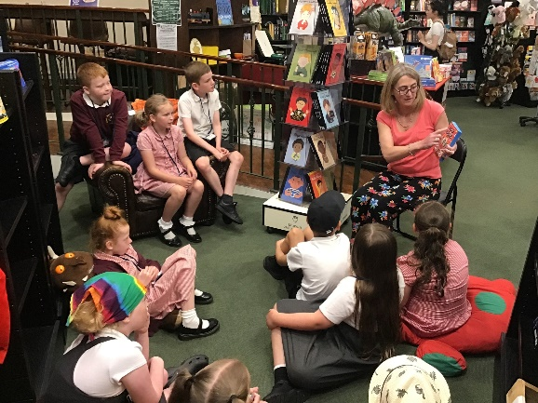

*Tigers class enjoying a story at Linghams*

* A digital library system has been set up to help pupils
* A record number of pupils entering, and being selected, in various Young Writers competition.
* Trips to a local bookshop.
* The growth of The Reading Ambassadors.
* Pupils’ continuing to make exceptional overall progress within English.
* Positive responses from external bodies with regards to our teaching of English.

Pupils’ have continued to be extremely positive about English this year. During pupil voices and conferencing I have seen the enthusiasm that children talk with, which highlights the skilled way that English is delivered.

**Subject Leader CPD**

Sarah Squared:

I have continued to attend the Sarah Squared subject leader updates throughout this year. They take place once a half term and continue to, not only provide national and global updates, but also provide opportunity to network with other English leads from the Wirral. This is beneficial as it has allowed me to hear about incentives, schemes and experiences to benefit our pupils.

Wirral Teacher Reading Group:

The Wirral Teacher Reading Group has continued this year and again has proven beneficial as a way of exploring a range of new books and looking at trends in reading. This year we have focused on Graphic Novels and books that could then be used to transition reluctant readers onto longer novels. Graphic novels have been extremely popular this year with pupils and this group has been able to suggest exciting new and appropriate books for our pupils.

**Staff CPD:**

All staff have had several CPD opportunities focusing on areas of English led by both myself and external bodies. These have included phonics and poetry.

Phonics Training:

I led phonics training again with new staff, as well as refresher training for staff that are working with different stages and ages than previously. This was followed up with phonics walks and observations, as well as remaining accessible for staff to ask for support when needed.

Colourful Semantics:

This year saw the start of a phased transition into using colourful semantics within school. I selected Wolves and Bears to trial this throughout the year. Colourful semantics is a system that can be used primarily to develop spoken language (a growing need within our school) as well as helping pupils develop their understanding of sentence structuring.

I led training for staff in these two classes and developed a short assessment that we could use to track how pupils have progressed throughout the year. Staff have worked very well feeding back to me, which has enabled me to envision how this works within our school.

This has been extremely successful this year and a session has been booked during the inset day in September to roll this out to the rest of the staff.

Poetry Inset:

At the beginning of the summer term Sarah Ratcliffe from Sarah Squared attended school to lead a training session around poetry. This has been highlighted through staff feedback as an area of least confidence. The training covered a variety of forms of poetry from early rhyme and song, to poetic structures in key stage 2.

This also provided a good basis towards planning the new writing curriculum and looking at how pupils could access poetry throughout the school.

Staff Meeting:

In addition to these courses I have also led several staff meetings throughout the year focusing on the development of writing; again with the aim of preparing staff for a new writing curriculum. The meetings proved beneficial and staff were keen to feedback how they

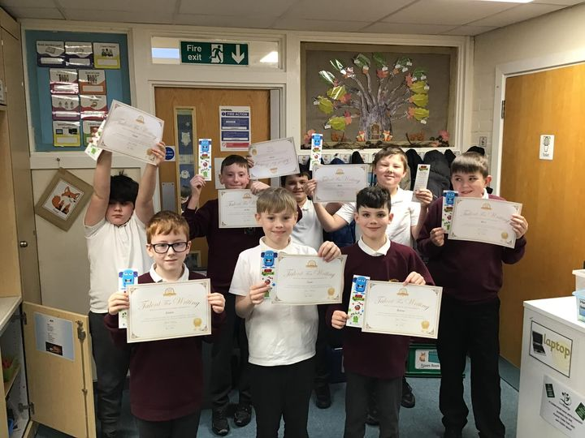

*Fox class got their poems published in a book!*

* Subject Literacy spines
* Drafting
* Revising and Editing
* Composition

**Reading for Pleasure at Orrets Meadow**

Reading Ambassadors:

Reading ambassadors has continued this year, which has given pupils the opportunity to lead the promotion of reading across the school. The reading ambassadors were privy to the knowledge of the new library that was to be installed this year. They worked very hard each week helping me to sort and label books ready for the online library management system.

In addition to this they co-ordinated creating a video that could be used to show off the new library. They have shown an excellent approach to reading and have spoken positively to other pupils to engage them with reading.

Library:

The library has had a major renovation this year. A new library space was provided and I researched library furniture providers and then worked alongside our chosen company to design the library. In addition to this I engaged the services of a company that creates wall art and again liaised with these in order to design art work to further engage pupils with a love of reading.

Further to this we have installed a digital library system through Libresoft. Again after researching library management systems and discussing with several English leads these were the best company to meet the needs required. Once this was installed the long and arduous process of labelling and adding all of the books to the library system began. Once this was complete training was provided to targeted staff in order start tracking the circulation of books.

Some pupils have really taken to it and have already started leaving reviews of the books that they have read.

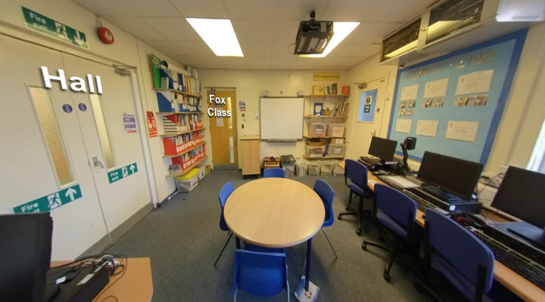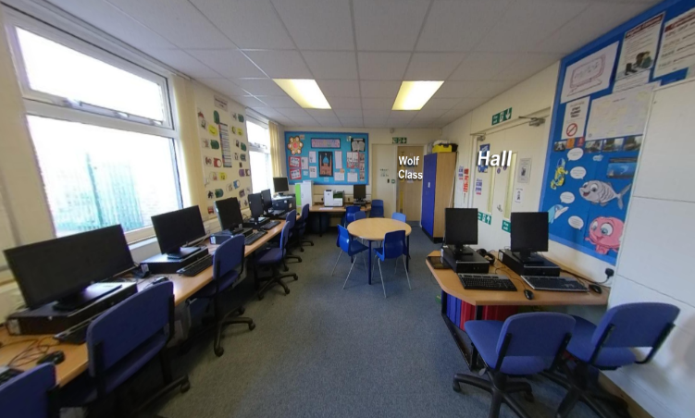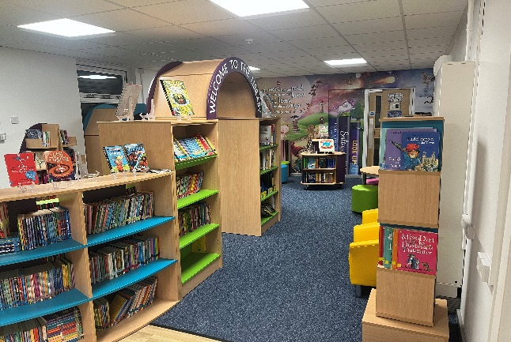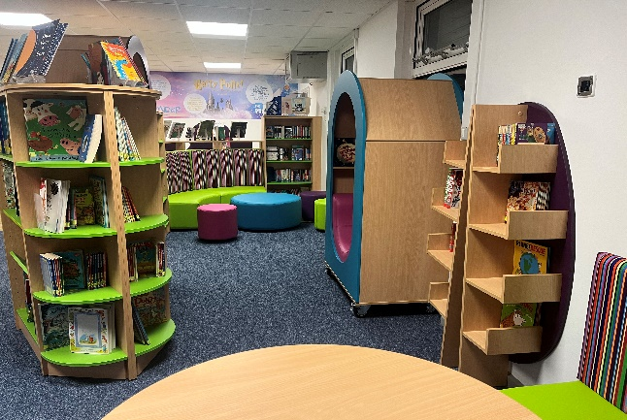

*Before: Computer Suite*

*After: New Library*

World Book Day:

This world book day was themed around heroes. Pupils rose to the challenge and we had a fantastic turn out from pupils. Throughout the day the pupils engaged with a range of stories, took part in a book choice bistro; aimed at developing how we select books and created art work surrounding books.

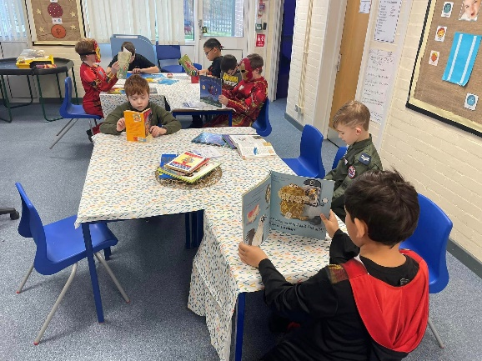

*Book Choice Bistro in the Zebra class*

Our book treasure hunt returned by popular demand, children solved riddles found on the back of book covers to, which led them to various locations around the school. The final clue led to treasure tokens that pupils could then exchange for a book that they could take home and keep. Our links with Linghams book store meant that we were able to order packs of books for pupils to select from.

Linghams:

Classes have once again been able to visit Linghams book shop throughout this year. Staff at the shop have been amazing with pupils. During visits staff have read books to the pupils and have also given us some freebies on some visits, including books, book marks, stickers, etc. Pupils have all really enjoyed these visits and next year we hope to further these by utilising the café to develop life skills.

Amazon Donations:

The Amazon wish list returned this year and was updated with new titles. There were many donations made, which helped stock our fantastic new library. The children gave suggestions of books that they would like to see and took part in unboxing the books as they arrived.

**Quality of teaching and learning**

I have continued to closely monitor and review the teaching and learning throughout the school this year. Following on from our focus on phonics in previous academic year I continued to monitor the implementation of our updated phonics scheme and ensure a level of consistency around the school. I have continued to track rates of progress from July 2023 and throughout each testing phase. Many pupils dipped in phonics during the summer, but so far all pupils have made outstanding progress in phonics, not only recovering, but excelling. I am awaiting the final testing to view the full progress picture of the year and look for any trends that may be present.

Also this year I have continued to collate reading data, monitoring reading test results, book bands and bug club book bands. This gives a strong overall picture of where the pupils are currently reading and is informing reading ages for book bands, at Orrets.

Further monitoring has been in the form of the reading and writing trackers that track the progress towards the national curriculum. Again I have been looking for actionable trends within these.

Pupil conferences highlighted how more readily pupils are able to partake in book talk. All pupils spoken to could name a book that they enjoyed, what books they had borrowed from the library and what books they had read within class.

Finally I have had the opportunity to complete book scrutinies in order to triangulate between work in books, planning and national curriculum targets. The English Governor joined me for another book scrutiny and we both agreed that the progress within the books was apparent and impressive. In addition to looking in books I have had a chance to observe the teaching of phonics in formal observations with the head teacher, as well as informal observations in order to coach and reassure staff.

**Ofsted:**

This year we had a visit from Ofsted part of the focus being on phonics and reading. I met with the lead inspector on the first day to talk through the phonics and reading, especially early reading, at Orrets. After this we had a learning walk looking at phonics around the school. There was also a pupil conference and observation of pupils reading.

Pupils showed real maturity and their enjoyment of English really shone through in their conversations.

**Strengths**

Orrets continues to have an exceptionally strong English curriculum offer, which is clearly evidenced in the progress that pupils make, as well as their enjoyment of the subject. We have a particular strength at helping children who are disaffected with reading get back on a journey to finding a love of books and enjoying exploring a new world. I feel strongly that within English as a subject we have strengths in all strands of the curriculum, and are consistent at exploring new strategies that can be used in order to further support pupils.

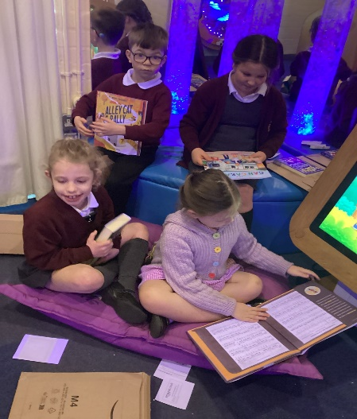

*Wolves unboxing Amazon donations*

Pupils remain highly engaged in phonics, reading, writing and speaking and listening, this shows through conversations with a range of staff and visitors, and the accelerated progress that pupils make within the subject.

**Ways forward**

*Continue to adapt the English curriculum to ensure there are writing opportunities for all, particularly the most complex pupils. (See school development plan 24/25 for further details)*