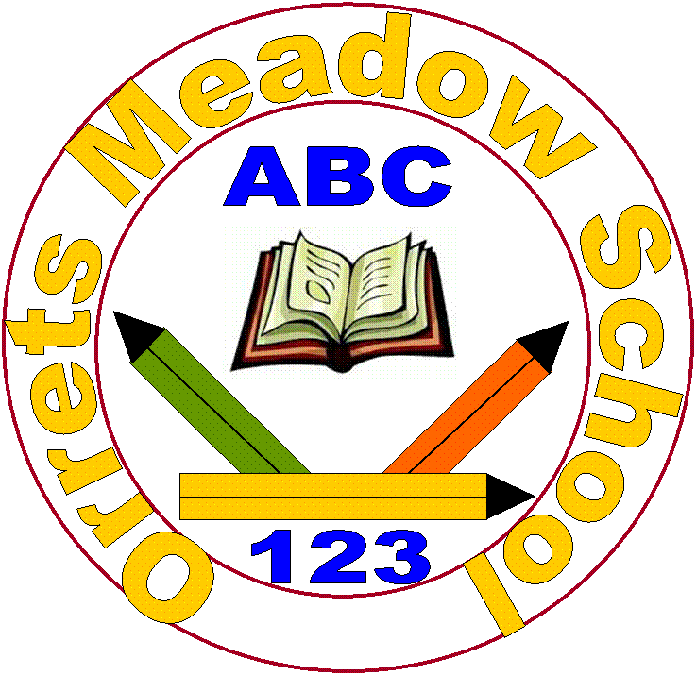
Orrets Meadow School
Parents and Carers Survey 2019 – 64 out of 70 returned

Question/Statement | Strongly agree | Agree | Disagree | Strongly disagree | Don’t know
1. My child is happy at this school. | 52 | 11 |  |  | 1
2. My child feels safe at this school. | 56 | 8
3. My child makes good progress at this school. | 58 | 5 |  |  | 1
4. My child is well looked after at this school. | 59 | 5
5. My child is taught well at this school. | 60 | 4
6. My child receives appropriate homework for their age. | 54 | 10
7. The school make sure its pupils are well behaved. | 58 | 6
8. The school deals effectively with bullying. | 46 | 9 |  |  | 8
9. The school is well led and managed. | 59 | 4 |  |  | 1
10. School responds well to any concerns I raise. | 56 | 8
11. I receive information from school about my child’s progress. | 58 | 6
12. I would recommend this school to another parent. | 62 | 1 |  |  | 1
Any other comments about your child’s experience of Orrets Meadow?

- Very pleased with his progress and very happy he attends OM.
- Wonderful school and wonderful staff!
- She has made lots of progress and seems happy and excited to go to school every day. She has settled well into her new setting. We have less tears and upset since moving here! Well done to the staff for their amazing support!
- This place is amazing and we are very lucky to have got a place here!
- I am very happy he attends OM as I know it offers the best education that he needs.
- She transitioned to OM from another specialist school and is doing excellently. The school have been very flexible in meeting her needs. Perfect placement!
- I have never experienced a bullying situation in OM, hence the don’t know.
- Fantastic school and staff.
- Very good school.
- He really enjoys coming to school each day and we are so happy with the fab progress he has made since starting in Sept 2018.
- Amazing school. We are happy with OM and would highly recommend. Teachers and TAs give great support, second to none.
- My child’s confidence has grown due to the surroundings and fantastic support from his staff, this has resulted in him wanting to come to school to learn and make great progress. We can’t thank you enough OM – You have been fantastic!
- We are very impressed with the progress she has made during the 6 months she has been at OM.
- Since she has been at the OM her confidence is unbelievable. Her reading and writing is fantastic. She has made lots of friends. Thank you for making her happy and safe.
- We couldn’t be happier about how he has progressed at OM.
- His anxiety has significantly improved since starting OM. He is also talking and communicating more at home.
- I could not recommend this school strongly enough. The teachers are absolutely wonderful and supportive. I literally couldn’t ask for anything more. Thank you!
- He is so happy at this school. We feel very lucky that he is attending OM. The progress he has made is unbelievable and the support we receive as parents is invaluable!
- He loves his rainbow school. We are very happy with his progress. Thank you to everyone, keep up the good work!
- Brilliant school. The staff are fab, They have worked wonders with my son.
- Thank you for all your ongoing support. You are all amazing!
- She loves this school as well as all the teachers and staff. She is very happy here and will miss everyone when she leaves in September.
- Since joining the school he has made amazing progress and looks forward to going to school. There is no better place he could be that provided everything for his needs.
- He has never been happier. He has come on in leaps and bounds. Thank you so much.
- My daughter has thrived at OM and is extremely happy at the school. I would 100% recommend the school to anyone!
- Both our son and family could not be happier as to his progress and how happy he is at the school. We cannot speak highly enough of the school and staff collectively.
- This school is amazing to think how much my son has achieved in one year of being here is unbelievable!
- We are really pleased with all the support he has received and can’t believe how much progress he has made in a short time. Thank you!
- We can’t thank the staff at OM enough for all they do. What it has done for our son is beyond words!
- Overall she has had a very positive experience and really enjoyed her time here.
- I cannot say enough good things about OM – it has changed all our live for the better beyond belief.
- OM has helped our son so much, all we can say if thank you so much!
- Moving our son to this school was the best decision we ever made!
- He often comments that he loves this school! We think it’s the best school ever! Thank you for being so amazing!
- My son has made excellent progress at OM in all areas. Great staff – amazing school!
- We would love a high school just like OM. He has progressed massively since starting OM. Thank you all!
- Our child continues to make great progress at OM. It is an excellent school in every way!
- Since starting in September our child has settled in well and is really happy at OM. She had made great progress in her reading and writing.
- His confidence within himself and his learning has had a significant boost since joining OM. Thank you!
- He has come on really, really well at OM. I can’t thank the teachers enough. Brilliant school!

