

Orrets Meadow School wins gold for sporting excellence
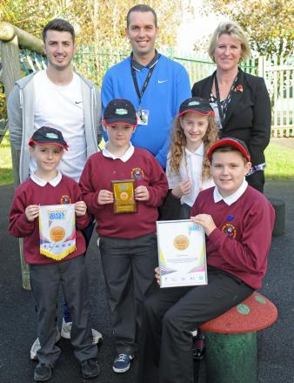
Michael Hayes, PE leader David Saul, headteacher Carolyn Duncan, Peter Solomons, 10, Joe Stebles, 10, Josie McMahon, 9 and Tobey Brace, 11, from Orrets Meadow School celebrate their GOLD Sainsbury's School Games Mark.
Wednesday 11 November 2015

A WIRRAL school is celebrating after receiving an award recognising its sporting achievement.
Orrets Meadow School in Moreton won the prestigious GOLD Sainsbury's School Games Mark award for its commitment to competitive sport. Staff and pupils found out they had won the award - which arrived this week - earlier this year.
The Sainsbury's School Games, which is supported by National Lottery funding from Sport England, and delivered by the Youth Sport Trust, provide a unique opportunity to motivate and inspire millions of young people across the country by encouraging them to take part in competitive school sport. The games are made up of four levels of activity: competition in schools, between schools, at county/area level and a national event for the most talented school age athletes. To recognise good practice schools are encouraged to apply for Mark to celebrate their achievement and Orrets Meadow School has been successful in achieving the GOLD standard.
Headteacher Carolyn Duncan said: "Well done to all the staff and pupils of Orrets Meadow. Special thanks go to David Saul, PE leader, for the enthusiasm and commitment he has shown to developing PE across the school over the year.
David Saul, PE and school sport leader, added: “It is a tremendous achievement for all the staff and pupils at Orrets Meadow.
"Everybody has worked so hard to create such a wide range of engaging and competitive sporting opportunities for the children.Our pupils have shown a great enthusiasm for PE and sport and have played a big part in helping to lead, manage and officiate in the games too."
The Sainsbury’s School Games is supported by a range of partners including the Department for Culture, Media and Sport, Sport England, Youth Sport Trust, Department of Health and British Paralympic Association.

