

**Governors Report – Summer 2024**

***Computing***

***Matthew Ferris-Rice***

**Achievements**

This academic year has seen the continuation of computing being embedded throughout dimensions topics, as well as being taught within discrete computing lessons. During this year we were successful in acquiring a set of micro bits, which can be used in order to further extend our hardware offer throughout the computing curriculum. The basic skills certificates are firmly embedded throughout the school at all ages and stages. This data has been captured at regular intervals throughout the year and pupils have been given certificates to show their progression.

**CPD**

The School Improvement Liverpool Primary Computing subject leader meetings have continued online each term this year and I have been lucky to access these. This has given the providers the opportunity to have a range of guest speakers, who have been able to highlight national and regional updates within the subject. In addition to this we have worked closely with another school to discuss how computing looks within their setting. This has been beneficial as it provided opportunities to explore ways to make the curriculum more accessible for pupils. I was also very lucky that I got to attend the MGL Liverpool Computing Conference. This was invaluable in order to explore a range of current research in the field of computing and it provided networking opportunities.

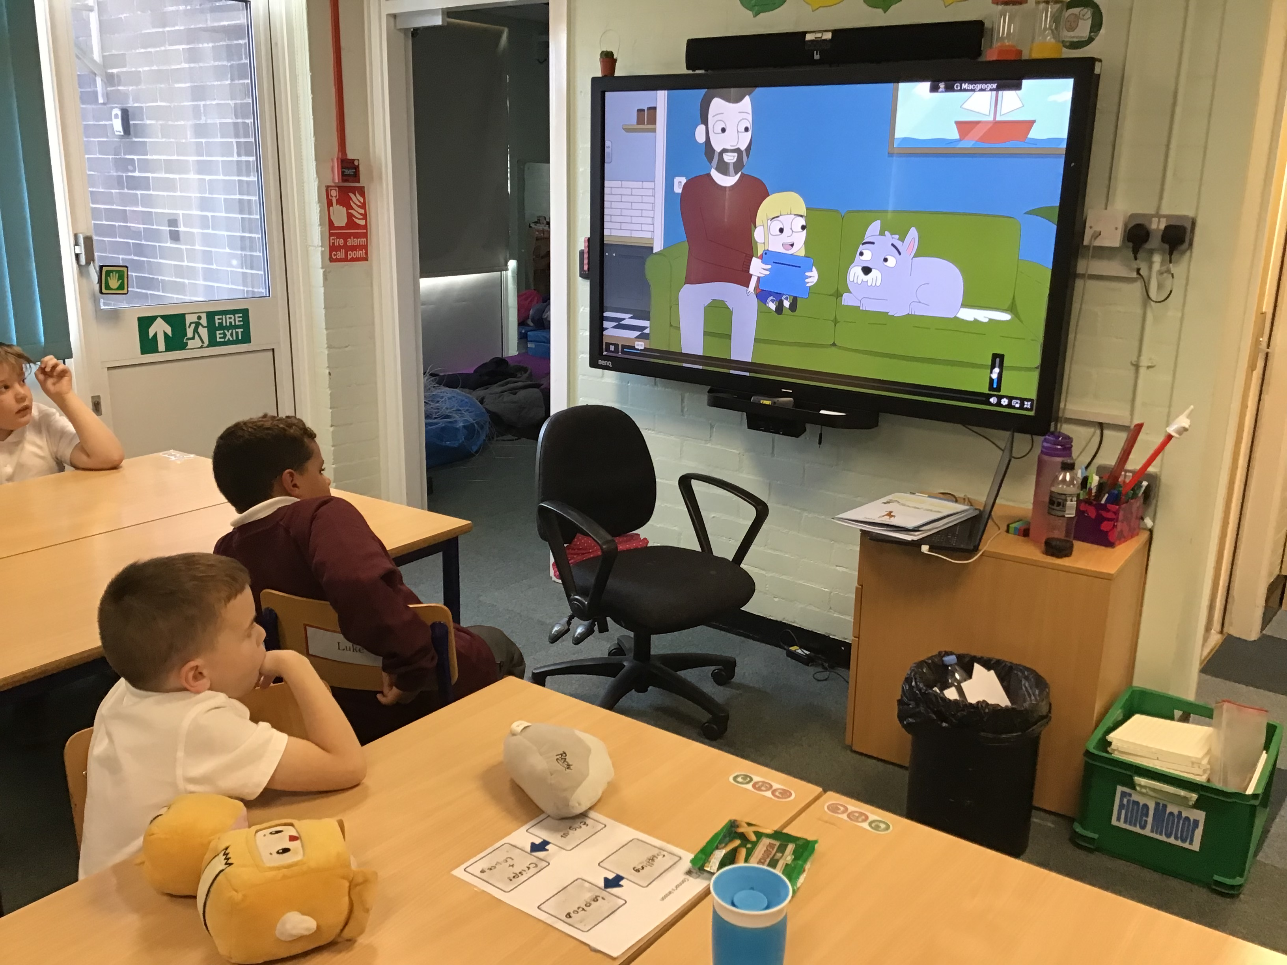

I have also continued to work with staff members around the school on a one to one basis, whenever they have required support with all things computing related.

**Quality of teaching and learning**

This year I have continued to monitor and review the quality of teaching within my computing. Throughout the year I have had several opportunities to conduct staff and pupil voice. These have yielded extremely positive results. During staff voice it has been evidenced that all staff are feeling more confident and enjoy delivering the computing curriculum. I have found staff extremely open about any issues they face within computing and they feel confident asking for help when they are unsure.

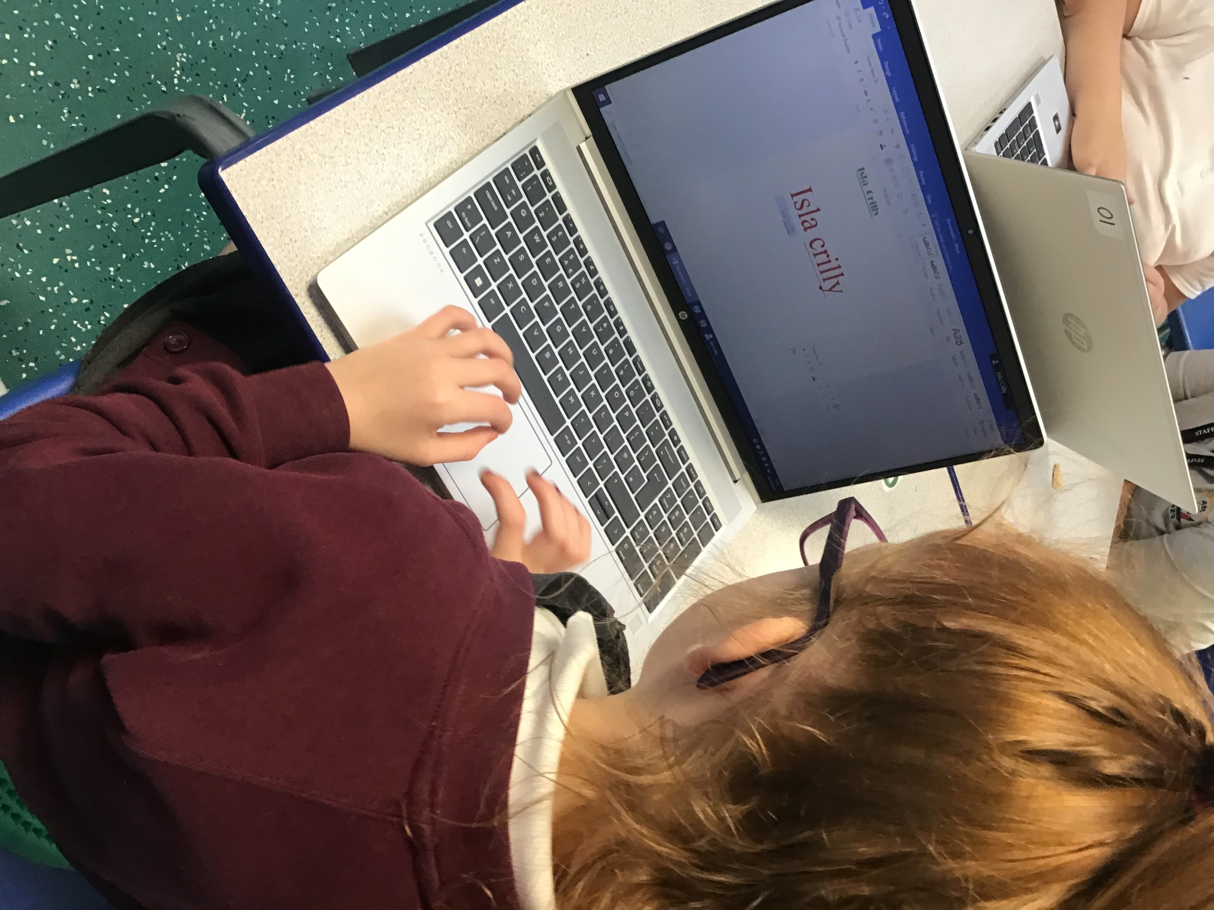

Pupil voices also highlighted the sheer enjoyment and engagement of pupils within computing. All pupils were extremely positive about computing with 90% of them saying they enjoyed every lesson and the other 10% stating they enjoyed most of their lessons. Pupils continue to favour the programming strand of computing. All pupils were able to explain how they use technology in their leisure time and explain how to be safe while using technology in a manner appropriate to their age and stages.

During the year I also lead an assembly for pupils to consolidate their learning within class about how we stay safe online, pegi rating and what to do in a range of situations. These messages were then shared with parents who attended the parent coffee morning focusing on online safety.

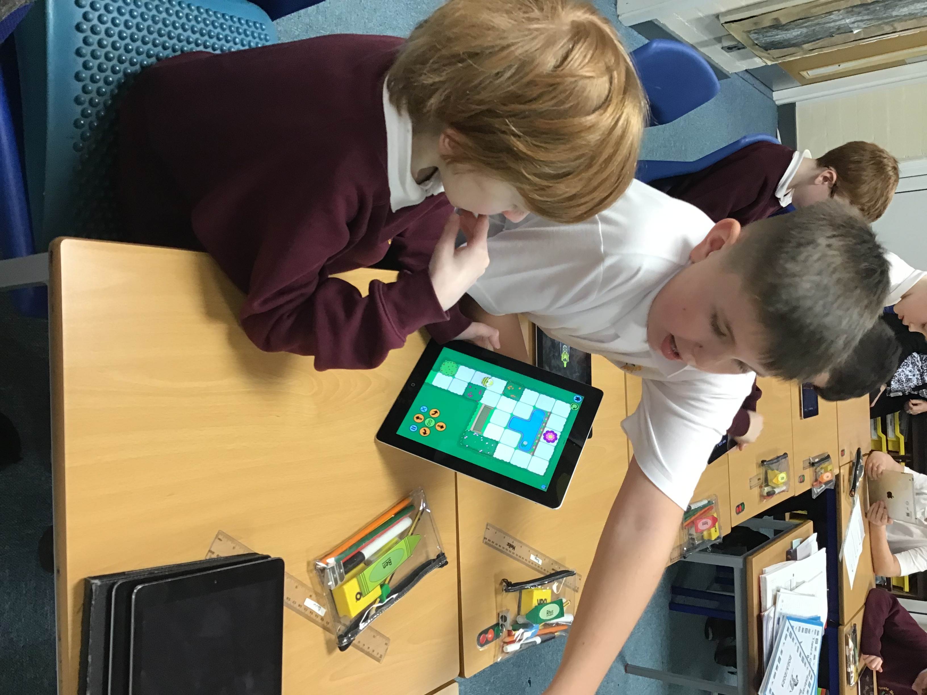

Building on the success of last year’s class scrapbooks to evidence computing, I completed book looks throughout the year and was happy to see on several occasions that all books continue to show high levels of pupil engagement, creativity in lessons, as well as a range of unplugged and plugged activities.

I had several opportunities throughout the year to visit classes around the school throughout discrete computing lessons, as well as computing lessons within dimensions. I completed learning walks and found an extremely consistent approach throughout the school. There were high levels of engagement, clear learning goals and a range of technology being used.

**Strengths**

The use of computing scrapbooks has continue to help to evidence the learning opportunities our pupils receive both within their topic and discrete computing lessons. They have proved extremely helpful during pupil voice and it has helped pupils to reflect and discuss what they have learnt; all pupils were able to talk me through their class books. Staff have continued to expertly ensure that pupils are able to access technology and learning within computing throughout this year.

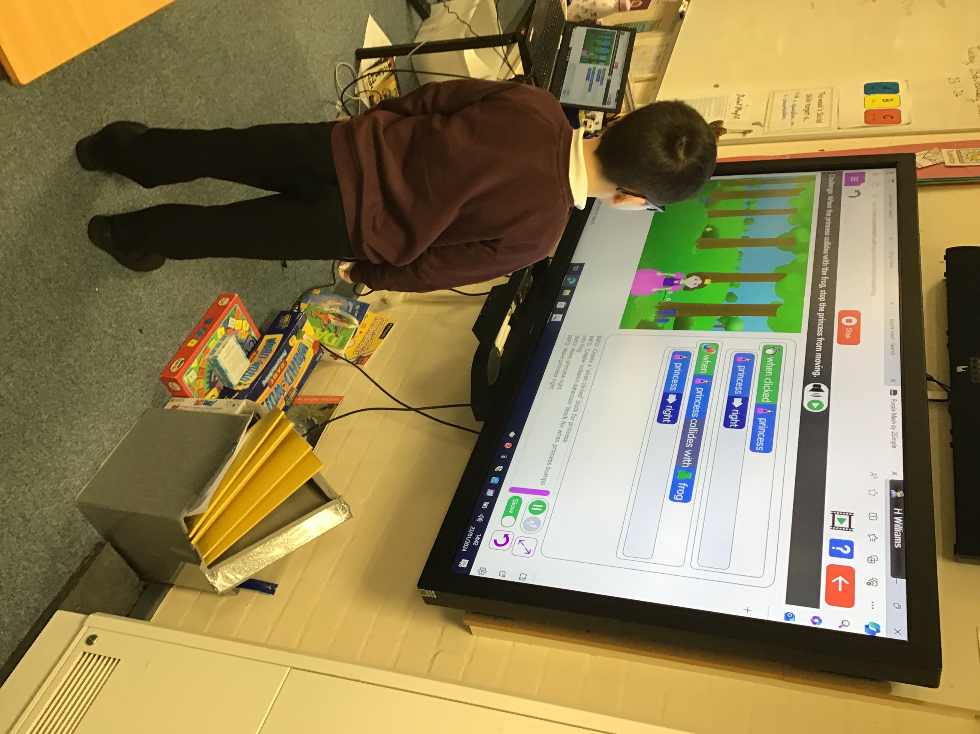

A literacy spine has been created for computing to highlight a range of texts for both pupil library loans and class readers. These texts can be used to further develop pupil understanding of computing and technology.

High levels of pupil engagement and enjoyment, supported by expertly tailored learning tasks has been apparent as the main strength within computing this year.

**Ways forward**

|  |  |  |
| --- | --- | --- |
| **Focus** | **Action Required** | **Intended Completion** |
| Introduce the use of Micro bits into the computing curriculum. | * Provide CPD for all staff on the use of micro bits. * Review the computing long term plan in order to include the use of micro bits. | Spring Term |
| Review and extend to pre-curriculum steps. | * Review the computing certificate objectives for pre-curriculum. * Use early learning goals to create a more robust pre-curriculum assessment. | Summer Term |
| Collect and monitor computing certificates. | * Collate data collected to monitor computing key skill development. | Ongoing |