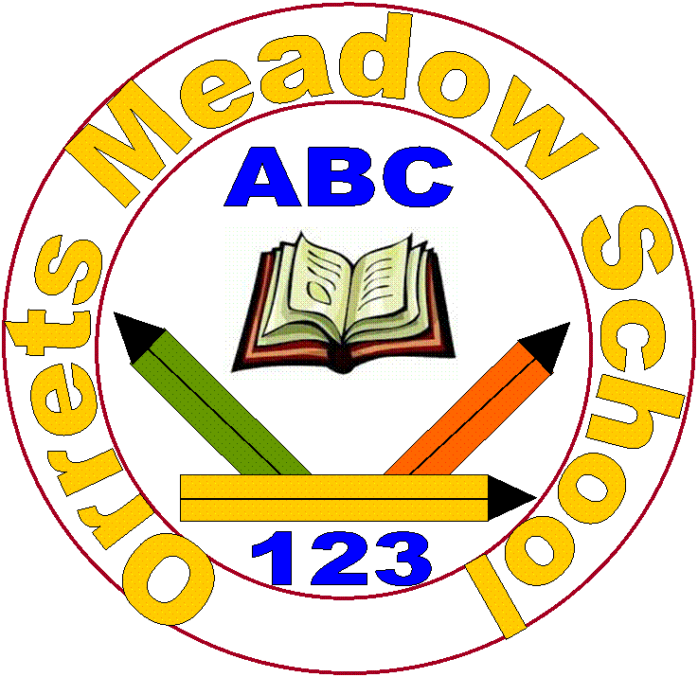
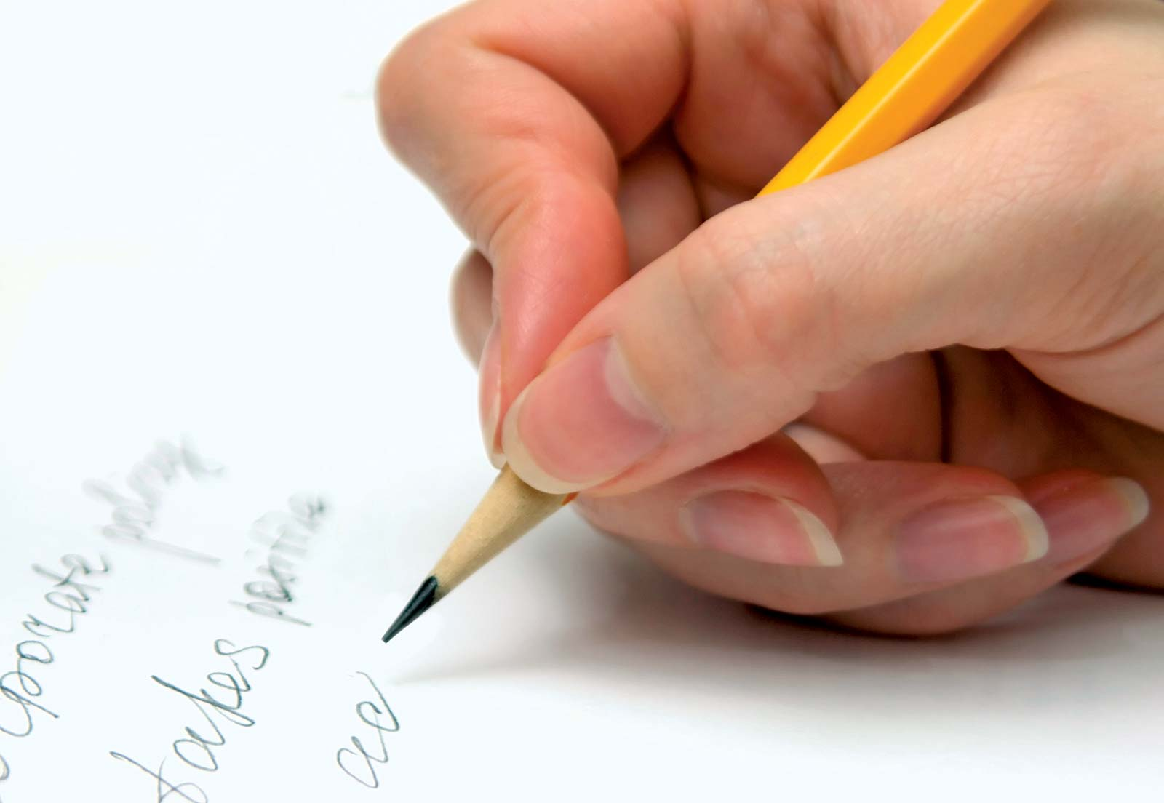
Orrets Meadow School

Handwriting Policy
and
Handwriting Scale
“To raise the aspirations of every child and give them confidence to fulfil their potential through positive experiences”

Orrets Meadow Curriculum Aims and Values
Aims
To ensure all our children are at the centre of a broad, varied and interesting learning experience that is enjoyable and relevant for the future. Our creative, multisensory curriculum will create a sense of awe and wonder and help to inspire a lifelong love of learning. The holistic nature of our practice will promote positive mental health and well-being and will enhance our children’s life skills, social skills and cultural awareness.
Values
Our curriculum will promote a range of values including:
- Respect
- Empathy
- Responsibility
- Equality
- Independence
- Happiness
- Resilience
- Gratitude
- Honesty
- Friendship

Intent

At Orrets Meadow School we want to not only equip pupils with the necessary skills to read and understand texts, but also to be able to share their own stories in a way that can be easily understood by others. This Handwriting Policy is an addendum to the whole-school English Policy outlining our approach to promoting the development of handwriting throughout the school at all ages and stages.

Aims:
This Handwriting Policy aims to:
- Set out a consistent cursive approach across the whole school to ensure high levels of presentation.
- Adopt a common approach towards handwriting by all adults when writing in children’s books, on the whiteboard or on displays/resources.
- Support pupils in achieving neat, legible writing using correctly formed letters in cursive handwriting.
- Help pupils develop the fluency and speed of writing that is required for written tasks.
- Help pupils to tackle difficulties with letter orientation.
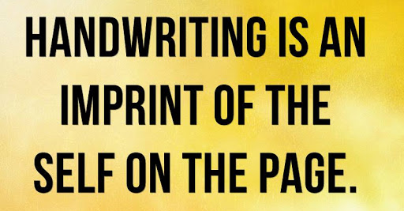

Why is cursive handwriting important?
The benefits of handwriting, cursive in particular, have long been documented. There have been positive links discovered between handwriting and:
- Brain development
- Development of fine motor skills and dexterity
- Greater engagement and retention.
In addition, research shows that cursive writing is beneficial for students with learning disabilities. A 2012 review suggested that cursive may be particularly effective for individuals with neurological disorders such as dyslexia and dysgraphia.
By equipping our pupils with the ability to produce neat, legible handwriting we are
- Providing them with the means to record their own ideas and experiences in a way that they can understand.
- Giving them the opportunity to further their communicative skills with others
- Helping them to correct any letter orientations they are unsure of.
- Enabling them to access a range of texts in a variety of handwriting styles.
- Improving their reading and spelling skills.
Appendix 1 of this policy explores some of the further benefits to teaching cursive handwriting.

Implementation

Teaching and Learning:
- At Orrets Meadow we adopt a continuous cursive style of writing, as recommended by the British Dyslexia Association.
- All staff should model the agreed cursive style when modelling writing both in class, on displays and in feedback in books.
- Handwriting is taught during phonics sessions, English lessons and in fine motor groups.
- Handwriting requires frequent and discrete, direct teaching.

Our agreed cursive style is as below:
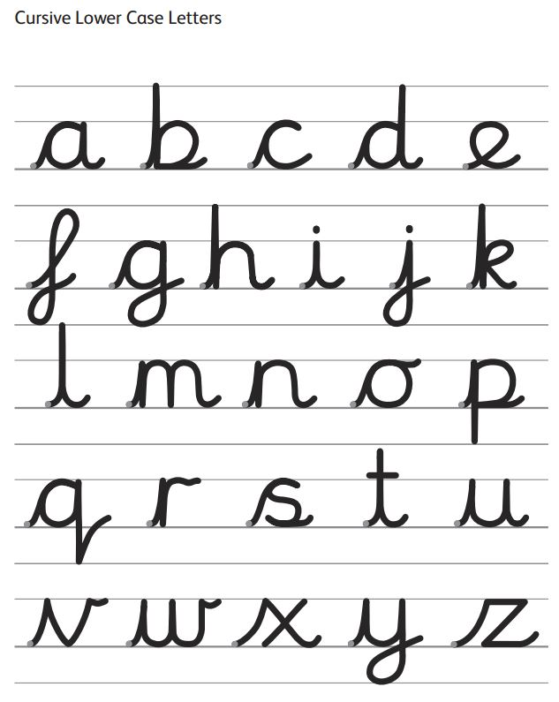

Pupils working Pre-curriculum:
- Pupils should be introduced to pre-cursive and cursive script at the earliest stages of writing.
- At this stage pupils will not be joining their letters but will be developing letters with flicks so they are ready for accessing National Curriculum Expectations.
- A range of tools such as; triangular pencils and large chalks are used in order to rehearse writing skills on different surfaces.
Pupils working within the National Curriculum:
- Handwriting is taught during phonics sessions, English lessons and in fine motor groups.
- Additional needs focusing on gross and fine motor may also cater to the development of handwriting, when appropriate.
- Pupils should be taught to use joined handwriting throughout a range of writing tasks.
- Once pupils are confident in letter formation and joins are accurate handwriting should continue to be taught with the aim of increasing fluency with which pupils are able to write.
- Children should develop their understanding of what style of handwriting is appropriate for a particular task, quick notes or final draft.
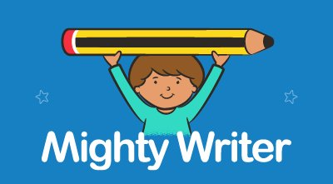
- Children should be taught to use pre-cursive handwriting for a range of purposes including capital letters, filling in forms and labelling diagrams.
Teaching Order
The teaching of letter formation and letters sounds occur in different ways. This is simply because it is easier for pupils to learn the formation of letters by association. For this reason, as stated in the National Curriculum, pupils are taught to form letters in ‘families’. This means that letters are grouped with others that are formed in a similar way.
The families and order of teaching are as follows;
Family 1: The anti-clockwise letters
Family 2: Down and off in another direction
Family 3: With a stick and a curve
Family 4: Zig Zag Letters
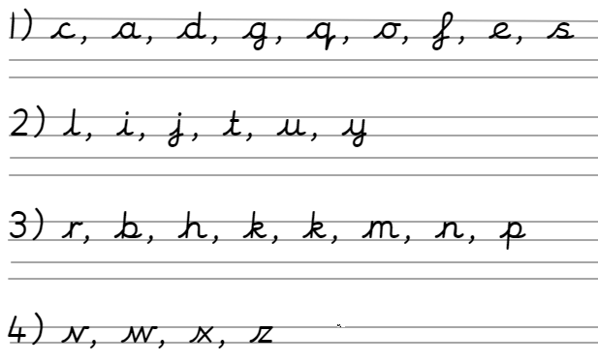

As pupils become more confident at forming these letters in isolation they will naturally begin to join many letters correctly as their awareness of letter spacing grows.
Further joins:
After pupils are taught to form the individual letters they should then be taught to join these letters together in order to join entire words together. Many of the bottom joins are joins that pupils will naturally develop. The top joins are often slightly trickier for pupils to develop. Below are the joins that pupils should be taught.
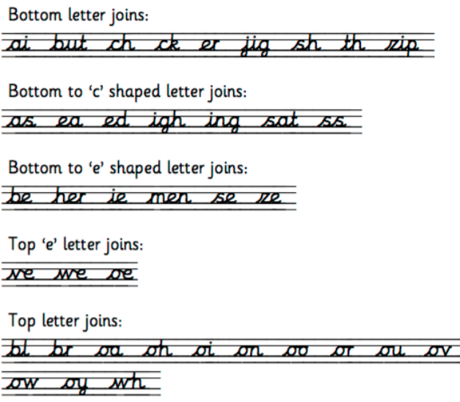

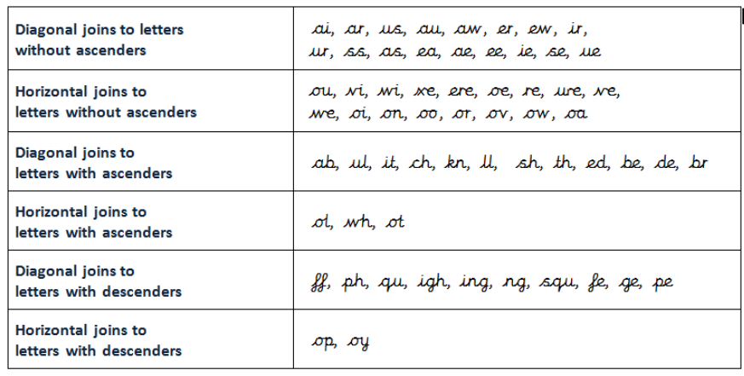

Posture and Pencil Grip:
Two key contributing factors to the production of correct handwriting are pupils’ posture and their grip on the pencil. Pupils are taught throughout Orrets Meadow the correct posture and pencil grip, the tripod pencil grip.
Chairs and desks within classrooms are matched to children’s ages and height.

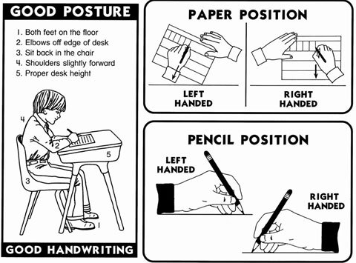
- Children’s feet should be straight and feet resting on the floor.
- A right handed child should have their book slanted to the left.
- A left handed child should have their slanted to the right.
- Make sure that the hand which is not holding the pencil should be holding the paper.

Pencil Grip
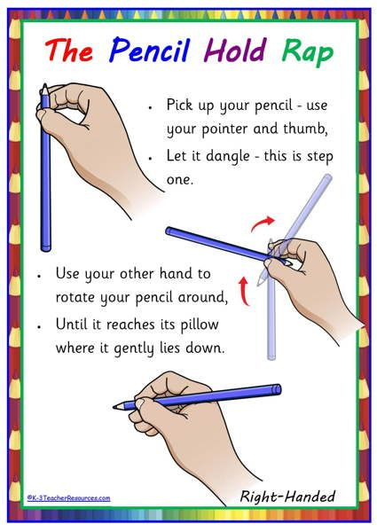
Holding the pen or pencil correctly allows the fingers and wrists to move freely without putting strain on the hand, helping to improve handwriting and making it more comfortable. The Tripod Pencil Grip is the best way to hold a pencil, for both right handed writers, however this isn’t the easiest grip to learn. With lots of practise and reinforcement, it can be achieved!

- Pupils should hold the pencil between their pointer finger and thumb.
- Tuck the other three fingers in towards the palm.
- Rest the pencil on the end of the middle finger.
- Ensure that the end of the pencil is pointing backwards.

Resources to support writing
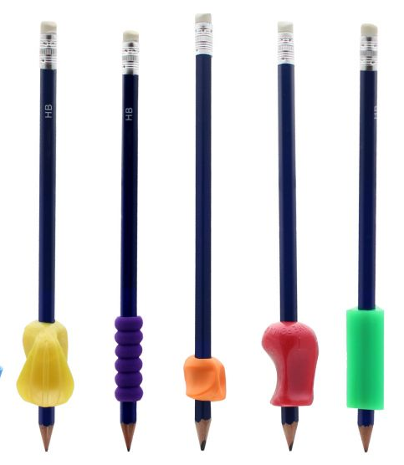
At Orrets Meadow there are a range of resources available to help pupils overcome individual barriers to perfecting their handwriting. The following resources are available in school:
- Writing slopes
- Posture Cushions
- Pencil/Pen grips
- Chunky triangular pencils
- Triangular pens
- Large chalks

Impact
How do we assess and monitor handwriting?
Handwriting is assessed biannually in December and July using the Orrets Meadow handwriting scale.

Orrets Meadow Handwriting Scale:
- The Orrets Meadow Handwriting Scale includes statements from the National Curriculum 2014 and the Orrets Meadow pre-curriculum English steps.
- Some steps on the scale are not linked to a specific year group.
- Pupils are awarded a place on the scale that securely fits their handwriting style and achievements in writing.
What will this achieve?
Our goal for the children of Orrets Meadow is for them to be confident and enthusiastic enough to write in a range of genre at the best level they are capable of before moving onto the next stage in their education. The impact on pupils’ should reflect the initial aims in this policy:
- Set out a consistent cursive approach across the whole school to ensure high levels of presentation.
- Adopt a common approach towards handwriting by all adults when writing in children’s books, on the whiteboard or on displays/resources.
- Support pupils in achieving neat, legible writing using correctly formed letters in cursive handwriting.
- Help pupils develop the fluency and speed of writing that is required for written tasks.
- Help pupils to tackle difficulties with letter orientation.
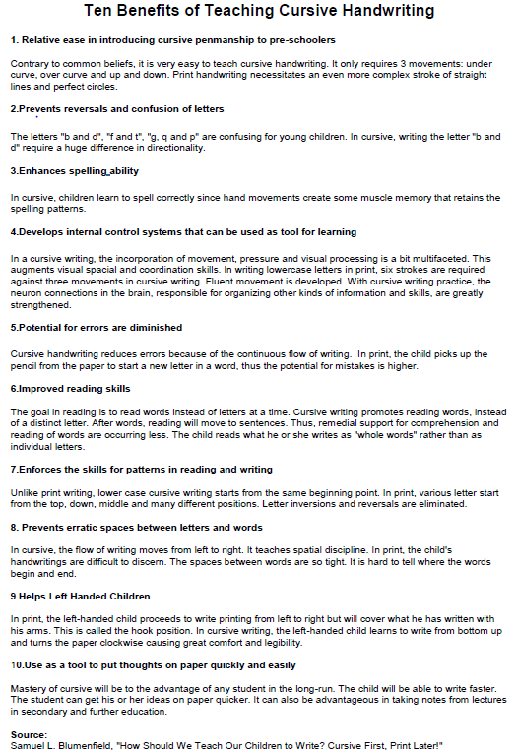
Appendix 1: Further Benefits of teaching cursive handwriting.
Orrets Meadow Handwriting Scale
Step 1
Orrets Meadow English Step 4:
- Distinguishes between the different marks they make.
- Sometimes gives meaning to marks as they draw and paint.
- Ascribes meanings to marks that they see in different places.

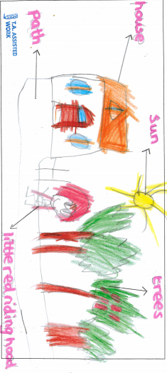
Pupil is able to explain or give a meaning to the marks they make.
Staff may be able to scribe beside these marks under the pupils’ direction.
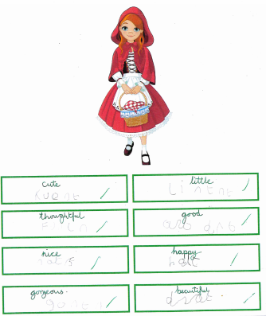
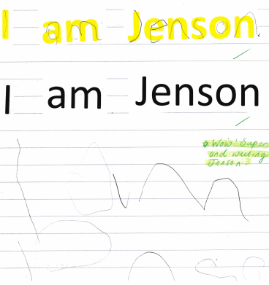
This pupil has traced letters and then made marks to represent each word.
This pupil has described what their pictures are to a member of staff and then attempted to overwrite.

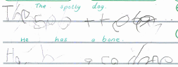
This pupil has made letter shapes and then explained their meaning to a member of staff.
This pupil has made letter shapes and then explained to a member of staff what they have attempted.

Orrets Meadow Handwriting Scale
Step 2
Orrets Meadow English Step 5:
- Uses some clearly identifiable letters to communicate meaning,
representing some sounds correctly and in sequence.
- Writes own name and other things such as labels, captions.
- Attempts to write short sentences in meaningful contexts.

Pupil attempts to create or copy letters.
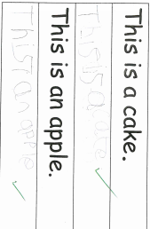
Little control while forming letters and orientation to the line.
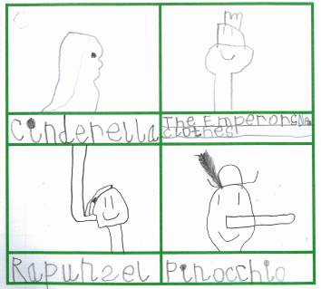
Inconsistent spacing between letters and words.
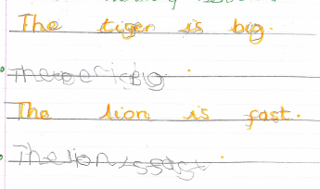

Orrets Meadow Handwriting Scale
Step 3
Orrets Meadow English Step 6:
- Write recognisable letters, most of which are correctly formed;
- Spell words by identifying sounds in them and representing the sounds with a letter or letters;
- Write simple phrases and sentences that can be read by others.

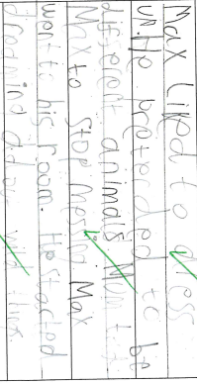
Recognisable letters
Some correctly formed letters in print, but without joins and minimal space in between words.
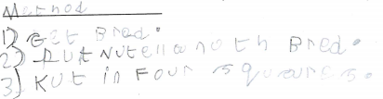
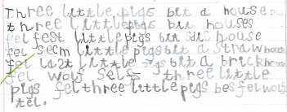

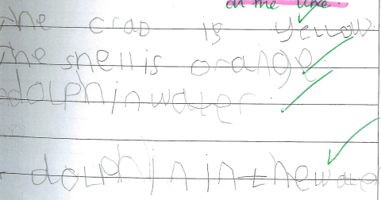

Orrets Meadow Handwriting Scale
Step 4
National Curriculum: Year 1 Handwriting
- Sit correctly at a table, holding a pencil comfortably and correctly
- Begin to form lower-case letters in the correct direction, starting and finishing in the right place
- Form capital letters
- Form digits 0-9
- Understand which letters belong to which handwriting ‘families’ (i.e. letters that are formed in similar ways) and to practise these.

Easily recognisable letters.
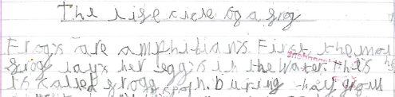
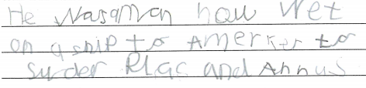
Some evidence of letters formed in a pre-cursive style, without joins.

Orrets Meadow Handwriting Scale
Step 5
National Curriculum: Year 2 Handwriting
- Form lower-case letters of the correct size relative to one another
- Start using some of the diagonal and horizontal strokes needed to join letters and understand which letters, when adjacent to one another, are best left unjoined.
- Write capital letters and digits of the correct size, orientation and relationship to one another and to lower case letters.
- Use spacing between words that reflects the size of the letters.

Some evidence of joined letters within words, diagonal joins.
Some evidence of spaces between words.
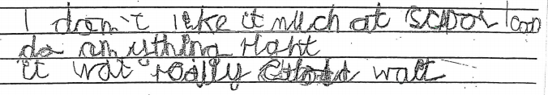
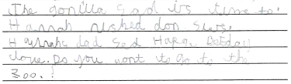
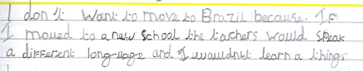
Orrets Meadow Handwriting Scale
Step 6
National Curriculum: Year 3 and 4 Handwriting
- Use the diagonal and horizontal strokes that are needed to join letters and
understand which letters, when adjacent to one another, are best left unjoined

Some evidence of correctly formed, joined letters, both diagonal and horizontal.
Irregular spacing between words and letters.
Inconsistent letter sizing, inconsistent ascenders and descenders.
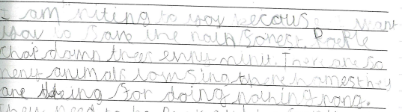
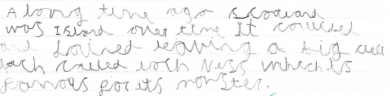
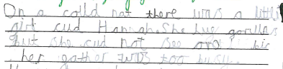
Orrets Meadow Handwriting Scale
Step 7
National Curriculum: Year 3 and 4 Handwriting
- Increase the legibility, consistency and quality of their handwriting [for example, by ensuring that the downstrokes of letters are parallel and equidistant; that lines of writing are spaced sufficiently so that the ascenders and descenders of letters do not touch].

More evidence of correctly formed letters with more accurate joins.
Clearer ascenders and spacing.
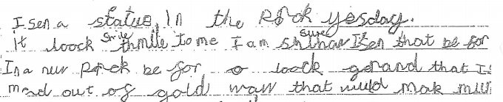
Descenders may be incorrectly placed on the line.
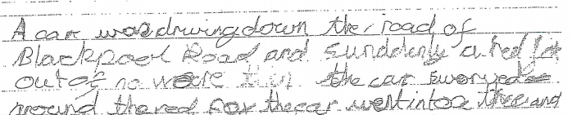
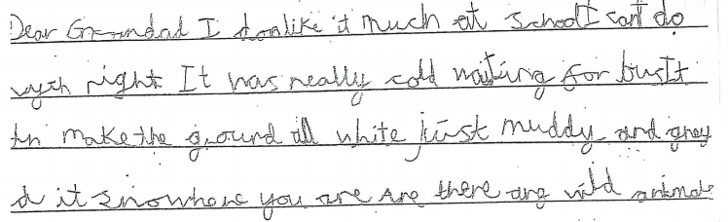
Orrets Meadow Handwriting Scale
Step 8
National Curriculum: Year 5 and 6 Handwriting
- Write legibly, fluently and with increasing speed.
- Chooses the writing implement that is best suited for a task.

Developing control over joins, spaces and positioning on the line.
Ascenders and descenders mostly correct.
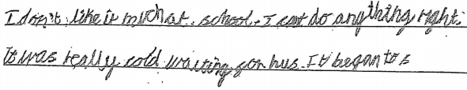
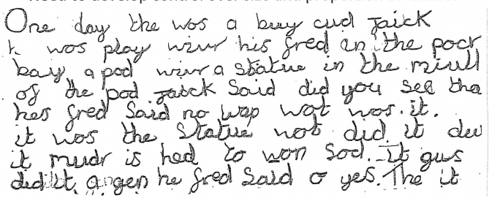
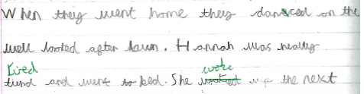
Letters sizing may be inconsistent throughout.
Orrets Meadow Handwriting Scale
Step 9
National Curriculum: Year 5 and 6 Handwriting
- Chooses which shape of a letter to use when given choices and decides
whether or not to join specific letters.

Letter formation correct and most joins correctly formed.
Positioning on the line may be inconsistent.
Some slight variation with letters and spaces.
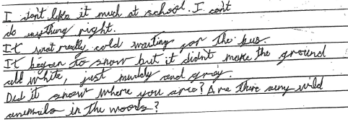

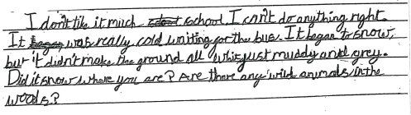

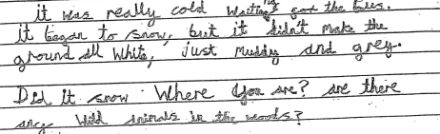

Orrets Meadow Handwriting Scale
Step 10
National Curriculum: Year 5 and 6 Handwriting
- Write legibly, fluently and with increasing speed.
- Chooses the writing implement that is best suited for a task.

Clear and legible writing with correct letter formations and joins.
Consistent letter sizes and spaces.
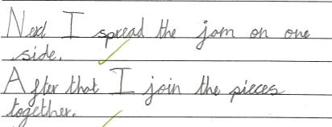
Capital letters are left unjoined.
