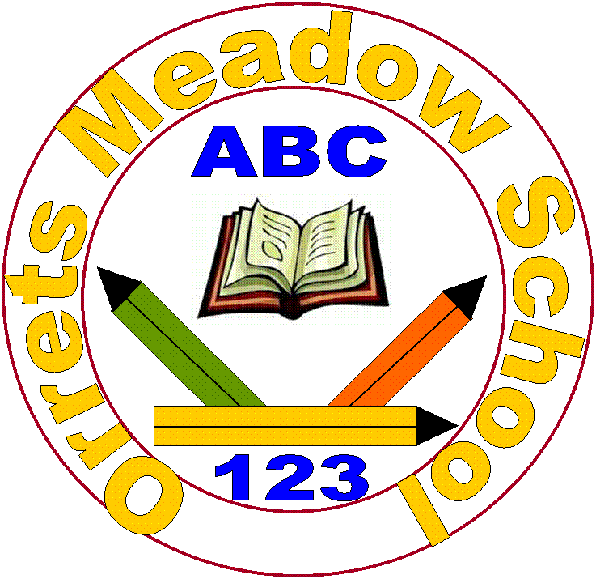
Orrets Meadow School
Parents and Carers Survey 2017
(Please tick √)
65 out of 72 surveys returned

Question/Statement | Strongly agree | Agree | Disagree | Strongly disagree | Don’t know
1. My child is happy at this school. | 54 | 11 | 0 | 0 | 0
2. My child feels safe at this school. | 58 | 7 | 0 | 0 | 0
3. My child makes good progress at this school. | 59 | 6 | 0 | 0 | 0
4. My child is well looked after at this school. | 58 | 7 | 0 | 0 | 0
5. My child is taught well at this school. | 59 | 6 | 0 | 0 | 0
6. My child receives appropriate homework for their age. | 56 | 7 | 1 | 0 | 1
7. The school make sure its pupils are well behaved. | 57 | 6 | 1 | 0 | 1
8. The school deals effectively with bullying. | 54 | 5 | 0 | 0 | 6
9. The school is well led and managed. | 58 | 6 | 0 | 0 | 1
10. School responds well to any concerns I raise. | 57 | 7 | 0 | 0 | 1
11. I receive information from school about my child’s progress. | 58 | 7 | 0 | 0 | 0
12. I would recommend this school to another parent. | 59 | 6 | 0 | 0 | 0
Any other comments about your child’s experience of Orrets Meadow?

- He came in September and his progress is absolutely outstanding. I couldn’t have asked for better support. This school is the best not only for my son, but also for me!
- Amazing! Like a family atmosphere.
- Everyone is treated as an individual. I don’t think a better school exists!
- She is very happy at school. She has lots of friends, loves all her teachers and learning has come on tremendously, especially her reading.
- He is a different boy since starting OM and that’s fantastic to see!
- My child has made fabulous progress since joining this wonderful school and is so much more confident and happy doing school work.
- Love this school and all it has done for my child. I feel blessed he has a place here!
- Since she has been at OM she come on loads which is what she needs and I’m very happy with her progress so far.
- Everyone is treated as an individual. I don’t think a better school exists!
- You are fantastic!
- She has really come out of herself!
- He enjoys going into school which he didn’t before. He is progressing a huge amount and he can now write and is beginning to read.
- Excellent support and advice is given from this school regarding all apects and my child. This school is outstanding and very rewarding to be part of.
- Since he has been at OM he has settled in very well.
- He has never been bullied at this school. We are very happy with his progress.
- He loves coming to school and he has progressed at lot.
- Simply loves OM and I always have. He is so much happier! Thank You!
- OM is an excellent school. Our daughter loves coming to school. She is happy, gaining confidence and achieving beyond our expectations. Thank you.
- He needs to work on maths a bit more but he loves OM school. Thank you!
- He has settled in so well and is progressing well.
- School is fabulous for my son.
- She has made incredible progress with her reading. She is much more confident and happier since starting at OM – Thank you!
- Very helpful, always have time for family problems and I interact loads with Michelle.
- The caring responsive team support my son receives is very good. A lot of effort is taken to make the school experience positive.
- You are fantastic!
- My 10 year old came to OM in September with a reading age of 7yrs 9 months and at Christmas he had a reading age of 9 yrs 10mths!
- We are so pleased with the amount of progress he has made and feel fortunate that he has a place at OM.
- She loves school! I am so proud that she is progressing. OM is like an extended family.
- She has had the best possible support for her Dyslexia. She is like a different child, confident and increased self esteem.
- She has really increased in confidence.
- The Home school link worker has been a fantastic link for the school and can not thank her enough.
- We are really happy with the progress he has made since he started.
- Our son used to hate school and got upset at homework as he couldn’t understand it and used to get upset about other children getting at him. Since being in OM he is a happier child, loves school homework and he had made lots of friends. He has been accepted, has friends, been to lots of parties and had them to play. One happy mum!

